SỞ GD & ĐT HẢI PHÒNG    ĐỀ ĐỀ XUẤT | KỲ THI HỌC SINH GIỎI CÁC TRƯỜNG THPT CHUYÊN KHU VỰC DUYÊN HẢI VÀ ĐỒNG BẰNG BẮC BỘ  LẦN THỨ XIV, NĂM 2023  HƯỚNG DẪN CHẤM MÔN: TIẾNG ANH 11  (Hướng dẫn chấm gồm 14 trang)
A. LISTENING (50 points)
Part 1. For questions 1-5, listen to a talk about office life and decide whether these statements are True (T), False (F) or Not Given (NG). Write your answers in the corresponding numbered boxes provided. (10 points – 2 points/a correct answer)

1. F | 2. T | 3. F | 4. F | 5. NG

Part 2. For questions 6-10, you are going to hear two students, Brett and Mica, on an environmental studies course talking to their tutor about photography assignment. Write NO MORE THAN THREE WORDS for each answer. (10 points – 2 points/a correct answer)
6. (the) landscape
7. stunning reflections
8. neck pain/hurting (your) neck
9. Scottish artists, designers
10. conservation
Part 3. . For questions 11-15, listen to part of a discussion in which two economists, Rita Manning and Paul Mason, are discussing the implications of global trade and choose the correct answer A, B, C, or D which fits best according to what you hear. (10 points – 2 points/a correct answer)
11. B | 12. A | 13. D | 14. D | 15. C

Part 4. For questions 16-25, you will listen to a recording of a presenter talking about Machu Picchu. Complete the summary by writing NO MORE THAN THREE WORDS and/or A NUMBER in each gap. Write your answers in the corresponding numbered boxes on the answer sheet. (20 points – 2 points/a correct answer)
  - accommodate pedestrians
  - proliferation
  - the frontage zone
  - newspaper racks
  - cash influx
  - capture demand
  - short driving trips
  - segways
  - entered the lexicon
  - drafting standards

B. LEXICO – GRAMMAR (30 points)
Part 1. For questions 26-45, choose the best option A, B, C or D to complete the following sentences and write your answers in the corresponding numbered boxes on the answer sheet. (20 points – 1 point/a correct answer)
26. A | 27. C | 28. B | 29. A | 30. C | 31. D | 32. C | 33. A | 34. A | 35. A
36. B | 37. D | 38. B | 39. C | 40.B | 41. A | 42. B | 43. A | 44. A | 45. B

Part 2. For questions 46-55, give the correct form of each given word to complete the following sentences and write your answers in the corresponding numbered boxes on the answer sheet. (10 points – 1 point/a correct answer)
46. offside | 51. ever-evolving
47. intracellular | 52. insensate
48. fortuitous | 53. birthmark
49. aheap | 54. containerization
50. discomposure | 55. run-down

C. READING (60 points)
Part 1. For questions 56-65, fill each of the following numbered blanks with ONE suitable word and write your answers in the corresponding numbered boxes on the answer sheet. (15 points – 1.5 points/a correct answer)
56. ourselves | 61. balance
57. what | 62. along
58. at | 63. entitled
59. raise | 64. not
60. abuse | 65. little
Part 2. For questions 66-75, read the passage below and choose the answer A, B, C or D that fits best according to the text. Write your answers in the corresponding numbered boxes provided on the answer sheet. (10 points – 1 point/a correct answer)
66. D | 67. C | 68. A | 69. C | 70. D | 71. A | 72. B | 73. C | 74. A | 75. B

Part 3. Read the following passage and do the tasks that follow. (13 points – 1 point/a correct answer)
76. T | 77. NG | 78. F | 79. NG | 80. T | 81. NG

82. consumer’s right/ consumer’s choice
83. risk and benefit
84. skiing
85. GM crops
86. wheat and rice
87. production
88. mistrust

Part 4: In the passage below, seven paragraphs have been removed. Read the passage and choose from paragraphs A-H the one which fits each gap. There is ONE extra pragraph which you do not need to use. Write your answers in the corresponding numbered boxes provided on the answer sheet. (7 points – 1 point/a correct answer)
89. B | 90. E | 91. H | 92. A | 93. F | 94. C | 95. G

Part 5: For questions 96-105, you are going to read an article about an art exhibition that focuses on the subject of whether paintings are authentic or fake. Answer the questions by choosing from the sections of the article (A - F). The sections may be chosen more than once. Write your answers in the corresponding numbered boxes provided on the answer sheet. (15 points – 1.5 points/a correct answer)
96. B | 97. C | 98. A | 99. D | 100. E | 101. D | 102. A | 103. C | 104. B | 105. E

D. WRITING (60 points)
Part 1: (15 points)
- Contents (10 points)
The summary MUST cover the following points:
* Main topic: plankton is the sea plant that is so rich in nutrition and krill is an example of this species (2 points)
* Supporting ideas:
- Plankton, a tiny plant in the sea, provide food for large animals. (2 points)
- In food value, plankton outweighs grasses. (2 points)
- Little effort was made to farm plankton but this plant is gaining considerable interest. (2 points)
- Krill, with its reddish color, is an example of how nutritious plankton is. It is the main food of blue whale and mostly lives in Antarctic. (2 points)
- Language use (5 points)
The summary:
- should show attempts to convey the main ideas of the original text by means of paraphrasing
(structural and lexical use)
- should demonstrate correct use of grammatical structures, vocabulary, and mechanics (spelling,
punctuations, ...)
- should maintain coherence, cohesion, and unity throughout (by means of linkers and
transitional devices)

Part 2: (15 points)
Contents (10 points)
The report MUST cover the following points:
- Introduce the charts (2 points) and state the overall trends and striking features (2 points)
- Describe main features with relevant data from the charts and make relevant comparisons (6 points)
Language use (5 points)
The report:
- should demonstrate a wide variety of lexical and grammatical structures,
- should have correct use of words (verb tenses, word forms, voice...) and mechanics (spelling,

Part 3: (30 points)
The mark given to part 3 is based on the following criteria:
1. Organization (5 points)
a. Ideas are well organized and presented with coherence, cohesion and unity.
b. The essay is well-structured:
* Introduction is presented with clear thesis statement.
* Body paragraph are written with unity, coherence and cohesion.
Each body paragraph must have a topic sentence and supporting details and examples when
necessary.
* Conclusion summarizes the main points and offers personal opinions (prediction,
recommendation, consideration ...) on the issue.
2. Content (15 points)
a. All requirements of the task are sufficiently addressed.
b. Ideas are adequately supported and elaborated with relevant and reliable explanations,
examples, evidence....
3. Language use (10 points)
a. Demonstration of a variety of topic-related vocabulary.
b. Excellent use and control of grammatical structures (verb tenses, word forms, voice...) and
mechanics (spelling, punctuations...)
- THE END -

TRANSCRIPT FOR LISTENING
Transcript part 1 https://www.youtube.com/watch?v=54mWcsTk8f0
Largely, workers proved to their employers that they could get their jobs done from home. So what does the future hold for the office?
80% of people who worked from home during the lockdown say they'd like to continue working at least one day from home in the future.
Meanwhile two out of three of us say that we're longing to return to the office in some form.
In other words, we want to have our cake and eat it. We want the best parts of the office
and the best parts of working from home. The workplace property expert Antony Slumbers
said no firm ever wanted an office, they wanted productive employees and the office was just one way to create that. Over the last few years, many companies had moved to open-plan offices. Well the promise was that we would be let loose in vast workplace savannahs, free to meet and bounce ideas off each other. In fact, open-plan offices tended to make us feel
like we were constantly interrupted and unable to get anything done. We've realised offices are good for some things.
The office had something called 'a network effect'. So it's chance encounters, bumping into colleagues and sharing thoughts just casually, that we're finding so difficult to replace.
And there seems to be some pretty good evidence that our best 'aha' moments happen in these chance encounters. Professor Sandy Pentland from the Massachusetts Institute of Technology says the reason why these conversations are so effective is that these are the moments that we don't find ourselves supervised by our bosses, we feel free to have honest discussions. So if the office was good for a few things and the top one - chatting to colleagues - is the one we're struggling to replace, what's the answer?
Maybe your firm will join something that's starting to be called the TW and T Revolution,
where workers work from the office on Tuesdays, Wednesdays and Thursdays but from home on Mondays and Fridays. And no doubt, in time, someone will come with a catchy name for people who work like this.
Other firms are being still more adventurous, saying they want to free up workers to do their work whenever they feel most productive. They're adopting what's being known as asynchronous working. When we do something synchronously it means we're coordinated in time, like the swimmers at the Olympics. Asynchronous work says, 'how about we allow people to give their feedback or their ideas whenever they're feeling most inspired?'
Companies who do this say it allows workers the flexibility to take their kids to school or even do leisure activities and this is what the asynchronous working firms believe will attract the best workers to come to work for them.
Expect to hear a lot more of the word 'hybrid'. At the more adventurous end of hybrid, some firms are even talking about only getting their employees together one week a quarter. Meaning that, almost certainly, they don't need an office. ...for many office workers, the era of getting up every day and going to the same place seems to be a thing of the past.
And the question is...... will you miss it?

Transcript part 2 (Complete IELTS, 6.0-7.5, 2013 CUP)

Tutor: Right, so do you have any further questions about the trip?

Brett: Well, yeah – I was wondering about the weather – They’re forecasting a lot of mist.

Tutor: Well, yes, but I wouldn’t worry – in the long run, you’ll still get your pictures.

Brett: But ….

Tutor: You just have to be careful. You know, experts say there’s no such thing as bad weather when it comes to photography.

Mica: What about driving rain?

Tutor: Well, yes, that doesn’t make things easy, but it does mean that you need to take the landscape into account. Perhaps to a greater degree than you would normally.

Mica: Is that because of shadow and things like that?

Tutor: Well, you get shadow in good weather.

Mica: Yeah – I guess so.

Brett: Um, I’m really looking forward to photographing the Scots pine trees. I want to make the most of all the stunning reflections in the water.

Tutor: Just take your time, and you might capture an amazing reflection – you really should profit from this with the water round you.

Mica: You were taking last week in your lecture about a piece of equipment called an angle finder, and I’ve been checking them out on the Internet...

Tutor: Ah-hah, it’s a clever little device – particularly useful if you’re down on your knees trying to get really close to something in the grass, like an insect or bird.

Brett: I’ve got one actually – and what’s great about it is that it prevents neck pain, because it’s like a periscope on a submarine – you can lie down and look through it without hurting you neck.

Mica: Definitely worth buying, then!

Tutor: Now, is there anything else?

Brett: Well, I’ve been looking at some wildlife paintings by Scottish artists. I thought they might help me get ideas.

Mica: That’s a good suggestion.

Tutor: Some designers can be helpful, too.... they can help give you ideas about camera angles and how you use natural light.

Mica: Hmm, I’ll look into that. One other thing .... I know you said we should consider matters related to conservation when we choose a scene to photograph.

Tutor: I made that point because, well, images like the ones you’re going to take can sometimes reveal some of the conservation problems faced by species and habitats. It’s just something to bear in mind.

Transcript part 3: (Prosperity – test 2)
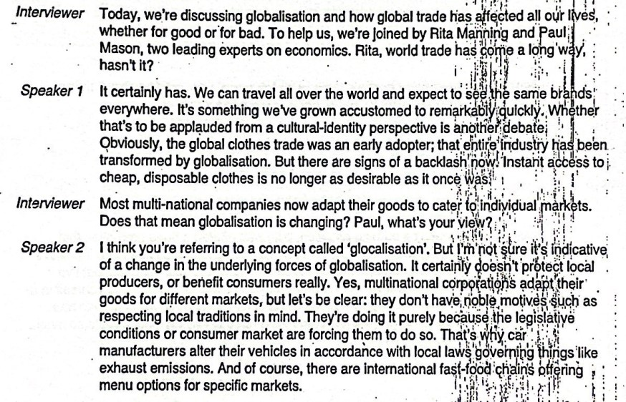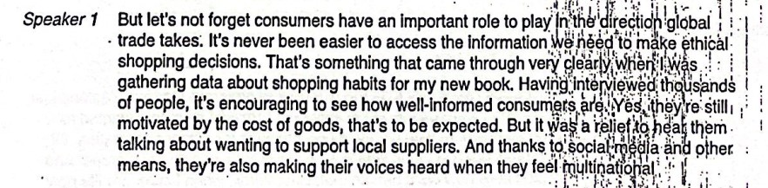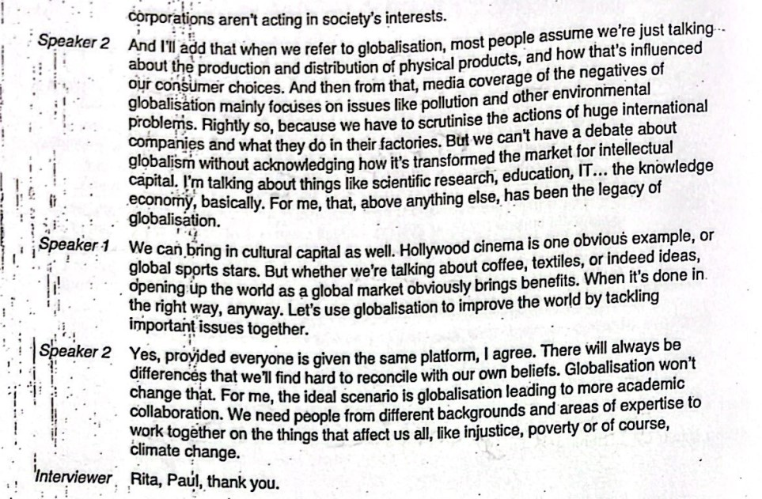

Transcript part 4: https://www.youtube.com/watch?v=c2YInNlzMDQ
You’ve seen them. Zipping through the streets. Blocking the sidewalks. Dockless electric scooters have appeared virtually overnight in dozens of cities. So far this year, millions of rides were taken on little machines just like this. And their operators have raised billions in investments. So if you haven’t yet, chances are you're going to see stuff like this pretty soon.
We see the scooters navigating through pedestrians. We see them being left anywhere. And this creates problems for a number of people. Problems indeed. If people on dockless scooters or bikes keep using the sidewalks … it’s going to get crowded.
the purpose of the sidewalk has changed considerably over the last 100 years. when cities first started building sidewalks, the reason for them was to accommodate pedestrians on the street. But this was not the only use of sidewalks. A lot of that happens before the automobile. This is a street scene from San Francisco in 1906. Notice the man, holding a baby, just, walking straight through traffic. Nobody seems too concerned. they are quite relaxed about it and they also know how to navigate the street.
But, eventually cars got bigger and faster. Traffic had to separate. We start seeing with the proliferation of the cars, many cities start widening their streets. and of course this happens at the expense of the sidewalk because a lot of times the buildings were pretty much set. So a sidewalk that was 12 — 15 feet becomes 6 - 8 feet. Which is pretty unfair for pedestrians. Because there is a lot more happening on sidewalks than walking. There’s the frontage zone — in cities, a business might put a cafe or signs there. Then there’s the furniture zone, full of streetlights, newspaper racks, and benches. Because sidewalks have frontage and furniture zones, pedestrians have smaller space to travel than it might seem. Some vigilantes have taken the space issue into their own hands And many cities have used pilot programs to really get the scooters under control. These pilots are likely to extend. After all, cities need alternative modes of transportation. First it takes vehicles off the street Because people who might be using ride hail, or taxis, or another personal vehicle, might instead opt for this other solution if a person takes a subway or a bus to a certain station or stop, and they still live a mile away from that station, they have to figure out how to get there
Even in cities with exceptional levels of public transportation, many residents have to travel a ‘last mile’
If dockless vehicles are deployed in areas like this, residents could make better use of public transportation. And not just rely on cars. Because what many people will do is say ‘I don’t have a last mile option that works for me. I’m just going to drive the whole way. The cash influx for scooter-share is a really a bet. Investors hope that e-scooters can capture demand in underserved transportation deserts, without adding congestion And the scooters might pull that off. One survey found robust support for e-scooters as a substitute for short driving trips. But the scooters won’t work if their riders have to compete for space with pedestrians and cars.
We’re reaching a point in cities across America, where it’s time to get people out of their cars and allow people more modes. Smaller transportation — bikes, segways, scooters — they only work when cities make space for them. Planners can do this by designing ‘complete streets’. So complete streets is a new term that entered the lexicon of planning and transportation planning relatively recently. but basically it is inspired by earlier streets where you used to have all these different sorts of uses social uses of the streets and sidewalks not only street for cars vehicular users
Complete streets start by reducing the amount of space given to cars. Making space for protected bus bulbs, wider sidewalks, street level plazas, and buffered bike lanes.
Scooters will be a more realistic last mile option when cities build networks of complete streets.
So, worry not, dear pedestrians — even if the scooters are here to stay…Cities are drafting standards for this brave new world of alternative transportation. With any luck, the love for scooters just might push cities to invest in safer, more accommodating streets.

