|  |  |  |
| --- | --- | --- |
| Phòng GD&ĐT TP Hà Tiên  Trường Tiểu học Thuận Yên  Lớp:..................................................................  Họ và tên:……………………………………. | | Bài kiểm tra cuối học kỳ I  Năm học: 2021 – 2022  Môn: Tiếng Anh  Khối: 5- Thời gian: 40 phút  Ngày kiểm tra:…………………… |
| Điểm | Nhận xét của giáo viên | Chữ ký giám thị:……………………  Chữ ký giám khảo: ………….…….. |

**Part 1: Read and circle:**(Đọc và khoanh tròn bức tranh tương ứng) **(1.0 marks)**

1. Tom: How many lessons do you have today, Quan?  
    Quan: I have four: Maths, Vietnamese, English and IT.

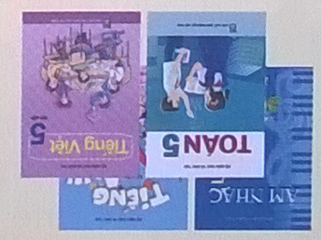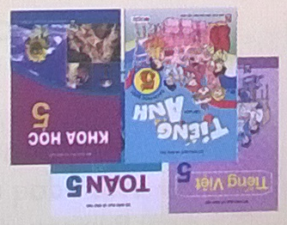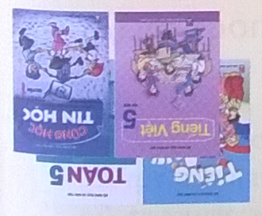

a.

b..

c. .

2. Akiko: You are very good at speaking English, Nam!  
    Nam: Thank you, Akiko.  
    Akiko: How do you practise speaking?  
    Nam: I speak English with my friends everyday.

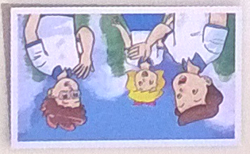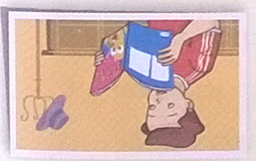

a.

b..

c. .

3.  Linda: How do you practise listening, Nam?  
    Nam: I watch English cartoons on TV.

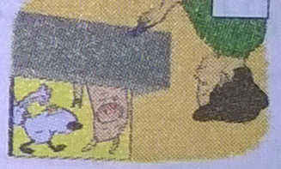

a.

b..

c. .

4. Linda: How do you learn English, Mai?  
    Mai: I sing English songs.

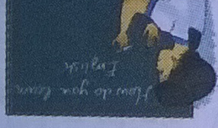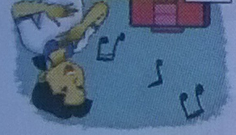

a.

b..

c. .

**Part 2: Read and number** (nghe và điền số vào tranh tương ứng) **(1.0 marks)**

1. Tony: How do you practise listening?  
    Mai: I often watch English cartoons on TV.  
    Tony: Great! Let’s watch cartoons together.  
2. Linda: What are you going to do on Sports Day?  
    Mai: I’m going to play badminton.  
    Linda: I like badminton, too. Let’s play together.  
    Mai: OK.  
3. Tom: What subject do you like best, Nam?  
    Nam: English. It’s my favourite subject.  
    Tom: How often do you have English?  
    Nam: I have it four times a week.  
4. Linda: What are you reading, Tom?  
    Tom: Snow White and the Seven Dwarfs.  
    Linda: What do you think of the main character?  
    Tom: Snow White is very kind.

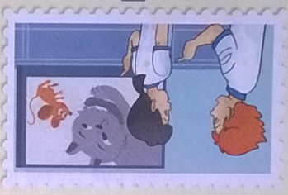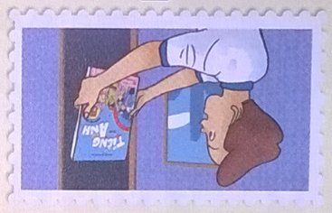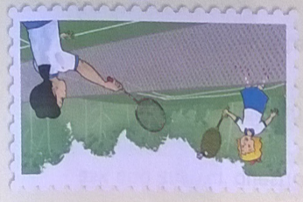

a b c d

**Part 3: Choose the correct answer***(Chọn đáp án đúng)* **(1.0 marks)**

1. ....................... will Sport Day be?

A. When B. Who C. What D. How

2. What did you .... at the zoo?

A. saw B. see C. did D. look

3. What .............. she reading?

A. do B. did C. is D.are

4. How do you practise ......... English?

A. speaks B. speak C. spoke D. speaking

**Part 4: Read and circle**(đọc và khoanh tròn đáp án đúng) **(2.0 marks)**

1. What are you reading now?
2. I’m reading a story about Halloween.
3. I read Tam Cam.
4. He is hard – working.
5. Will you take part in Sports Day?
6. No, I will.
7. Yes, I will.
8. Yes, I do.
9. What are you going to do?
10. I’m going to play football.
11. I play football.
12. I will play football.
13. Do you like comic books?
14. Yes, I like.
15. Yes, I do like.
16. Yes, I do.

**Part 5: Write (viết)- Answer the questions**(Trả lời các câu hỏi) **(2.0 marks)**

Example***:* what do you do in your free time?*****I often watch TV***

1) What did the peacocks do when you were there? ______________________

2) What’s An Tiem like? ___________________________________________

3) How do you practise listening to English? _______________________________________

4) How many lessons do you have today? _____________________________

**Part 6: Arrange the following words to make meaningful sentences and circle:** (Sắp xếp các từ thành câu có nghĩa và khoanh tròn đáp án đúng) **(1.0 marks)**

1. often/ do/ How/ you/ English?/ have
2. How often do you have English?
3. How do you often have English?
4. How often you do have English?
5. What/ your/is/favourite/ lesson?
6. What your is favourite lesson?
7. What is your favourite lesson?
8. What favourite is your lesson?
9. were/ really/ They/ noisy!
10. They really were noisy!
11. They noisy were really!
12. They were really noisy!
13. are/ What/ do?/ going/ to/ you
14. What are you going to do?
15. What you are going to do?
16. What are going you to do?

The end

**ĐÁP ÁN MÔN TIẾNG ANH KHỐI 5 HKI**

**Part1: Read and circle: (1đ)**

1. c 2. a 3. c 4. b

**Part 2: Read and number. (1đ)**

a.1 b.4 c.2 d.3

**Part 3: Choose the correct answer. (1đ)**

1. a 2.b 3. c 4. d

**Part 4: Read and circle. (2đ)**

1.a 2. b 3. a 4. c

**Part 5: Write (2đ)**

1) They moved beautifully.

2) He’s hard-working.

3) I watch English cartoons on TV.

4) I have *three: Maths, Vietnamese, Music*

**Part 6: Arrange the following words to make meaningful sentences and circle: (1đ)**

1. a. How often do you have English?
2. b. What is your favourite lesson?
3. c.They were very noisy!
4. a.What are you going to do?

**MA TRẬN ĐỀ TIẾNG ANH 5 HKI**

**Liệt kê các chủ đề, cấu trúc và từ vựng cần kiểm tra**

|  |  |  |
| --- | --- | --- |
| Topic | Sentence partterns | Vocabulary |
| Lessons | How many lessons do you have today?  I have ……  How often do you have ..?  I have it + *frequency expression* | Once/ twice a week, three/four times a week |
| How someone learns English | How do you practice …?  I …..  Why do you learn English?  Because I want to ….. | Speak, listen, write, read, email, short story, practice, foreign |
| What story/book someone is reading | What are you reading?  I’m reading …..  What’s ….. like?  She’s/ he’s …… | Names of books/ stories, kind, hard-working, clever, gentle, generous, funny, fairy tale |
| Animals in a zoo | What did you see at the zoo?  I saw …  What did the … do when you were there?  They ….. | Python, peacock, gorilla, roar, move, panda, quietly, loudly, slowly, beautifully |
| School events | When will ….. be?  It’ll be on …..  What are you going to do on Sports Day?  I’m going to ……. | Sports Day, singing contest, independence Day, table tennis |

**Lựa chọn các nhiệm vụ đánh giá, phân chia kiến thức ngôn ngữ vào các nhiệm vụ đánh giá:**

|  |  |  |  |  |  |
| --- | --- | --- | --- | --- | --- |
| Kỹ năng | Nhiệm vụ đánh giá/Kiến thức đánh giá | Tổng số câu, số điểm. | | | |
| M1  Nhận Biết | M2  Kết nối | M3  Vận dụng |  |
| Reading | **Read and tick**  Learn English, lessons | 1  0.25 đ | 2  0.5 đ | 1  0.25 đ | 16 câu/ 5 điểm |
| **Read and number**  Lessons, story | 2  0.5 đ | 1  0.25 đ | 1  0.25 đ |
| **Choose the correct answer**  Animals in a zoo | 2  0.5 đ | 1  0.25 đ | 1  0.25 đ |
| **Read and circle**  School events, What story/book someone is reading | 1  0. 5 đ | 2  1đ | 1  0.5 đ |
| Writing | **Write about you**  Animals in a zoo,story, How someone learns English, lessons | 2  1đ | 1  0. 5 đ | 1  0.5 đ | 8 câu/ 3 điểm |
| **Arrang the following words to make meaningful sentences**  Animals in a zoo,story, How someone learns English, lessons | 1  0.25 đ | 2  0.5 đ | 1  0.25 đ |
| Speaking | **Greeting and test taker’s name check.** | 1  0.5 đ |  |  | 7 câu/ 2 điểm |
| **Getting to know each other** | 1  0.25 đ | 1  0.25 đ | 1  0.25 đ |
| **Describe a picture** | 1  0.25 đ | 1  0.25 đ | 1  0.25 đ |