Date of preparing: ………………………………….
Date of teaching: ………………………………….

Period……
UNIT 2: SCHOOL
Lesson 2 - Part 1 (Page 17) - Vocabulary and Reading

I. OBJECTIVES
By the end of the lesson, Ss will be able to…
1. Knowledge
- know more vocabulary about school activities.
- talk about school activities.
- read for comprehension.
2. Ability
- improve the use of English and Reading skills.
3. Quality
- have positive attitude in English language learning so that they actively participate in all classroom activities, especially with the topic “School” conducted by the teacher.
- love their school, take part in school activities, school clubs and be more active.

II. TEACHING AIDS AND LEARNING MATERIALS
Lesson plan, PPT slides, student’s book, workbook, notebook, personal computer (if any), projector/TV, speakers, DCR & DHA on EDUHOME, handouts…
III. PROCEDURES
A. Warm up: (5’)
a) Objective: to introduce the new lesson and set the scene for Ss to acquire new language; get students' attention at the beginning of the class by means of enjoyable and short activities as well as to engage them in the steps that follow.
b) Content: introduction of indoor activities and outdoor activities / school clubs
c) Product: Ss know what indoor activity is and what outdoor activity is.
d) Competence: teamwork, critical thinking, communication
e) Organization of the activity:
Teacher’s Activities | Students’ Activities
- Give greetings  - Check attendance  - Option 1:  - Show pictures on the screen, have Ss give name of the activity in each picture  - Call Ss to give answers  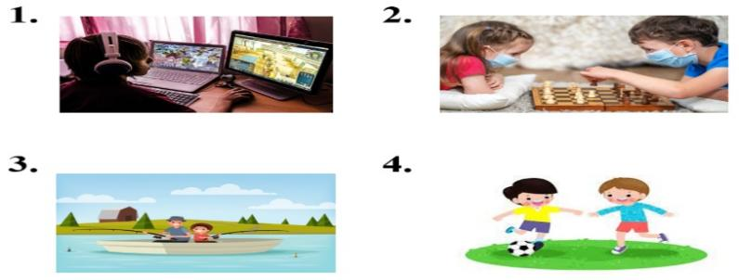  - Ask Ss: Where can people do these activities?  - Give feedback and lead to the new lesson  - Option 2:  - Divide class into 4 groups  - Ask Ss to list as many as possible school clubs they know Ss can write on the extra board  - Have Ss hang their extra boards on the big board  - Check the accuracy, spelling, give mark to each group  - The group which has the most correct answers will be the winner  - Give a round of applause or a small gift to the winner  → Lead to the new lesson: School activity and school clubs | - Greet T  - Look and give answers  Answer keys  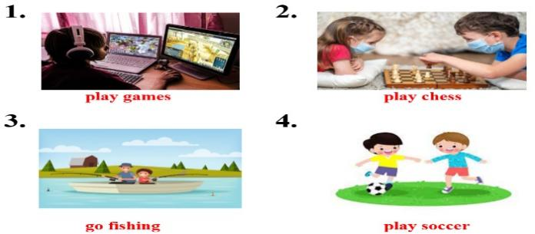  Expected answers: People can play football outside, but they have to play games inside …  - Form groups  - Work in groups  - Hang the extra boards  - Look and check together with the teacher  Suggested answers: sport club, chess club, art club, music club, life-skill club, English club…  - Listen

B. New lesson (35’)
- Activities 1: Vocabulary (17’)
a) Objective: Ss know more vocabularies about school activities
b) Content:
- Definition of some vocabularies about school activities
- Adding more activities
c) Products: Ss know how to pronounce the new words correctly and use them in appropriate situations.
d) Competence: communication, collaboration, presentation, listening, analytical skill.
e) Organization of the activity:
Teacher’s Activities | Students’ Activities
a. Circle the definitions for the underlined words. Listen and repeat  - Option 1:  - Demonstrate the activity, using the example in the book  - Have Ss read the sentences and circle the correct definition  - Ask Ss to work in pairs to check their answers with their partners  - Check answers as a whole class  - Play the audio (CD1 – Track 22) for Ss to listen and repeat  - Call some Ss to read the words / phrases again, correct their pronunciation and stress  - Option 2: Matching  - Have Ss sit in groups to match words with pictures  - Call Ss to give answers  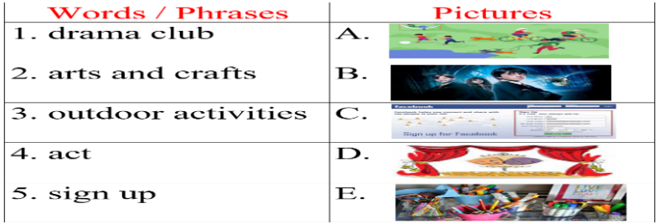  - Have Ss do the task individually (circle the correct definition for the underlines words)  - Call Ss to give answers  - Check answers as a whole class  - Play the audio (CD1 – Track 22) for Ss to listen and repeat  - Call some Ss to read the words/phrases again, correct their pronunciation and stress  b. Draw the table. Add any activities you can think of to the correct column  - Have Ss draw the table in their notebooks and add new words form task a. to the table  - Have Ss work in pairs to add any activities they can think of to the correct column of the table  - Remind Ss to use the phrases in the Warm-up activity.  - Call some pairs to share their ideas with the class  - Make comments on Ss’ presentation, give evaluation (marks) if necessary | - Look and listen  - Read and choose the correct answers  - Work in pairs  - Listen and check  - Listen and repeat  - Read  Answer keys  2.b 3.a 4.b 5.b 6.a  - Work in groups  - Give answers, guess the meaning of words/phrases through the pictures  Answer keys  1D 2E 3A 4B 5C  - Work individually  - Give answers  - Listen and repeat.  - Read the words/phrases  - Work individually  - Work in pairs  - Present  Suggested answers  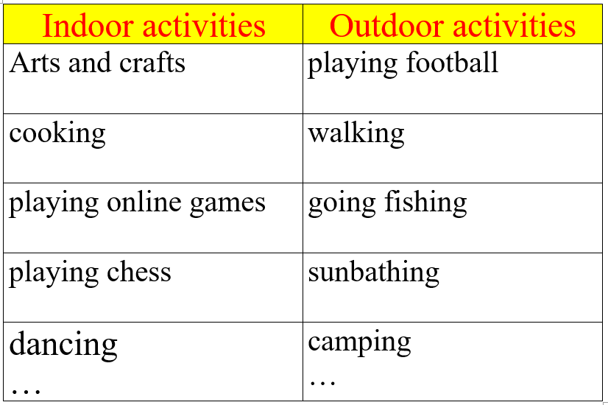
- Activity 2: Reading (18’)
a) Objective: Ss can develop their reading comprehension skills, practice scanning skill
b) Content: Reading a school newsletter and answering the questions that follow.
c) Products: Ss improve their reading skills esp. read for specific information.
d) Competence: Collaboration, communication, synthesizing skill
e) Organization of the activity:
Teacher’s Activities | Students’ Activities
Read the school newsletter and answer the questions  - Option 1:  - Have Ss read the newsletter individually  - Read the newsletter as a whole class  - Have Ss answer the questions  - Call Ss to write answers on the board  - Check answers as a whole class  -Ask Ss to practice in pairs – asking and answering the questions  - Call some pairs to present  - Option 2:  - Have Ss read the questions first, then underline the key word(s) that can help them find the answers quickly and accurately  - Have Ss read the newsletter and answer the questions, underline or highlight the clues of their answers  - Call Ss to write answers on the board  - Check, give feedback  *Extra activity:  - Ask Ss some more comprehension questions:  1. Which club is outdoor activity? And which ones are indoor activities?  2.Which club is on Thursday?  3. In the Book club, what do you need to bring to the library at 4pm on Wednesday?  4.How much money do we need to pay for materials per term?  - Call Ss to give answers  - Give feedback and evaluation | - Read  - Answer the questions  - Write answers  - Work in pairs  Answer keys  1. (the) Soccer club  2. (the) Board Games club  3. (the) Book Club  4. (the) Arts and Crafts club  - Read individually  Suggested keywords  1. Tuesday  2. sign up/notice board  3. take something  4. money  - Read and give answers, focus on the key words  - Write answers  - Listen, then write in notebooks  - Listen, read the newsletter again and give answers (in pairs or individually – it depends)  Answer keys  1. Outdoor: (the) Soccer club  Indoor: (the) Board Games club, (the) Book Club and (the) Arts and Crafts club  2. (the) Tennis club  3. the own copy of “The Secret Garden”  4. $20  - Answer

C. Consolidation (3’)
* Vocabulary about school activities: indoor activities, outdoor activities, drama club, sign up, arts and crafts, act
* Some popular indoor activities (cooking, playing games, working from home …) and outdoor activities (playing outside sports, camping, biking…)

D. Homework (2’)
- Learn by heart the vocabulary about school activities.
- Make 6 sentences of the 6 words / phrases Ss have learnt in this lesson
- Do exercises in Workbook: Lesson 2 - New words – Part a and b (page 10)
- Prepare: Lesson 2 – Grammar (page 18 – SB)

