## **Tiếng Anh 8 i-Learn Smart World_Unit 3.2 Time allotted: 45**

**PART 1**  **PRONUNCIATION (5 questions)**

**Choose the word whose underlined part differs from the other three in pronunciation in the following question.**

1. A. tourist B. listen C. plant D. team

2. A. pollute B. stop C. future D. heart

3. A. pollution B. transport C. waste D. plastic

**Choose the word that differs from the other three in the position of the main stress in the following question.**

4. A. affect B. pollute C. disease D. damage

**Choose the word whose primary stress is placed on the first syllable.**

5. A. effect B. environment C. tourism D. reduce

**PART 2**  **USE OF ENGLISH (12 questions)**

**Choose the option that best completes the following sentence.**

6. Air ______________ is a serious problem in cities where there are big factories.

A. pollution B. wildlife C. effect D. tourism

7. The Friends of the Beach is organizing a campaign to clean ______________ the Front Beach.

A. up B. with C. from D. of

8. A lot of people ______________ trash into rivers and make the water polluted.

A. throw B. pass C. shoot D. kick

9. Plants and animals cannot grow and live well in ______________ areas.

A. pollute B. polluted C. pollution D. pollutant

10. There are factories that ______________ broken glass and make it into new glassware.

A. reduce B. produce C. waste D. recycle

11. Turning off the air conditioner ten minutes before leaving saves a lot of ______________.

A. water B. electricity C. air D. plastic

12. If you ______________ enough water, you won't be thirsty.

A. drink B. drinks C. to drink D. drinking

13. Barry loves running, ______________ he is also a member of our school's running club.

A. or B. but C. and D. if

14. We should reduce the use of plastic ______________ that we can save the environment.

A. to B. for C. so D. because

15. She won't pass the exam if she ______________ hard.

A. studies B. doesn't study C. will study D. won't study

16. My father loves traveling, ______________ he never had a chance to go abroad.

A. but B. and C. so D. because

17. We won't complete the task on time unless we ______________ working hard.

A. stop B. keep C. don't stop D. don't keep

**PART 3**  **WORD FORMATION (3 questions)**

**Write the correct form of the given word.**

18. Those products are not ______________, so don’t put them in the recycling bin. ***(RECYCLE)***

19. Vung Tau City welcomes thousands of ______________ every holiday season. ***(TOURISM)***

20. Trash should be processed carefully so it doesn't ______________ the environment. ***(POLLUTION)***

**PART 4**  **ERROR IDENTIFICATION (2 questions)**

**Find the underlined part that needs correction in the following question.**

21. If you don't pay attention, you will understand the lesson.

A. pay B. will C. understand D. lesson

22. It is too hot today - please turn on the air condition.

A. is B. too C. on D. condition

**PART 5**  **READING (5 questions)**

**Read the blog from Alison on an environmental website and choose the best answer for each question. (5 questions)**

|  |
| --- |
| **Start your own …**  **School Environmental Group!**  Everyone wants to do something to protect the environment. Your school is an excellent place to start. It probably wastes lots of things, including electricity, water, and paper. For example, I found that my school pollutes the local area with dirty water.  **1. Do your homework!**  There are a few questions to answer before you get started.  •Do at least five of your classmates want to start an environmental group?  •Is one of your teachers interested in helping you? If not, it will be very difficult to get your school to help you with a room for meetings, for example, and other things, like letting you make photocopies.  •Are there any environmental groups in other classes? If there are, would **they** like to join your group? Remember: You are stronger together.  **2. Have a team meeting!**  Start by asking two questions:  •Why are we here?  •What do we want to do?  People will have different answers to the first question, but unless you have the same answer to the second question, your group will not be successful. Is it the most important thing to you to  •reduce paper waste in the school?  •save electricity?  •find ways to save water?  •do something else?    Good luck! |

23. What does the writer say about her school?

A. It wastes a lot of things.

B. It uses too much electricity.

C. It pollutes local water.

D. It should use less paper.

24. Alison calls Section 1 **Do your homework!** because she thinks ______________.

A. students should start a group as a homework project

B. people should learn about environmental problems first

C. school environmental groups are like homework

D. people should find out some basic information first

25. Why do you need a teacher to help you?

A. Because you will need help with the photocopier

B. Because every school group needs help from the school

C. Because teachers understand about environmental groups

D. Because students cannot run an environmental group on their own

26. What does **they** mean in Section 1?

A. Other classes

B. Other students

C. Other environmental groups

D. Other teachers

27. You should start with a team meeting ______________.

A. to decide on the most important project to work on

B. because you all must have the same reason for joining the group

C. to choose a number of projects to work on

D. to agree on the reason for the group

**PART 6**  **LISTENING (5 questions)**

**You will hear an advertisement for a summer camp. Complete the summary. Write ONE WORD AND / OR A NUMBER in each numbered space. (5 questions)**

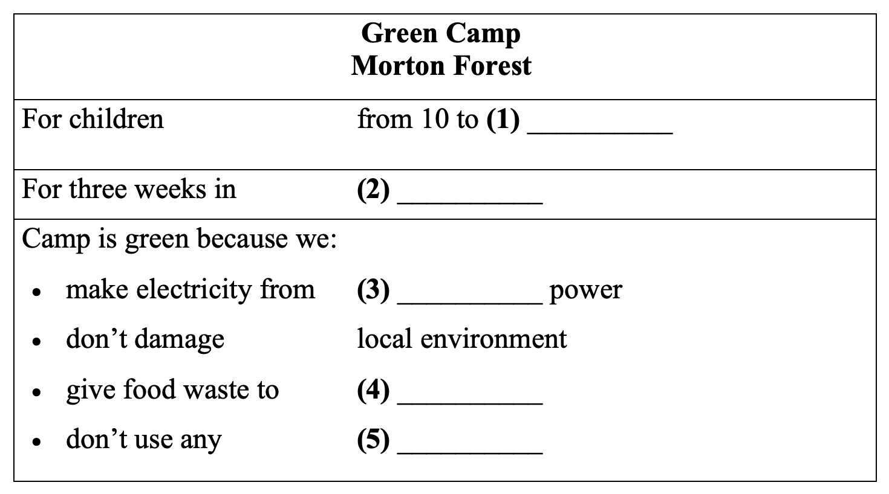

(28)___________________  
(29)___________________  
(30)___________________  
(31)___________________  
(32)___________________

**PART 7**  **WRITING (8 questions)**

**Rewrite the following sentence without changing its meaning. Use the given word(s) if any.**

33. Exercise regularly and you will be fit and healthy. (IF)

→ You will___________

34. I am saving money. I can buy a new car in three years. (SO THAT)

→ ___________

35. Taylor will not forgive him if he doesn't apologize. (UNLESS)

→ ___________

36. Tuan wants to reduce air pollution. He planted more trees. (SO)

→ ___________

**Use the given words or phrases to make complete sentence.**

37. Single-use plastic / be / main cause / pollution / the ocean.

→ ___________

38. We / should / throw trash / the streets / that / we can / prevent / land pollution.

→ ___________

**Put the words in the correct order to make correct sentence.**

39. Keywords: our/use/often/trying/bicycles/is/more/to/family/./My

→ .......................................

40. Keywords: their/to/have/bottles/school/./water/bring/to/Students/own

→ .......................................

**---THE END---**

## **Tiếng Anh 8 i-Learn Smart World_Unit 3.2 Time allotted: 45 ANSWER KEY**

**PART 1**  **PRONUNCIATION (5 questions)**

**Choose the word whose underlined part differs from the other three in pronunciation in the following question.**

1. A. tourist B. listen C. plant D. team

2. A. pollute B. stop C. future D. heart

3. A. pollution B. transport C. waste D. plastic

**Choose the word that differs from the other three in the position of the main stress in the following question.**

4. A. affect B. pollute C. disease D. damage

**Choose the word whose primary stress is placed on the first syllable.**

5. A. effect B. environment C. tourism D. reduce

**PART 2**  **USE OF ENGLISH (12 questions)**

**Choose the option that best completes the following sentence.**

6. Air ______________ is a serious problem in cities where there are big factories.

A. pollution B. wildlife C. effect D. tourism

7. The Friends of the Beach is organizing a campaign to clean ______________ the Front Beach.

A. up B. with C. from D. of

8. A lot of people ______________ trash into rivers and make the water polluted.

A. throw B. pass C. shoot D. kick

9. Plants and animals cannot grow and live well in ______________ areas.

A. pollute B. polluted C. pollution D. pollutant

10. There are factories that ______________ broken glass and make it into new glassware.

A. reduce B. produce C. waste D. recycle

11. Turning off the air conditioner ten minutes before leaving saves a lot of ______________.

A. water B. electricity C. air D. plastic

12. If you ______________ enough water, you won't be thirsty.

A. drink B. drinks C. to drink D. drinking

13. Barry loves running, ______________ he is also a member of our school's running club.

A. or B. but C. and D. if

14. We should reduce the use of plastic ______________ that we can save the environment.

A. to B. for C. so D. because

15. She won't pass the exam if she ______________ hard.

A. studies B. doesn't study C. will study D. won't study

16. My father loves traveling, ______________ he never had a chance to go abroad.

A. but B. and C. so D. because

17. We won't complete the task on time unless we ______________ working hard.

A. stop B. keep C. don't stop D. don't keep

**PART 3**  **WORD FORMATION (3 questions)**

**Write the correct form of the given word.**

18. Those products are not ______________, so don’t put them in the recycling bin. ***(RECYCLE) => recyclable***

19. Vung Tau City welcomes thousands of ______________ every holiday season. ***(TOURISM) => tourists***

20. Trash should be processed carefully so it doesn't ______________ the environment. ***(POLLUTION) => pollute***

**PART 4**  **ERROR IDENTIFICATION (2 questions)**

**Find the underlined part that needs correction in the following question.**

21. If you don't pay attention, you will understand the lesson.

A. pay B. will C. understand D. lesson

22. It is too hot today - please turn on the air condition.

A. is B. too C. on D. condition

**PART 5**  **READING (5 questions)**

**Read the blog from Alison on an environmental website and choose the best answer for each question. (5 questions)**

|  |
| --- |
| **Start your own …**  **School Environmental Group!**  Everyone wants to do something to protect the environment. Your school is an excellent place to start. It probably wastes lots of things, including electricity, water, and paper. For example, I found that my school pollutes the local area with dirty water.  **1. Do your homework!**  There are a few questions to answer before you get started.  •Do at least five of your classmates want to start an environmental group?  •Is one of your teachers interested in helping you? If not, it will be very difficult to get your school to help you with a room for meetings, for example, and other things, like letting you make photocopies.  •Are there any environmental groups in other classes? If there are, would **they** like to join your group? Remember: You are stronger together.  **2. Have a team meeting!**  Start by asking two questions:  •Why are we here?  •What do we want to do?  People will have different answers to the first question, but unless you have the same answer to the second question, your group will not be successful. Is it the most important thing to you to  •reduce paper waste in the school?  •save electricity?  •find ways to save water?  •do something else?    Good luck! |

23. What does the writer say about her school?

A. It wastes a lot of things.

B. It uses too much electricity.

C. It pollutes local water.

D. It should use less paper.

24. Alison calls Section 1 **Do your homework!** because she thinks ______________.

A. students should start a group as a homework project

B. people should learn about environmental problems first

C. school environmental groups are like homework

D. people should find out some basic information first

25. Why do you need a teacher to help you?

A. Because you will need help with the photocopier

B. Because every school group needs help from the school

C. Because teachers understand about environmental groups

D. Because students cannot run an environmental group on their own

26. What does **they** mean in Section 1?

A. Other classes

B. Other students

C. Other environmental groups

D. Other teachers

27. You should start with a team meeting ______________.

A. to decide on the most important project to work on

B. because you all must have the same reason for joining the group

C. to choose a number of projects to work on

D. to agree on the reason for the group

**PART 6**  **LISTENING (5 questions)**

**You will hear an advertisement for a summer camp. Complete the summary. Write ONE WORD AND / OR A NUMBER in each numbered space. (5 questions)**



(28) 16/sixteen  
(29) July  
(30) water  
(31) animals  
(32) plastic

**PART 7**  **WRITING (8 questions)**

**Rewrite the following sentence without changing its meaning. Use the given word(s) if any.**

33. Exercise regularly and you will be fit and healthy. (IF)

→ You will be fit and healthy if you exercise regularly.

34. I am saving money. I can buy a new car in three years. (SO THAT)

→ I am saving money so that I can buy a new car in three years.

35. Taylor will not forgive him if he doesn't apologize. (UNLESS)

→ Unless he apologizes, Taylor will not forgive him./Taylor will not forgive him unless he apologizes.

36. Tuan wants to reduce air pollution. He planted more trees. (SO)

→ Tuan wants to reduce air pollution, so he planted more trees./Tuan planted more trees so he can reduce air pollution./Tuan planted more trees so that he can reduce air pollution./Tuan planted more trees so as to reduce air pollution.

**Use the given words or phrases to make complete sentence.**

37. Single-use plastic / be / main cause / pollution / the ocean.

→ Single-use plastic is the main cause of pollution in the ocean.

38. We / should / throw trash / the streets / that / we can / prevent / land pollution.

→ We should not throw trash on the streets so that we can prevent land pollution./We should not throw trash in the streets so that we can prevent land pollution.

**Put the words in the correct order to make correct sentence.**

39. Keywords: our/use/often/trying/bicycles/is/more/to/family/./My

→ My family is trying to use our bicycles more often .

40. Keywords: their/to/have/bottles/school/./water/bring/to/Students/own

→ Students have to bring their own water bottles to school .

**---THE END---**