Date of preparing: ………………………………….
Date of teaching: ………………………………….

Period …
UNIT 5: AROUND TOWN
Lesson 2 - Part 3 (Page 43) – Pronunciation and Speaking

I. OBJECTIVES
By the end of the lesson, Ss will be able to…
1. Knowledge
- use sound changes in the question: “…would you like …?”
- order food and drink politely.
2. Ability
- improve speaking skills.
3. Quality
- have positive attitude in English language learning so that they actively participate in all classroom activities.
- order food and drink politely.

II. TEACHING AIDS AND LEARNING MATERIALS
Lesson plan, PPT slides, student’s book, workbook, notebook, personal computer (if any), projector/TV, speakers, DCR & DHA Eduhome, handouts...

III. PROCEDURES
A. Warm up: (5’)
a) Objective: Introduce the new lesson and set the scene for Ss to acquire new language; get students' attention at the beginning of the class by means of enjoyable and short activities as well as to engage them in the steps that follow.
b) Content: Revision of vocabularies about food and drink / the structures to order
c) Product: Ss review the language in previous lessons and be ready for the new lesson
d) Competence: collaboration, observation, critical thinking.
e) Organization of the activity:
Teacher’s Activities | Students’ Activities
- Give greetings  - Check attendance  - Option 1:  - Have Ss close all books  - Divide class in 4 groups  - Give extra boards to all groups  - Have Ss work in groups to write food and drinks they know (as many as possible) in 2 minutes  - Call Ss to hang their extra boards in front of the class  - Check and announce the winner  - Give a small gift to the winner  Lead to the new lesson.  - Option 2: Arranging  - Show some sentences with words not in correct order  - Have Ss work in groups to arrange each set of words to make a meaningful English sentence.  1. would / what / like / drink / you / to?  2. like / dessert / you / what / for / would?  3. like / some / juice / would / have / to / orange / you?  4. what / you / dinner / for / would / like?  - Have Ss read answers  - Give feedback.  Lead to the new lesson. | - Greet T  - Close books  - Work in groups  - Listen  Answers keys  - Arrange given words in each set to make a meaningful English sentence  - Give answers  - Check answers with the teacher.  Answers keys  1. What would you like to drink?  2. What would you like for dessert?  3. Would you like to have some orange juice?  4. What would you like for dinner?

B. New lesson (35’)
- Activities 1: Pronunciation (10’)
a) Objective: Ss know how to use sound changes in the question: “…would you like …?”
b) Content:
- Recognizing the sound changes in the question: “…would you like …?”
- Listening and focusing pronunciation feature, finding and correcting mistakes
- Practicing
c) Products: Ss can apply the sound changes correctly and actively in communication.
d) Competence: communication, collaboration, presentation
e) Organization of the activity:
Teacher’s Activities | Students’ Activities
a + b. Listen. Notice the sound changes of the underlined words  - Play the recording (CD1, track 62)  - Ask Ss to listen and pay attention to the sound changes  - Call Ss to make their comments on the sound changes of the questions: “…would you like …?”  - Give feedback, explain the pronunciation feature: “…would you like …?” often sounds like /wədʒʊlaɪk/  - Play the recording again, have Ss listen and repeat with a focus on the pronunciation feature.  c + d. Listen and cross out the one with the wrong sound changes, then read the sentences with the correct sound changes to a partner.  - Play the recording (CD1, track 63), have Ss listen and cross out the option that doesn’t use the correct sound changes  - Call Ss to give answers  - Play the recording again and check answers as a whole class.  - Then have Ss practice saying the sentences with a partner, using the correct sound changes, then encourage Ss to use their own sentences  - Call some Ss to read their sentences in front of the class.  -Check and correct Ss’ pronunciation | - Listen  - Comment  - Listen  - Listen again and repeat  - Listen and cross out  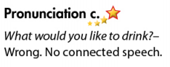  - Give answers  Answer key:  - Work in pairs  - Present
- Activity 2: Practice (10’)
a) Objective: Ss can ask and answer questions about ordering
b) Content: Practicing a conversation and using pictures on the right as a cue
c) Products: Ss can practice what they have learnt successfully.
d) Competence: collaboration, communication, creativity.
e) Organization of the activity:
Teacher’s Activities | Students’ Activities
Take turns ordering. Swap the roles and repeat. (controlled practice)  - Option 1:  - Demonstrate the activity by practicing role-play with a student  - Have Ss retell the structures:  Would you like + to infinitive?  Would you like + noun?  What would you like for + noun?  - Have pairs practice the conversation  - Call some pairs to read in front of the class  - Have pairs swap roles and repeat-using the pictures on the right.  - Have some pairs demonstrate the activity in front of the class  - Check Ss’ pronunciation  - Option 2: (for class with better students) (free - practice)  - Follow the same steps as option 1  - Then give Ss an extra activity: Practice the conversation in the text book; however, they try to remember the conversation content and they can use their own ideas  - Have some pairs demonstrate the activity in front of the class, not looking at the textbook; encourage Ss to present as naturally as possible.  - Give feedback and evaluation | - Listen  - Work in pairs  - Act out the conversation  - Listen to the instruction and work in pairs  - Act out the conversation  - Listen
- Activity 3: Speaking – What would you like to order? (15’)
a) Objective: Ss can order food and drinks
b) Content: Asking and answering questions about ordering
c) Products: Ss can use what they have learnt in producing the language in a more meaningful way.
d) Competence: collaboration, communication, creativity, public speaking
e) Organization of the activity:
Teacher’s Activities | Students’ Activities
a. You’re at a restaurant. Work in pairs. Student A, you’re a customer, order some food. Student B, you’re a waiter. Take the customer’s order  - Demonstrate the activity by practicing role-play with a student  - Remind Ss to use words/ phrases/sounds to get time to think  - Have Ss work in pairs to role-play the conversation  - Go round and support Ss  - Have some pairs demonstrate their role-play in front of the class.  b. Swap roles. Use the menu from the reading  - Have Ss swap roles and use the menu from the reading  - Remind Ss to use ways to start a conversation politely  - Ask Ss to demonstrate the role-play on front of the class  - Give feedback and evaluation  *Extra activity:  - Have Ss watch a video clip about ordering food and drinks in a restaurant as a reference, link: https://www.youtube.com/watch?v=bgfdqVmVjfk  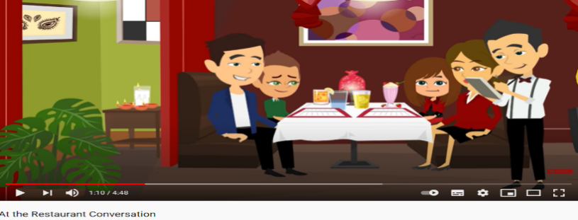 | - 1 S practices role-play with the teacher  - Listen  - Work in pairs  - Role play  - Work in pairs  - Present  - Watch the video clip and quickly take notes useful languages

C. Consolidation (3’)
* Pronunciation: “…would you like …?” often sounds like /wədʒʊlaɪk/
* Useful structures:
Would you like + to infinitive?
Would you like + noun?
What would you like for + noun?

D. Homework (2’)
- Practice using sound changes in the question: “…would you like …?”
- Practice ordering food and drinks.
- Find out the English names of some Vietnamese food.
- Prepare: Lesson 3: Social Studies– New Words and Listening (page 44 – SB).

