Week:………  Period :……… | Date of planning:………..  Date of teaching:………..

UNIT 9: NATURAL DISASTERS

Lesson 1: Getting started – We are all safe!

I. OBJECTIVES
By the end of this lesson, Ss will be able to:
1. Knowledge
- Gain an overview about the topic Natural disasters.
- Gain vocabulary to talk about Natural disasters.
2. Competences
- Develop communication skills and creativity
- Be collaborative and supportive in pair work and teamwork
- Actively join in class activities
3. Personal qualities
- Develop awareness of Natural disasters.
- Be concerned to Natural disasters.
II. MATERIALS
- Grade 8 textbook, Unit 9- Getting started
- Computer connected to the Internet
- Projector / TV/ pictures and cards
- Hoclieu.vn
III. PROCEDURES
1. WARM-UP (5 mins)
a. Objectives:
Introduce the new lesson and set the scene for Ss to acquire new language; get students' attention at the beginning of the class by enjoyable and short activities as well as to engage them in the follow-up steps.
b. Content:
Network: Introduce the names of some natural disasters.
c. Expected outcomes:
Ss have general ideas about the topic Natural disasters.
d. Organisation
TEACHER AND STUDENTS’ ACTIVITIES | CONTENTS
- Teacher asks Ss to work in 2 groups and think of some natural disasters they know.  - Teacher writes the name of one natural disaster as a modeling activity.  - Ss (one by one) go to the board and write the names of natural disasters that they know.  - Teacher checks Ss’ results.  - The group with more correct names of natural disasters becomes the winner.  *Teacher’s feedback. | Network:  Natural disasters  Earthquake  Suggested answers:  Earthquake, snow storm, acid rain, typhoon, tidal wave, flood, drought, …
2. ACTIVITY 1: PRESENTATION (8 mins)
a. Objectives:
Ss know words about Natural disasters.
b. Content:
Vocabulary: damage, funnel, tornado, eruption, pull up, landslide.
c. Expected outcomes:
Ss know how to pronounce the new words correctly and use them in appropriate situations.
d. Organisation
TEACHER AND STUDENTS’ ACTIVITIES | CONTENTS
Vocabulary pre-teaching  - Teacher introduces the vocabulary.  - Teacher explains the meaning of the new vocabulary, using pictures, explanation and translation.  - Teacher checks students’ understanding with the “Matching” technique.  - Teacher reveals that these words will appear in the reading text and asks students to open their textbook to discover further.  *Teacher checks students’ pronunciation and gives feedback. | New words:  1. Damage (v,n)  2. Funnel (n)  3. Tornado (n)  4. Eruption (n)  5. Pull up  6. Landslide (n)
3. ACTIVITY 2: PRACTICE (22 mins)
a. Objectives:
- To have Ss get to know the topic.
- To have Ss get specific information of the text.
- Students can develop their reading and listening skills.
- To develop Ss’ vocabulary related to the topic.
b. Content:
Listen and read the conversation between Tom and Mi, then complete each sentence with no more than TWO words, write the narural disasters from the box under the pictures. Then listen, check, and repeat; choose the correct answer to complete each sentence.
c. Expected outcomes:
Students can read and understand general and specific information about Natural disasters.
d. Organisation
TEACHER AND STUDENTS’ ACTIVITIES | CONTENTS
Task 1. Listen and read. (7 mins)
- Teacher asks Ss to look at the picture on pages 92,93 and answer the following questions:  +) What can you see in the pictures?  +) What natural disaster is it?  - Teacher elicits answers from Ss.  - Teacher introduces the two characters: Tom and Mi and explains that they are friends and they are talking about natural disasters.  - Teacher plays the recording twice for Ss to listen and read along.  - Teacher asks some pairs of students to read the conversation aloud. | 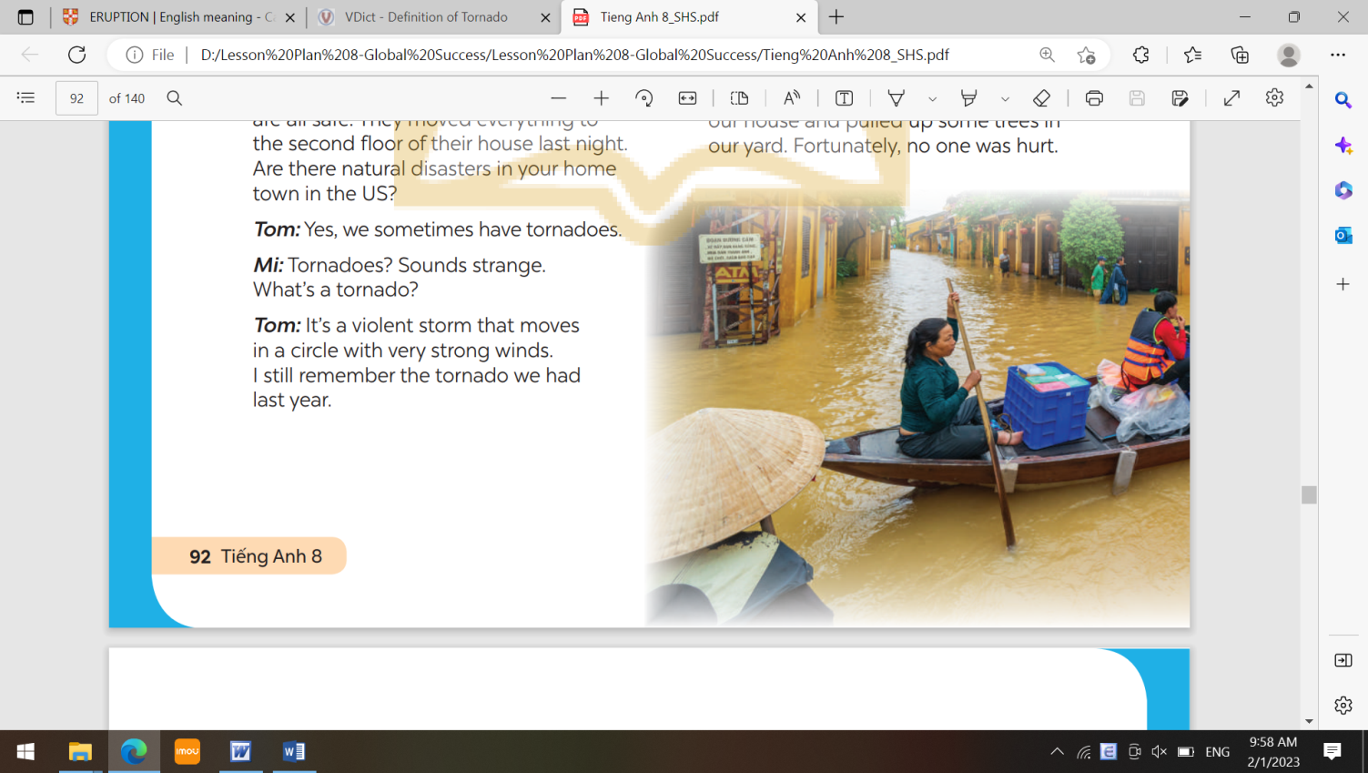  - What can you see in the picture?  - What natural disaster is it?
Task 2. Read the conversation again. Complete each sentence with no more than TWO words from it(5 mins)
- Teacher tells Ss to read the conversation again and work independently to find the answers.  - Ss work independently to find the best answers.  - Teacher has Ss compare the answers in pairs before checking with the whole class.  - Teacher checks the answers as a class and gives feedback. | Answer key:  1. flood  2. second floor  3. natural disaster  4. were having  5. pulled
Task 3. Write the natural disasters from the box under the pictures. Then listen, check, and repeat. (5 mins)
- Teacher asks Ss to look at the pictures and say if they know the natural disaster shown in each picture.  - Ss work individually to write the natural disasters in the box under the pictures.  - Ss compare their answers with a partner.  - Teacher invites some Ss to go to the board and write their answers.  - Teacher confirms the correct answer.  - Teacher has some Ss practice saying the natural disasters again. | Answer key:  1. flood  2. tornado  3. volcanic eruption  4. storm  5. landslide  6. earthquake
Task 4. Choose the correct answer to complete each sentence. (5 mins)
- Teacher asks Ss to work in pairs, read the sentences and choose the correct answers.  - Teacher asks for Ss’ answers and confirms the correct ones.  - For a more able class, teacher has Ss work in pairs to do the activity and explain why the other word is not the correct answer.  *T’s observation and feedback | Answer key:  1. volcanic eruption  2. earthquake  3. landslide  4. storms  5. tornado
4. ACTIVITY 3: PRODUCTION (7 mins)
a. Objectives:
Ss can revise the words and phrases indicating natural disasters.
b. Content:
Work in groups. Complete the web with all of the words and phrases related to natural disasters you know.
c. Expected outcomes:
Ss can write the names of natural disasters they know.
d. Organisation
TEACHER AND STUDENTS’ ACTIVITIES | CONTENTS
Task 5: Word web:  Work in groups. Complete the web with all of the words and phrases related to natural disasters you know.  - Teacher asks Ss to work in groups to complete the word web with all the words and phrases related to natural disasters they know.  - Teacher asks Ss to include the words and phrases learnt in this lesson or other words.  - Teacher invites some Ss to share their groups’s answers with the class.  *T’s feedback. | 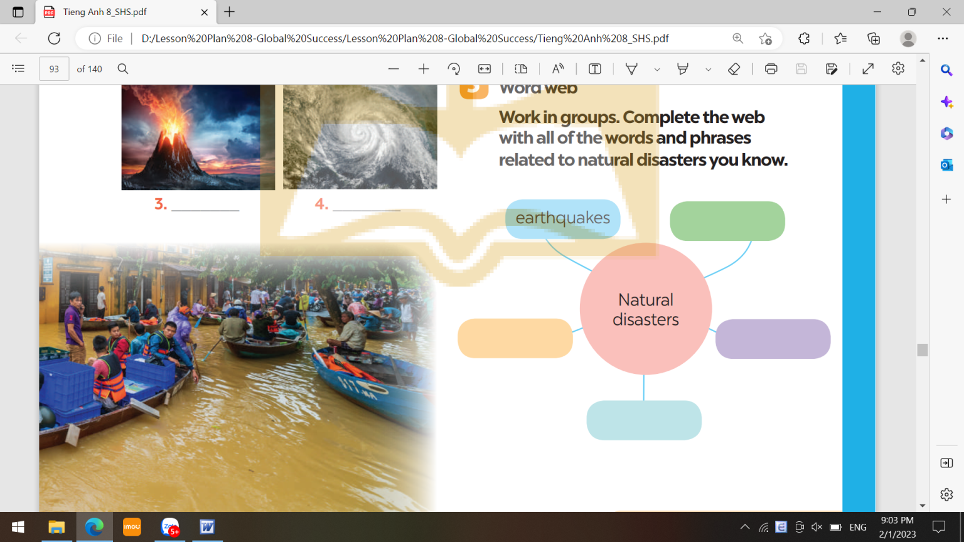
5. CONSOLIDATION: (3 mins)
a. Wrap-up
- Teacher asks one or two Ss to tell the class what they have learnt. Teacher shows them the slide with the objectives. Teacher ticks the objectives that have been learnt.
- Teacher asks Ss to say aloud some words and phrases they remember from the lesson.
b. Homework
- Learn by heart all the words that they have just learnt.
- Do exercises in the workbook.
- Prepare for Lesson 2 - A closer look 1

