School: ……………………………………….. | Date: …………………………………..
Class: ……………………………..................... | Period: ………………………….........

UNIT 10: ENERGY SOURCES
Lesson 1.3 – Pronunciation and Speaking (Page 78)

I. OBJECTIVES
By the end of the lesson, Ss will be able to:
1.1. Language knowledge and skills
- put stress on the first syllable for numbers which are multiples of ten correctly.
- ask and answer about energy.
- compare energy sources in different places.
1.2. Competences
- improve listening and speaking skills.
1.3. Attributes
- save energy.
- choose suitable and economical types of energy for everyday use.

II. TEACHING AIDS AND LEARNING MATERIALS
1. Teacher’s aids: Student book and Teacher’s book, class CDs, Digital Book (DCR phần mềm tương tác SB, DHA (từ vựng/ cấu trúc) phần mềm trò chơi tương tác), projector/interactive whiteboard / TV (if any), PowerPoint slides, handouts.
2. Students’ aids: Student’s book, workbook, notebook, paper.

III. ASSESSMENT EVIDENCE
Performance Tasks | Performance Products | Assessment Tools
- Listen to the words and focus on the underlined letters. | - Ss’ performance and answers. | - T’s observation.
- Listen and cross out the word that doesn’t follow the note in “a”. | - Ss’ answers. | - T’s feedback/Peers’ feedback.
- Read the words with the correct stress to a partner. | - Ss’ performance. | - T’s feedback/Peers’ feedback.
- Ask and answer. Then, compare energy sources in Bigton and Greenville. Swap roles and repeat. | - Ss’ performance. | - T’s feedback/Peers’ feedback.
- You're an energy expert interested in how two different cities use different kinds of energy. In pairs: Student B, turn to page 123, File 11. Student A, ask about Springfield and complete the table. Swap roles. Answer questions about Twin Peaks. | - Ss’ performance /  Presentation. | - T’s observation, T’s feedback/Peers’ feedback.
- Compare the energy sources for Twin Peaks and Springfield. Which city uses more renewable energy? | - Ss’ performance /  Answers. | - T’s feedback/Peers’ feedback.
IV. PROCEDURES
A. Warm up: (5’)
a) Objective: Introduce the new lesson and set the scene for Ss to acquire new language; get students' attention at the beginning of the class by enjoyable and short activities as well as to engage them in the steps that followed.
b) Content: Review sources of energy / Review: numbers.
c) Expected outcomes: Ss know some information that is useful for them in other speaking activities.
d) Organization of the activity:
TEACHER’S ACTIVITIES | STUDENTS’ ACTIVITIES
- Option 1: Review sources of energy.  - Divide class into 4-5 groups.  - Have Ss in each group write as many as possible the sources of energy they know.  - Call Ss to write answers on the board.  - Check Ss’ answers give feedback.  - The group which has the most correct answers will be the winner. (T also checks spelling.)  - Announce the winner and give a small present.  - Lead to the new lesson: /ð/ sound.  Option 2: Review: numbers.  - Have Ss watch and listen to the song: Counting by 10.  - Have Ss sing together.  - Lead to the new lesson.  *Illustration:  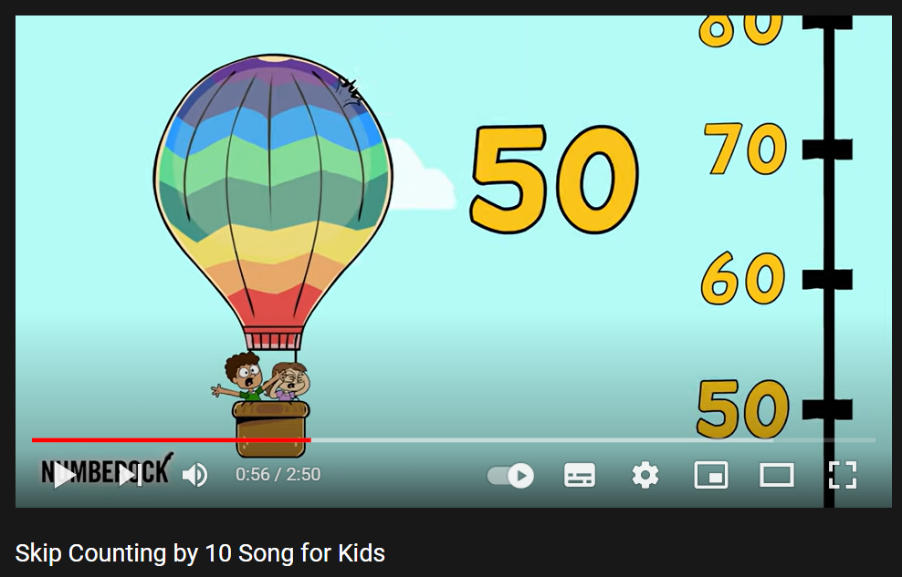  Link: https://www.youtube.com/watch?v=dSdjzFl9H6k | - Form groups.  - Work in groups to take part in the game.  - Write answers.  - Listen.  - Watch and sing.  - Listen.

B. New lesson (35’)
- Activity 1: Pre-Speaking: Pronunciation (8’)
a) Objective: Introduce: Stress the first syllable for numbers which are multiples of ten.
b) Content:
- recognize: stress the first syllable for numbers which are multiples of ten.
- listen and check, cross out the word that doesn’t follow the note in “a”.
- practice.
c) Expected outcomes: Ss put stress on the first syllable for numbers which are multiples of ten in their speaking.
d) Organization of the activity:
TEACHER’S ACTIVITIES | STUDENTS’ ACTIVITIES
Task a + b. Listen to the words and focus on the underlined letters.  - Play the recording (CD2, track 27).  - Ask Ss to listen and focus on the underlined letters.  - Play the recording again, have Ss listen and repeat with a focus on the stress feature.  Task c + d. Listen and cross out the word that doesn’t follow the note in “a”.  - Play the recording (CD 2 – Track 28), have Ss listen and cross out the option that doesn’t follow the note in “a”.  - Call Ss to give answers.  - Play the recording again and check answers as a whole class using DCR.  - Give feedback and evaluation. | - Listen.  - Listen again and repeat.  - Listen and give answers.  Answer keys  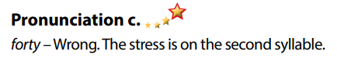
- Activity 2: While-speaking (22’)
a) Objective: Students can compare energy sources.
b) Content:
- Ask and answer. Then, compare energy sources in Bigton and Greenville. Swap roles and repeat.
- You're an energy expert interested in how two different cities use different kinds of energy. In pairs: Student B, turn to page 123, File 11. Student A, ask about Springfield and complete the table. Swap roles. Answer questions about Twin Peaks.
- Compare the energy sources for Twin Peaks and Springfield. Which city uses more renewable energy?
c) Expected outcomes: Ss produce the new language successfully.
d) Organization of the activity:
TEACHER’S ACTIVITIES | STUDENTS’ ACTIVITIES
PRACTICE  * Ask and answer. Then, compare energy sources in Bigton and Greenville. Swap roles and repeat.  - Demonstrate the activity by practicing the role-play with a student.  - Divide the class into pairs.  - Have pairs ask and answer using the information in the table and compare energy sources in Bigton and Greenville.  - Swap roles and repeat.  - Observe, give help if necessary.  - Have some pairs demonstrate the activity in front of the class.  - Give feedback and evaluation.  SPEAKING: Which City is Greener?  Task a. You're an energy expert interested in how two different cities use different kinds of energy. In pairs: Student B, turn to page 123, File 11. Student A, ask about Springfield and complete the table. Swap roles. Answer questions about Twin Peaks.  - Demonstrate the activity by practicing the activity with a student.  - Divide the class into pairs.  - Have Student B turn to page 123, File 11.  - Have students ask and answer to complete the table. - Have students swap roles and repeat.  - Observe, give help if necessary.  - Remind Ss to use ways to ask for clarification. | - Observe, listen.  - Work in pairs.  - Present.  - Observe and listen.  - Work in pairs.  - Swap roles and repeat.
- Activity 3: Production (5’)
a) Objective: Students compare the energy usage of two cities.
b) Content: Compare the energy sources for Twin Peaks and Springfield. Which city uses more renewable energy?
c) Expected outcomes: Ss produce the new language successfully in everyday speaking and writing.
d) Organization of the activity:
TEACHER’S ACTIVITIES | STUDENTS’ ACTIVITIES
Task b. Compare the energy sources for Twin Peaks and Springfield. Which city uses more renewable energy?  - Have Ss compare the energy sources for Twin Peaks and Springfield. Then answer: Which city uses more renewable energy?  - Have some students share their findings with the class.  - Give feedback and evaluation. | - Discuss in pairs.  - Present.

C. Consolidation and homework assignments (5’)
* Consolidation: put stress on the first syllable for numbers which are multiples of ten.
* Homework:
- Practice: Putting stress on the first syllable for numbers which are multiples of ten.
- Prepare: Unit 10 - Lesson 2.1 – New words and Reading (page 79 – SB).
- Review the vocabulary and grammar notes in Tiếng Anh 7 i-Learn Smart World Notebook
(pages 60 & 61).
- Play consolation games in Tiếng Anh 7 i-Learn Smart World DHA App on www.eduhome.com.vn

D. Reflection
a. What I liked most about this lesson today:
…………………………………………………………………………………………
- What I learned from this lesson today:
…………………………………………………………………………………………
c. What I should improve for this lesson next time:
…………………………………………………………………………………………

