Mã đề 7.2.30
ĐỀ KIỂM TRA GIỮA HỌC KÌ II
Môn: Tiếng Anh - Lớp 7
Thời gian làm bài: 60 phút, không tính thời gian phát đề
A. LISTENING: (2pts)
Question 1. You will hear five conversations. You will hear each conversation twice. You choose the best answer for each question. (1,0pt)
1.What was the weather like when the holiday begin?
 |  | 
A | B | C
2.What did Peter buy today?
 |  | 
A | B | C
3. How far is it to the beach?
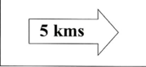 | 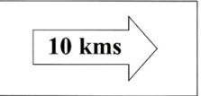 | 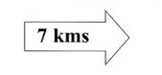
A | B | C
4.What did Tom and his dad play today?
 |  | 
A | B | C
5.What does the woman want?
 |  | 
A | B | C

Question 2. You will hear a man making a telephone call. Listen and complete questions 6-10. You will hear the conversation twice (1,0pt)

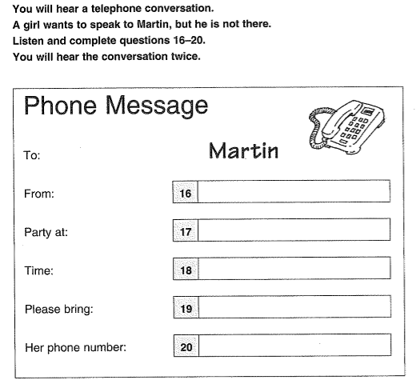
PHONE MESSAGE
To : Diana
From : Ian
Name of hotel : (6) ………………………..
Adress :(7) …………….…………Street
Meetings starts at (8) …………………………….
Bring: (9) …………… ………………………….
Visit factory on: (10)………….…………………..

SECTION B: LANGUAGE FOCUS - READING – WRITING (7,5 points)
I/ Choose the word (A, B, C, or D) whose underlined part is pronounced differently. (0,4 point)
11. a. park b. pavement c. plane d. safety
12. a. cycle b. bicycle c. fly d. skyscraper
II. Choose the best word and phrase (A, B, C, or D) to complete the sentences below. (2,6 points)
13. It is ………….to see elephants racing in the Elephant Race Festival in Dak Lak.
A. amaze | B. amazing | C. amazed
14 He found the book so ………………. that he couldn’t put it down.
A. interest | B. interested | C. interesting
15. ……………is not very far from here to the city center.
A. There | B. It | C. That
16. During Tet holiday, the ……………atmosphere is felt around the country.
A. festive | B. local | C. celebrate
17. A film that shows real life events or stories is called a(n) _________.
A. thriller | B. comedy | C. documentary
18. Carnival is a popular…………….in many countries in South America.
A. festive | B. festival | C. festivals
19. You have to wear a ______ when you ride a motorbike on the road.
A. helmet | B. hat | C. cap
20. Did he feel …………..when he saw the snake at his feet?
A. frighten | B. frightening | C. frightened
21. She didn’t ……………….to play the guitar but now she does.
A. use | B. uses | C. used
22. We didn’t find it funny ……………….it was a comedy.
A. in spite of | B. despite | C. although
23. A: How about going cycling round the lake on Saturday? B: - ___________
A. Yes, I do. | B. Great idea! | C. It’s nice of you
24. “How far is Vung Tau from Ho Chi Minh City”-“_______”
A. It’s not very far B. it takes about two hours or more.
C. It’s about 120km
25. “Could I ask you a few question about your favorite movies?”____________________
A. That sound good. C. Sure. Go ahead C. But I don’t want to.

III, Read and choose the correct word marked A, B, or C to fill each blank in the following email.(1,25 points)
Hoa soon gets used to the busy traffic. She can cross the road and she isn’t (26) ............... Her mother bought her a new bike (27)..................she goes out more often. In the morning, she goes to school by bike. In the evening, she cycles round the lake near her home. Sometimes, she visits her friends. She remembers the rules about the road(28) ................for cyclists. When she cycles, she always keeps both hands(29) .................the handle bars and give signal before turning left or fight.
Now Hoa is confident when she goes out. Sometimes, she helps younger children or old people to cross the roads. She feels(30) .................to live in this city.
26. A. scare B. scaring C. scared
27. A. and B. but C. or
28. A. safe B. safety C. safely
29. A. on B. in C. at
30. A. unhappy B. happiness C. Happy
IV, Read the passage and choose the correct answer for each question (1,25 points)
Da Lat Flower Festival is one of the most famous festivals in the South of Viet Nam. It takes place every year, but its date is not fixed. It’s often held at the end of December. The first festival was in December 2005 and it attracted about eighty thousand visitors. During the festival, people go to Da Lat to see flower exhibitions. There are hundreds of kinds of flowers; most of them come from Viet Nam, but there are some kinds from other countries as well. They make the streets colorful and beautiful. People also have chance to watch lively street parade and visit Flower Market. The festival attracts local people and visitors from all over the world.
31. Da Lat Flower Festival takes place………………………
A. every two years B. every year C. every spring
32. It’s been held in Da Lat ………………………..
A. in 2005 B. since December C. since 2005
33. In the first Flower Festival, there were eighty thousand…………………
A. kinds of flowers B. flowers C. visitors
34. Most flowers ……....from Viet Nam, but there are some kinds from other countries as well.
A. are B. go C. comes
35. People also have a chance to watch lively street ……………and visit Flower Market.
A. dance B. artists C. parade
V. Find out the mistake in which following sentence. (0,5 point)

36. Paul listened to his iPod, so he didn’t hear the doorbell ring.
A B C
37. While we were having a picnic, it was starting to rain.
A B C
VI. Rewrite the sentences, using the words given. (0,5 point)
38. I find watching Monster Inc. very interesting.
I am___________________________________________________
39. Despite his English-sounding name, James Martin is in fact German.
Although___________________________________________________
VII. Complete the sentences using the clues given. (0,5 point)

40. How far/ it/ your house/ the bookstore?
_____________________________________________________
41. Mai/ used/ go/ school/ foot/ when/ she/ primary school.
_____________________________________________________

VIII, Write about the festival (60-80 words) (1.0 pts)
You should base on the suggestions below:
- What is the festival ?
- When is the festival held ?
- Where is the festival held ?
- How many poeple are there ?
- How do you feel about the festival ?

ĐÁP ÁN VÀ HƯỚNG DẪN CHẤM ĐỀ KIỂM TRA GIỮA KÌ II
MÔN: TIẾNG ANH – LỚP 7

I.Trắc nghiệm: (9 pts)
Câu | Đáp án | Thang điểm | Câu | Đáp án | Thang điểm
1 | A | 0.2 | 21 | A | 0.2
2 | C | 0.2 | 22 | C | 0.2
3 | B | 0.2 | 23 | B | 0.2
4 | C | 0.2 | 24 | C | 0.2
5 | B | 0.2 | 25 | C | 0.2
6 | April (Hotel) | 0.2 | 26 | C | 0.2
7 | Leith | 0.2 | 27 | A | 0.2
8 | 10.20 | 0.2 | 28 | B | 0.2
9 | book | 0.2 | 29 | A | 0.2
10 | Tuesday | 0.2 | 30 | C | 0.2
11 | A | 0.2 | 31 | B | 0.4
12 | B | 0.2 | 32 | C | 0.4
13 | B | 0.2 | 33 | C | 0.4
14 | C | 0.2 | 34 | A | 0.4
15 | B | 0.2 | 35 | C | 0.4
16 | A | 0.2 | 36 | A | 0.2
17 | C | 0.2 | 37 | B | 0.2
18 | B | 0.2
19 | A | 0.2
20 | C | 0.2
VI. Rewrite the sentences, using the words given. (0,5 point)
38. I am interested in watching Monster Inc
39. Although James Martin has English-sounding name, he is in fact German.
VII. Complete the sentences using the clues given. (0,5 point)
40. How far is it from your house to the bookstore?
41. Mai used to go to school on foot when she was at the primary school.

VIII, Write about the festival (60-80 words) (1.0 pts)
* Form andTask fulfillment: (0,5pt)
- correct form
- complete the passage with all relevant information
- well- organized.
- Content
*Language: (0,5p)
- accurate grammar. - appropriate vocabulary.

