Week: ….. Date of planning:……
Period: …. Date of planning:……
UNIT 6: LIFESTYLES
Lesson 2: A closer look 1
I. OBJECTIVES: * By the end of this lesson, Ss will be able to gain the following:
1. Knowledge
- Use and practice more with vocabularies related to the topic “lifestyles”
- Pronounce words containing the clusters /br/ and /pr/ correctly in isolation and in context.
+ Vocabulary: - Use the lexical items related to Lifestyles.
+ Distinguish two sounds /br / and / pr / correctly.
2. Competences
- Students will be able to know more new words about lifestyles.
- Develop communication skills and creativity
- Be collaborative and supportive in pair work and teamwork
- Be actively join in class activities
3. Personal qualities
- Love and respect the lifestyles of Viet Nam and other countries around the world
- Develop self-study skills.
II. MATERIALS
- Teacher: Grade 8 textbook, teaching plan, teacher’s book ,computer, projector/TV,..
- Students: Text books, workbook,notebook,..
- Computer connected to the Internet
- Hoclieu.vn or sachmem.vn
III. PROCEDURES
1. WARM-UP (5 mins)
a. Objectives:
- To create an active atmosphere in the class before the lesson.
- To lead into the new lesson.
b. Content:
- To have some warm-up activities to create a friendly and relaxed atmosphere to inspire Ss to warm up to the subject and new lesson.
- Matching game (Task 1)
c. Expected outcomes:
- Students get some vocabulary from the lesson and be ready for the lesson.
d. Organisation:
TEACHER’S AND STUDENTS’ ACTIVITIES | CONTENTS
* Matching game: (Task 1)  - T gives out the handouts and divides the class into 10 groups and explains the rules.  - Ss match the given words to the pictures and they have to send one to stick the handout onto the board as quickly as possible.  - T shows students the answer on the screen and announces the winning group.  - T sets the context for the lesson  - Teacher shows students the answer on the screen and announces the winning group.  - T leads in the new lesson. | Questions:  Match the words with the correct pictures  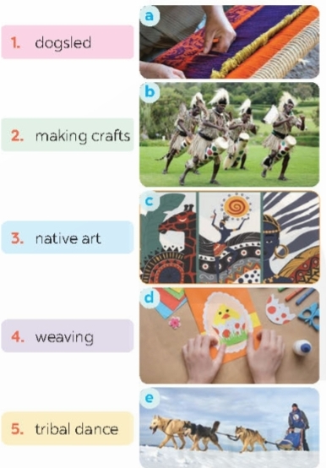  Answer key:  1. dogsled - e  2. make crafts – d  3. native art –c  4. weave – a  5. tribal dance - b
2. ACTIVITY 1: PRESENTATION (8 mins)
VOCABULARY
a. Objectives:
- To help Ss know more vocabularies about the topic: “Lifestyles”
b. Content:
- Vocabulary teaching.
- Ss work individually to study new words.
c. Expected outcomes:
- Students know how to use the target vocabulary.
- Ss know how to pronounce the new words correctly and use them in appropriate situations.
d. Organisation:
TEACHER’S AND STUDENTS’ ACTIVITIES | CONTENTS
Vocabulary teaching
- Teacher asks students to try explaining the meaning of the words that they have matched in Warm-up activity.  - Teacher uses different techniques to teach vocabulary (situation, realia…..), follows the seven steps of teaching vocabulary.  - Ss listen carefully the T’s modeling twice, repeat in chorus and individually, then copy all the words in their notebooks.  - Teacher checks students’ understanding by the follow-up tasks in the student's book. | New words:  1. dogsled (n): xe trượt tuyết chó kéo  2. make crafts : làm đồ thủ công  3. native (adj): thuộc bản xứ  4. tribal (adj): thuộc bộ tộc, thành bộ lạc
3. ACTIVITY 2: PRACTICE. (15 mins)
a. Objectives:
- Teacher helps Ss understand more clearly the meaning of some words and phrases.
- Teacher helps Ss use the words and phrases to do exercise
b. Content:
- Task 2: Complete the sentences with the words and phrases from the box.
- Task 3: ﻿Choose the correct answer A, B, or C to complete each sentence.
c. Expected outcomes:
- Ss can use vocabularies about the topic: “Lifestyles” to do exercises well.
d. Organisation: Teacher’s instructions …
Task 2: ﻿Complete the sentences with the words and phrases from the box. (8’)
- T has Ss read the sentences and choose the correct word given to fill each blank in the sentences.  ﻿- T tells Ss to read the sentences carefully and look for clues so that they can choose the correct words.  - T asks Ss to check their answers with their partners. Ask for translation of some of the words to check their understanding.  - T confirms the correct answers. | - T - Ss  * Answer key:  ﻿1. weaving  2. tribal dances  3. native art  4. making crafts  5. dogsled
Task 3: ﻿Choose the correct answer A, B, or C to complete each sentence. (7’)
- Have Ss read the sentences and choose the correct options to complete the sentences.  - Go around and give assistance if necessary and check their answers.  - Confirm the correct answers as a class.  - Teacher checks students’ pronunciation and gives feedback. | Answer key:  1. A 2. B  3. A 4. C  5. B
4. ACTIVITY 3: PRODUCTIONS (14 mins)
PRONUNCIATION /br/ and /pr/
a. Objectives:
- To help Ss identify how to pronounce the sounds /br/ and /pr/;
- To help Ss practise pronouncing these sounds correctly in words and sentences.
b. Content:
- Task 4: Listen and repeat the words. Pay attention to the sounds /br/ and /pr/.
- Task 5: Listen and practise the sentences. Underline the words with the sound /br/ and circle the words with /pr/.
c. Expected outcomes:
- Students can pronounce the /br/ and /pr/ sounds in words in sentences correctly
d. Organisation:
TEACHER’S AND STUDENTS’ ACTIVITIES | CONTENTS
Task 4: Listen and repeat the words. Pay attention to the sounds /br/ and /pr/. (7’)
- Teacher asks some Ss to read out the words first. Then play the recording for them to listen and repeat the words they hear. Ask them to pay close attention to the two sounds. Play the recording as many times as necessary.  - Explain to Ss the difference between the two sounds if needed:  + /br/: Put your lips together, then open them slowly to let the air out to make the sound /b/. Close your tongue up and round your lips to make the sound /r/.  + /pr/: Press your lips together, then open your mouth suddenly to let the air out to make the sound /p/. Close your tongue up and round your lips to make the sound /pr/. The puff of air that happens with the /r/ sound is bigger for the /pr/ cluster than the puff of air for the /br/ cluster.  * T can show Ss the pronunciation video of this Unit:  - Invite some Ss to say some words they know that include the two sounds. | 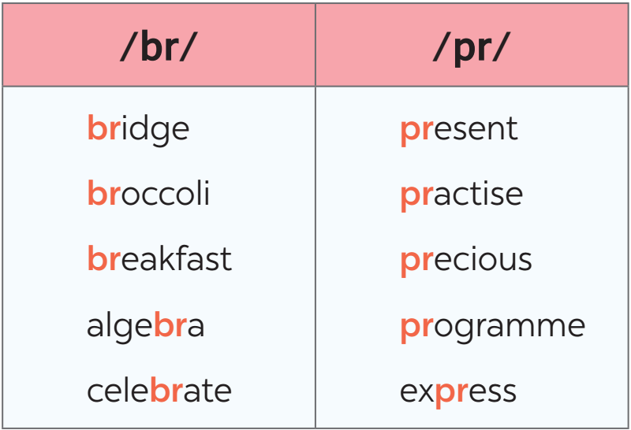
Task 5: Listen and practise the sentences. Underline the words with the sound /br/ and circle the words with /pr/. (7’)
- Teacher aks Ss to quickly read the sentences and underline the words having the sounds /br/, and circle the words having the sound /pr/. Then play the recording for Ss to listen and check.  - Invite some Ss to share their answers. Confirm the correct ones.  - Play the recording again for Ss to repeat the sentences.  - Have Ss practise the sentences in pairs. Invite some pairs to read the sentences aloud. Comment on their  pronunciation of the sounds.  * Teacher gives corrections and feedback to students’ pronunciation. | Answer key:  ﻿1. My brother says online learning improves our IT skills.  2. Santa Claus brings a lot of presents to children.  3. She briefly introduced the new programme.  4. He spent a lot of time preparing for his algebra test.  5. My mum prays at the temple before breakfast on Sundays.
5. CONSOLIDATION (3 mins)
a. Wrap-up
- Ask one or two Ss to summarise the class what they have learnt in the lesson.
- Ask Ss to say make some sentences with words and phrases they remember from the lesson
b. Homework
- Learnt by heart all the new words that they have just learnt.
- Practice the sounds /br/ and /pr/.
- Do exercises in workbook
- Prepare next lesson : Lesson 2: A closer look 2

