UNITS | VOCABULARY | GRAMMAR
Unit 8  FESTIVALS AROUND THE WORLD | - Talks about festivals around the world  - Compare how different countries celebrate festivals | - Future simple  - “like” and “different from”
Tiếng Anh 7 – i-LEARN SMART WORLD

UNIT 8 TEST
Note: Each correct answer earns 0.2 points.

I. PRONUNCIATION (0.8 points)
A. Choose the word whose underlined part is pronounced differently.
1. A. lightning B. dinner C. Christmas D. visit
2. A. Italian B. Brazilian C. Australian D. Egyptian
B. Choose the word that has a different stressed syllable from the rest.
3. A. demon B. balloon C. special D. welcome
4. A. family B. festival C. introduce D. celebrate

II. VOCABULARY AND GRAMMAR (2.4 points)
Choose the best option (A, B, C or D) to complete each of the following questions.
5. On the day of the Fire Dancing Festival, the Pà Thẻn ethnic group in Hà Giang set a big __________ on the yard and start the rituals.
A. bonfire B. firework C. flame D. light
6. The U.S. always celebrates the Fourth of July with an amazing __________ display in the sky.
A. bonfires B. fireworks C. fire D. lightning
7. During Tết holiday, Vietnamese people give each other best __________ for a lucky and successful Lunar New Year.
A. greetings B. sayings C. traditions D. wishes
8. Christmas time is coming around, so next Friday, each student in my class will bring a gift and then __________ it with another student.
A. give B. hand C. exchange D. send
9. During the Harbin Ice and Snow Festival in China, artists use different tools to carve the hard ice and snow, and visitors can see huge snow __________ of people, buildings and animals.
A. statues B. sculptures C. exhibitions D. paintings
10. Japan is _________ Spain. In Spain, people eat twelve grapes on New Year’s Eve, while Japanese people eat toshikoshi soba noodles.
A. different from B. like C. similar D. same as
11. _________ in Chinese culture, red is a symbol of luck in most Vietnamese celebrations.
A. Similar B. Different C. Like D. Same
12. Easter’s exact date varies because it depends on the moon. In 2022, Easter was on April 17th, and next time, in 2023, it __________ on April 9th.
A. was going to be B. is being C. was D. will be
13. During Hội An Lantern Festival, visitors can __________ in many interesting activities and watch various art performances, all of which are completely free of charge.
A. take part B. take place C. takes on D. takes off
14. Person A: Do you know that in Greece, people hang an onion on the front door of their house on New Year’s Eve?
Person B: _________
A. I like onions.
B. That’s interesting.
C. When is New Year’s Eve?
D. I think so.
15. What does this sign mean?
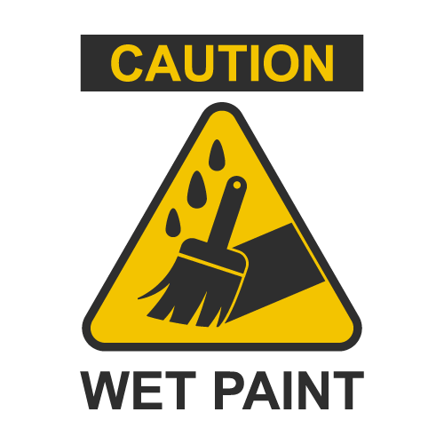 | A. Be careful because you must use wet paint on this item.  B. Be careful because the paint is still wet.  C. You can find only wet paint here.  D. Be careful when you use wet paint.

16. What does this sign mean?
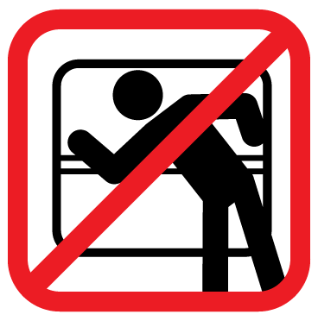 | A. Passengers have to open the window.  B. Passengers can’t look at the window.  C. Passengers mustn’t lean out of the window.  D. This window is not for passengers.

III. WORD FORMATION (1.2 points)
Write the correct form of the words in brackets.
17. The Thames Festival is an annual ___celebration_______ of the River Thames in London with many exciting events and talks. (CELEBRATE)
18. Bon Om Touk is one of the most amazing __traditional_________ festivals in Cambodia. (TRADITION)
19. Last year, I participated in one of the Scottish dancing ___competitions_______. I didn’t win, but I enjoyed myself a lot. (COMPETE)
20. During the Chiang Mai Flower Festival, __participants________ of the parade often hand out flowers to the spectators along the street. (PARTICIPATE)
21. __Preparations________ for Diwali Festival begin several weeks before the first day of Diwali. People clean their houses, put up decorations and light the lanterns. (PREPARE)
22. Last year on May Day, we wore our ___colorful/ colourful_______ costumes and danced around the Maypole. (COLOR)
IV. LISTENING (2 points)
A. You will listen to a conversation. For each question, complete the notes with NO MORE THAN TWO WORDS.
Sam, a TV reporter, interviewed the city's Mayor about next month’s summer (23)__festival__. During the interview, he asked about some of the planned (24)__activities__.
The Mayor said there would be lots of fun activities for the children like a (25)__water__ balloon fight and a dunking booth. She also said there would be lots of activities for adults like a hot dog eating (26)__contest__ and a fashion show.
The Mayor was looking forward to a nice (27)__relaxing__ day in the sun.
B. You will listen to a conversation. For each question, circle the correct option A, B, C, or D.
28. What is the main topic of the conversation?
A. Christmas Eve B. Christmas decorations
C. Christmas traditions D. Christmas trees

29. What is a tradition in America?
A. hang lights on a tree B. play in the snow
C. take pictures D. eat cold meat and seafood

30. Which country eats cold meat and seafood?
A. Japan B. Australia
C. Vietnam D. America

31. Why do children in Iceland place shoes in the window?
A. for good luck B. for decoration
C. to receive presents D. to keep them warm

32. Which country throws confetti?
A. Iceland B. America
C. Australia D. Vietnam
V. READING (2 points)
A. Read the following passage. For each question, circle the correct option A, B, C, or D that best suits each blank.
Last spring, I visited my cousin living in Ho Chi Minh City. She suggested the best time to visit the city was during the Tet (33)__________. I had such a great time, so I want to share my personal (34)__________ and what I learned about the Vietnam Lunar New Year.

First, Tet is a (35)__________ of the start of spring. The city is full of flower vendors, and all the trees are in bloom. Second, it’s about paying respect to your ancestors. I saw many people burning incense and families putting out food and fruit for their loved ones who have passed away. Finally, Tet (36)__________ about spending time with your family. I was surprised at how empty the city was. My cousin told me it's a (37)__________ for families to return to their hometown to celebrate the New Year.

33. A. tradition B. festival C. celebrate D. experience
34. A. experience B. competition C. performance D. interest
35. A. festival B. experience C. tradition D. celebration
36. A. won’t be B. is C. will be D. can be
37. A. competition B. experience C. tradition D. holiday
B. Read the following passage. For each question, write T if the statement is TRUE, F if it is FALSE, and NI if there is NO INFORMATION.
The largest festival in the world is Brazil’s Carnival which is considered by many to be “the greatest show on Earth.” More than 5 million people travel to Brazil in February or March to attend this religious celebration that begins 40 days before Easter. The festival is full of live music and people dancing in the streets. More than 70+ samba schools compete every year for cash and prizes. Dancers from these schools wear colorful and creative costumes. They form a long line of people in the street called a parade that starts in the city center and stops at the ocean. The festival takes place before the Catholic season of Lent and celebrates the last day before Brazilians must give up the things they love for 40 days. The festival ends with a beautiful fire show on the beach when the sun goes down.

38. The Carnival is a large festival in Brazil. __T__
39. You can find lots of great food at the festival. __NI__
40. Dancers from local samba schools wear costumes and compete for cash and prizes. __T__
41. The festival takes place after the Catholic season of Lent. __F__
42. The festival begins with a beautiful fire show on the beach. __F__

VI. WRITING (1.6 points)
A. Rearrange the following words or phrases to make a complete sentence.
43. in Canada / turkey / people / On Thanksgiving, / like / people / have / in the U.S.
→ On Thanksgiving, people in Canada have turkeys like people in the U.S.
44. Canadians celebrate / Thanksgiving / the second Monday / ; that’s / American people / on / from / in / different / October, / .
→ Canadians celebrate Thanksgiving on the second Monday in October; that’s different from American people.

B. Rewrite the following sentences without changing their meaning. Use the given word(s) if any.
45. Both Vietnamese and Chinese people give children lucky money on Lunar New Year.
→ Like Chinese people, Vietnamese people give children lucky money on Lunar New Year.
46. People will hold Mid-Autumn Festival on September 10th, 2022. (TAKE)
→ Mid-Autumn Festival will take place on September 10th, 2022.

C. Use the given words or phrases to make complete sentences.
47. Vesak / be / most popular / Buddhist festival / Vietnam.
→ Vesak is the most popular Buddhist festival in Vietnam.
48. It / celebrate / Buddha’s birthday / and / be / 14th April / Lunar calendar.
→ It celebrates Buddha’s birthday and is on 14th April on the Lunar calendar.
49. People / decorate / pagodas / lanterns / lotus flowers.
→ People decorate pagodas with lanterns and lotus flowers.
50. People / also / have / vegetarian meals / visit / pagodas.
→ People also have vegetarian meals and visit the pagodas.

***End – Of – Test***
Listening Scripts
Script A
Sam (TV reporter), Ms. Jackson (Mayor)

Sam: Today, I’m talking with a special guest. She is the current Mayor of our city and is here to talk about next month's summer festival. So, what can you tell us about some of the planned activities?
Ms. Jackson: This year's theme is about keeping cool during the summer, so there will be lots of fun activities for the children like a water balloon fight and a dunking booth.
Sam: Will there be activities for the adults?
Ms. Jackson: Yes, of course. There will be a hot dog eating competition and a summer-themed fashion show.
Sam: What do you think will be the most exciting part of the festival?
Ms. Jackson: I’m looking forward to spending time with everyone in the community and enjoying a nice relaxing day in the sun.
Sam: Me too. I can’t wait. It sounds like it will be a special event for everyone.

Script B

Tim: Hey Mom, the teacher asked us to write a report about Christmas traditions. Could you help me?
Mom: Well, Christmas is celebrated all around the world, and every country has its own traditions.
Tim: You mean like here in America, where they put lights around the house and on Christmas trees.
Mom: That’s right, but did you know, in Australia, it’s a tradition to eat cold meat and seafood?
Tim: Cold meat and seafood!? I've never heard about that.
Mom: And in Japan, they eat fried chicken.
Tim: Fried chicken!?
Mom: In Iceland, children place their shoes in a window on Christmas Eve to receive presents from 13 little trolls that travel around the town.
Tim: That’s interesting. I’ll have to put that in my report, anything else?
Mom: I’ve heard that in Vietnam, people in the city like to throw confetti and take pictures of all the lights and decorations.
Tim: That sure helps. Thanks, mom!

