|  |  |
| --- | --- |
| **PART 1** | **Listening (10 questions)** |

**Listen to the following conversation. For each question, write T if the statement is TRUE, F if it is FALSE, and NI if there is NO INFORMATION. (5 questions)**

| **Answers** | **True** | **False** | **Not given** |
| --- | --- | --- | --- |
| 1. The main topic of the conversation is about two guys traveling around the city. | **◯** | **◯** | **◯** |
| 2. Steve had a wonderful time using public transportation to get around. | **◯** | **◯** | **◯** |
| 3. Locals like to take the train because it’s cheap. | **◯** | **◯** | **◯** |
| 4. Trains are usually not near the cities. | **◯** | **◯** | **◯** |
| 5. The food on a train is better than on a bus. | **◯** | **◯** | **◯** |

**You will listen to a conversation about two types of transportation. Complete the table with ONE WORD for each blank. (5 questions)**

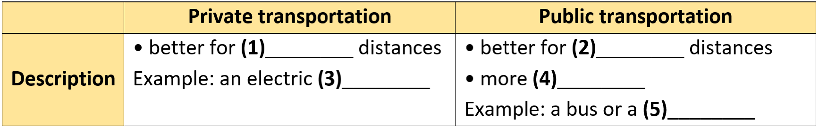

(6) ___________________  
(7)___________________  
(8)___________________  
(9)___________________  
(10)___________________

**---THE END---**