|  |  |
| --- | --- |
| **Mã đề 7.1.14.1** | **ĐỀ KIỂM TRA GIỮA HỌC KÌ I**  **MÔN: Tiếng Anh 7** |

**A. LISTENING**

**I. Listen, then write** **the right answer (A, B, C) on your test paper.** **(1.0 pt)**

1. What does Daisy want for supper?

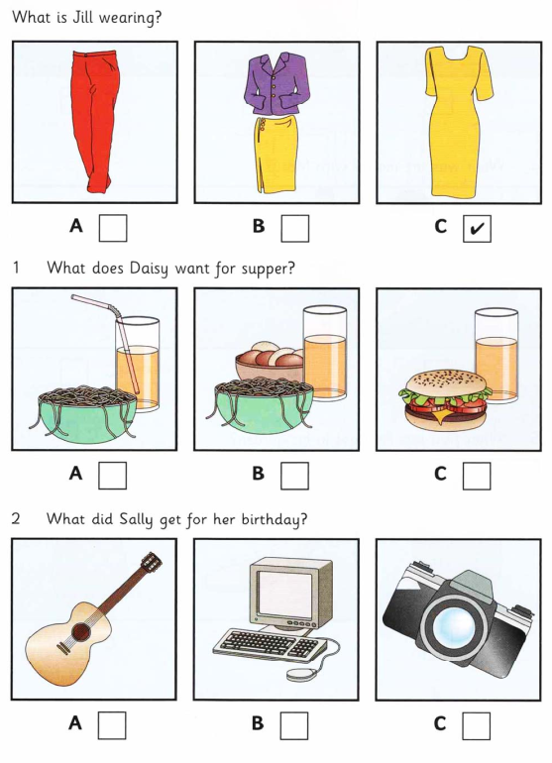

2. What did Sally get for her birthday?



3. Where did Peter go at the weekend?

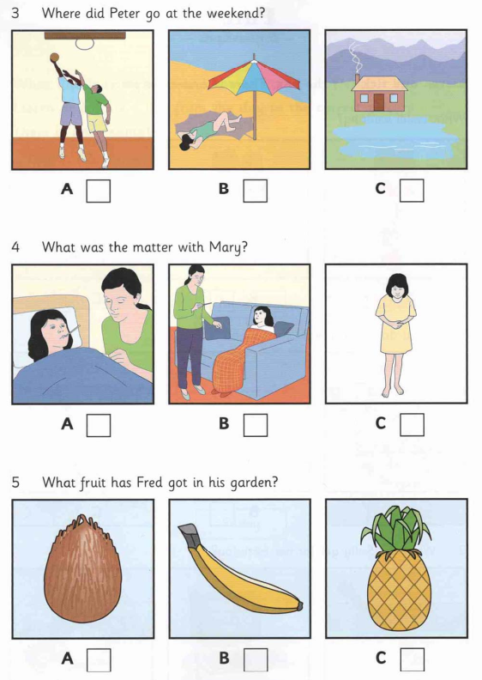

4. What was the matter with Mary?



5. What fruit has Fred got in his garden?



**II/ Listen and write: (1pt)**

Name: **Mary Smith**

6. How old: ..................................................................................

7. Hair colour: ..................................................................................

8. Eye colour: ..................................................................................

9. How many brothers: ..................................................................................

10. How many sisters: ..................................................................................

**B. VOCABULARY - GRAMMAR - LANGUAGE FUNCTION**

**I. Choose the best option A, B or C to complete the sentences (2pts):**

11. My father can make beautiful pieces of art ________ empty eggshells.

A. of B. from C. in

12. Be careful not to drop it; it’s very ________.

A. fragile B. unique C. difficult

13.Collecting cars is a(n) ________ hobby. It costs a lot of money.

A. interesting B. cheap C. expensive

14. Junk foods are high in fat, sodium and sugar, which can lead to ________.

A. fever B. allergy C. obesity

15. If you want to stay healthy, eat vegetables, whole grains, fruit and fish.

A. less B. more C. fewer

16. She stays in ________ by exercising daily and eating well.

A. health B. fit C. shape

17. Why don’t you take ________ a new hobby ?

A. up B. in C. over

18. I ______ her recently. The last time we met was at a party.

A. didn’t see B. haven’t seen C. saw

19. In 2012, they ______ their project for street children.

A. starting B. have started C. started

20. A: “Thank you very much for helping the community.”

– B: .

A. You’re welcome B. Thanks C. Yes, I do

**II. Choose the answer (A,B or C) that needs correcting (1 pt)**

21. When did you buy this house? - We buy it three years ago.

A B C

22. Ann gets up at 6 o’clock and is having breakfast every day.

A B C

23. My mom enjoys to go jogging in the park.

A B C

24. We often do models after school.

A B C

25. My cousin likes getting up early and have breakfast with bread.

A B C

**C.READING**

**I. Read the passage and choose the best option (A, B or C) (1,0 pt).**

I go on the Internet every day, but I never (26) ____ more than an hour at a time online. I’ve got laptop and also a smart phone, so I can (27)____the Internet anywhere. Today, for instance, I’ve been (28) ___ three times. Mainly I just (29) _______ my friends. I (30)_____ online magazines and I look for information, too.

|  |  |  |
| --- | --- | --- |
| 1. A. spend | B. spending | C. spent |
| 1. A. have | B. use | C. play |
| 1. A. online | B. Internet | C. computer |
| 1. A. write | B. email | C. send |
| 1. A. read | B. think | C. speak |

**II. Read the following text and complete the statements below (1,0 pt)**

Maintaining a healthy body is not that easy and not so difficult also. Most important tip for a healthy body is to have healthy food and eat them at proper time. Avoid eating junk food. Your diet should contain food which has more nutrients. Try to include vegetables, fruits, milk, and fish in your daily diet. Make sure you are having your breakfast regularly. Skipping your breakfast regularly will definitely affect your health. Make sure you drink more amount of water daily. Regular exercise will also keep your body in good health. You can go for running, do cycling, walking faster etc. Apart from these always try to manage your stress. By controlling your stress you can maintain a healthy body. Your body should get enough time to take rest. Make sure you get a sleep of 8 hours daily. Sleep is very important for healthy body and also for mental and emotional happiness.

31. To have a healthy body, you should _________.

A.eat junk food B. put on weight C. have a healthy diet

32. Skipping breakfast is _________ for your health.

A.good B. bad C. necessary

33. Which of the followings is not keep your body in good health?

A.smoking B. cycling C. running

34. Managing stress can help people _________.

A.have a good body B. stay healthy C. sleep enough time

35. Which of the followings is NOT true?

A.It’s difficult to maintain a healthy body.

B.Water is important for your health.

C.Getting enough sleep can make you happier.

**D.WRITING**

**II. Choose the correct sentence (A, B or C) in such a way that it means the same as the sentence before it. (1pt)**

**36. She worked very hard, so she got good grades.**

A. She worked very hard, but she didn’t get good grades.

B. She got good grades because she worked very hard.

C. She worked very hard because she got good grades.

**37. No one in my class is taller than Nam.**

A. Nam is the tallest student in my class.

B. Nam is taller than student in my class.

C. Nam is the shortest student in my class.

**38. He finds reading books interesting.**

A. He thinks reading books interesting.

B. He is interested in reading books

C. He thinks reading books is interesting.

**39. My father likes to do gardening at the weekend.**

A. My father hates to do gardening at the weekend.

B. My father enjoys doing gardening at the weekend.

C. My father dislikes to do gardening at the weekend.

**40. Why don’t we go swimming this afternoon?**

A. What about going swimming this afternoon?

B. Let’s going swimming this afternoon.

C. How about to go swimming this afternoon?

**III. Write a paragraph (about 70-80 words) about your favourite hobby. (2 pts**)

* Name of the hobby
* When you started it
* Why you like it
* Who you share this hobby with
* How you feel about it
* What you will do in the future with this hobby

_________The end___________

|  |  |
| --- | --- |
| **Mã đề 7.1.14.1** | **ĐÁP ÁN BIỂU ĐIỂM**  **ĐỀ KIỂM TRA GIỮA HKI**  **MÔN:Tiếng Anh 7** |

|  |  |  |
| --- | --- | --- |
| **Parts** | **Answer key** | **Marks** |
| **A** | ***I.Tổng 1,0 điểm. Mỗi đáp án đúng 0,2 điểm***  1.A 2.C 3.C 4.B 5.C | 1.0 pt  0.2 x 5 |
| ***II.Tổng 1,0 điểm. Mỗi đáp án đúng 0,2 điểm***  6.nine/9 7. blonde 8. blue  9 . three/3 10. Four/4 | 1.0 pt  0.2 x 5 |
| **B** | ***I. Tổng 2,0 điểm. Mỗi đáp án đúng 0,2 điểm***  11.B 12. A 13. C 14. C 15. B  16. C 17.A 18. B 19. C 20. A | 2.0 pts  0.2 x 10 |
| ***II. Tổng 1,0 điểm. Mỗi đáp án đúng 0,2 điểm***  ***21. C 22. C 23. B 24. B 25. C*** | 1.0 pt  0.2 x 5 |
| **C** | ***I. Tổng 1,0 điểm. Mỗi đáp án đúng 0,2 điểm***  **26**.A 27.B. 28. A 29. B 30.A | 1.0 pt  0.2 x 5 |
| ***II. Tổng 1,0 điểm. Mỗi đáp án đúng 0,2 điểm***  31. C 32. B 33. A 34. B 35. A | 1.0 pt  0.2 x 5 |
| **D** | ***II. Tổng 1,0 điểm. Mỗi câu viết đúng 0,2 điểm***  36. B. 37. A. 38. C. 39. B. 40. A | 1.0 pt  0.2 x 5 |
| ***II. Tổng 2.0 điểm. Gợi ý cho điểm như sau:***  - Form: correct form of the paragraph giving an opinion, using appropriate connectives. (0.5 pt)  - Content and grammar: (1.5 pts)  + Introduction: show opinion clearly. (0,25 pt)  + Body: giving reasons (1.0 pt)  + Conclusion: summarising opinion. (0,25 pt) | 2.0 pts |