Date of preparing: ………………………………….
Date of teaching: ………………………………….

Period …
UNIT 1: HOME
Lesson 1 - Part 1 (Page 6) - Vocabulary and Listening

I. OBJECTIVES
By the end of the lesson, Ss will be able to…
1. Knowledge
- ask about people’s home.
- get someone’s attention to start a conversation.
2. Ability
- improve Listening and Speaking skills.
3. Quality
- have positive attitude in English language learning so that they actively participate in all classroom activities.
- love home and help parents do housework.

II. TEACHING AIDS AND LEARNING MATERIALS
Lesson plan, PPT slides, student’s book, workbook, notebook, personal computer (if any), projector/TV, speakers, DCR & DHA on EDUHOME, handouts…
III. PROCEDURES
A. Warm up: (5’)
a) Objective: Introduce the new lesson and set the scene for Ss to acquire new language; get students' attention at the beginning of the class by means of enjoyable and short activities as well as to engage them in the steps that follow.
b) Content: Introduction of vocabularies about home.
c) Product: Ss have general ideas about the topic “home”.
d) Competence: Collaboration, communication, critical thinking.
e) Organization of the activity:
Teacher’s Activities | Students’ Activities
- Give greetings  - Check attendance  - Option 1: Number the pictures  - Use the “New words” part a.– page 6 for the warm-up activity  - Show pictures and words, have Ss number the pictures (in pairs)  - Call Ss to give answers  - Give feedback and show correct answers  - Lead to the new lesson  - Play the audio (CD1 – Track 02), have Ss listen and repeat  - Correct Ss’ pronunciation if necessary  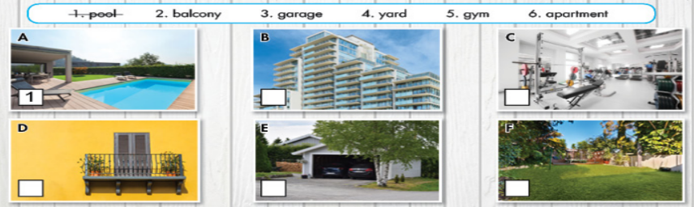  - Option 2: Drawing  - Have Ss work in groups and sketch their dream house.  - Set a limit time (3-4’)  - Have Ss hang their pictures on the board  - Make comments on Ss’ works  - Have Ss vote for the most beautiful house  - Give a small present to the winner  - Lead to the new lesson | - Greet T  - Work in pairs and use their critical thinking to number the pictures  - Give answers  - Listen  Answer keys  A1 B6 C5 D2 E3 F4  - Sketch out the dream house  - Hang pictures on the board  - Listen

B. New lesson (35’)
- Activities 1: Vocabulary (20’)
a) Objective: Ss know words about home and things around home.
b) Content:
- Vocabulary study
- Speaking
c) Products: Ss know how to pronounce the new words correctly and use them in appropriate situations.
d) Competence: Communication, collaboration, presentation, imagination.
e) Organization of the activity:
Teacher’s Activities | Students’ Activities
a. Number the pictures. Listen and repeat.  - Option 1 (If the teacher hasn’t used this part for the Warm-up activity)  - Demonstrate the activity, using the example  - Have Ss number the pictures  - Divide class into pairs and have them check their answers with their partners  - Call Ss to give answers (read or write)  - Check answers as a whole class  - Play audio (CD1 – Track 02). Have Ss listen and repeat  - Correct Ss’ pronunciation  - Option 2: Matching (If the teacher has used part a. for the Warm-up activity)  - Have Ss review the vocabularies they have known in the warm-up activity by matching words with pictures (T uses different pictures from those in the textbook)  - Call Ss to give answers (read or write)  - Check answers as a whole class  - Call some Ss to read the words again  - Correct Ss’ pronunciation if necessary  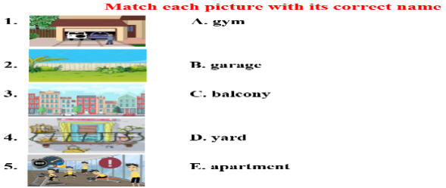  b. Talk about your home using the new words and three other words you know  - Option 1:  - Have Ss talk about their home using the new words and three other words they know  - Remind Ss to use the structure:  There + be + noun +…  - Have Ss share their ideas in front of the class  - Give feedback and evaluation  - Option 2: (for class with better students)  - Give Ss an extra activity: Show a picture of a house and have Ss describe the house and things around the house    Example:  - Call some Ss to share their ideas with the class  - Give feedback and evaluation  - Then, follow the same steps as option 1 | - Look and listen  - Work individually  - Work in pairs  - Give answers  - Listen and repeat  Answer keys  A1 B6 C5 D2 E3 F4  - Work in pairs  - Give answers  - Read  Answer keys  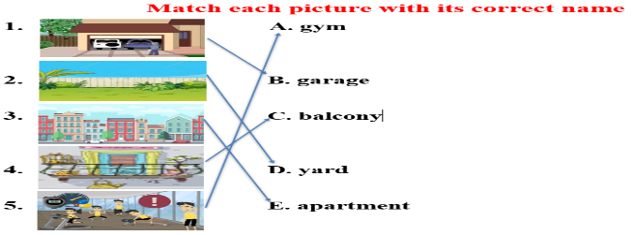  - Work in pairs  - Present  Suggested words: garden, swing, basement  - Work in pairs  Suggested answers  - There’s a chimney / fireplace in my house  - My house has a garden  - There are many trees around my house
- Activity 2: Listening (16’)
a) Objective: Ss can make questions or answer the questions to develop a conversation, and they can also finish the listening task in the textbook.
b) Content: Listening to a girl asking a boy questions about his home.
c) Products: Ss can listen for main ideas and specific information.
d) Competence: collaboration, guessing/reasoning, communication, listening.
e) Organization of the activity:

Teacher’s Activities | Students’ Activities
a. Listen to a girl asking a boy questions about his home. Are they friends?  - Have Ss look at the question and the picture.  - Play the audio once (CD 1 – Track 03)  . Have Ss listen and answer the question by circling “Yes” or “No”  - Play the audio again. Check answers as a whole class  b. Now, listen and fill in the blanks.  - Have Ss read the sentences  - Have Ss guess the answers/ guess part of speech of the missing word(s)  - Play the audio (CD1 – Track 03). Have Ss listen and fill in the blanks  - Check answers as a whole class  *Conversation Skill  - Play the first 2 sentences of the recording, ask Ss to find which sentence / phrase that the speaker uses to get someone’s attention  - Focus attention on the Conversation Skill box  - Explain that we can get someone’s attention by saying “Excuse me”  - Play audio (CD 1 – Track 4). Have Ss listen and repeat  - Have some Ss practice the conversation skill in front of the class  - Have Ss think of other ways to get someone’s attention and make up a conversation that contains these phrases, words | - Look at the picture and the question  - Listen and circle  - Check answers  Answer key: No  - Look and read  - Guess the answers  - Listen and fill in the blanks  - Check answers  Answer keys  1. an apartment  2. bedrooms  3. pool  4. a garage  - Try to find the indicator that speaker uses to get someone’s attention  - Look and listen  - Listen and repeat  - Present  Suggested answers  Other ways to get someone’s attention  - Hey, …  - Sorry …

C. Consolidation (2’)
* Vocabularies about home and things around home: gym, balcony, apartment, yard, garden, basement, garage, pool, …
* Getting someone’s attention: Say “Excuse me.”

D. Homework (2’)
- Learn by heart the new vocabularies.
- Practice talking about your home.
- Do exercises in Workbook: Lesson 1 - New words (page 4).
- Prepare: Lesson 1 – Grammar (page 7 – SB).

