ĐỀ SỐ 3  FORM 2026 | ĐỀ THI GIỮA HK2 MÔN TIẾNG ANH 8 GLOBAL SUCCESS  Thời gian: 60 phút

Mark the letter A, B, C or D on your answer sheet to indicate the word whose underlined part differs from the other three in pronunciation in each of the following questions.
Question 1. A. end | B. effect | C. extinction | D. upset
Question 2. A. typhoon | B.goose | C. flood | D. food
Mark the letter A, B, C or D on your answer sheet to indicate the word that differs from the other three in the position of primary stress in each of the following questions.
Question 3. A. seller | B. discount | C. attract | D. enter
Question 3. A. arrival | B. natural | C. national | D. physical

Mark the letter A, B, C or D on your answer sheet to indicate the correct answer to each of the following questions.
Question 5.- Store assistant:” What’s wrong with your computer?”
- Customer:” _______________
A. My computer costs a lot of money.
B. I bought it yesterday.
C. The screen is blank.
D. I want to buy a new computer.
Question 6. The bowl is ______ glass and paper is _________tree.
A. made from/made by | B. made by/ made in | C. made of/ made by | D. made of/ made from
Question 7. A bakery and a florist are two examples of ______ stores.
A. specialize | B. specially | C. special | D. speciality
Question 8. They _____________ swimming at weekends.
A. go hardly ever | B. hardly ever go | C. ever go hardly | D. hardly go ever
Question 9. The violent earthquake ________ the road system and many vehicles.
A. pulled off | B. damaged | C. flooded | D. trembled
Question 10. I’ve seen the notice. The game ________at one o’clock tomorrow afternoon.
A. starts | B. will start | C. start | D. will be start
Question 11. Environmental pollution is becoming an ________serious problem that needs to be taken care of as soon as possible.
A. increasingly | B. increasing | C. increase | D. increased
Question 12. While the other passengers _______________ to the exits, Brian _______________ out of the window.
A. ran - climbed | B. ran - was climbed | C. run - was climbing | D. were running – climbed

Read the following announcement and mark the letter A, B, C or D on your answer sheet to indicate the correct option that best fits each numbered blank from 13 to 16.

Stay Safe During an Earthquake
- Drop down to the floor, take cover under (13)____ sturdy table or desk.
- Stay (14)____ from windows, heavy furniture, and falling objects.
- If indoors, remain inside (15)____the shaking stops.
- If outside, move to an open area away from buildings and power lines.
- If in a vehicle, stop (16)____ and stay inside.

Question 13. A. a | B. an | C. the | D. no article
Question 14. A. up | B. away | C. on | D. off
Question 15. A. before | B. after | C. until | D. as
Question 16. A. safely | B. safety | C. unsafely | D. safeties

Mark the letter A, B, C or D on your answer sheet to indicate the correct answer to each of the following questions from 17 to 18.
Question 17. Put the sentences (a-c) in the correct order, then fill in the blank to make a logical text.
Yesterday, I bought a gift for my friend’s birthday online. ..........
a. I found a beautiful necklace on a popular e-commerce website and added it to my cart.
b. Before making the payment, I used a discount code to save some money.
c. The website confirmed my order and promised delivery within three days.
A. b - c- a | B. a - c - b | C. a - b - c | D. b - a - c
Question 18. Choose the sentence that most appropriately ends the text (in Question 17).
A. I was disappointed because the gift didn’t look as good as the picture.
B. I can’t wait to see my friend’s reaction when she opens the gift.
C. The necklace was delivered late, which ruined my surprise plan.

Read the following announcement and mark the letter A, B, C or D on your answer sheet to indicate the correct option that best fits each numbered blank from 19 to 24.
There are various causes of air pollution, and one of the (19)_____ is emissions from vehicles. In many cities, cars, trucks, and motorcycles emit large amounts of carbon monoxide, nitrogen oxides, and other harmful gases that contribute to the deterioration of air quality. These emissions are particularly dangerous because they affect both human health and the environment. (20)_____vehicle emissions, industrial factories are (21)_____ major source of air pollution. These factories release smoke, dust, and chemicals into the atmosphere, which can cause respiratory problems and contribute (22)_____ the formation of acid rain.

Another cause of air pollution is the widespread use of household products such as paints, solvents, and cleaners. These products release volatile organic compounds (VOCs) that evaporate into the air, further degrading air (23)_____. Additionally, deforestation is another contributing factor, as trees play (24)_____ in absorbing carbon dioxide. When forests are cut down, more carbon dioxide is released into the atmosphere, worsening air pollution.

Question 19. A. most significant | B. more significant | C. many significances | D. most significances
Question 20. A. Moreover | B. In addition to | C. Therefore | D. Nevertheless
Question 21. A. the other | B. others | C. another | D. other
Question 22. A. to | B. of | C. on | D. in
Question 23. A. waste | B. quality | C. quantity | D. life
Question 24. A. a crucial role | B. a role crucial | C. an crucial role | D. much crucial role

Read the following announcement and mark the letter A, B, C or D on your answer sheet to indicate the sentence that is closest in meaning to the original sentence in each of the following questions.
Question 25. On our way to the island, a tornado occurred.
A. When we were on the way to the island, a tornado occurred.
B. When we was on the way to the island, a tornado occurred.
C. When we was in the way to the island, a tornado occurred.
D. When we were in the way to the island, a tornado occurred.
Question 26. The polluted water results in the death of many aquatic animals and plants
A. The polluted water causes in the death of many aquatic animals and plants.
B. The polluted water leads to the death of many aquatic animals and plants.
C. The polluted water causes to the death of many aquatic animals and plants.
D. The polluted water leads in the death of many aquatic animals and plants.

Read the following announcement and mark the letter A, B, C or D on your answer sheet to indicate the sentence that is made from the given cues in each of the following questions.
Question 27. Many/ people/ this area/ have/ cholera/ because/ they/ drink/ untreat/ water.
A. Many people in this area have cholera because they drink untreated water.
B. Many people on this area have cholera because they drink untreated water.
C. Many people on this area have cholera because they drink untreating water.
D. Many people in this area have cholera because they drink untreating water.
Question 28. Ha Noi Night Market / must-see place / visitors.
A. Ha Noi Night Market is an must-see place to visitors.
B. Ha Noi Night Market was a must-see place to visitors.
C. Ha Noi Night Market are a must-see place to visitors.
D. Ha Noi Night Market is a must-see place for visitors.

Read the following sign or notice and mark the letter A, B, C or D on your answer sheet to indicate the correct answer to each of the following questions.
Question 29. What does the sign mean?
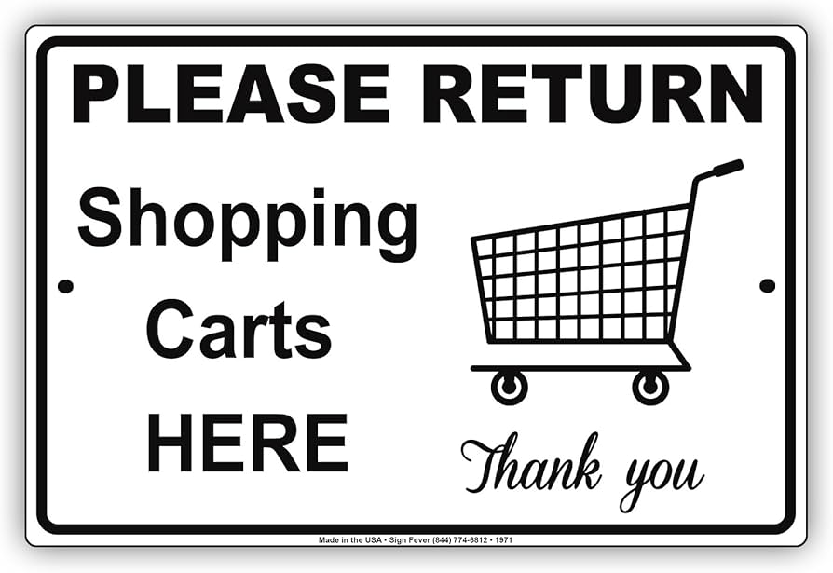 | A. Return your cart anywhere in the parking lot.  B. Return the cart to the designated cart area.  C. Keep the cart in your car until you get home.  D. Return the cart at the store entrance.
Question 30. What does the sign mean?
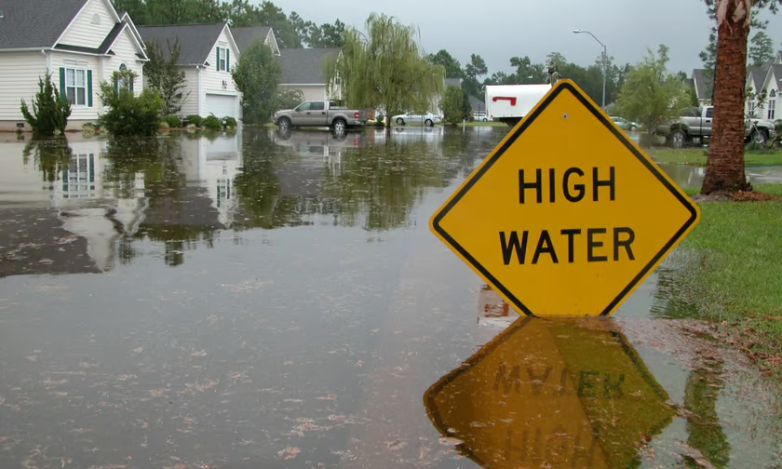 | A.You should watch out for flooded areas.  B. You must not approach water areas.  C. You shouldn’t swim in high water.  D. You must not watch out for water.
Read the following passage and mark the letter A, B, C or D on your answer sheet to indicate the correct answer to each of the following questions from 31 to 36.
Scientists have made significant progress in predicting natural disasters, which helps minimize the risks to people and property. Through research and technology, they can now predict earthquakes, hurricanes, floods, and volcanic eruptions, although the accuracy varies.
Earthquakes are difficult to predict because they occur suddenly and without warning. However, scientists use seismographs to monitor the Earth’s movements. They track seismic activity to identify patterns and make predictions about areas where earthquakes are more likely.
Hurricanes are easier to predict. Meteorologists use satellite images to monitor storms as they form. By studying wind patterns, air pressure, and ocean temperature, scientists can predict where a hurricane will strike and how strong it will be.
Floods can be predicted by monitoring weather patterns and river levels. Scientists use radar systems and weather satellites to observe rainfall and track rising water levels. If water levels rise too quickly, there is a high risk of flooding.
Volcanic eruptions are predicted by studying gas emissions and earthquake activity near volcanoes. When there are unusual changes in these factors, scientists can warn nearby communities of a possible eruption.

Question 31. What is the main challenge in predicting earthquakes?
A. They are difficult to study | B. They occur suddenly without warning
C. They only happen in certain areas | D. They are easy to forecast
Question 32. How are hurricanes predicted?
A. By studying seismic activity | B. By measuring rainfall only
C. By observing gas emissions | D. By monitoring weather satellites and wind patterns
Question 33. What is the most significant factor in predicting volcanic eruptions?
A. Gas emissions and seismic activity | B. Ocean temperatures
C. Wind patterns | D. Rainfall levels
Question 34. What is the main idea of the passage?
A. Predicting earthquakes is easier than predicting hurricanes
B. Only hurricanes and floods can be predicted
C. Volcanic eruptions are predictable all the time
D. Natural disasters can be predicted with varying levels of accuracy
Question 35. What is the CLOSEST meaning of the word "minimize" in the passage?
A. Reduce | B. Increase | C. Avoid | D. Control
Question 36. What is the OPPOSITE meaning of the word "accuracy" in the passage?
A. Exactness | B. Precision | C. Error | D. Clarity

Four phrases/sentences have been removed from the text below. For each question, mark the letter A, B, C or D on your answer sheet to indicate the correct option that fits each of the numbered blanks from 37 to 40 the most.

A. a great way to experience the true spirit
B. must-see destination for travelers
C. vibrant and full of life
D. These markets are not just for shopping

In Ha Giang, a northern province of Vietnam, local markets are (37)_____. Popular ones like the Dong Van Market and Meo Vac Market are where ethnic groups such as the H'mong and Tay gather every week to trade goods, from textiles and handicrafts to fresh produce and livestock. (38)____, but offer a rich cultural experience, with traditional foods and local customs on display. Visiting these markets is (39)_____ of Hà Giang and connects with the diverse communities that call it home, making it a (40)_____.

