Họ và tên: ....................................................  Lớp: ............................................................. | PHIẾU GHI BÀI HÓA HỌC 11 CÁNH DIỀU  Bài 3: pH CỦA DUNG DỊCH  CHUẨN ĐỘ ACID–BASE
MỞ ĐẦU
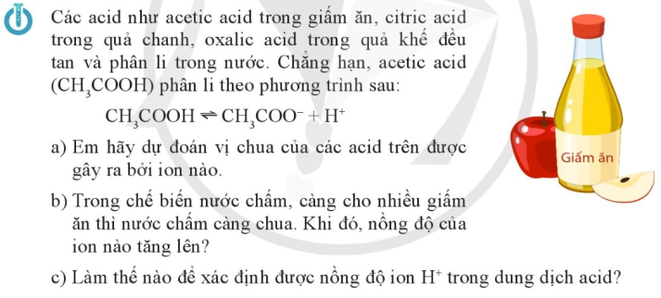
..........................................................................................................................................................................
..........................................................................................................................................................................
..........................................................................................................................................................................

I. pH CỦA DUNG DỊCH. CHẤT CHỈ THỊ
1) pH của dung dịch
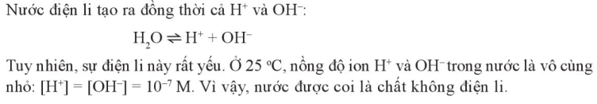
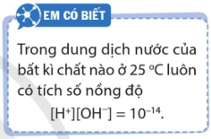

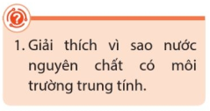 | ..................................................................................................................  ..................................................................................................................  ..................................................................................................................
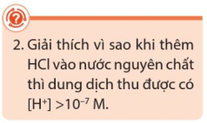 | ..................................................................................................................  ..................................................................................................................  ..................................................................................................................  ..................................................................................................................
Khái niệm pH
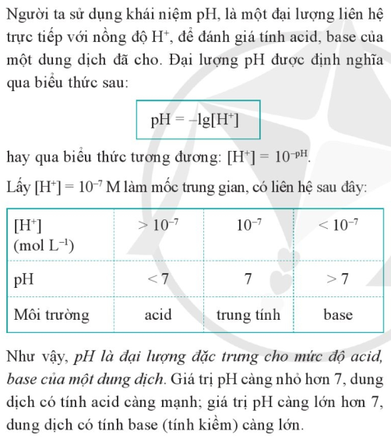 |  | 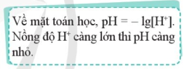
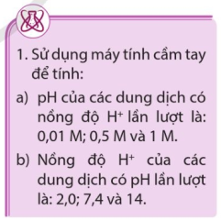 | ................................................................................................................  ................................................................................................................  ................................................................................................................  ................................................................................................................  ................................................................................................................  ................................................................................................................  ................................................................................................................
2) Ý nghĩa của pH trong thực tiễn
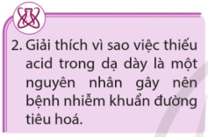 | ................................................................................................................  ................................................................................................................  ................................................................................................................  ................................................................................................................
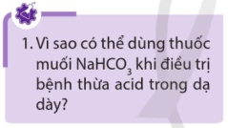 | ................................................................................................................  ................................................................................................................  ................................................................................................................  ................................................................................................................
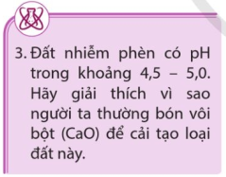 | ................................................................................................................  ................................................................................................................  ................................................................................................................  ................................................................................................................  ................................................................................................................
3) Xác định pH bằng chất chỉ thị
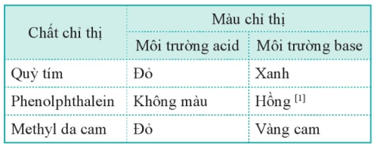
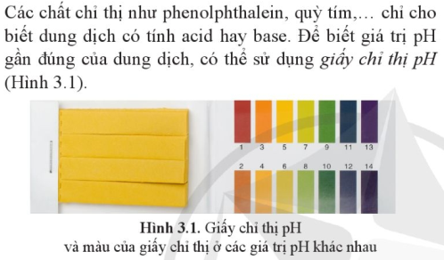
III. CHUẨN ĐỘ ACID - BASE
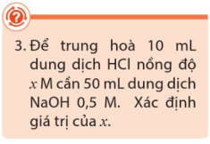 | ..................................................................................................................  ..................................................................................................................  ..................................................................................................................  ..................................................................................................................  ..................................................................................................................  ..................................................................................................................  ..................................................................................................................  ..................................................................................................................  ..................................................................................................................
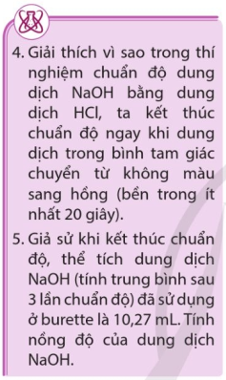 | ..................................................................................................................  ..................................................................................................................  ..................................................................................................................  ..................................................................................................................  ..................................................................................................................  ..................................................................................................................  ..................................................................................................................  ..................................................................................................................  ..................................................................................................................  ..................................................................................................................  ..................................................................................................................
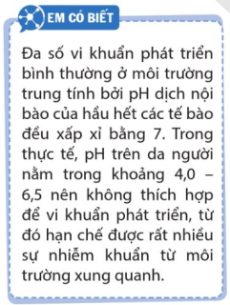 | 