Họ tên thí sinh: .................................................................
Số báo danh: ......................................................................
Mã Đề: 018.
Câu 1. When was the sports bag found?
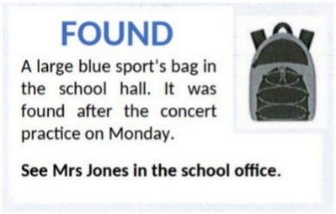
A. Before the concert practice B. During the concert practice
C. After the concert practice D. The next day after the practice
Câu 2. Look at the signs. Choose the best answer for the question.
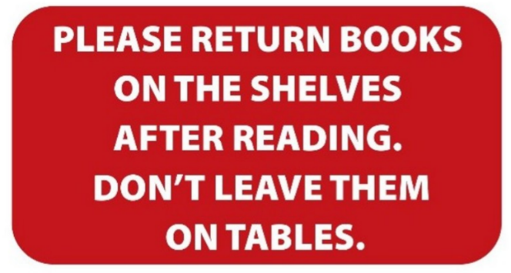
A. You need to put the books both on the table and the shelves.
B. After you finish reading, you have to put the books back on the shelves.
C. You can leave books either on the shelves or on the tables.
D. Books should be left on the tables instead of the shelves.
Câu 3. Look at the signs. Choose the best answer for the question.
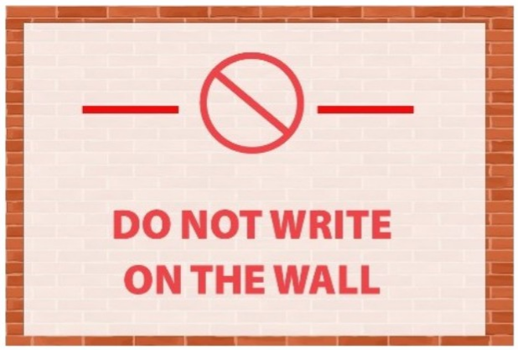
A. Writing on the wall is not possible. B. You are not allowed to write on the wall.
C. You needn’t write on the wall. D. You don’t have to write on the wall.
Câu 4. What made Michael send this message to Arthur?
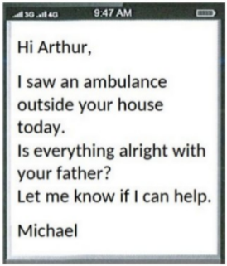
A. He received a message from Arthur's father B. He heard about Arthur's father being ill
C. Arthur called him about an emergency D. He saw an ambulance outside Arthur's house
Câu 5. What is the main reason Emma cannot attend Dorothy's birthday party?
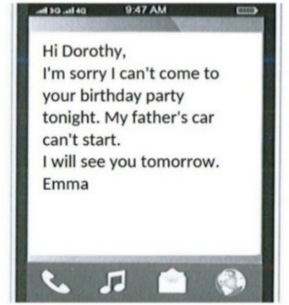
A. She is sick B. Her father's car won't start
C. She forgot about the party D. She has another commitment
Câu 6. What does the sign say?
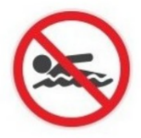
A. No diving B. Swimming is optional here.
C. No swimming D. Swimming is useful here.
Câu 7. What will be available at the end-of-year celebration on December 15 at the Downtown Club?
Please join us for our end-of-year celebration on December 15 at 8 pm at the Downtown Club. We'll have a live DJ, drinks, and appetizers as we celebrate the end of another great year. We hope to see you there!
A. A movie screening and popcorn B. A silent auction and live music
C. A live DJ, drinks, and appetizers D. A fashion show and cocktails
Câu 8. Look at the signs. Choose the best answer for the question.
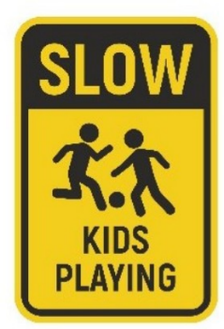
A. Kids should play slowly in the area.
B. Slow down and play with the kids in the area.
C. There may be children in the area, so drive slowly.
D. It’s slow because the kids are playing.
Câu 9. What does it say?
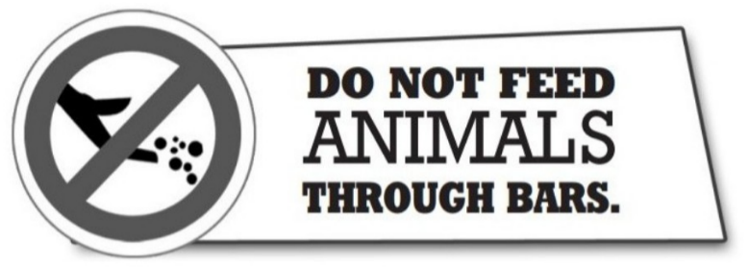
A. Visitors should not get too close to the animals. B. Visitors are a danger to the animals.
C. Visitors must not give food to the animals. D. Visitors can feed animal here.
Câu 10. Which of the following statements is true?
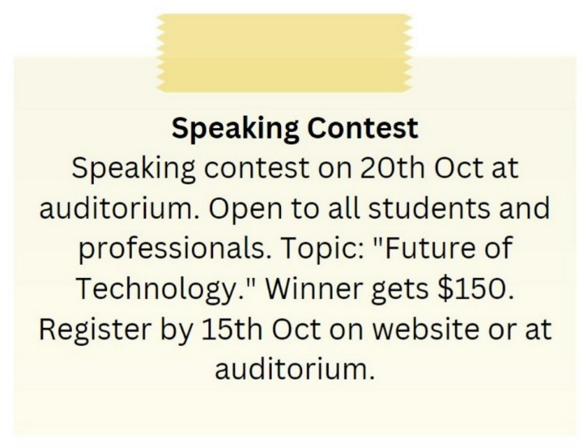
A. The topic of the speaking contest is "Future of Technology."
B. The winner of the speaking contest gets $100.
C. The speaking contest is only open to students.
D. The speaking contest is on 15th October.
----HẾT---

