|  |  |
| --- | --- |
| *Họ và tên: ....................................................*  *Lớp: .............................................................* | PHIẾU GHI BÀI HÓA HỌC 11 CÁNH DIỀU  **Bài 9: PHƯƠNG PHÁP TÁCH BIỆT**  **VÀ TINH CHẾ HỢP CHẤT HỮU CƠ** |

**MỞ ĐẦU**

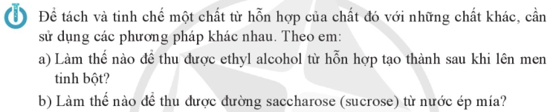

..........................................................................................................................................................................

..........................................................................................................................................................................

**I. PHƯƠNG PHÁP KẾT TINH**

*Nguyên tắc*: ......................................................................................................................................................

..........................................................................................................................................................................

Phạm vi: ...........................................................................................................................................................

..........................................................................................................................................................................

|  |  |
| --- | --- |
|  | .................................................................................................................  .................................................................................................................  .................................................................................................................  .................................................................................................................  .................................................................................................................  .................................................................................................................  ................................................................................................................. |

|  |  |
| --- | --- |
|  |  |

**II. PHƯƠNG PHÁP CHIẾT**

*Nguyên tắc*: ....................................................................................................................................................

|  |  |
| --- | --- |
|  | ............................................................... |
|  | ............................................................... |

|  |  |
| --- | --- |
|  |  |

**III. PHƯƠNG PHÁP CHƯNG CẤT**

*Nguyên tắc*: ....................................................................................................................................................

.........................................................................................................................................................................

.........................................................................................................................................................................

.........................................................................................................................................................................

|  |  |  |
| --- | --- | --- |
|  | |  |
|  | ..................................................................................................................  ..................................................................................................................  ..................................................................................................................  ..................................................................................................................  ..................................................................................................................  .................................................................................................................. | |

|  |  |
| --- | --- |
|  | ................................................................  ................................................................  ................................................................  ................................................................  ................................................................  ................................................................  ................................................................  ................................................................  ................................................................ |

**IV. PHƯƠNG PHÁP SẮC KÍ**

*Nguyên tắc*: ....................................................................................................................................................

.........................................................................................................................................................................

.........................................................................................................................................................................

.........................................................................................................................................................................

.........................................................................................................................................................................

.........................................................................................................................................................................

.........................................................................................................................................................................

.........................................................................................................................................................................

.........................................................................................................................................................................











































