TRƯỜNG THCS .......................  ĐỀ CHÍNH THỨC | ĐỀ KIỂM TRA ĐÁNH GIÁ CUỐI KÌ II  NĂM HỌC 2024-2025  Môn: Tiếng Anh – Lớp 9  Thời gian: 60 phút  (không kể thời gian giao đề)
Họ và tên Lê Thị Nguyệt Tên Zalo: Lê Thị Nguyệt GV
SDT zalo: 0978336017/ 0366.517.015 Email: nguyetthcsthanhhong@gmail.com
I. LISTENING:
Part 1. Listen to the recording/ the conversation and circle the letter A, B, C, or D to indicate the correct answer to each of the following questions. (You will hear the recording TWICE.) (1 point)
Question 1. What must Michael paint first?
A. The wall B. The bicycle C. The chairs D. The table
Question 2. What must Michael wear?
A. Jeans B. Shorts C. Sweater D. Trousers
Question 3. What can Michael eat?
A. Bread and soup B. Chocolate biscuits C. Soup D. Rice
Question 4. Where’s the paint that Michael needs?
A. On the table B. In the cupboard C. In the kitchen D. on the wall

Part 2. Listen to the conversation and state whether the statements below are true (T) or false (F). (You will hear the recording TWICE.) (1 point)
STATEMENTS | T | F
Question 5. The class visit to Sunny Farm will be on Monday.
Question 6. The farmer’s name is Mr. Boyle.
Question 7. The farmer grows flowers.
Question 8. The children will draw vegetables during the visit.

II. PRONUNCIATION
Part 1. Choose the letter A, B, C, or D to indicate the word whose underlined part differs from the other three in pronunciation in each of the following questions. (0.5 point)
Question 9. A. career B. cashier C. fabric D. standard
Question 10. A. downtown B. knowledge C. towel D. power

Part 2. Choose the letter A, B, C, or D to indicate the word that differs from the other three in the position of the primary stress in each of the following questions. (0.5 point)
Question 11. A. national B. monument C. translation D. charity
Question 12. A. traveler B. authentic C. incurious D. correction
III. GRAMMAR AND VOCABULARY
Part 1 Choose the letter A, B, C, or D to indicate the correct answer to each of the following questions. (1.75 points)
Question 13. When the Earth’s average temperature increases, we face__________.
- ecological balance B. global warming C. habitat loss D. nature reserve
Question 14. It takes the Earth, __________is the fifth largest planet in the solar system, about 365 days to complete its orbits around the sun.
- that B. who C. which D. when
Question 15. ___________refer to the plants and animals of a particular place
- Water bodies B. Liquid water C. outer space D. flora and fauna
Question 16. Nowadays we often use __________keyboards because they are portable.
- wireless B. touchscreen C. aluminum D. virtual
Question 17. The children need a piece of ____________to easily cut shapes and make toys.
- rubber B. cardboard C. steel D. 3D printer
Question 18. My friend recommended that I ____________ carefully of my real ability and interests before making a decision about my future career.
- think B. would think C. thought D. thinking
Question 19. The robot is __________a smart vacuum cleaner __________we feel it’s worth the price.
- so- that B. too – that C. enough – that D. such - that
Part 2 Read the following advertisement and choose the letter A, B, C, or D to indicate the correct option that best fits each of the numbered blanks from 20 to 22. (0.75 point)
START A NEW CAREER!
Are you 18 or older? Are you eager to pursue new job opportunities when you can earn a (20) __________and achieve your dreams?
Apply at MNO Professional Training Center for top-notch career training and job placement services:
- No prior background required
- (21) ____________course fees
We suggest (22) ____________ our programs because they offer excellent preparation for new career opportunities:
- Email: enroll@mnoacademy.org

Question 20. A. living B. salary C. money D. life
Question 21. A. Reasoner B. Reason C. Reasonably D. Reasonable
Question 22. A. to explore B. exploring C. explore D. to exploring

IV. READING:
Part 1. Read the following passage and choose the letter A, B, C, or D to indicate the correct option that best fits each of the numbered blanks from 23 to 27. (1.25 points)
In our vast universe, planet Earth is the third planet from the Sun and the only one known to support (23) __________. Its surface is covered by water, with oceans making up about 71% of the Earth's surface. The remaining land is divided into several (24) _________, including continents and islands. Earth has a diverse range of (25) __________, from icy polar regions to lush rainforests. The atmosphere protects living organisms by (26) __________ harmful solar radiation and helping to regulate the planet’s climate. Human activities have significant impacts on the environment, leading to (27) __________ such as climate change and deforestation. These challenges require global cooperation and sustainable practices to ensure the health of our planet for future generations.
Question 23. A. life B. water C. planets D. moons
Question 24. A. cities B. regions C.planets D. oceans
Question 25. A. ecosystems B. machines C. products D. clouds
Question 26. A. reflecting B. ignoring C. blocking D. absorbing
Question 27. A. benefits B. solutions C. problems D. questions

Part 2. Read the following passage and choose the letter A, B, C, or D to indicate the correct answer to each of the questions from 28 to 32. (1.25 points)
Nowadays, more and more people are choosing to use electronic devices to meet their needs for studying, working, and entertainment. Tablets, smartphones, and laptops have all become popular tools in daily life. These devices not only help users connect with each other through social media and chat applications but also support remote learning and working.
Some people can afford to buy the latest electronic devices without financial concerns due to high income or strong financial resources. Meanwhile, many others have to save money or find ways to earn extra income to be able to own these products. For example, they might take on part-time jobs or work on freelance projects to earn additional income.
In addition to using electronic devices for entertainment and study, some individuals also participate in community support programs related to technology. These programs might include teaching programming to children, joining maintenance projects for charity organizations, or helping elderly people learn to use new technologies. These activities not only enhance their skills but also create positive value for the community.
Using electronic devices is not just a part of modern life but also opens many opportunities for learning and contributing to society. For many people, this is a way to develop themselves and connect with the world around them.
Question 28. What could be the best title for the passage?
A. Using Electronic Devices
B. Connecting Through social media
C. Teaching Programming to Children
D. Buying New Technology Products
Question 29. The word “own” in paragraph 2 could be best replaced by _______.
A. Use B. Buy C. Order D. Learn
Question 30. The word “they” in paragraph 2 refers to _______.
A. People participating in technology community programs
B. People with strong financial resources
C. People who save money or work extra to buy devices
D. People choosing to use electronic devices
Question 31. According to the passage, which of the following is TRUE?
A. Electronic devices have no significant impact on modern life.
B. Everyone can easily afford the latest electronic devices.
C. Many people use electronic devices for studying and entertainment.
D. Only rich people can participate in technology community programs.
Question 32. According to the passage, what is perhaps the most important benefit of using electronic devices?
A. They help people learn and develop personal skills.
B. They provide opportunities to do freelance work.
C. They help people buy new technology products.
D. They allow people to connect with others through social media.

V. WRITING
Part 1. Choose the letter A, B, C, or D on your answer sheet to indicate the sentence that is closest in meaning to the sentence given in each of the following questions. (0.5 point)
Question 33. “Why don’t you join our clean-up activities?”, Jane asked me.
A. Jane asked me not to join her clean- up activities.
B. Jane suggested that I should join her clean- up activities.
C. Jane suggested joining our clean- up activities.
D. Jane asked me why I didn’t join her clean- up activities.
Question 34. Although people put more effort into saving planet Earth, it is facing many problems.
A. Although people put more effort into saving planet Earth, but it is facing many problems.
B. People put more effort into saving planet Earth, so it is facing many problems.
C. People put more effort into saving planet Earth because it is facing many problems.
D. People put more effort into saving planet Earth; however, it is facing many problems.
Part 2
Write an email (100- 120 words) to your friend telling him/her about your future/dream job (1.5 points)
These questions may help you:
- What is your favorite future/ dream job?
- What does this job involve?
- What skills does this job need?
- What personalities do you need to have for this job?
Start and end the email as follows
Dear Jim,
____________________________________________________________________________________________________________________________________________________________________________________________________________________________________________________________________________________________________________________________________________________________________________________________________________________________________________________________________________________________________________________________________________________________________________________________________________________________________________________________________________________________________________________________________________________________________________________________________________________________________________________________________________________________________________________________________________________________________________________________________________________________________________________________________________________________________________________________________________________________________________________________________________________________________________________________________________________________________________________________________________________________________________________________________________________________
Write to me soon
Cheers,
Jame
=== THE END ===

Answer key
0.25p for each correct answer
1.C | 2.B | 3.C | 4.B | 5.T | 6.F | 7.T | 8.F | 9.A | 10.B | 11.C | 12.A
13.B | 14.D | 15.A | 16.C | 17.A | 18.D | 19.A | 20.A | 21.D | 22.B | 23.A | 24.B
25.A | 26.C | 27.C | 28.A | 29.B | 30.C | 31.C | 32.A | 33.B | 34.D

V. Part 2 (1,2p)
1. Form:
- Correct form of an email (0.2 point)
2. Task fulfillment:
- Task completed with relevant information (0.2 point)
- Well-organized (0.2 point)
3. Language:
- Accurate grammar (0.2 point)
- Appropriate vocabulary (0.3 point)
- Correct spelling and punctuation (0.1 point)

Điểm của bài kiểm tra trên giấy là 10, sau đó quy đổi về 8 điểm (chiếm 80% tổng số điểm).

Tapescript
Listening 1
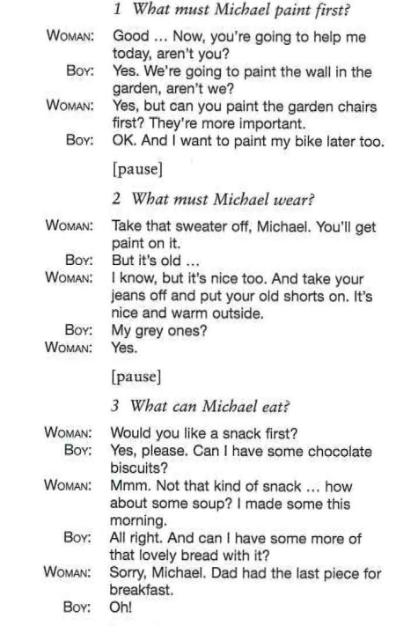 | 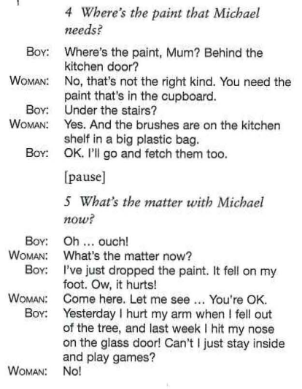
Listening 2

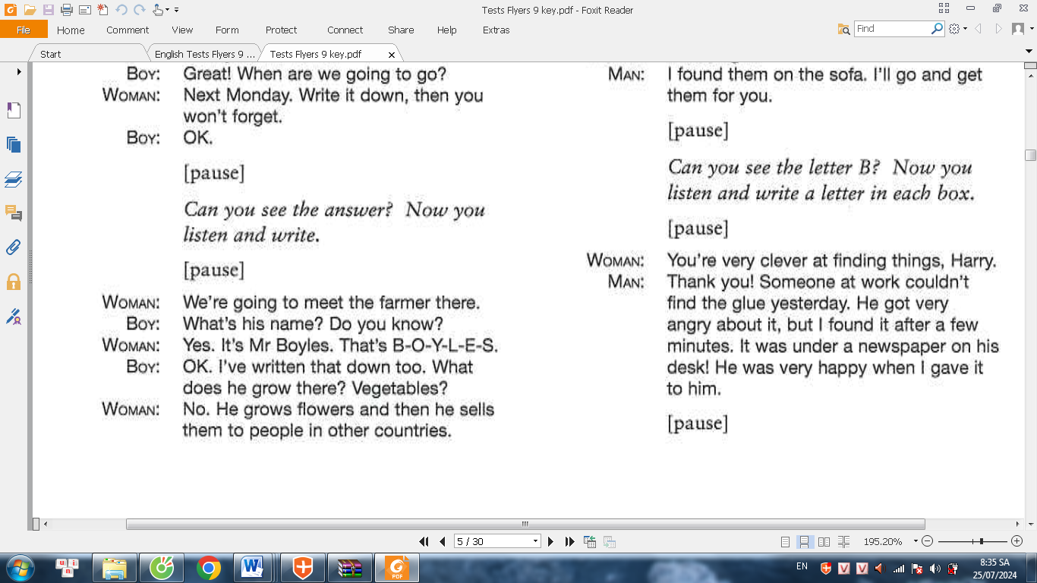 | 