Thời gian làm bài: 40 phút (Không kể thời gian giao đề)
-------------------------
Họ tên thí sinh: .................................................................
Số báo danh: ......................................................................
Mã Đề: 005.
Câu 1. What is true about the Iceland advertisement?
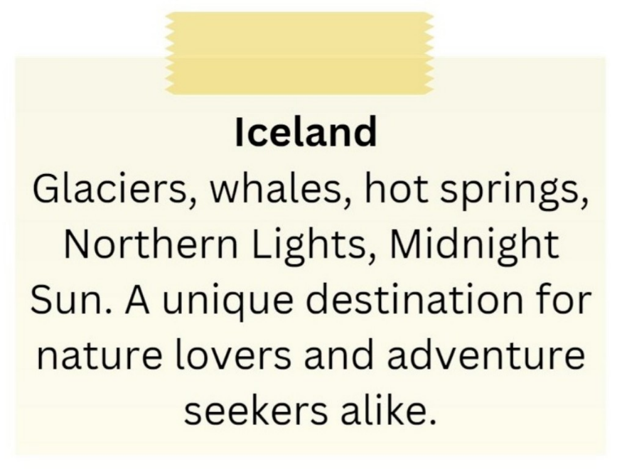
A. It emphasizes tropical beaches and sunbathing.
B. It is exclusively for adventure seekers.
C. It showcases skyscrapers and bustling city life.
D. It includes attractions such as glaciers, whales, hot springs, and the Northern Lights.
Câu 2. Look at the signs. Choose the best answer for the question.

A. You don’t have to run in this area. B. You don’t need to run in this area.
C. Running is not good for you to do. D. You are not allowed to run in this area.
Câu 3. When can students receive a 20% discount at Sam's Café?
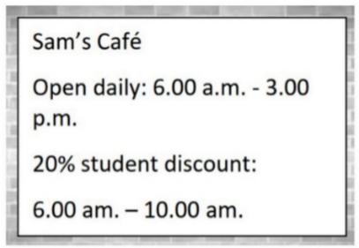
A. After 10:00 a.m. B. From 6:00 a.m. to 3:00 p.m.
C. All day D. From 6:00 a.m. to 10:00 a.m.
Câu 4. What is the main issue mentioned in the notice?
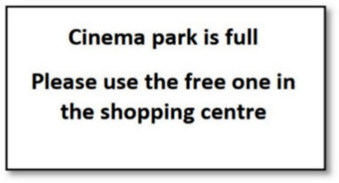
A. There are no free parking spaces B. The shopping centre is closed
C. The cinema park is full D. The cinema is closed
Câu 5. What can customers expect at the new store opening?

A. Exclusive deals and entertainment B. Expensive prices on everything
C. Only fashion items D. No entertainment, only shopping
Câu 6. Which of the following is NOT mentioned as available at the Indoor Market?
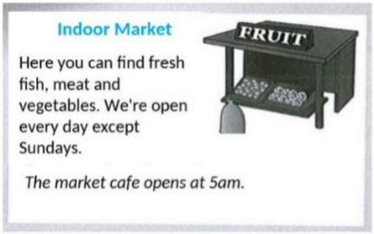
A. Dairy products B. Meat C. Vegetables D. Fresh fish
Câu 7. "What does the person sending the message want to do?"
Hi there! I hope you're doing well. I wanted to see if you're interested in going to a show this weekend. There's a new play that just opened at the local theatre, and I've heard great things about it. Let me know if you're free and we can get tickets together.
A. Go to a show B. Watch a movie C. Visit a museum D. Attend a concert
Câu 8. How long is the flight to France?
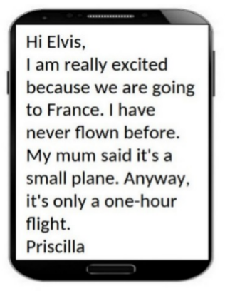
A. 30 minutes B. Three hours C. One hour D. Two hours
Câu 9. Who can participate in this cycle ride?
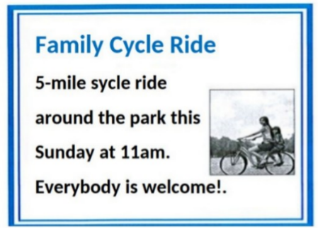
A. Anyone who wants to join B. Only families with children
C. Only park members D. Only experienced cyclists
Câu 10. Where does Rafa suggest meeting Mark instead of the café?
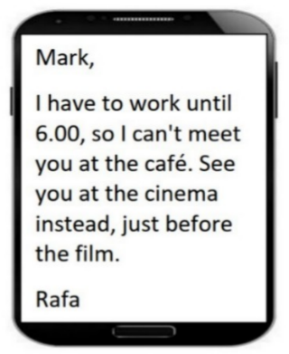
A. At a restaurant B. At work C. At the cinema D. At home
----HẾT---

