Họ và tên: ....................................................  Lớp: ............................................................. | PHIẾU GHI BÀI HÓA HỌC 11 CÁNH DIỀU  Bài 12: ALKANE
MỞ ĐẦU
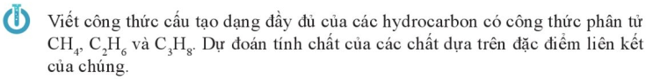
..........................................................................................................................................................................
..........................................................................................................................................................................
..........................................................................................................................................................................
..........................................................................................................................................................................
..........................................................................................................................................................................

I. KHÁI NIỆM VÀ DANH PHÁP
1) Khái niệm
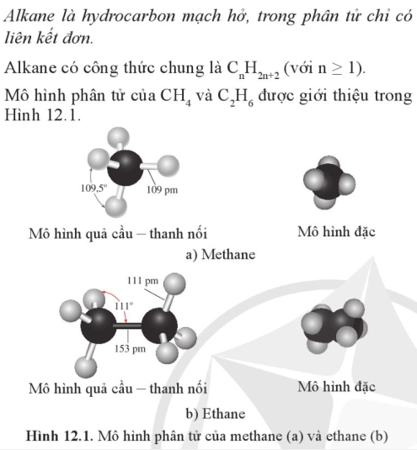 | 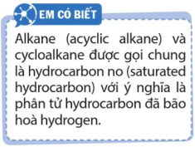  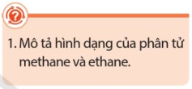  ...............................................................  ...............................................................  ...............................................................  ...............................................................  ...............................................................  ...............................................................
2) Đồng phân
........................................................................................................................................................................
........................................................................................................................................................................
........................................................................................................................................................................
........................................................................................................................................................................
........................................................................................................................................................................
3) Danh pháp
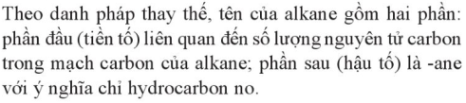  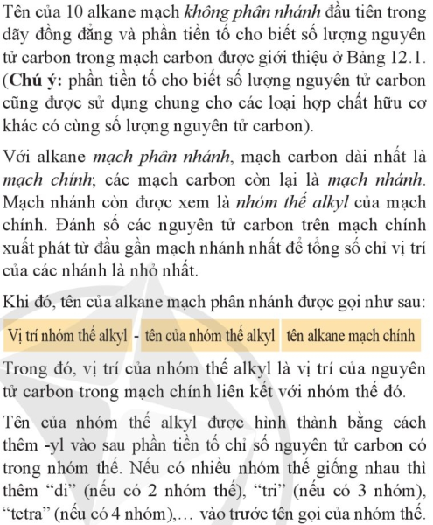 | 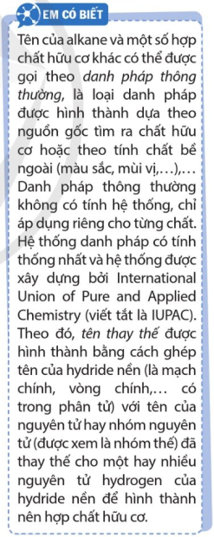  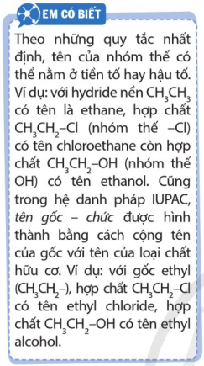  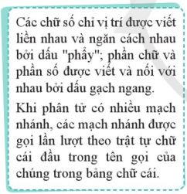
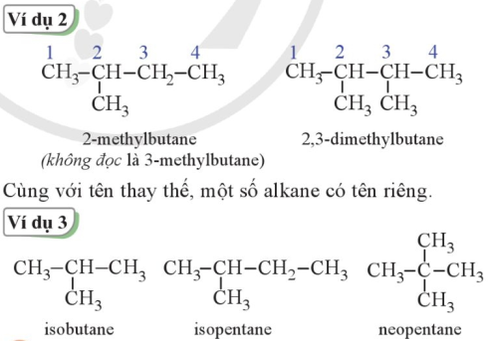
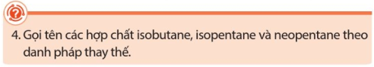
.........................................................................................................................................................................
.........................................................................................................................................................................
.........................................................................................................................................................................
.........................................................................................................................................................................
.........................................................................................................................................................................
.........................................................................................................................................................................
.........................................................................................................................................................................
.........................................................................................................................................................................
.........................................................................................................................................................................
.........................................................................................................................................................................
.........................................................................................................................................................................
.........................................................................................................................................................................
.........................................................................................................................................................................
.........................................................................................................................................................................
.........................................................................................................................................................................
II. TÍNH CHẤT VẬT LÍ
Trạng thái: .......................................................................................................................................................
Nhiệt độ sôi, nhiệt độ nóng chảy, khối lượng riêng: .......................................................................................
Tính tan trong nước: ........................................................................................................................................
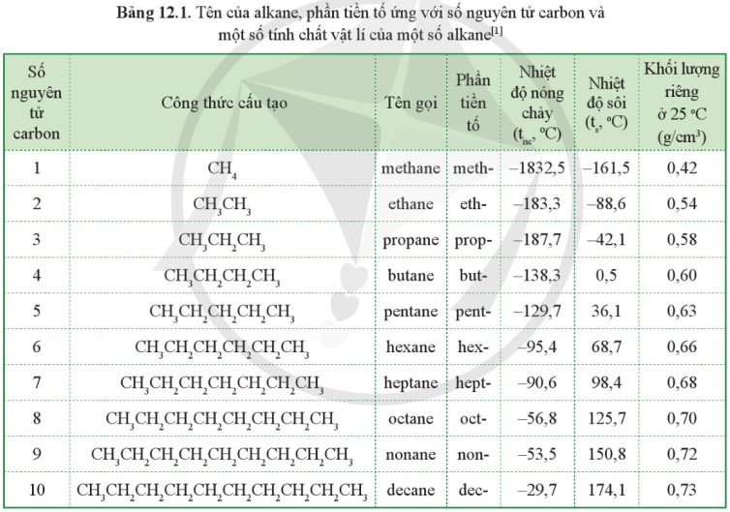
III. TÍNH CHẤT HÓA HỌC
Nêu đặc điểm liên kết trong phân tử alkane? ..................................................................................................
Nhận xét về khả năng phản ứng của alkane? ..................................................................................................
Các phản ứng đặc trưng của alkane? ................................................................................................................
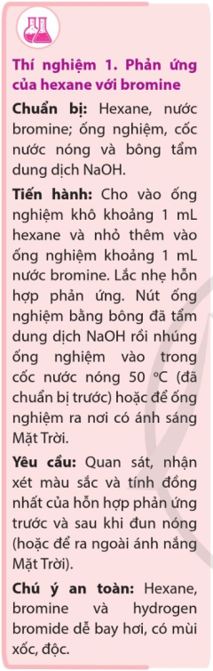 | ...............................................................................................................  ...............................................................................................................  ...............................................................................................................  ...............................................................................................................  ...............................................................................................................  ...............................................................................................................  ...............................................................................................................  ...............................................................................................................  ...............................................................................................................  ...............................................................................................................  ...............................................................................................................  ...............................................................................................................  ...............................................................................................................  ...............................................................................................................  ...............................................................................................................  ...............................................................................................................  ...............................................................................................................  ...............................................................................................................  ...............................................................................................................  ...............................................................................................................  ...............................................................................................................
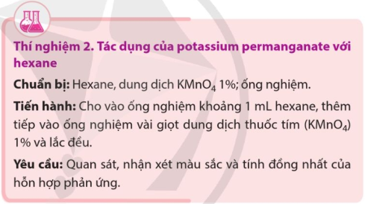 |  | .............................................................  .............................................................  .............................................................  .............................................................  .............................................................  .............................................................  .............................................................  .............................................................

1) Phản ứng thế halogen
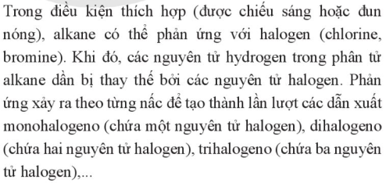
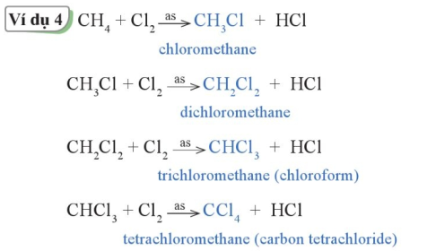
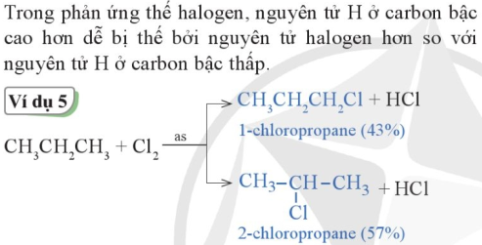 |  | 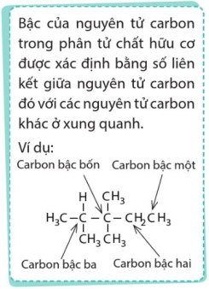
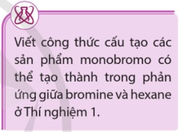 | ..................................................................................................................  ..................................................................................................................  ..................................................................................................................  ..................................................................................................................  ..................................................................................................................

2) Phản ứng cracking và phản ứng reforming
■ Phản ứng cracking  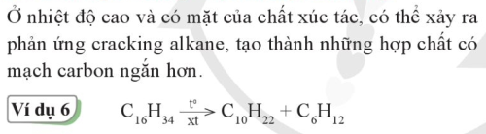 | 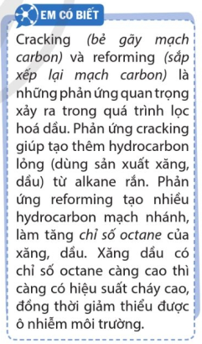
■ Phản ứng reforming
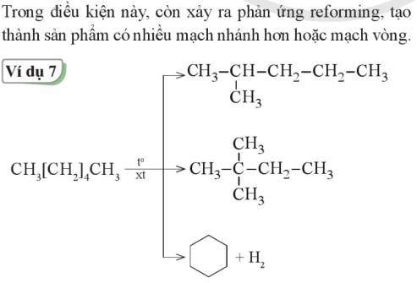
3) Phản ứng oxi hóa
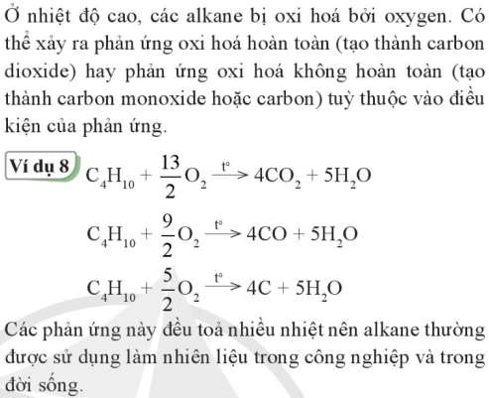 | 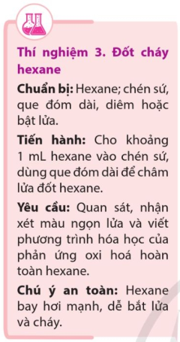

IV. NGUỒN ALKANE TRONG TỰ NHIÊN - ỨNG DỤNG CỦA ALKANE
1) Nguồn alkane trong tự nhiên - Điều chế alkane trong công nghiệp
..........................................................................................................................................................................
..........................................................................................................................................................................
..........................................................................................................................................................................
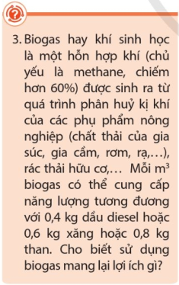 | ..................................................................................................................  ..................................................................................................................  ..................................................................................................................  ..................................................................................................................  ..................................................................................................................  ..................................................................................................................  ..................................................................................................................  ..................................................................................................................  ..................................................................................................................  ..................................................................................................................
2) Ứng dụng
..........................................................................................................................................................................
..........................................................................................................................................................................
..........................................................................................................................................................................
3) Nhiên liệu và môi trường
..........................................................................................................................................................................
..........................................................................................................................................................................
..........................................................................................................................................................................
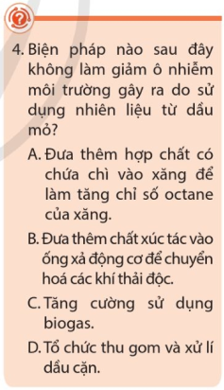 |                 

