**Tourism, travel, transport**

**Task 1.** **Listen to six recordings about holidays and match them with the photos (A-E). Which recording does not have a photo? Write your answers in the given spaces.**

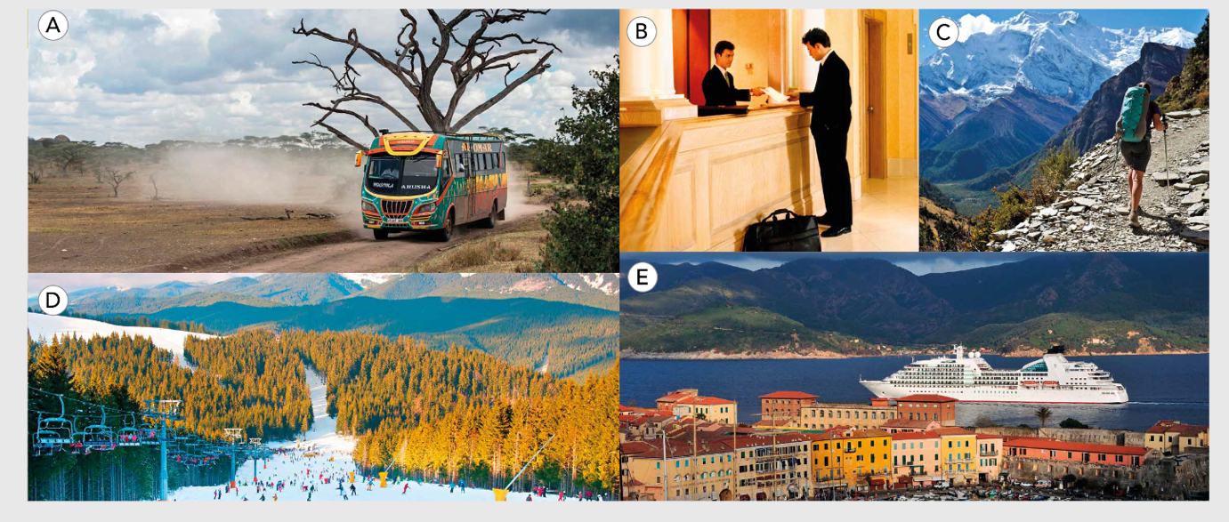

Photo A: Recording ______________ Photo B: Recording ______________

Photo C: Recording ______________ Photo D: Recording ______________

Photo E: Recording c

*Recording ______________ doesn’t have a photo.*

**Task 2: Listen to the recordings again. For questions 1–6, choose the correct answer, A, B or C.**

**1**. The speaker thinks her sister is ______________.

**A.** selfish **B.** stupid **C.** boring

**2**. The man wants to spend the night ______________.

**A.** in a youth hostel **B.** in a three-star hotel **C.** in a tent

**3.** Mr Baker ______________.

**A.**  has to pay for one breakfast

**B..** has to pay for two breakfasts

**C** has already paid for two breakfasts

**4**. Skiers in Megève ______________.

**A.** couldn't ski last week because of the rain

**B.** have nothing to do in Megève when they can't ski

**C.** have good skiing conditions in Megève now

**5**. The advert is for ______________.

**A.** a beach holiday **B.** a travel company **C.** a job of tour leader

**6**. The mother ______________.

**A.** doesn't want her daughter to go away.

**B.** is worried about the dangers of travelling alone.

**C.** wants her daughter to go to Canada only.

**ANSWER KEY**

**Task 1.**

Photo A: Recording 5 Photo B: Recording 3

Photo C: Recording 6 Photo D: Recording 4

Photo E: Recording 1

*Recording 2 doesn’t have a photo.*

**Task 2.**

**1. A 2. C 3. A**

**4. C 5. B 6. B**

***AUDIO SCRIPT*** (Recording 1.42)

**1**

A: So, how was your family cruise?

B: Oh, it was okay. Pretty good really. We saw some amazing places, and considering we were with our parents, we all got on well most of the time. We didn't have any arguments. Well, not until the last day, and then I had a really big argument with my sister. It was stupid really. I wanted to get off the ship and visit Naples. I've never been there before and I thought it was a perfect opportunity to see somewhere new. But my sister was tired and wanted to stay on the ship by the pool. We tried to persuade her to come with us, but she always does what she wants, and she doesn't think of other people. I had to go to Naples on my own with our parents. It was really boring.

**2**

A: I just don't think we should stay here. It's not a very nice campsite and the weather's awful. I really think we should go and find a budget hotel.

B: A budget hotel? I can't believe you said that. That's so boring and this is supposed to be an adventure.

A: I know, and I've really enjoyed it so far. I want to have an adventure, I really do. But putting a tent up in this weather is horrible. Everything's going to be wet.

B: It's raining a bit, but we'll be lovely and warm in the tent. It's going to be more comfortable than a three-star hotel, I promise.

**3**

A: Yes, can I help you?

B: Er yes, I've booked a single room for two nights. My name's Baker. James Baker.

A: Baker. Yes, here you are. Two nights. Is it a business trip?

B: Yes, it is.

A: Would you like breakfast?

B: Oh, yes please.

A: That will be an extra £16.

B: Oh, I thought it was included.

A: Did you book online?

B: Yes, I did.

A: Oh, right. We have an online special offer at the moment. Your first breakfast is free, so you just need to pay for the second day. Can you fill in this form please?

**4**

A: For today's ski update, we go over to Mary Eden in the French Alps.

B: Thank you. Yes, I'm here in the wonderful French Alps, beneath Mont Blanc. I'm in the village of Megeve, one of the oldest ski resorts in the world. The weather is perfect today but last week we had a few warm rainy days when skiing was not much fun. But it's impossible to be disappointed with Megeve – there are so many different things to do here. There are more than ninety restaurants and cafés. Fortunately, the rain has turned to snow. It's time to get out of the cafés and go skiing.

**5**

It's time to leave package holidays behind and take a trip that you will remember for the rest of your life. With Overland Tours you will see the real world. Overland Tours believe that travelling is not only about the destination. The bus journey is an important part of the experience. Come with us on one of our Overland buses and travel to places other travel companies don't reach. You will meet local people and learn about their culture. Our tour leaders will take care of you and make sure you have everything you need. Come and join an Overland Tour. You'll be in a small group, but we can guarantee that you'll have big experiences.

**6**

You're too young to go backpacking on your own. You've never been abroad before – you have no idea what to expect. You might not like it – you'll probably be lonely. And anything could happen – you could get ill, or somebody could steal your money. I know you want to get away and have new experiences, but I'd feel much happier if you were with friends. You could stay with your aunty Margaret in Canada, or your penfriend in France. I just don't understand why you want to go trekking in Nepal on your own.