Thời gian làm bài: 40 phút (Không kể thời gian giao đề)
-------------------------
Họ tên thí sinh: .................................................................
Số báo danh: ......................................................................
Mã Đề: 037.
Câu 1. Look at the signs. Choose the best answer for the question.

A. This voucher is used to buy two meals.
B. You can pay less for your meals with this voucher.
C. Without this voucher, you cannot buy meals.
D. You must use this voucher to pay for your meals.
Câu 2. What does this sign mean?
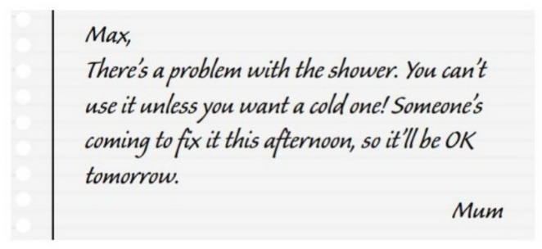
A. Max can take a hot shower now. B. Max can only have hot shower tomorrow.
C. Mum needs Max to fix the shower. D. Someone helped Max fix the shower.
Câu 3. What can be inferred about the new location of the post office?
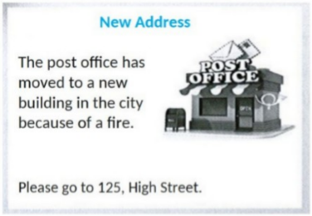
A. It's in a shopping mall B. It's on High Street in the city
C. It's in a rural area D. It's in a residential neighborhood
Câu 4. Where does Rafa suggest meeting Mark instead of the café?
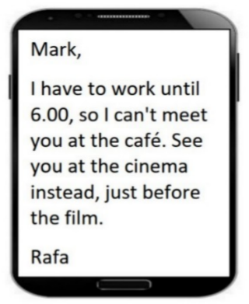
A. At a restaurant B. At home C. At work D. At the cinema
Câu 5. Look at the signs. Choose the best answer for the question.
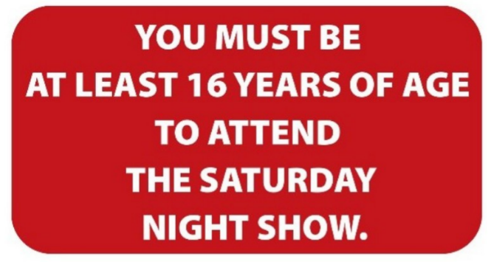
A. Children under 16 years old cannot watch any shows on Saturday.
B. If you are over 16 years old, you must watch the Saturday Night Show.
C. Nobody under the age of 16 will be allowed into the Saturday Night Show.
D. The Saturday Night Show is now 16 years old.
Câu 6. Look at the signs. Choose the best answer for the question.
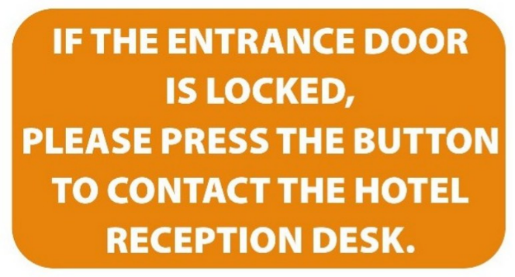
A. Use this button to call the hotel staff when you can’t get in.
B. You need to contact the receptionist if you cannot lock the door.
C. Contact the hotel reception if you want to press the button.
D. When the entrance door is locked, press the button to open it.
Câu 7. What are students asked to do after using the kitchen?
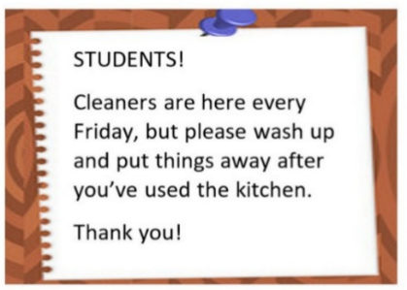
A. Call the cleaners B. Deep clean the entire kitchen
C. Leave everything as it is D. Wash up and put things away
Câu 8. Why is the Chess club changing its meeting location?
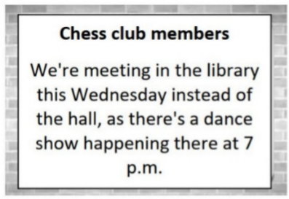
A. The chess tables are in the library B. The library is more spacious
C. There's a dance show in the hall D. The hall is being renovated
Câu 9. What did the person run out of?
“Hi, I hope your day is going well. I ran out of notebook paper and I have a lot of notes to take in class today. Would it be possible for me to borrow some paper from you? I’ll make sure to return the favor if you ever need anything. Thank you!”
A. Eraser B. Ruler C. Notebook paper D. Pencil
Câu 10. What subject does John need help with?
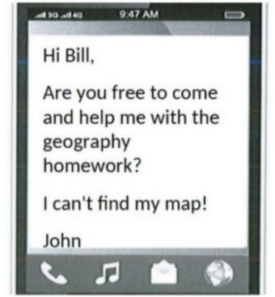
A. Geography B. History C. English D. Math
----HẾT---

