Date of preparing: ………………………………….
Date of teaching: ………………………………….

Period …
UNIT 5: AROUND TOWN
Lesson 1 - Part 2 (Page 39) - Grammar

I. OBJECTIVES
By the end of the lesson, Ss will be able to…
1. Knowledge
- use demonstratives and object pronouns.
2. Ability
- improve speaking skills.
- improve the use of English.
3. Quality
- have positive attitude in English language learning so that they actively participate in all classroom activities.

II. TEACHING AIDS AND LEARNING MATERIALS
Lesson plan, PPT slides, student’s book, workbook, notebook, personal computer (if any), projector/TV, speakers, DCR & DHA on Eduhome, handouts

III. PROCEDURES
A. Warm up: (5’)
a) Objective: Introduce the new lesson and set the scene for Ss to acquire new language; get students' attention at the beginning of the class by means of enjoyable and short activities as well as to engage them in the steps that follow.
b) Content: Unit of currency / vocabularies about clothes
c) Product: Ss review vocabularies about home or Ss have general ideas about the grammar point they are going to study in the new lesson.
d) Competence: collaboration, communication, critical thinking.
e) Organization of the activity:
Teacher’s Activities | Students’ Activities
- Give greetings  - Check attendance  - Option 1: Units of Currency  - Have Ss write name of the country / region in the box under each unit of currency  - Call Ss to give answers  - Check Ss’ answers, give feedback  - Have Ss read the units of currency, help them pronounce the units of currency correctly  - Lead to the new lesson    - Option 2: Vocabularies about clothes  - Have Ss give names of the clothes  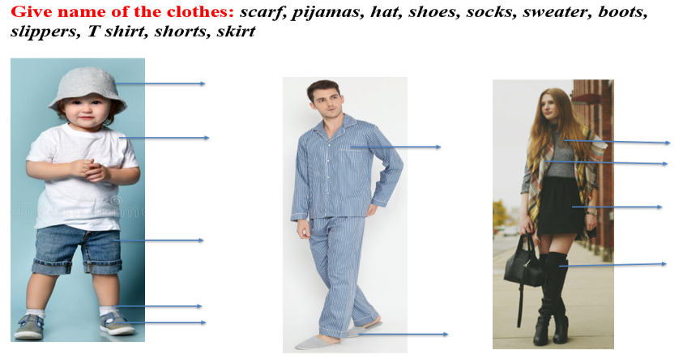  - Help Ss pronounce the words correctly  Lead to the new lesson. | - Greet T  - Work in pairs  - Give answers  - Read  Answers keys    Read the units of currency  1. England: pound  2. Japan: Yen  3. Korea: Won  4. The USA: dollar  5. Europe: Euro  6. Malaysia: Ringgit (Ringgit Malaysia)  - Work in groups to give name of these clothes  Answers keys  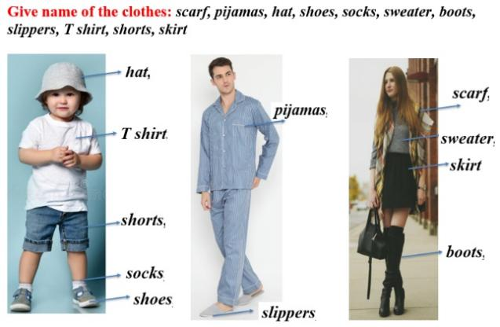  - Pronounce words  - Listen

B. New lesson (35’)
- Activities 1: Grammar: Demonstratives and Object Pronouns “it” / “them” (17’)
a) Objective: Ss know how to use Demonstratives and Object Pronouns “it” / “them”
b) Content:
- The usage of Demonstratives and Object Pronouns “it” / “them”
- Listening and repeating
c) Products: Ss can use Demonstratives and Object Pronouns in everyday communication.
d) Competence: communication, collaboration, presentation, creativity
e) Organization of the activity:
Teacher’s Activities | Students’ Activities
a. Listen and repeat  - Have Ss look at the picture  - Play audio (CD1 – Track 57) and have Ss listen and read the speech bubbles  - Play audio again and have Ss listen and repeat.  Grammar box  - Option 1:  - Have Ss look at the grammar explanation  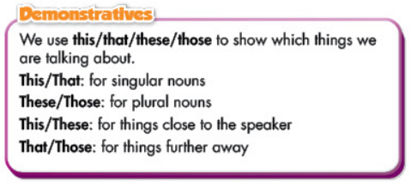  - Have Ss look at the box with the different forms    - Explain more about demonstrative: this, that, these, those, using objects around the class  - Explain: Asking about price:  How much is / are …?  What is the price of …?  How much does + name of clothe + cost?  - Have Ss look at the Object Pronoun “it”, “them”  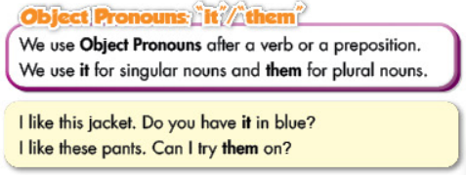  - Have some Ss read the sentences in the Grammar Box aloud  - Ask Ss to give more examples using demonstratives and object pronouns “it”, “them”  - Option 2:  - Have Ss close books  - Give some model sentences, explain demonstratives this, that, these, those, using things around the class  - Call Ss to give answers, give feedback  - Then, have Ss open their books and look at the questions in the speech bubbles, ask Ss to make comments on the way the girls use to ask and answer about the price.  - Let Ss read the grammar box  - Have Ss give more examples of demonstratives and object pronouns “it”, “them”, encourage Ss to make sentences with their own ideas.  - Give feedback and evaluation | - Look  - Listen, then read  - Listen and repeat  - Look and read  - Read  - Listen and take notes  - Read  - Give examples  - Close all books  - Look and answer  - Read  - Give examples
- Activity 2: Practice (18’)
a) Objective: Ss can do some exercises, using demonstratives and object pronouns “it”, “them”
b) Content: practice of using demonstratives and object pronouns “it”, “them” correctly
c) Products: Ss can apply the grammar point in everyday communication.
d) Competence: collaboration, communication, analytical skill, presentation, creativity.
e) Organization of the activity:
Teacher’s Activities | Students’ Activities
b. Read the sentences. Circle the correct words  - Demonstrate the activity, using the example  - Have Ss read the sentences and circle the correct words  - Have Ss work in pairs to check each other’s work  - Have some Ss share their answers with the whole class  - Check, correct Ss’ answers  c. Complete the dialogue with this, those, it or them  - Demonstrate the activity, using the example  - Have Ss read the dialogue, then complete it with this, those, it or them  - Have Ss work in pairs to check each other’s work  - Have some Ss share their answers with the whole class  - Check, correct Ss’ answers  d. Practice the conversation with your partner  - Option 1:  - Have Ss do the task in pairs, then swap the roles  - Call Ss to demonstrate the activity in front of the class  - Give feedback and evaluation  - Option 2:  - First, follow the same steps as option 1  - Then, have Ss role-play: Buying clothes in a clothing store (choosing clothes, asking about prices, …)  - Encourage Ss to use phrases to start a conversation to offer help and use their own ideas to make the conversation more interesting and natural  - Call Ss to demonstrate the activity in front of the class  - Give feedback and evaluation | - Look and listen  - Work individually  - Work in pairs  - Read answers  Answer keys  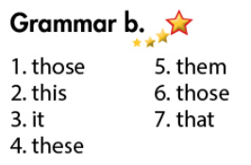  - Look and listen  - Work individually  - Work in pairs  - Read answers  Answer keys  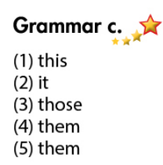  - Work in pairs  - Present  - Work in pairs  - Present

C. Consolidation (3’)
* Demonstratives:
This / That: for singular nouns
These/Those: for plural nouns
This / These: for things close to the speaker
That / Those: for things further away to the speaker
* Asking about price:
How much is / are …?
What is the price of …?
How much does + name of clothe + cost?

*Object pronouns:
“it” for singular nouns. “them” for plural nouns

D. Homework (2’)
- Make 3 sentences, use the demonstratives and object pronouns.
- Do exercise in Work Book: Lesson 1 - Grammar (page 27).
- Prepare: Lesson 1 – Pronunciation and Speaking (page 40 – SB).

