|  |  |  |
| --- | --- | --- |
| Phòng GD&ĐT TP Hà Tiên  Trường Tiểu học Thuận Yên  Lớp:..................................................................  Họ và tên:……………………………………. | | Bài kiểm tra cuối học kỳ I  Năm học: 2021 – 2022  Môn: Tiếng Anh  Khối: 4 - Thời gian: 40 phút  Ngày kiểm tra:…………………… |
| Điểm | Nhận xét của giáo viên | Chữ ký giám thị:……………………  Chữ ký giám khảo: ………….…….. |

**Part 1: Questions 1 – 4: Read and circle** (Đọc và khoanh tròn tranh tương ứng cuộc hội thoại ). **(1.0 marks)**

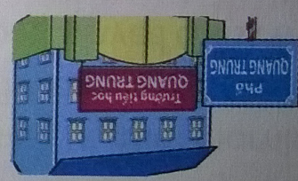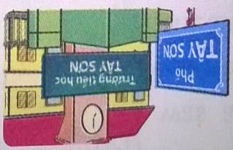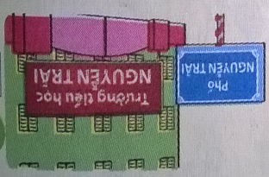1. Quan: What's the name of your school, Daisy?  
    Daisy: Nguyen Trai Primary School.  
    Quan: Where is it?  
    Daisy: It's in Nguyen Trai Street.

2. Miss Hien: Hello, class.  
    Class: Hello, Miss Hien.  
    Miss Hien: What day is it today?  
    Class: It's Thursday.  
    Miss Hien: That's right! Let's start our lesson.

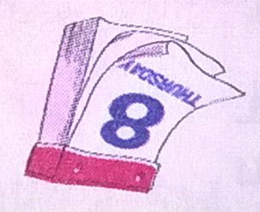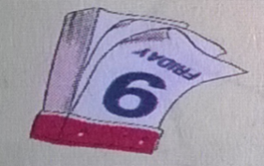

a...

b. ...

c.

c.

b. ...

a...

3. Mai: What day is it today, Nam?  
    Nam: It's Tuesday.  
    Mai: What subjects do you have today?  
    Nam: I have Maths, Music and English.

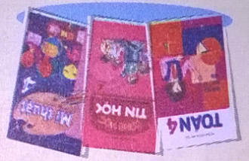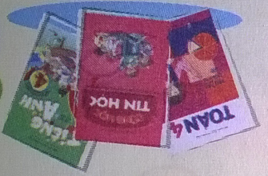

a...

b. ...

c.

4. Quan: Where's Nam?  
    Mai: He's in the classroom.  
    Quan: What's he doing?  
    Mai: I think he's reading a book.

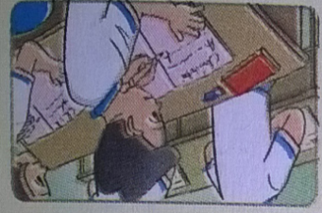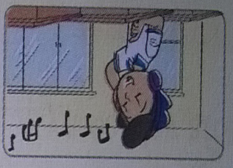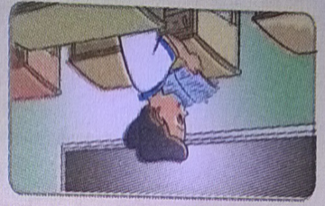

a...

b. ...

c.

**Part 2: Read and number.**(Đọc các câu và đánh số cho phù hợp với các hình ) **(1.0 marks)**

It is break time now.  
1. The boys are playing football.  
2. The girls are playing badminton in the playground.  
3. The girls are making a kite.  
4. They have Maths, Vietnamese and Art.

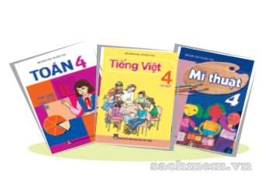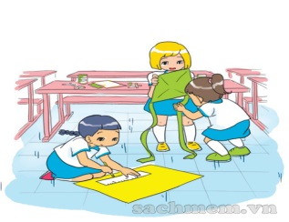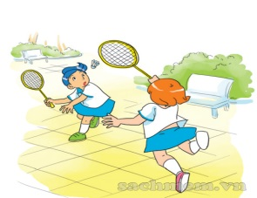

a

b

ca

dD

**Part 3: Read and choose the correct answers:** (Đọc và chọn đáp án đúng) **(1.0 marks)**

1. What class are you in?
2. I am in class 4/1.
3. I am on class 4/1.
4. You are in class 4/1.
5. Are they having an Art lesson?
6. Yes, I do.
7. Yes, they are.
8. Yes, there are.
9. What did they do yesterday?
10. They played football.
11. They play football.
12. They are playing football.
13. Do you have Music today?
14. No, I do.
15. Yes, I don’t.
16. Yes, I do.

**Part 4: Read and tick: *(*✓*)***(Đọc và đánh dấu✓vào ô đúng (T) và sai (F) ) **(2.0 marks)**

Hi, My name is Peter. I study at Oxford Primary School. It is in Oxford Street, London. I go to school from Monday to Friday. At school, I have English, Maths, Science, Music, Art, PE, IT. Music is my favourite subject.

It was Sunday yesterday. I was at home. In the morning, I played games with my friends on the Internet. In the afternoon, I played football. In the evening, I watched TV. I went to bed early.

|  |  |  |
| --- | --- | --- |
| ***Sentences:*** | ***True ( T )*** | ***False ( F )*** |
| ***0)Peter studies at Oxford Primary School.*** | **✓** |  |
| 1)I go to school from Monday to Friday. |  |  |
| 2) English is my favourite subject. |  |  |
| 3) It was Sunday yesterday. |  |  |
| 4) In the morning, I played football. |  |  |

**Part 5: Write**(Viết) **(1.0 marks)**

1. ***Where are you from? I’m from Viet Nam.***
2. What’s the name of your school? ________________________________
3. What’s your hobby? . _________________________________________
4. What subjects do you have today? _______________________________
5. When’s your birthday? ________________________________________

**Part 6:** **Arrange the following words to make meaningful sentences and circle**: (Sắp xếp những từ sau thành câu có nghĩa và khoanh tròn đáp án đúng) **(2.0 marks)**

1. is/ she/ What/ class/ in?
2. What is class she in?
3. What she is class in?
4. What class is she in?
5. is/ Who/ teacher?/ English/ your
6. Who is English your teacher?
7. Who is your English teacher?
8. Who English is your teacher?
9. like/ I/ to/ listening/ music.
10. I like listening to music.
11. I like to listening music.
12. I to like listening music.
13. were/ you/ Where/ yesterday?
14. Where were yesterday you?
15. Where were you yesterday?
16. Where you were yesterday?

The end

**ĐÁP ÁN MÔN TIẾNG ANH KHỐI 4 KHI**

**READING**

**Part 1: Questions 1 – 4: Read and circle** (Nghe và khoanh tròn ). **(1 đ)**

1.d 2.b 3.a 4.c

**Part 2: Read and number**. (Nghe và đánh số)**(1 đ)**

a 4 b 2 c 3 d 1

**Part 3: Read and choose the correct answers:**(Đọc và chọn đáp án đúng.)(**1 đ**)

1. a 2. b 3.a 4.c

**Part 4: Read and tick: *(*✓*)*** (Đọc và đánh dấu✓vào ô đúng và sai ) (**2 đ**)

1.T 2. F 3.T 4. F

**Part 5: Write**(Viết) (**1 đ**)

1.It’s Thuan Yen Primary School

2.I like *taking photo/ riding a bike/ playing badminton/flying a kite…*

3. I have *Maths, Vietnamese, Music, PE, IT, English, ....*

4. It’s on *the first of January, ....*

**Part 6: Arrange the following words to make meaningful sentences and circle:** (Sắp xếp những từ sau thành câu có nghĩa và khoanh tròn đáp án đúng) (**2 đ**)

1. c. What class is she in?

2. b. Who is your English teacher?

3. a. I like listening to music.

4. b. Where were you yesterday?

|  |  |  |
| --- | --- | --- |
| * Where a school is * Someone likes doing/ someone’s hobbies * School subjects * What someone is doing * Where someone was in the past | Where is your school?  It’s in ……  What class are you in?  I’m in class…………  What do you like doing?  I like…….  What’s your hobby?  I like………  What subjects do you have?  I have………  What’s he/she doing?  He’s/she’s……  What are they doing?  They’re……..  Where were you yesterday?  I was ….  What did you do yesterday?  I + verb-ed | Street, road,village,district, address, class, school, study.  Swimming, cooking, collecting stamps, riding a bike, playing badminton, flying a kite, taking photographs, watching TV  Subject, IT(information Technology), Maths, Music, Art, Science, Vietnamese, PE( Physical Education)  Listen to music, read, write, paint, make, watch, video, text, dictation, mask, plane, puppet, exercise  Yesterday, at home, at school, at the zoo, on the beach, in the school library, wash, water |

**MA TRẬN ĐỀ MÔN TIẾNG ANH KHỐI 4 HKI**

**Liệt kê các chủ đề, cấu trúc và từ vựng cần kiểm tra**

**Lựa chọn các nhiệm vụ đánh giá, phân chia kiến thức ngôn ngữ vào các nhiệm vụ đánh giá, số câu, tỉ lệ mức độ nhận thức, số điểm.**

|  |  |  |  |  |  |
| --- | --- | --- | --- | --- | --- |
| **Kĩ năng** | **Nhiệm vụ đánh giá/ kiến thức cần đánh giá** | **Tổng số câu, số điểm, tỉ lệ %** | | | |
| **M1**  Nhận biết | **M2**  Kết nối | **M3**  Vận dụng |  |
| Reading | **Read and circle**  School, days, subjects, someone’s doing | 2  0. 5đ | 1  0.25đ | 1  0.25đ | 8 câu  2đ  20% |
| **Listen and number**  Subjects, What someone is doing | 1  0.25đ | 2  0.5đ | 1  0.25đ |
| **Read and circle**  Subjects, days, where someone was in the past | 1  0.25đ | 2  0. 5đ | 1  0.25đ | 8 câu  3đ  30% |
| **Read and tick**  Where someone was in the past | 1  0.5đ | 2  1 đ | 1  0.5đ |
| Writing | **Write about school subjects, birthday and hobby** | 2  0.5 đ | 1  0.25 đ | 1  0.25đ | 8câu  3đ  30% |
| **Arrange the following words to make meaningful sentences.**  Someone like doing, subjects, school, where someone was in the past | 2  1đ | 1  0.5đ | 1  0.5đ |
| Speaking | **Getting to know each other** | 2  0.5 đ |  |  | 8 câu  2đ  20% |
| **Talking about school** | 1  0.25đ | 1  0.25đ | 1  0.25đ |
| **Describing picture** | 1  0.25đ | 1  0.25đ | 1  0.25đ |