|  |  |
| --- | --- |
|  |  |

**Họ tên thí sinh: .................................................................**

**Số báo danh: ......................................................................**

**Mã Đề: 018.**

**Câu 1.** When was the sports bag found?

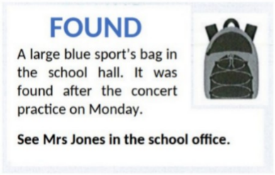

**A.** Before the concert practice  **B.** During the concert practice

**C.** After the concert practice  **D.** The next day after the practice

**Câu 2.** **Look at the signs. Choose the best answer for the question.**

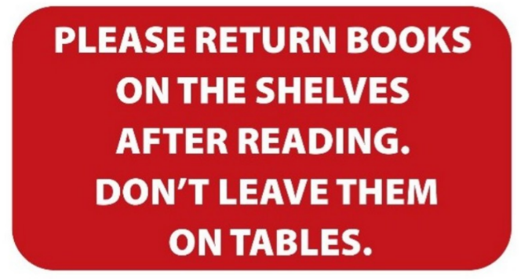

**A.** You need to put the books both on the table and the shelves.

**B.** After you finish reading, you have to put the books back on the shelves.

**C.** You can leave books either on the shelves or on the tables.

**D.** Books should be left on the tables instead of the shelves.

**Câu 3.** **Look at the signs. Choose the best answer for the question.**

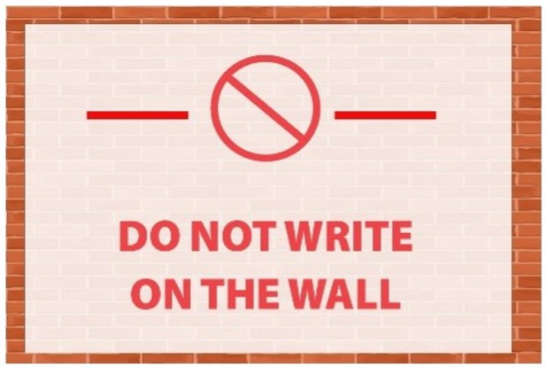

**A.** Writing on the wall is not possible.  **B.** You are not allowed to write on the wall.

**C.** You needn’t write on the wall.  **D.** You don’t have to write on the wall.

**Câu 4.** What made Michael send this message to Arthur?

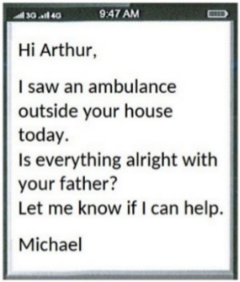

**A.** He received a message from Arthur's father  **B.** He heard about Arthur's father being ill

**C.** Arthur called him about an emergency  **D.** He saw an ambulance outside Arthur's house

**Câu 5.** What is the main reason Emma cannot attend Dorothy's birthday party?

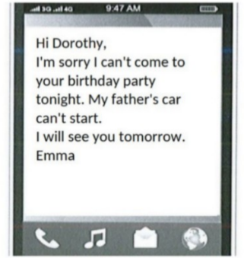

**A.** She is sick  **B.** Her father's car won't start

**C.** She forgot about the party  **D.** She has another commitment

**Câu 6.** What does the sign say?



**A.** No diving  **B.** Swimming is optional here.

**C.** No swimming  **D.** Swimming is useful here.

**Câu 7.** What will be available at the end-of-year celebration on December 15 at the Downtown Club?

Please join us for our end-of-year celebration on December 15 at 8 pm at the Downtown Club. We'll have a live DJ, drinks, and appetizers as we celebrate the end of another great year. We hope to see you there!

**A.** A movie screening and popcorn  **B.** A silent auction and live music

**C.** A live DJ, drinks, and appetizers  **D.** A fashion show and cocktails

**Câu 8.** **Look at the signs. Choose the best answer for the question.**

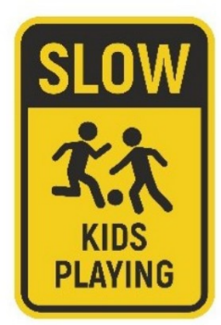

**A.** Kids should play slowly in the area.

**B.** Slow down and play with the kids in the area.

**C.** There may be children in the area, so drive slowly.

**D.** It’s slow because the kids are playing.

**Câu 9.** What does it say?

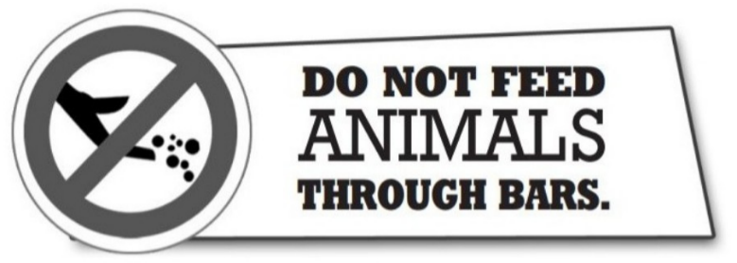

**A.** Visitors should not get too close to the animals.  **B.** Visitors are a danger to the animals.

**C.** Visitors must not give food to the animals.  **D.** Visitors can feed animal here.

**Câu 10.** Which of the following statements is true?

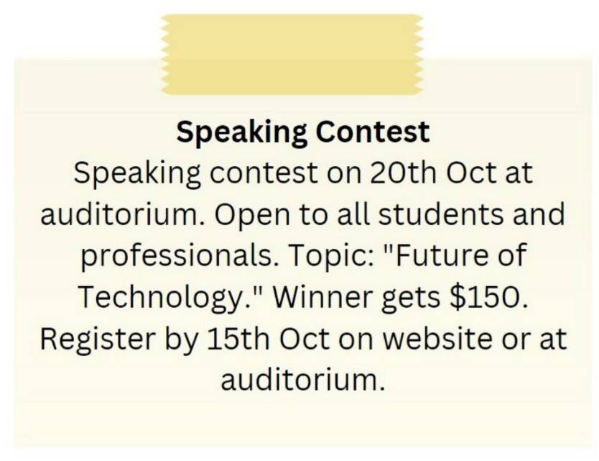

**A.** The topic of the speaking contest is "Future of Technology."

**B.** The winner of the speaking contest gets $100.

**C.** The speaking contest is only open to students.

**D.** The speaking contest is on 15th October.

**----HẾT---**