Week:  Period: | Date of planning:  Date of teaching:

UNIT 12: LIFE ON OTHER PLANETS

Lesson 3: A closer look 2
I. OBJECTIVES
By the end of this lesson, Ss will be able to:
1. Knowledge
- Use reported speech to report questions.
2. Competences
- Be collaborative and supportive in pair work and team work
- Actively join in class activities
3. Personal qualities
- Be encouraged to know more about Life on other planets.
- Develop self-study skills
II. MATERIALS
- Grade 8 textbook, Unit 12, Getting started
- Computer connected to the Internet
- Projector / TV/ pictures and cards
- Phần mềm tương tác hoclieu.vn
III. PROCEDURES
1. WARM-UP (5 mins)
a. Objectives:
- To create an active atmosphere in the class before the lesson
- To lead into the new unit.
b. Content:
- review the changes of words in reported speech, introduce about reported speech
c. Expected outcomes:
- Ss have general ideas about the grammar.
d. Organisation

TEACHER’S AND STUDENTS’ ACTIVITIES | CONTENTS
- Teacher helps Ss play game: Find your partner  Devide class into three groups, give each student in each group a word related to verb tenses, place expressions,time expressions, pronouns  - Teacher asks Ss find their partner in their group. For example: to night – that night  - Ss do the task in groups  Which group finishes first will be winner  - Leading: Ask Ss: “ Who is winner?” – Group …  Ask Ss: What have I asked?.  T write Ss’ answer on the board : “ Who was winner”  - Tell Ss:Last lesson, we studied what someone said. Today, we will study how to tell what someone asked another. | Answer:  Now – Then  Tonight – That night  Today – That day  Tomorrow – the following day  Next… – The next…  Yesterday – the day before  …..ago - …….before  Here – There  This – That  These - Those
2. ACTIVITY 1: PRESENTATION (7 mins)
a. Objectives:
- To help Ss use the appropriate adverbs, verb tenses, word order in reported questions.
b. Content:
- Underline correct words or phrase for each sentence.
c. Expected outcmes:
- Ss understand how to use reported speech (questions) correctly.
d. Organisation

TEACHER’S AND STUDENTS’ ACTIVITIES | CONTENTS
Task 1: Underline the correct word or phrase for each sentence. (Ex 1, p.127)
– T asks a student, “How often do you exercise in the morning?” and write the question on the board. Then asks the whole class, “What did I just ask ….?”  - Ss answer individually  - T elicits the answers from Ss. Say and write the sentence “I asked …. how often he did exercise in the morning.” Explain to Ss that the first sentence is a direct question and the second is the equivalent reported question.  - Ss answer individually  – T asks Ss to look carefully at the two questions on the board. Underline the words How often, you, do in the first question and asked, how often, he, did in the second question and compare the two questions in terms of the question words we use reported speech (Questions), verb tense, word order, and punctuation.  - Elicit the answers from Ss and comment or correct if necessary.  - Ss answer individually  – T draws Ss’s attention to the instructions and example in the Remember! box. Ask them to read the box carefully. Answer any questions and ensure that Ss understand the instructions  - Give the form:  - T asks Ss do the exercise individually and then check their answer in pairs.  - Ss do the task individually  - Invite some Ss to share their answers. Confirm the correct answers.  - T checks students’ understanding about the article and gives feedback | 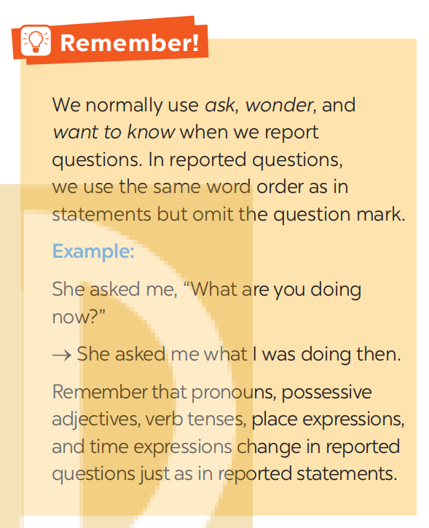  S+ ask (wonder, want to know) + question word + clause.  Answer key:  1. then 2. grew 3. there 4. could 5. there were
3. ACTIVITY 2: PRACTICE (20’ mins)
a. Objectives:
- To help Ss to make reported questions with given words, phrases or direct questions.
- To practice reported speech (both statements and questions) in situations.
b. Content:
- To put the words and phrases in correct order.
- To change questions into reported questions
- To report the conversation.
c. Expected outcomes:
- Students can use the reported speech (questions) correctly
d. Organisation
TEACHER’S AND STUDENTS’ ACTIVITIES | CONTENTS
Task 2.Put the words and phrases in the correct order to make reported questions. (Ex 2, p.128)
- T has Ss do this exercise individually and then compare their answers with a partner.  - Ss do the task individually  - T asks some Ss to write their answers on the board.  - Ss answer individually  - T checks the answers with the whole class. Confirm the correct answers. | Answer key:  1. My little brother asked me how many moons Venus had.  2. She wanted to know which planet was the closest to the sun.  3. The journalist asked the scientists what they were using telescopes in space for.  4. The scientists wanted to know when humans would be able to travel to Mars.  5. He asked the professor what the conditions were for a planet to have life on it.
Task 3. Change the following questions into reported questions. (Ex 3, p.128)
- T has Ss do this exercise individually and then compare their answers with a partner.  Ss do the task individually then in pairs  - T asks some Ss to write their answers on the board.  Ss go to the board to write answer  - T checks the answers with the whole class. Confirm the correct answers. | Answer key:  1. Mary asked the scientist who would be the first to step on Mars.  2. I asked my father how fast a UFO could travel.  3. The student asked his friend how many craters the moon had.  4. The pupils asked the teacher where they could find information about the solar system.  5. I asked my teacher what the weather on Mars was like.
Task 4. Report the conversation between An and Mai. (Ex 4, p.128)
- First T asks Ss to read the instruction. Use the example to make it clear to Ss what they are supposed to do.  - T shows the conversation on the screen and ask Ss to report it.  An asked Mai…………..  Mai told An that……………..  If necessary, T may explain how to use the reporting verbs say, tell and ask. Ask Ss to complete the sentences in pairs  - T asks some Ss to write their answers down their notebook  - Ss write down their answer  - T shows some Ss’ answers on the screen, asks whole class to check and correct. | Suggested answers:  An asked Mai what she was reading. Mai told An that she was reading Aliens and she was almost done. Next, An asked Mai what kind of book it was. Mai said to An that it was science fiction. And An asked Mai what it was about. Mai told An that it was about three aliens who tried to take over Earth.
4. ACTIVITY 3: Production (10 mins)
a. Objectives:
- To give further practise with reported speech (both statements and questions) in real situations.
b. Content:
- To ask and report.
c. Expected outcomes:
- Students can use the reported speech (questions and statements) correctly
d. Organisation
Task 5. Work in pairs. Ask your partner five questions about his / her daily routine and make notes of his / her answers. Then report your questions and your partner’s answers to the class.
(Ex 5, p.128)
– First T asks Ss to read the instructions. Use the example to make clear to Ss what they are supposed to do. With a weaker class, model the activity with a more able student.  – T has Ss work in pairs, asking and answering about their daily routine. Remind Ss to make notes of their partners’ answers. Set time (4-5 minutes) for Ss to do this activity. Go round to help weaker Ss.  - Ss do the task in pairs  – T calls on some Ss to report their questions and their partners’ routine to the class. Correct any grammar and pronunciation mistakes if necessary  Ss do the task individually  - T checks the exercises and gives feedback.  - T checks Ss’ understanding and gives feedback | Example:  I asked A what time he got up in the morning and he told me (that) he got up at ...
5. CONSOLIDATION (3mins)
a. Wrap-up
– T asks Ss to summarise what they have learnt in the lesson.
b. Homework
- Make 5 sentences by using reported speech (questions). ( My mother asked me…, my father wondered………, my sister wanted to know……….?.....
-Prepare lesson: communication, how to express uncertaintly.

