|  |  |
| --- | --- |
| **Mã đề 6.1.9** | **ĐỀ KIỂM TRA GIỮA KI I**  **NĂM HỌC: 2022 - 2023**  **MÔN: TIẾNG ANH 6**  *Thời gian làm bài: 60 phút*  *Đề gồm: 04 trang* |

**I. LISTENING**

**1. Listen then circle the right answer: A, B, or C (1point)**

1. What’s Tom playing?

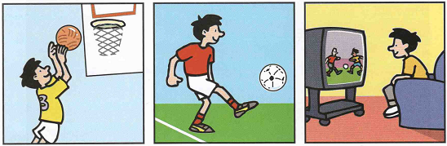

**A B C**

2. What’s Nick doing?

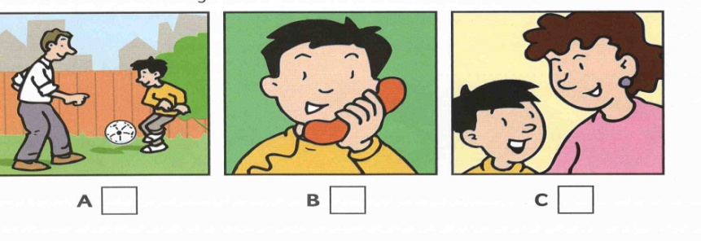 3. What’s Ben doing?

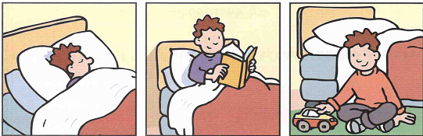

**A B C**

4. What’s Kim doing?

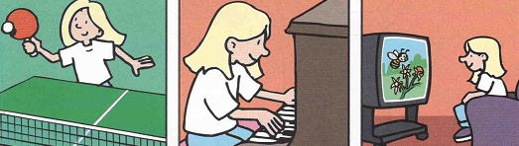

**A B C**

5. What’s Ann painting?

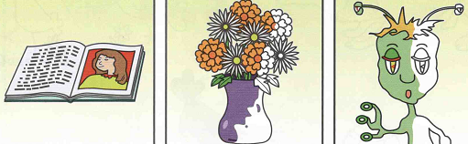

**A B C**

**2. You will hear a conversation between 2 people. Listen and complete questions 1-5.**

**There’s one example (1. point)**

*Name:* ***Mary Smith***

6. How old: …………

7. Hair colour: ………..

8. Eye colour: ……………

9. How many brothers: …………

10. How many sisters: …………

**II. GRAMMAR-VOCABULARY – LANGUAGE FUNCTION (3.0 pts)**

**I. Choose the word whose underlined part is pronounced differently from that of the others by circling A, B, C, or D (0.4 points)**

11. A. nice B. bicycle C. ride D. live

12. A. mine B. history C. exercise D. library

**II. Choose the best option (A, B, C, or D) to complete these sentences. (2.6 points)**

13. Now we ………………… English in the class

A. study B. are studying C. studying D. studies

14. My friends always do their homework. They’re ……………students

A. hard-working B. creative C. patient D. lazy

15. Where is the cat? It’s in………….. of the TV

A. front B. on C. behind D. next to

16. **Lan**: Can you pass me the biscuits, please? **Hoa**: ……….

A. Yes, I do B. No, I don’t C. Yes, of course! D. Yes, I can

17. He ……….. tall and fat.

A. has B. is C. are D. be

18. Would you like ………………….to Mai’s birthday party?

A. come B. to come C. comes D. coming

19. I often ………….. my homework in the afternoon.

A. do B. have C. study D. learn

20. There …………. many green trees and flowers around my school.

A. is B. isn’t C. are D. have

21. **A**: “What are you doing tomorrow?” **B**: “______________.”

A. I’m not doing anything B. I have long black hair

C. Yes, I’d love to. D. He is playing football.

22. My brother can do all the difficult Math exercises. He is a(n) ............ student.

A. intelligent B. confident C. careful D. hard-working

23. My Mum always asks me to wash my ......... before meals.

A. fingers B. arms C. hands D. face

24. It is called the tiger room …………. there is a big tiger on the wall.

A. so B. because C. but D. or

25. There is a family photo …………. the wall.

A. on B. at C. in D. middle

**III. READING.**

**1. Read the passage and then choose the correct answer to complete the passage. (1.5 points)**

This is Peter. He is twelve years old. He is a student. He .............. (26) in a big villa in the suburb of the city. There .................. (27) 4 people in his family: his parents, his younger sister and him. His father is an engineer. His mother is a teacher. And his younger sister is a pupil. There are 5 rooms .............. (28) his house: living room, kitchen, bathroom, bedroom and toilet. The living room is his ................ (29) place .............. (30) he can sit on the armchair and watch television with his family.

26**.** A. lives             B. live                         C. living                     D. lived

27**.** A. is                  B. be                           C. being                     D. are

28**.** A. at                   B. in                           C. of                           D. to

29**.** A. favorite       B. boring                     C. messy                    D. noisy

30**.** A. because       B. but                          C. so                           D. and

**2. Read the following passage and choose the correct answer A, B, C, or D. (1,5points)**

I’m Max. My friend Helen is very beautiful. She is taller than me. She has blonde hair, a chubby cheek, and round blue eyes. She’s clever, patient, and funny. She loves telling jokes. Her jokes are so funny that they make us laugh a lot. I love being with her because she helps me with a lot of things. On the weekend, she often goes to my house and does homework with me. But this weekend, we are going to the cinema to see a new film, Annabelle. It would be fun.

31. Is the writer taller than Helen?

A No, Helen is shorter than Max.

B. Yes, Helen is taller than Max.

C. Yes, Max is taller than Helen.

D. No, Max isn’t taller than Helen.

32**.** Why does the writer love being with Helen?

A. She’s funny          B. She helps her       C. She tells jokes      D. She’s beautiful

33**.** What do they often do on the weekends?

A. do homework       B. do housework      C. make cakes           D. ride horses

34**.** What does Helen have?

A. blonde hair           B. chubby cheek       C. round eyes              D. All are correct

35**.** What are they going to do this weekend?

A. watch TV              B. see a film              C. do homework       D. go to school

**IV.WRITING (2.0 points)**

**1. Rewrite the sentences with unchanged meaning using the words given. (1.0 point)**

36.The TV is behind the lamp.

🡪 The lamp________________________________________________________.

37.There are 5 rooms in my house.

🡪 My house__________________________________________________________.

38.Her hair is long and black.

🡪 She has ____________________________________________________________.

39. I don’t have a television in my room.

🡪 There is not _________________________________________________________.

40. Does your house have six rooms?

🡪 Are there __________________________________________________________?

**2. Use the cue words to write an e-mail to your friend to tell her/him about your favourite room in your house. (1.0 point)**

**From:** thaoduongsocute@gmail.com

To: ……………………..

Subject: ……………….

Dear ……..,

41. I/ live/ small/ house/ country.

→..............................................................................................

42. There/ a/ flower garden/ a lot of/ tree/ around/ house.

→...............................................................................................

43. The room/I/ like/ best/ my bedroom.

→..............................................................................................

44. There/ a/ picture/ wall/two/ window// there/ a/ big/ bed/ next/ the bookshelf.

→.................................................................................................

45. It/ small/ clean/ I/often/ listen/ music/ bedroom.

→...............................................................................................

**The end**