School: ……………………………………….. | Date:……………………………………..
Class: ……………………………..................... | Period: 7

UNIT 1: FREE TIME
Lesson 2.3 – Pronunciation & Speaking, pages 10 & 11
1. Objectives
By the end of this lesson, students will be able to…
1.1. Language knowledge/ skills
- practice the sound /sk/
- make free time activity plans with friends, using Present Simple for future meaning and prepositions of time
1.2. Competences
- improve Ss’ communication, collaboration, analytical, critical thinking skills.
1.3. Attributes
- have healthy lifestyles.
- spend free time in a good way.
2. Teaching aids and materials
- Teacher’s aids: Student’s book and Teacher’s book, class CDs, DCR– Phần mềm tương tác trực quan, DHA – Ứng dụng trò chơi tương tác, projector / interactive whiteboard /TV (if any), PowerPoint slides.
- Students’ aids: Student’s book, Workbook, Notebook.
3. Assessment Evidence
Performance Tasks | Performance Products | Assessment Tools
- Listen and cross out the one with the different sound.  - Read the words to your partner the correct pronunciation.  - Practice the conversation. Fill in the blanks with the correct prepositions.  - Make familiar conversations using the given ideas.  - Work in fours: Take turns role-playing phone calls inviting a friend to join you for each activity.  - Tell a partner about your plans for the weekend. | - Ss’ answers.  - Ss’ answers.  - Ss’ answers.  - Ss’ answers.  - Ss’ answers.  - Ss’ answers. | - Observation.  - Observation.  - Observation.  - Observation.  - Observation.  - Observation.
4. Procedures
A. Warm up: 5 minutes
a. Objective: to review lesson 2.2 and lead in the new lesson.
b. Content: speaking activity.
c. Expected outcomes: Ss can talk about their schedule on the weekends.
d. Organization

Teacher’s activities | Students’ activities
Speaking activity.  - Ask Ss to go around to ask their friends’ schedule on the weekend and take notes the names, the activities, and the times.  - Give Ss three minutes.  - Go around to help if necessary.  - Decide the winner with the most information and ask him/her to report the result. | -Go around to ask their friends’ schedule on the weekend and take notes the names, the activities, and the times.  -Report the result.
B. New lesson (35’)
1. Pronunciation: 10’
a. Objective: to help Ss pronounce /sk/
b. Content: task a, b, c & d.
c. Expected outcomes: Ss can pronounce /sk/ correctly
d. Organization
Teacher’s activities | Students’ activities
Task a:  - Introduce the sound /sk/  - Explain how to pronounce it.  - Give some examples:  skating, basketball, school  -Ask Ss to give more examples.  Task b:  - Ask Ss to listen to the words and focus on  the underlined letters (using the IWB).  skating, basketball, school  - Gets Ss to listen again and repeat chorally.  - Pick some Ss to say the words individually and correct their pronunciation if necessary.  Task c: Listen and cross out the one with the different sound.  skateboard science scooter basket  - Ask Ss to listen and cross out the one with the different sound.  - Pick some Ss to give the answers.  - Check their answers.  - Get Ss to listen again and repeat.  Task d: Read the words to your partner using the sounds noted in "a."  -Ask Ss to work in pairs, reading the words to their partners with the correct pronunciation.  - Pick some students to say the words and correct their pronunciation if necessary. | - Listen and take notes.  - Give more examples.  -Listen to the words and focus on  the underlined letters.  -Listen again and repeat.  - Listen and cross out the one with the different sound.  - Give their answers.  Answer Keys: science  -Listen again and repeat.  -Work in pairs, reading the words to their partners with the correct pronunciation.
2. Practice: 15’
a. Objective: to help Ss practice talking about schedules.
b. Content: task a & b
c. Expected outcomes: Ss can make conversations about schedules, using given ideas.
d. Organization:
Teacher’s activities | Students’ activities
Task a: Practice the conversation. Fill in the blanks with the correct prepositions.  Swap roles and repeat.  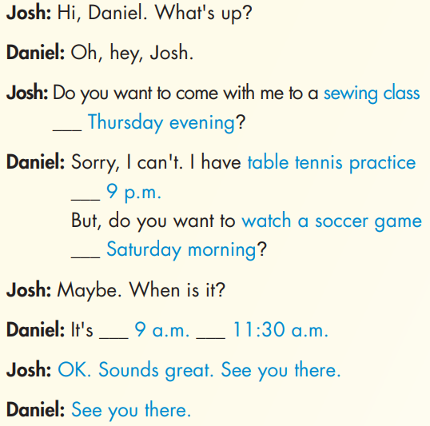  - Ask Ss to work in pairs, filling in the blanks with the correct prepositions and practicing the conversation.  - Go around and help if necessary.  - Pick one pair to read the conversation.  - Check their answers. | -Work in pairs, filling in the blanks with the correct prepositions and practicing the conversation.  Answer keys:  On; at; on; from; to
Task b: Make two more conversations using the ideas on the right.  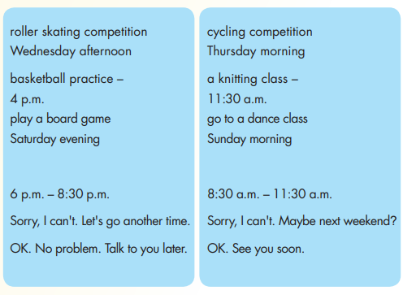  - Ask Ss to work in pairs to make two more conversations using the ideas on the right.  - Pick two pairs to perform the new conversations.  - Give feedback. | -Work in pairs to make two more conversations using the ideas on the right.  Answer keys:  Conversation 1:  Josh: Hi Daniel. What’s up?  Daniel: Oh, hey, Josh.  Josh: Do you want to come with me to a roller skating competition on Wednesday afternoon?  Daniel: Sorry, I can’t. I have basketball practice at 9 p.m. But do you want to play a board game on Saturday evening?  Josh: Maybe. When is it?  Daniel: It’s from 6 p.m. to 8:30 p.m.  Josh: Sorry, I can’t. Let’s go another time.  Daniel: OK. No problem. Talk to you later.  Conversation 2  Josh: Hi Daniel. What’s up?  Daniel: Oh, hey, Josh.  Josh: Do you want to come with me to a cycling competition on Thursday morning?  Daniel: Sorry, I can’t. I have a knitting class at 11:30 a.m. But do you want to go to a dance class on Sunday morning?  Josh: Maybe. When is it?  Daniel: It’s from 8:30 a.m. to 11:30 a.m.  Josh: Sorry, I can’t. Maybe next weekend.  Daniel: OK. See you soon.
3. Speaking: 10’
a. Objective: to help Ss practice talking about their schedule.
b. Content: task a, b and c.
c. Expected outcomes: Ss can talk about their schedule.
d. Organization:
Teacher’s activities | Students’ activities
Task 3a: You have lots of plans this weekend and you want your friends to join you. Look at the table and write six activities you have over the weekend.  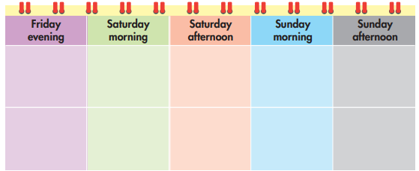  - Ask Ss to write six activities they have over the weekend in the table. | -Write six activities they have over the weekend in the table.
Task b: In fours: Take turns role-playing phone calls inviting a friend to join you for each activity. Invite each person in your group at least once. Note who you will do each activity with.  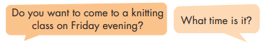  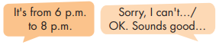  - Ask Ss to work in group of four, taking turns role-playing phone calls inviting a friend to join them for each activity; inviting each person in their group at least once; noting who they will do each activity with.  - Go around to help if necessary.  - Pick some pairs to perform their conversations.  - Give feedback. | -Work in group of four, taking turns role-playing phone calls inviting a friend to join them for each activity; inviting each person in their group at least once; noting who they will do each activity with.
Task c. Tell a partner about your plans for the weekend.  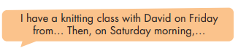  - Ask Ss to tell a partner about their plans for the weekend, using the information in the table.  - Pick some Ss to share their plans.  - Give feedback. | - Tell a partner about their plans for the weekend, using the information in the table.  - Share their plans to the whole class.
C. Consolidation and homework assignments: 5’
- Pronunciation: the sound /sk/
- Prepare the next lesson: Lesson 3.1 – Reading & Writing, pages 12 & 13
5. Reflection
a. What I liked most about this lesson today:
…………………………………………………………………………………………
b. What I learned from this lesson today:
…………………………………………………………………………………………
c. What I should improve for this lesson next time:
…………………………………………………………………………………………

