Unit 1: A LONG AND HEALTHY LIFE

GLOBAL SUCCESS 11
TỜ SỐ 02 – TEST 01

ENG LISH
THÁNG ...
Read the following advertisement and mark the letter A, B, C or D on your answer sheet to indicate the option that best fits each of the numbered blanks from 1 to 6.
🌙 Recharge Your Life with Deep Sleep! 🌙
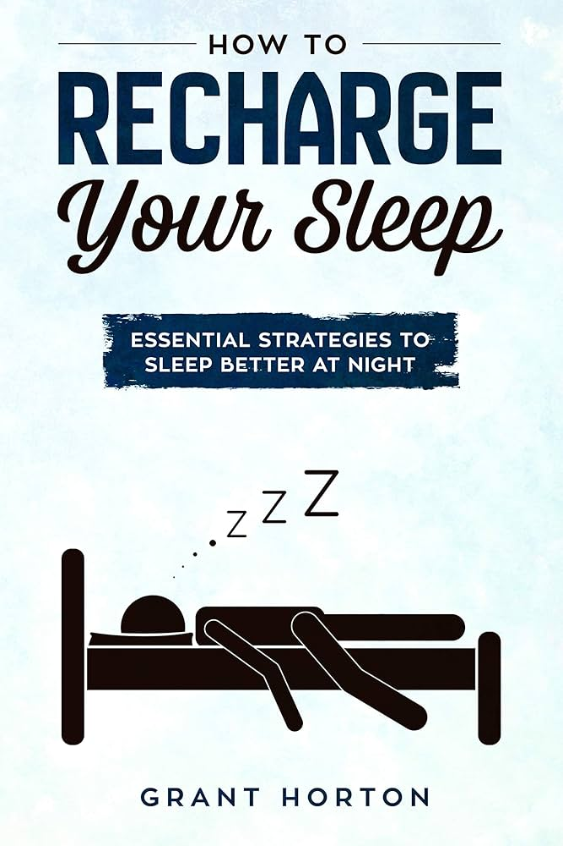
Discover the secret to a healthier lifestyle — quality sleep and proper rest! Sleep, often (1) ____________, plays a key role (2) ____________ mental and physical health. Getting enough rest at night, you can improve your focus, reduce stress, and boost energy levels — all important factors (3) ____________ productivity.
Our scientifically (4) ____________ sleep program, created by health experts, offers a step – by – step routine that helps you fall asleep faster and sleep more deeply. Packed with natural ingredients, our sleep supplements support the relaxation of both body and mind.
Instead of suffering from sleep disorders, choose a solution trusted by thousands. With regular practice, you will build a (5) ____________, leading to a balanced lifestyle full of energy and strength.
✨ Don’t wait! Start your journey to better sleep today and (6) ____________ up feeling refreshed and ready to take on the day!
Question 1: A. which overlooked B. overlooked C. overlooking D. overlooks
Question 2: A. at B. in C. with D. for
Question 3: A. to influencing B. influenced C. influencing D. influence
Question 4: A. designed B. designable C. designing D. design
Question 5: A. habit healthy sleep B. healthy habit sleep C. sleep healthy habit D. healthy sleep habit
Question 6: A. make B. take C. wake D. go
Read the following leaflet and mark the letter A, B, C or D on your answer sheet to indicate the option that best fits each of the numbered blanks from 7 to 12.
Tips for a Healthy Diet

Nowadays, many people are trying to eat a healthier diet. Eating healthy meals is not hard to do. Here are some easy ways to eat better:
- (7) ____________ the time to prepare delicious dishes that are also good for you. Food you make at home is usually healthier than food from a restaurant or cafeteria.
- Eat dishes with healthy (8) ____________, such as vegetables, and ones without mụch sugar or salt.
In many places, fresh food is available at farmers' markets. Farmers bring a (9) ____________ of crops to these markets, including many kinds of fruits and vegetables. (10) ____________ most of your meals should be healthy, it is fine to enjoy (11) ____________ ice cream or cookies on special (12) ____________ like your birthday.
[Adapted from Explore New Worlds ]
Question 7: A. Spend B. Take C. Use D. Do
Question 8: A. materials B. substances C. supplies D. ingredients
Question 9: A. variety B. level C. number D. group
Question 10: A. another B. much C. some D. other
Question 11: A. In spite of B. Even though C. With a view to D. Due to
Question 12: A. chances B. events C. events D. occasions
Mark the letter A, B, C, or D on your answer sheet to indicate the correct arrangement of the sentences to make a meaningful exchange or text in each of the following questions.
Question 13:
a. Mei: Yes, I went through it last night. The insights were truly eye – opening!
b. Farrah: Hmm, they made me reflect on how important it is to balance our digital habits. Perhaps setting some boundaries, like limiting screen time before bed, could help us manage stress better.
c. Farrah: Morning, Mei! Did you read the article about the correlation between excessive screen time and mental well – being?
A. c – b – a B. a – b – c C. c – a – b D. a – c – b
Question 14:
a. Clara: I love that. It sounds like you thought this through.
b. Ophelia: Yes, I have been pushing myself with more advanced bodyweight exercises lately – It’s tough but rewarding.
c. Clara: That’s awesome! What made you want to try something so different?
d. Ophelia: Honestly, it’s not just about building strength but also fostering discipline and resilience.
e. Clara: Are you still committed to those calisthenics routines you mentioned last week?
A. b – a – e – d – c B. c – e – a – b – d C. c – d – a – b – e D. e – b – c – d – a
Question 15:
Dear Phuc,
a. It’s fascinating to see how a nutritious diet can significantly boost both mental clarity and energy levels.
b. Thanks to your recommendation, I’ve started combining more whole foods with my meals, and I feel a tangible difference.
c. Your insights into the benefits of reducing ultra – processed foods were incredibly valuable.
d. I’ll continue exploring these strategies to refine my approach further.
e. I’m deeply grateful for the time you took to guide me through the nuances of healthy eating.
Talk soon,
Khanh
A. e – d – b – a – c B. e – b – c – a – d C. b – a – d – e – c D. b – d – c – e – a
Question 16:
a. Thus, while we may see health as a simple foundation, it is the unseen force shaping every aspect of our existence.
b. Many fail to recognize that poor health can silently erode not just our physical capabilities, but our mental resilience as well.
c. Good health is the cornerstone of a fulfilling life, providing the strength and vitality needed to pursue our goals.
d. This gradual decline often goes unnoticed until it becomes too late to reverse the damage which leaves individuals facing an uphill battle.
e. Without it, even the most driven individuals can find their aspirations slipping out of reach.
A. b – a – c – e – d B. c – d – b – e – a C. c – e – b – d – a D. b – c – e – a – d
Question 17:
a. Maintaining optimal kidney function is paramount for overall health, as these vital organs play a critical role in filtering waste and regulating fluid balance.
b. Moreover, managing chronic conditions such as hypertension and diabetes is crucial, as they are significant risk factors for kidney disease.
c. By adopting a proactive approach to kidney health, individuals can significantly reduce their risk of renal failure and enhance their life expectancy.
d. To safeguard kidney health, it is essential to adopt a lifestyle that prioritizes hydration, balanced nutrition, and regular exercise.
e. Reducing the intake of high – sodium foods and processed sugars can alleviate undue strain on the kidneys while ensuring an adequate intake of antioxidants from fruits and vegetables can help protect against cellular damage.
A. c – b – d – e – a B. a – d – e – b – c C. a – b – e – d – c D. c – b – e – d – a

Read the following passage and mark the letter A, B, C or D on your answer sheet to indicate the option that best fits each of the numbered blanks from 18 to 22.
Smoking poses significant dangers to both smokers and those exposed to secondhand smoke. Cigarettes contain numerous harmful chemicals, such as nicotine, tar, and carbon monoxide. Prolonged smoking greatly increases the risk of developing many life – threatening diseases. (18) ____________.
In addition to its direct impact on smokers, smoking also harms those around them through secondhand smoke. This smoke, (19) ____________, can be just as toxic as the smoke inhaled by the smoker. Non – smokers (20) ____________ are at a heightened risk of developing respiratory issues, cardiovascular diseases, and even cancer. Particularly vulnerable (21) ____________.
Quitting smoking offers immediate and long – term benefits for both the individual and their loved ones. Once a person stops smoking, their body begins to repair the damage caused by tobacco, (22) ____________. While quitting can be difficult due to nicotine addiction, there are various resources available to help people overcome their dependence and lead healthier lives.
Question 18:
A. We can address this by raising awareness about its dangers and offering more support programs.
B. The longer a person smokes, the greater their likelihood of suffering from these health conditions.
C. Smoking does not have any serious impact, and the body can fully recover once a person stops.
D. Occasional smoking is generally harmless, and many believe it helps improve focus and alleviate stress.
Question 19:
A. that is released into the air when a cigarette is lit
B. released into the air when a cigarette is lit
C. of which they release into the air when a cigarette is lit
D. having released into the air when a cigarette is lit
Question 20:
A. compelled to have their health compromised by regular exposure to secondhand smoke
B. compromised their health through regular exposure to secondhand smoke
C. whose health is compromised by regular exposure to secondhand smoke
D. that were under the influence of being regularly exposed to secondhand smoke
Question 21:
A. hazards associated with children's and pregnant women's health due to exposure to secondhand smoke
B. long – term health hazards may be faced by children and pregnant women due to secondhand smoke
C. children and pregnant women may face long – term health hazards due to exposure to secondhand smoke
D. exposure to secondhand smoke may result in health hazards among children and pregnant women
Question 22:
A. and the risk of serious health problems decreases significantly
B. but the damage caused by years of smoking is irreversible
C. although it takes a couple of decades for the body to fully recover
D. yet it often leads to increased weight gain and other health complications
Read the following passage about health tracking and mark the letters A, B, C, and D on your answer sheet to indicate the best answer to each of the following questions from 23 to 30.
In today’s busy world, maintaining a healthy lifestyle is both a challenge and a necessity. Unhealthy habits such as consuming fast food, skipping exercise, and sacrificing sleep are widespread due to hectic schedules and increasing reliance on modern conveniences. These behaviors, while seeming to do no harm in the short term, can have lasting consequences for physical and mental well – being.
A healthy lifestyle brings countless benefits. A balanced diet rich in fruits, vegetables, lean proteins, and whole grains helps the body function effectively and reduces the risk of chronic illnesses like obesity and diabetes. Regular physical activity strengthens the heart, improves circulation, and helps maintain a healthy weight. Exercise also boosts mental health by releasing endorphins, which reduce stress and improve mood. Additionally, adequate sleep is critical for brain function and emotional stability, allowing the body to recover and recharge.
Despite these advantages, many people struggle to adopt healthier habits. Fresh, nutritious food tends to be pricier and less accessible, particularly in low – income areas. Sedentary jobs and packed schedules make it difficult to find time for exercise. Furthermore, digital distractions and long working hours frequently interfere with sleep routines. These challenges can lead to long – term issues such as heart disease, high blood pressure, and chronic fatigue.
The consequences of neglecting health are severe. Poor lifestyle choices can weaken the immune system, making the body more vulnerable to illness. Over time, they reduce life expectancy and diminish overall quality of life. However, these issues are not insurmountable.
To promote healthier living, governments can increase access to affordable nutritious food and provide public exercise spaces. Employers can encourage wellness through flexible schedules and health initiatives. Individuals, meanwhile, can make small changes, such as taking short walks, preparing meals at home, or setting consistent sleep schedules.
In conclusion, while maintaining a healthy lifestyle requires effort, the rewards far outweigh the challenges. A balanced approach ensures better physical health, improved mental well – being, and a more fulfilling life.
Question 23: The word "widespread" in paragraph 1 is closest in meaning to ____________.
A. uncommon B. popular C. effective D. restricted
Question 24: Which of the following is NOT mentioned as a benefit of a healthy lifestyle?
A. Preventing chronic illnesses like diabetes B. Strengthening the immune system
C. Improving emotional stability D. Guaranteeing longer life expectancy
Question 25: The word "vulnerable" in paragraph 3 is OPPOSITE in meaning to ____________.
A. uncertain B. invincible C. weakly D. substantial
Question 26: Which of the following best paraphrases the underlined sentence in paragraph 2?
A. Endorphins released during exercise play a role in reducing anxiety and stabilizing emotions.
B. Regular physical activity primarily reduces stress but has a limited effect on improving mood.
C. Regular exercise reduces stress and enhances mood through the release of endorphins.
D. Exercise not only supports physical health but also lowers stress levels and uplifts mood slightly.
Question 27: The word "they" in paragraph 4 refers to ____________.
A. severe consequences B. the immune system C. poor lifestyle choices D. these issues
Question 28: Which of the following is TRUE according to the passage?
A. Governments should focus solely on creating public gyms.
B. Healthy food is always affordable and accessible.
C. A healthy lifestyle eliminates the need for exercise.
D. Poor sleep habits can lead to long – term health problems.
Question 29: In which paragraphs is it permissible to use contrast to emphasize a point?
A. Paragraph 1 B. Paragraph 2 C. Paragraph 3 D. Paragraph 4
Question 30: In which paragraph does the author suggest collective efforts for promoting healthy living?
A. Paragraph 1 B. Paragraph 2 C. Paragraph 4 D. Paragraph 5
Read the following passage and mark the letters A, B, C, and D on your answer sheet to indicate the best answer to each of the following questions from 31 to 40.
MAKING THE ZZZS... COME EASY
You're sleeping deeply when, suddenly, the alarm goes off. No! You just need five more minutes... Does this sound familiar? Well, you're not alone. Teenagers everywhere complain for a lack of sleep, but why is this?
To start with, on average, teenagers need to sleep 8 – 10 hours, compared to adults' 7 – 9. They also usually feel sleepy later at night than adults, and take longer to wake up in the morning. That's the reason why they always want to sleep in!
[I] But can this tiredness actually hurt you? Unfortunately, it can. [II] If you don't get enough sleep, you find it harder to concentrate at school and you might do worse in your exams. [III] You're also more likely to become ill or suffer from stress. [IV]
Luckily, there's a simple solution. Get more sleep and sleep better with a good evening routine. Firstly, eat dinner early so you don't go to bed on a full stomach. Then, about an hour before you go to bed, start doing something quiet and relaxing like reading a book. Switch off your screens as the bright light from your smartphone or tablet can wake your body up. Finally, go to bed and get up at the same time every day. This helps your body find the right time for bedtime.
If you follow these tips to get more sleep, you will boost your performance at school while staying happy and healthy. Remember, there are no dreams without sleep. So, if you want to follow your dreams, make sure you catch up on those ZZZs!
[Adapted from Bright]
Question 31: Where in paragraph [ ] does the following sentence best fit?
"A lack of sleep can affect everything."
A. [I] B. [II] C. [III] D. [IV]
Question 32: The word "complain for a lack of sleep" in paragraph 1 is closest in meaning to ____________.
A. shout loudly about being sleepy B. cheer about a good night's sleep
C. demand more sleeping hours D. grumble about sleepless nights
Question 33: The word "they" in paragraph 2 refers to ____________.
A. adults B. sleepy people C. teenagers D. early risers
Question 34: Which of the following is NOT mentioned in the passage as a way to improve sleep quality?
A. Turning off electronic devices before sleeping B. Avoiding going to bed on a full stomach
C. Doing homework right before going to bed D. Keeping a regular sleeping schedule
Question 35: What is the main idea of paragraph 2?
A. Teenagers are naturally lazy and sleep a lot
B. Teenagers need more sleep than adults and tend to wake up later
C. Adults and teenagers have similar sleep needs
D. Adults always wake up early because of work stress
Question 36: The word "boost" in the last paragraph is OPPOSITE in meaning to ____________.
A. improve B. increase C. reduce D. support
Question 37: Which of the following is TRUE according to the passage?
A. Teenagers function better on 6 – 7 hours of sleep than adults
B. Lack of sleep can affect students’ physical and academic performance
C. Dinner should be eaten right before going to bed to relax the stomach
D. Reading on a tablet before bed is a recommended activity
Question 38: Which of the following best paraphrases the sentence: "Switch off your screens as the bright light from your smartphone or tablet can wake your body up." in paragraph 4?
A. Using your phone or tablet before sleeping helps you relax and fall asleep faster.
B. The light from digital devices can keep your body awake, so turn them off before bed.
C. Bright screens on phones and tablets make your body fall asleep more quickly.
D. You should turn off your phone or tablet to save battery before going to bed.
Question 39: What can be inferred from the passage?
A. Teenagers suffer more than adults from irregular sleeping patterns
B. Most teenagers don’t need a bedtime routine to sleep well
C. Teenagers’ sleep habits are mostly caused by poor parenting
D. Teenagers perform well at school even with limited sleep
Question 40: Which of the following best summarizes the passage?
A. Sleep is not important as long as you eat and study well
B. Teenagers can sleep less if they learn to relax more during the day
C. Understanding sleep patterns and routines helps teenagers sleep better and live healthier lives
D. Teenagers need to avoid dreaming if they want to succeed in school
----- The end -----

