**Mã đề 9.1.10**

**ĐỀ KIỂM TRA GIỮA HỌC KÌ I**

**Môn: Tiếng Anh Lớp 9**

**Năm học 2022-2023**

Thời gian làm bài: 60 phút

(*Đề gồm: 04 trang )*

**A. LISTENING**

**I. Listen and tick (v) the box. There is one example. (1.0pt)**

1. Where’s the new bird cage?

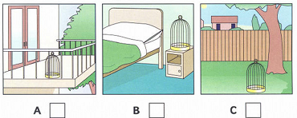

2. How did Peter go to work today ?

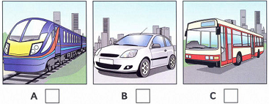

3. Which is Tom’s favourite sport ?

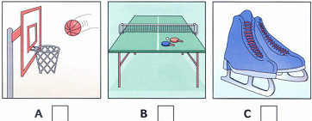

4. What dis May buy in the shop today ?

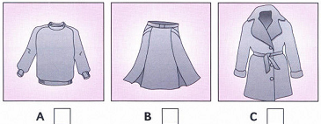

5. Where’s Sally’s grandma ?

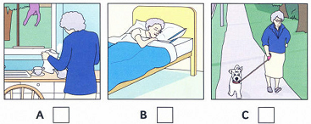

**II. Listen and write. There is one example. (1.0pt)**

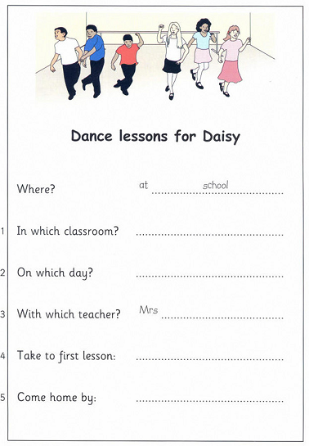

**B. VOCABULARY- GRAMMAR: (2.0pts)**

**Circle the correct answer ( A, B or C) to complete the following sentences .**

1. This school……………… in 2005.

A. was built B. is built C. has been built

2. She moved to France, but we still keep in ………………

A. writing B. touch C. contact

3. I wish my brother ……………… here to help me now.

A. is B. are C. were

4. The ……………… is the system of money that a country uses.

A. official religion B. unit of currency C. population

5. I am not used ……………… up early.

A. to get B. got C. to getting

6. Jack often goes to the ……………… to pray because his religion is Islam.

A. church B. pagoda C. mosque

7. Mathematics and Literature are ............ subjects in high school.

A. adding B. compulsory C. optional

8. This report is divided ……………… two parts.

A. with B. in C. into

9. My mother hasn’t worn ‘Ao Dai’ ……………… at least ten years.

A. for B. since C. in

10. Vietnamese women usually wear the ao dai as………………dress.

A. tradition B. traditional C. traditionally

**C. READING (3 POINTS)**

**I. Circle the best choice to complete the passage below ( 1.5 pts)**

Rice is (1)______by Vietnamese people every day. It often (2)______in tropical countries such as Vietnam, Thailand or Malaysia. The Chinese have also been growing rice for (3)______years. The seeds are planted in special beds to grow into young rice plants. Then they are taken to fields covered (4)______muddy water called paddies. The fields of rice look very (5)______After 3 or 5 months, the rice is ready to be picked. People often drain away water before colleting rice. Eating rice is a special action in the world. They don’t use spoons or forks to enjoy bowls of rice. However, they use two short sticks known as chopsticks to put rice into their mouths. China and Vietnam are the two countries in which people use chopsticks very well.

1.A. used B. taken C. eaten

2.A. grows B. keeps C. plants

3.A. thousands B. thousand C. thousands of

4.A. in B. by C. with

5.A. beauty B. beautiful C. beautifully

**II. Read the following passage and circle A, B or C that is the right answer for each of the questions. (1.5pts)**

**Clothes**

Clothes can tell a lot about a person. Some people like very colorful clothes because they want everyone to look at them and they want to be the center of things. Other people like to wear nice clothes, but their clothes are not colorful or fancy. They do not like people to look at them. Clothes today are very different from clothes of the 1800s. One different is the way they look. For example, in the 1800s, all women wore dresses. The dresses all had long skirts. But today women do not always wear dresses with long skirts. Sometimes they wear with short skirts, sometimes they wear pants. Another difference between 1800 and today is cloth . In the 1800s, clothes were made only from natural kinds of cloth. They were made from cotton, wool, silk or linen. But today there are many kinds of man made cloth. A lot of clothes are now made from nylon, rayon, or polyester.

1. Some people like colorful clothes because .......... .

A. they want everyone to look at them B. they want to be the center of things

C. both "A" and " B" are correct

2. Clothes today are the same as the ones of the 1800s.

A. True B. False C. No information

3. All women wore ................. in the 1800s.

A. dresses B. short skirts C. loose pants

4. Nowadays women don't always wear dresses with ................ .

A. long skirt B. short skirt C. loose pants

5. "What were clothes in the 1800s made from?" - "............."

A. nylon B. natural cloth C. rayon

**D. WRITING (3 POINTS)**

**I. Rewrite the following sentences without changing their meaning. (1.5pts)**

1.What a pity! I don’t know how to play chess.

**=>**I wish..................................................................................................................................

2.This boy broke the class window yesterday.

**=>**The class window...............................................................................................................

3. Lan asked her boyfriend, “What will you do tomorrow?”

=> Lan asked........................................................................................................................

4. I can’t play basketball well because of my height.

=> Because I……………………………………………………………….

5. It takes Minh 2 hours to do his homework every day.

=> Minh spends……………………………………………………………….

**II.** **Make a complete letter. ( 1.5pts)**

Dear......,

1. I/ arrive/Ho Chi Minh City/ 6 PM yesterday.

2. I/ staying / Hong Ha hotel/ near city centre.

3.I/ already visit/ Dam Sen park/ some places of interest here.

4. Tomorrow/ I/ going on a trip / Hue.

5. I/ return /home/ Saturday, September 18th.

I hope you are well.

Your friend,

...........

......................................................................................................................................................................

......................................................................................................................................................................

......................................................................................................................................................................

......................................................................................................................................................................

......................................................................................................................................................................

......................................................................................................................................................................

......................................................................................................................................................................

......................................................................................................................................................................

......................................................................................................................................................................

**HƯỚNG DẪN CHẤM**

**ĐỀ KIỂM TRA GIỮA HỌC KÌ I**

**MÔN TIẾNG ANH 9**

**A. LISTENING**

**I. Listen and tick (v) the box. There is one example. (1.0pt)**

(2 x 5= 10)

|  |  |  |  |  |
| --- | --- | --- | --- | --- |
| 1.A | 2. B | 3. A | 4.C | 5. B |

**II. Listen and write *.* (1.0pt)**

(2 x5= 10)

1. 10 4. shoes

2. Monday 5. bike

3. Caris

**B. VOCABULARY- GRAMMAR:**

**I Circle the correct answer ( A, B or C) to complete the following sentences ( 2.0pts)**

( 10 x 0.2 = 2.0 )

|  |  |  |  |  |  |  |  |  |  |
| --- | --- | --- | --- | --- | --- | --- | --- | --- | --- |
| 1.A | 2.B | 3.C | 4.B | 5.C | 6.C | 7.B | 8.C | 9.A | 10.B |

**C.READING:**

**I. Circle the best choice to complete the passage below ( 1.5 pts)**

**( 5 sentences x 0,2 point = 1 point)**

1.C.

2.A.

3.C.

4.C.

5.B.

**II. 0,2 x 5 = 1.5 (pts)**

1.C 2. B 3. A 4. A 5. B

**D. WRITING:**

**I. Rewrite the following sentences.**

**Mỗi câu đúng được 0,3 x5 = 1,5 p**

1. I wish I knew how to play chess.

2. The class window was broken by this boy yesterday.

3. Lan asked her boyfriend what he would do the next day/ the following day.

4. Because I am not tall enough ( too short/ short) , I can’t play basketball.

5. Minh spends 2 hours doing his homework every day.

**II.** **Make a complete letter. ( 1.5pts)**

( 5 x 0.3 = 1.5 )

Dear Hoa,

I arrived in Ho Chi Minh city at 6 p.m yestreday. I’m staying in Hong Ha hotel, It’s near city centre. I have already visited Dam Sen Park and some places of interest here.

Tomorrow I am going on a trip to Hue city. I’ll return home on Saturday, September 18th. I’ll tell you more about trip when I’m in Hue.

I hope you are well.

Your Friend

Huong