Unit 3 | Global warming and Ecological systems

A. VOCABULARY (TỪ VỰNG)
Unit opener
No | Words |  | Transcription | Meaning
1 | desert | (n) | /ˈdezət/ | sa mạc
2 | ecosystem | (n) | /ˈiːkəʊˌsɪstəm/ | hệ sinh thái
3 | global warming | (n) | /ˈɡləʊbəl ˈwɔːmɪŋ/ | sự nóng lên toàn cầu
4 | grassland | (n) | /ˈvæli/ | thung lũng
5 | grassland | (n) | /ˈɡrɑːslænd/ | đồng cỏ
6 | jungle | (n) | /ˈʤʌŋɡl/ | rừng nhiệt đới
7 | ocean | (n) | /ˈəʊʃən/ | biển, đại dương
8 | pond | (n) | /pɒnd/ | (cái) ao
9 | swamp | (n) | /swɒmp/ | đầm lầy
Lesson 3a
No | Words |  | Transcription | Meaning
10 | conditions | (pl.n) | /kənˈdɪʃənz/ | điều kiện (sống)
11 | effect | (n) | /ɪˈfekt/ (n) | sự tác động, sự ảnh hưởng
12 | extinct | (a) | /ɪksˈtɪŋkt/ | tuyệt chủng
13 | extreme weather | (n) | /ɪksˈtriːm ˈwɛðə/ | thời tiết khắc nghiệt
14 | marine | (a) | /məˈriːn/ | (thuộc) biển
15 | drought | (n) | /draʊt/ | hạn hán
16 | flood | (n) | /flʌd/ | lũ lụt
17 | heatwave | (n) | /ˈhiːtweɪv/ | đợt nóng
18 | hurricane | (n) | /ˈhʌrɪkən/ | bão nhiệt đới (hình thành ở Đại Tây Dương)
19 | ice caps | (n) | /aɪs ˈkæps/ | các chỏm băng
20 | landslide | (n) | /ˈlændslaɪd/ | sạt lở đất
21 | sea level | (n) | /siː ˈlevl/ (n) | mực nước biển
22 | wildfire | (n) | /ˈwaɪldˌfaɪə/ | đám cháy lớn, cháy rừng
Lesson 1c
No | Words |  | Transcription | Meaning
23 | put off | (phr v) | /pʊt ɒf/ | trì hoãn
24 | put on | (phr v) | /pʊt ɒn/ | bật, mở (các thiết bị điện)
Lesson 1d
No | Words |  | Transcription | Meaning
25 | food waste | (phr) | /fuːd weɪst/ | thức ăn thừa
26 | get rid of | (v) | /ɡet rɪd ɒv/ | bỏ, loại bỏ
27 | organic | (a) | /ɔːˈɡænɪk/ | (thức ăn) hữu cơ, không sử dụng hóa chất trong quá trình nuôi trồng
28 | recycle | (v) | /ˌriːˈsaɪkl/ | tái chế
29 | reusable | (a) | /ˌriːˈjuːzəbəl/ | Có thể tái sử dụng

* WORD FORMATION
- conditions /kənˈdɪʃənz/ (pl n): điều kiện (sống)
conditional /kənˈdɪʃənl/ (adj): có điều kiện
unconditional /ˌʌnkənˈdɪʃənl/ (adj): không điều kiện
conditionally /kənˈdɪʃənli/ (adv): một cách có điều kiện
unconditionally /ˌʌnkənˈdɪʃənli/ (adv): một cách không điều kiện
- effect /ɪˈfekt/ (n): sự tác động, sự ảnh hưởng
effective /ɪˈfektɪv/ (a): có hiệu quả, có ảnh hưởng
- extinct /ɪksˈtɪŋkt/ (adj): tuyệt chủng
extinction /ɪksˈtɪŋkʃən/ (n): sự tuyệt chủng
- flood /flʌd/ (n): lũ lụt
flooded /ˈflʌdɪd/ (adj): bị ngập
- danger /ˈdeɪndʒər/ (n): sự nguy hiểm, mối đe dọa
dangerous /ˈdeɪndʒərəs/ (a): nguy hiểm
endanger /ɪnˈdeɪndʒər/ (v): gây nguy hiểm
endangered /ɪnˈdeɪndʒəd/ (a): bị đe dọa
- electricity /ˌelɪkˈtrɪsəti/ (n): điện
electric /ɪˈlektrɪk/ (a): chạy bằng điện
electrical /ɪˈlektrɪkəl/(a): liên quan tới điện
electrician /ˌɪlekˈtrɪʃən/ (n): thợ điện
- environment: /ɪnˈvaɪrənmənt/ (n): môi trường
environmental /ɪnˌvaɪrənˈmentəl/ (a): thuộc về môi trường
environmentally /ɪnˌvaɪrənˈmentəli/ (adv): về phương diện môi trường
- recycle /ˌriːˈsaɪkl/ (v): tái chế
recyclable /riˈsaɪkləbəl/ (adj): có thể tái chế được
- use /juːz/ (v): sử dụng
reuse /ri:ˈju:z/ (v): tái sử dụng
reusable /riːˈjuːzəbəl/ (adj): có thể tái sử dụng
- harm /hɑːm/ (n): sự tổn hại, thiệt hại
harmful /ˈhɑːmfəl/ (a): có hại, gây hại
harmless /ˈhɑːmləs/ (a): vô hại, không có hại
- protect /prəˈtekt/ (v): bảo vệ
protection /prəˈtekʃən/ (n): sự bảo vệ
protective /prəˈtektɪv/ (a): bảo hộ, bảo vệ, che chở
B. GRAMMAR
I. Present Perfect (Thì hiện tại hoàn thành):
- Công thức
Câu khẳng định | Chủ ngữ + have/has + V₃/V_{-ed} | e.g. I have been to India.  She has lived here for years.
Câu phủ định | Chủ ngữ + haven’t/hasn’t + V₃/V_{-ed} | e.g. They haven’t helped since 2005.  Peter hasn’t arrived yet.
Câu hỏi | Have/Has + chủ ngữ + V₃/V_{-ed}?  Từ để hỏi Wh- + have/has + chủ ngữ + V₃/V_{-ed}? | e.g. Have you ever met this man  – Yes, I have./No, I haven’t.  Where has she gone?
- Cách dùng
- Nói về tình trạng hoặc hành động đã bắt đầu trong quá khứ và vẫn còn diễn ra hiện tại.
e.g. I’ve been here for 15 minutes. (Tôi đến đây 15 phút trước và hiện vẫn còn ở đây.)
- Nêu kết quả ở hiện tại của một hành động đã xảy ra, có thể không rõ xảy ra khi nào hoặc không quan tâm xảy ra khi nào.
e.g. I have bought some new clothes for Tết. (Nêu kết quả “tôi có quần áo mới”, không chú trọng
mua khi nào.)
Someone has stolen my bike. (Nêu kết quả “tôi không còn chiếc xe đạp”, không rõ bị lấy cắp lúc nào.)
- Nói về một kinh nghiệm cho tới thời điểm hiện tại.
e.g. I’ve never eaten this food before. (Diễn tả kinh nghiệm: chưa từng ăn món này)
He has played several games of this type. (Diễn tả kinh nghiệm: đã từng chơi nhiều game
dạng này)
c. Dấu hiệu nhận biết
- for + khoảng thời gian (2 hours, 5 days, 10 weeks, 15 years,…)
- since + mốc thời gian bắt đầu (1998, July, Monday,…)
- ever / never (khi nói về kinh nghiệm)
- Cấu trúc: It’s the first time … / This is the first time … (khi nói về kinh nghiệm)
- Các từ chỉ thời gian khác: just, already, yet, recently, before, so far…
II. Present perfect & Past simple
Present perfect | Past simple
- Thì hiện tại hoàn thành diễn tả một sự việc/ hành động bắt đầu trong quá khứ, kéo dài tới hiện tại và còn tiếp diễn.  I have lived in Hanoi for 10 years. (I’m still living here.) | - Thì quá khứ đơn diễn tả hành động/ sự việc xảy ra và hoàn tất trong quá khứ.  - I lived in Hanoi for 10 years. (Now I’m not.)
- Thì hiện tại hoàn thành diễn tả một hành động/ sự việc xảy ra tại một thời điểm không xác định trong quá khứ.  - Mary has come to Viet Nam. | - Thì quá khứ đơn có kết quả của sự việc không ảnh hưởng đến hiện tại, xảy ra tại một thời điểm xác định và kết thúc hoàn toàn trong quá khứ.  - She graduated from the university last year.

C. EXERCISE (BÀI TẬP)
❶ PHONETICS
I. Choose the words whose underlined part is pronounced differently from that of the others in each group.
1. A. concrete B. desert C. effect D. terrace
2. A. pond B. pocket C. stone D. modern
3. A. accept B. annoyed C. agree D. anxiuos
4. A. global B. organic C. social D. ecosystem
5. A. exctint B. landslide C. ruin D. etiquette
6. A. glassland B. hot C. pond D. worship
7. A. stopped B. turned C. stayed D. moved
8. A. school B. church C. architecture D. chemistry
9. A. played B. lived C. cooked D. happened
10. A. watched B. washed C. walked D. waited
II. Choose the word whose main stressed syllable is placed differently from that of the other in each group.
11. A. attitude B. powerless C. pagoda D. difficult
12. A. mountain B. etiquette C. modern D. accept
13. A. behaviour B. architecture C. traditional D. historical
14. A. temple B. annoyed C. narrow D. valley
15. A. confused B. palace C. tower D. crowded
❷ WORD FORMATION
Complete the sentences with the correct form of the words.
- The lighting for the production made a very effective use of shadow. (effect)
- The extinction of the dinosaurs occurred millions of years ago. (extinct)
- She would never do anything to endanger the lives of her children. (danger)
- Most electrical equipments come with a one-year guarantee. (electricity)
- They’’re here to discuss environmental issues. (environment)
- Are plastic bottles recyclable or do they go in the garbage? (recycle)
- Some think television hurts children and others regard it as harmless entertainment. (harm)
- The protection of the environment must be our first priority today. (protect)
- The farm and surrounding area were flooded. (flood)
- To conserve resources, please reuse this carrier bag. (use)

❸ FURTHER PRACTICE
UNIT OPENER
I. Write the suitable word for each picture.

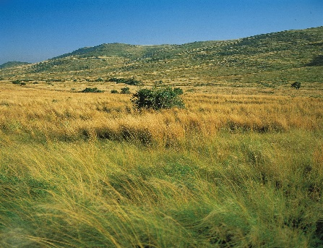 | 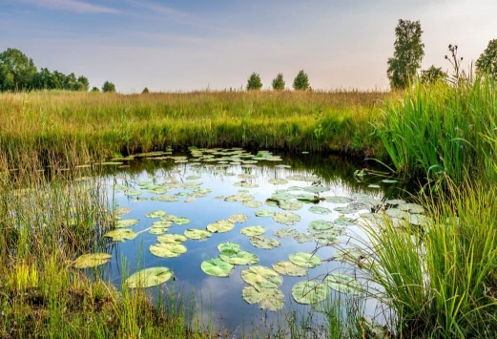 | 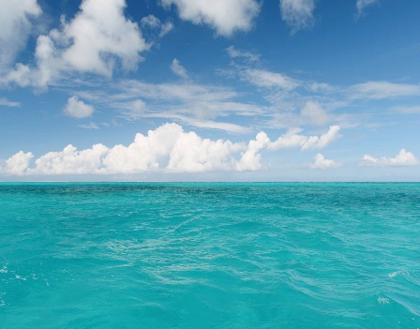
1. _________________ | 2. _________________ | 3. _________________
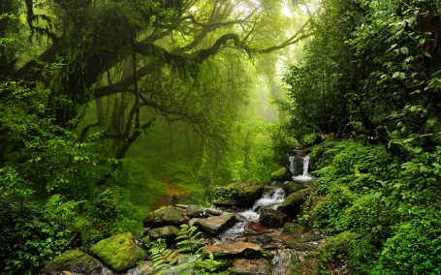 | 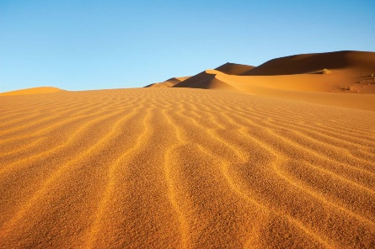 | 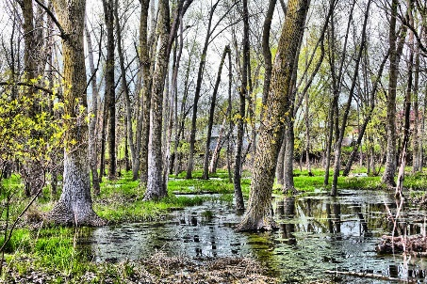
4. _________________ | 5. _________________ | 6. _________________

II. Complete the sentences with the words in exercise I.
- The lion is often called the king of the_________________.
- They lost their way in the _________________ and died of thirst.
- A flock of sheep are ranging over the _________________.
- Have any fish been contaminated in the Arctic _________________?
- This is a crocodile - infested _________________.
- She chose a bench beside the duck _________________ and sat down.
III. Put the words into the correct STRESS column. Then practise saying them with a partner.
worried selfish accept extinct valley career
arrange annoyed repair social jungle select
replace preserve tower palace temple terrace



LESSON 3A. READING
I. Fill in the blanks using the words in the box.
effect | marine | conditions | extreme weather | extinct | temperature | emission
global warming | ecosystems | endangered | greenhouse gas | wildfires | droughts | forest

- A good night's sleep has a positive _________________on your day.
- There are many wild animals in this _________________.
- Heat and _________________ had continued for more than two weeks.
- A heatwave in southern Australia triggered _________________ that destroyed more than 100 homes.
- Carbon monoxide is also a powerful _________________.
- Mountain gorillas are an _________________ species.
- The rainforest is a self-supporting _________________.
- _________________could be accelerated due to the thinning of the ozone layer.
- The ___________ of gases such as carbon dioxide should be stabilised at their present level.
- In hot weather the _________________gets very high.
- Dinosaurs have been _________________ for millions of years.
- Are recent _________________events due to global warming?
- The match has been cancelled due to adverse weather _________________.
- Seals and whales are _________________ animals.

II. Write the suitable word for each picture.

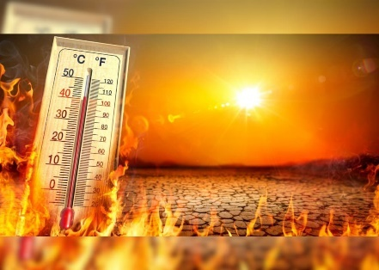 | 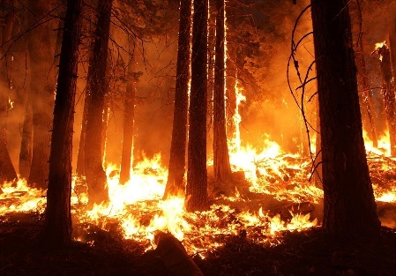 | 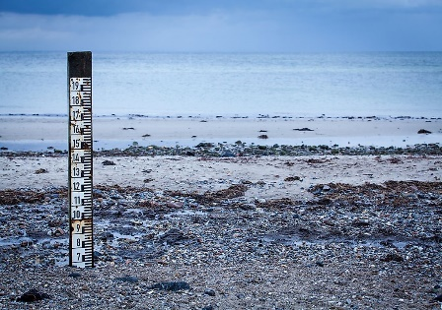
1. _________________ | 2. _________________ | 3. _________________
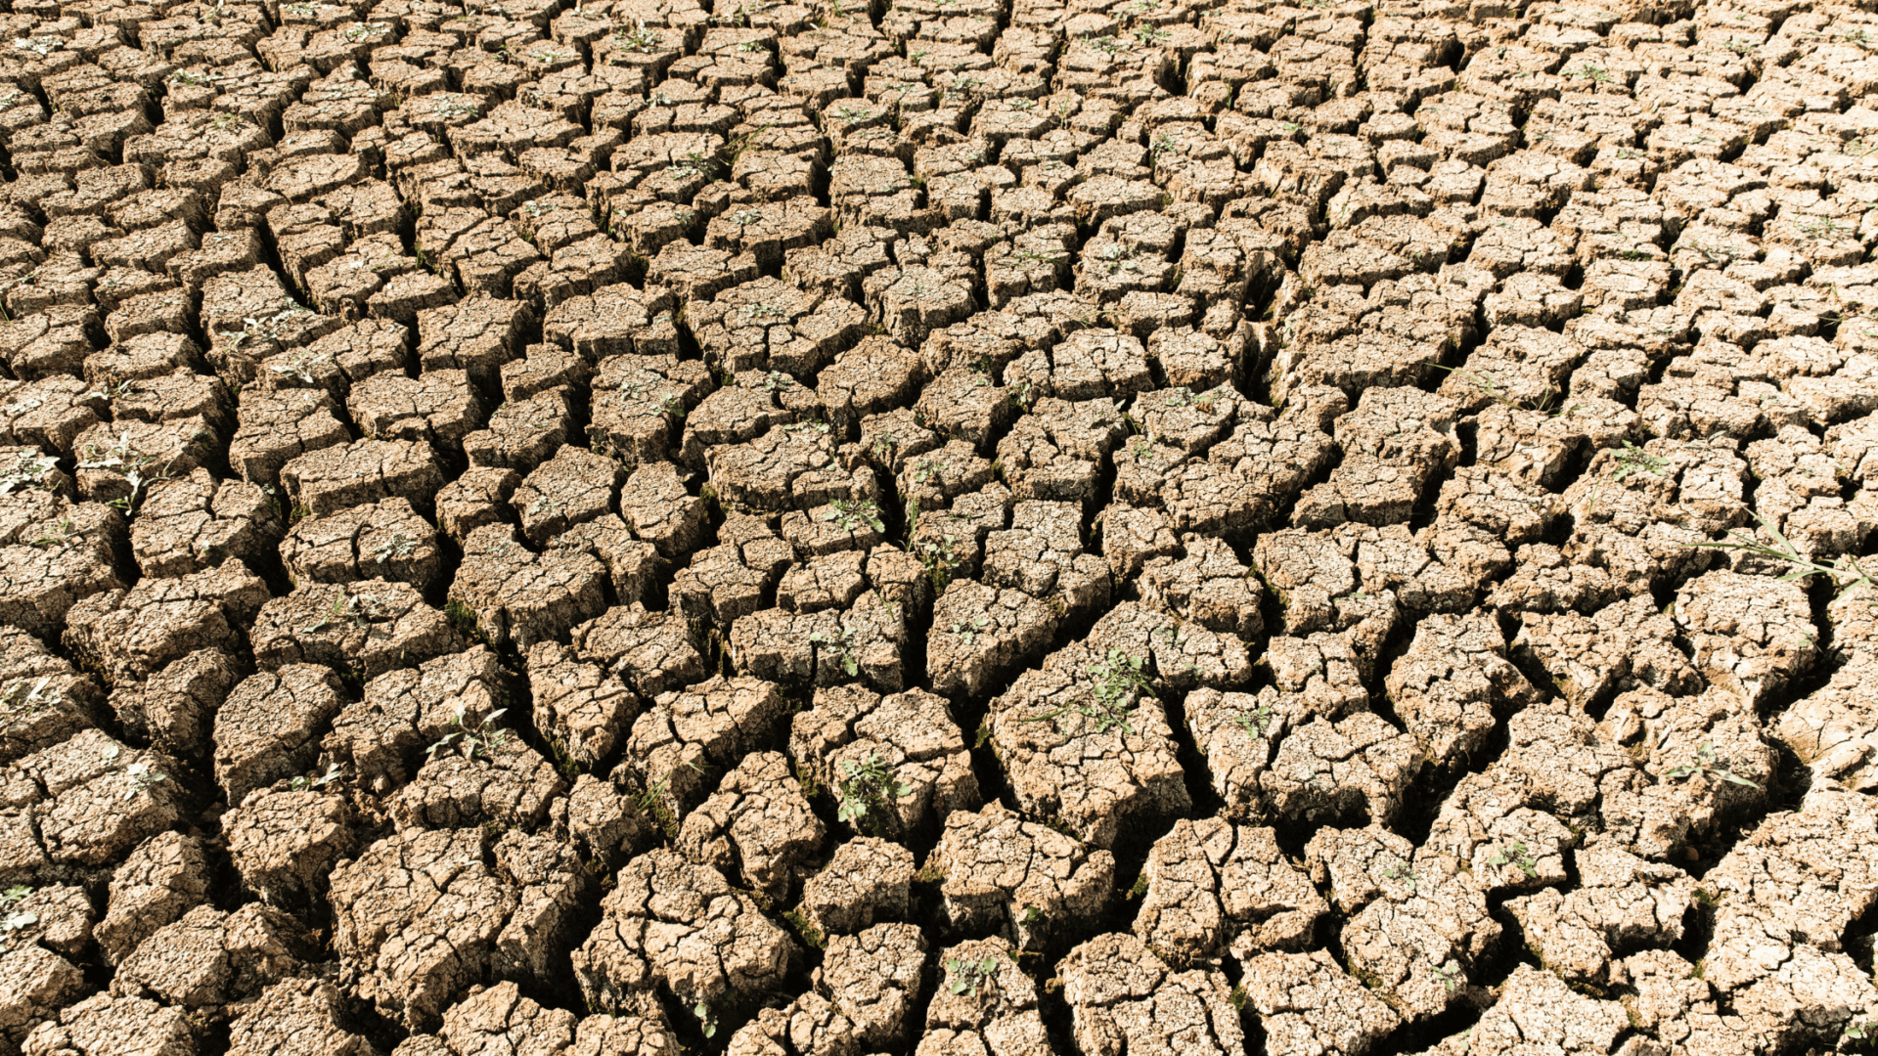 | 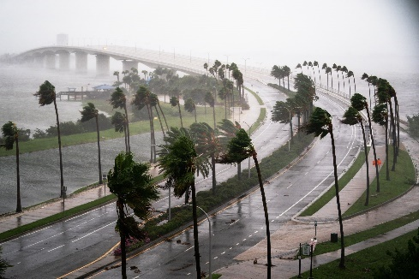 | 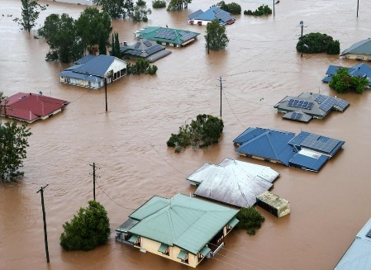
4. _________________ | 5. _________________ | 6. _________________
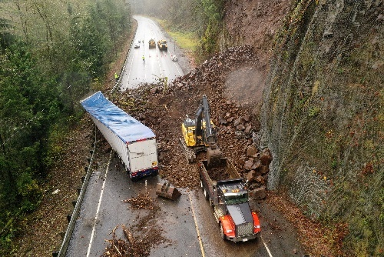 | 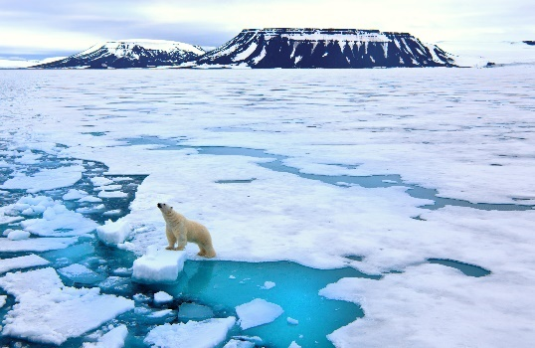 | 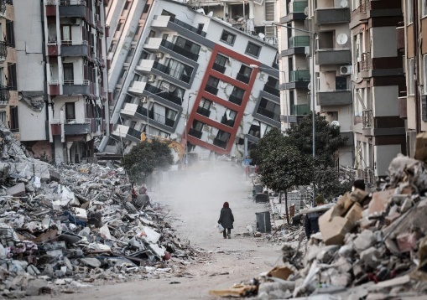
7. _________________ | 8. _________________ | 9. _________________

III. Reading
Mega Earthquake and Tsunami
by Gillian Frost (weather correspondent)
At 14.46pm on the 11th March 2011, Japan experienced a powerful earthquake. It reached a magnitude of 9.0 and even though it lasted 6 minutes, it left parts of the country completely destroyed.
The earthquake struck close to the north coast, about 250 miles from Tokyo. It triggered a super tsunami which swept inland near the city of Sendai. Waves reached heights of up to 405 metres and travelled 6 miles inland. The Japanese National Police Agency reported that 15,883 people were killed and another 6,145 were injured during the disaster. Around 129,225 buildings were destroyed.
Jeremy Michael, an English teacher working in Japan at the time, described the whole event. ‘It was like a horrific dream,’ he recalls. He was teaching a class of primary school children when the earthquake hit. He said it had felt like it was never going to end. Crouching under their desks while it was happening, when they finally went outside, they were met with more danger. Children were panicked and many were crying. Tsunami alarm bells were also ringing, he remembers, warning the town to evacuate immediately to higher ground.
Within 10 minutes, they had all managed to reach the safety of a train station high up on a hill. He recalls looking back and seeing the wave approaching rapidly. Water had already flooded the school. The tsunami waves had destroyed most of the town and everyone was made homeless. Jeremy and his class waited for an hour on the hill until the water returned back to normal levels. It was snowing and the temperatures were freezing.
In Utatsu alone, where Jeremy was living, only 9,000 survivors from 18,000 residents had been confirmed. Millions of people suffered across Japan. It was the single worst natural disaster they had ever experienced.
A. Read the article and match the words below with their definitions. Circle the words in the text.
crouching recall horrific inland flood triggered

0 something that is the cause of a particular development, especially a bad one ___triggered
1 in a direction towards the middle of a country, away from the coast _____________________
2 extremely bad and shocking _____________________
3 bending down with your knees under you close to the ground _____________________
4 remember certain information _____________________
5 worried that something bad has happened _____________________

B. Read the article again and match the information with the numbers.

0 number of people who survived F  1 height of the tsunami waves _  2 number of inhabitants in Utatsu _  3 minutes the earthquake lasted _  4 magnitude of the earthquake _  5 number of people who were injured _ | A 6  B 9.0  C 18,000  D 6,145  E 405  F 9,000
C. Read the article again and decide if the sentences are true or false. Correct the false sentences.
0 Jeremy was teaching children in a classroom when he felt the earthquake. True
1 The emergency services warned people to evacuate to safety. ___________
2 Jeremy and his class escaped to safety by train. ___________
3 Tsunami waves covered the whole town. ___________
4 People rescued their belongings from their homes. ___________
5 Jeremy and the children waited in the freezing cold for the water levels to reduce. _______

D. Read the following article and choose the correct answer for each question.
Scientists believe that something very serious is happening to the Earth. It is becoming warmer. Scientists predict that there will be major changes in the climate during the 21st century. Coastal waters will have higher temperatures. This will have a serious effect on agriculture. Farmers will have trouble producing good crops. In warm regions, the weather will be too dry. The amount of water could decrease by 50 per cent. This would cause a large decrease in agricultural production.
World temperatures could increase from 1.5 to 5.6 degrees Celsius by the middle of the 21st century. And the increase in temperature could be even greater in the Arctic and Antarctic regions. A rise in temperature could cause the great ice sheets to melt, which, in turn would raise the level of oceans by one to two meters. Many coastal cities would be underwater. Why is all this happening?
The Earth and its atmosphere are kept warm by the Sun. The atmosphere lets most of the light from the Sun pass through to warm the Earth. The Earth is warmer by the sunlight and sends heat energy back into the atmosphere. Much of this energy escapes from the Earth’s atmosphere. However, some of it remains. Gases such as carbon dioxide, ozone and water vapor absorb this energy and create more heat. Then, this heat is sent back down to Earth, and the Earth becomes warmer.
Recently, however, an increase of carbon dioxide in the atmosphere is causing serious problems. Too much carbon dioxide in the atmosphere prevents heat energy from escaping. Too much heat is sent back down to the Earth, and the amount of carbon dioxide in the atmosphere continues to increase. When oil, gas, and coal burn, they create large amounts of carbon dioxide. The destruction of rain forests that absorb carbon dioxide also helps to increase the amount of carbon dioxide in our atmosphere. Some scientists believe that the amount of carbon dioxide in the air will double by the late 2000s.
Scientists call this warming of the Earth and its atmosphere “the greenhouse effect”. A greenhouse, made of glass and plastic, is a special place where plants are grown. The sunlight passes through the glass or plastic and warms the air inside. The heat inside escapes very slowly, so the greenhouse remains very warm. This is exactly what is happening on the Earth.
Another reason why the Earth is growing warmer is because of the amount of ozone in our atmosphere. Ozone is a form of oxygen. In the upper atmosphere, very far from the Earth, a layer of ozone helps to protect the Earth from 95 percent of the harmful light that comes from the sun. If your skin receives too much of this light, you would develop skin cancer. We need the ozone layer to protect ourselves. But the ozone layer is in trouble. Scientists have observed that the ozone layer is becoming thin, and above Antarctica there is a hole. This allows too much of the sun’s dangerous light into our atmosphere and makes the Earth warmer.
Scientists say we must start making changes and planning now. We need to continue to do research, so we can predict what will happen in the future. We must burn less coal, oil, and gas. Other scientists believe that the problem is not so serious. They think that the Earth is growing warmer naturally, that we don’t need to worry about it now, and that we should just get ready for life in the warmer climate. Most scientists agree that the causes of the world’s climate are very complicated. They say that we must continue to measure the amount of carbon dioxide and ozone in the atmosphere. Scientists also encourage people to learn about the changes that are occurring in the world and how we can all help protect our atmosphere.
(https://climate.nasa.gov/effects/)
Question 1: Which of the following will be one of the consequences of a warmer earth?
A. Crops will be poor unless they are grown in the green house.
B. The amount of water will be decreased by half.
C. Farmer will get into trouble because of the heat.
D. There will be no winter on earth.
Question 2: A rise in temperature will be more remarkable ____.
A. in the Arctic and Antarctic regions B. in the coastal cities
C. by the year 2050 D. under the great ice sheets
Question 3: The melting of the polar ice sheets will probably lead to ____.
A. a rise in global temperature B. the extinction of many polar animals
C. flooding of many coastal cities D. a serve winter all over the world
Question 4: The Earth wouldn’t become warmer if ____.
A. the heat energy didn’t escape from the Earth’s atmosphere
B. sunlight didn’t pass through the atmosphere
C. the Earth didn’t send heat energy back into the atmosphere
D. carbon dioxide, ozone and water vapor didn’t retain the heat energy
Question 5: When the rainforests are destroyed ____.
A. people have to burn coal, oil, gas instead of wood for fuel.
B. heat energy fails to escape from the atmosphere.
C. there is nothing to absorb carbon dioxide.
D. serious problems are caused for the scientists.
Question 6: How useful is the ozone layer?
A. It protects the earth from the harmful radiation from the sun.
B. It absorbs much of the carbon dioxide.
C. It sends the extra heat energy back into space and thus keeps the earth cool.
D. It helps treat skin cancer.
Question 7: The two factors that directly cause the greenhouse effects are ____.
A. the destruction of rain forests and the melting of the polar ice
B. the burning of fossil fuels and the changes of the climate
C. the increase of carbon dioxide in the atmosphere and the decrease of the ozone layer
D. the ignorance of greenhouse owners and the development of skin cancer
Question 8: Which is the best title for the passage?
A. The global warming B. The greenhouse effects
C. The heat energy D. The change of climate in the poles

LESSON 3B. GRAMMAR
I. Complete the chart below with the correct form of the verb.

Simple form | Simple past | Past participle
 | knew
 |  | met
fly
 | wrote
 |  | read
 | fell
feel
 |  | taken
 | drove
write
 |  | gone
 | cut
break

II. Put the verbs in the correct form of the present perfect tense.
- Our teacher________________ (be) sick since last Saturday.
- We________________ (not talk) about the problem yet.
- She________________ (play) football since she was a little girl.
- Jackson and Simon________________ (not call) us for months.
- Richard________________ (stay) with us for weeks.
- Bo _____ (drive) Rose to work today.
- They _____ (work) all day and night.
- We _____ (see) the new bridge.
- He ____ (have) breakfast this morning.
- Ann and Don ____ (wash) the car.
- Kathy ____ (want) to go to Queensland for a long time.
- Mel ____ (give) up smoking.
- I ____ (forget) that man’s name.
- They ____ (lose) their keys.
- Jack ____ (be) to England.
- They ____ (leave) London this month.
- He ____ (bring) a lot of English papers.
- She ____ (tell) me about it.
- I ____ (get) a long letter from father this week.
- She ____ (come), she will speak to you in a minute.
- I ____ (be) to Radio City.
- I think the director ____ (leave) the town.
- I ___ (paint) my office.
- We ____ (know) her since she arrived in our city.
- I ____ (forget) your name.
III. Complete the sentences with present perfect or simple past.
  - Mr. Brown ________________ (start) teaching here many years ago.
  - We________________ (work) here since 2009.
  - She________________ (not play) football since she broke her leg.
  - Jackson and Simon________________ (stop) calling us months ago.
  - My neighbor________________ (move) here in 1967.
  - My neighbors________________ (live) in this town since 2001.
- Peter _______________( play) football yesterday.
- They ______________________(clean) the car. It looks new again.
- Last year we ___________________(go) to Italy.
- John and Peggy _____________________ (just/read ) the book. Now they can watch the film.
- I ____________________ (meet) my friend two days ago.
- We _______________________ (never/ visit) another country before.
- She _____________________ (buy) a new car in 2011.
- I'm sorry, but I _______________________ (forget) my homework.
- (you/ win) __________________the game of chess?
IV. Fill in the blanks using ever, never, just, already and yet.
  - My best friend started working there 5 years________________.
  - We haven’t talked to each other________________ we argued that day.
  - They have used that fridge________________ many years.
  - It has been a long time________________ we last met.
  - Maria started her business a few months________________ .
  - I haven’t cooked for the family________________ nearly 3 weeks.
  - Have you ______________________ been in America?
  - Do you hear the noise? The train __________________ arrived.
  - No. Your cousin hasn't come to the party _________________________.
  - Can you open the door? Oh, it is __________________ open.
  - Your daughter has ______________________returned home. You don't have to worry anymore.
  - Haven't you finished your food _____________________ ? No, I am still eating mom.
  - I am a very lucky person. I have _________________________ had nightmares.
  - Are you going to meet me at the shop? Yes, I am ____________________ there.
  - I have ____________________________ realized how beautiful you are.
V. Complete the sentences with present perfect or simple past.
- The weather around here______________________terrible in the last few weeks. (BE)
- Maria______________________her suitcase last night. (PACK)
- I__________________volleyball since I was a teenager. (NOT PLAY)
- We______________________wash the dishes. They're all clean now. (HELP)
- They_____________the factory. – Really? When________________? (CLOSE, THAT HAPPEN)
- _____________yet? (YOUR BUSINESS COURSE – START)
- How long______________________that camera? – About a month. I_____________it because it was on sale just before Christmas. (YOU HAVE, BUY)
- ________________last week's magazine? – It must be here because I _________it on Monday. (YOU SEE, BUY)
- The books you ordered____________. The delivery service ___________ them an hour ago. (ARRIVE, BRING)
- The Queen______________her two-week tour through Australia yesterday. (START)
- The plane from New York_______________. The passengers are getting out. (JUST LAND)
- We__________a party at school for ages. (NOT HAVE)
- I a cold in school a few days ago and_____________ill ever since. (CATCH, BE)
- Dinosaurs_____________around the earth millions of years ago. (WANDER)
- Prices________up last year, but they_____________by 8% already this year. (NOT GO, INCREASE)
- I'm so tired. I________________all the way to the underground station. (WALK)
- We_______________home from our holidays and getting ready to settle in. (JUST COME)
- She______________________in London for three years. However, when her mom _____________, she______________________to Leeds and______________________there ever since. (LIVE, DIE, MOVE, LIVE)
- Dusty______________________a match so far this year. He is more successful than last year, when he ______________________the first three matches. (NEVER LOSE, LOSE)
- He______________________off the ladder and______________________his ankle. That's why he ______________________in school for a while. (FALL, BREAK, NOT BE)

LESSON 3C LISTENING
A.Vocabulary
I. Match the words with their definitions.
a. a person who has suffered the effects of violence or illness or bad luck
b. (of a liquid or gas) to escape from a hole or crack in a pipe or container
c. a dangerous or unpleasant situation which you have got into and from which it is difficult or impossible to escape
d. a person employed by a newspaper, a television station, etc. to report on a particular subject or send reports from a foreign country
e. a violent burst, often with a loud noise
f. to burn brightly and strongly
g. to fall down suddenly because of pressure or having no strength or support
h. a sudden very loud noise or an explosion
i. a person who continues to live, esp. after a dangerous event
j. to try to deal with something or someone

1. tackle
2. explosion
3. blast
4. blaze
5. correspondent
6. trap
7. collapse
8. survivor
9. gas leak
10. victim

B. Listening
I. Listen to a radio news report and choose the correct answer, A, B or C.
1. The fire started … .
B. on a residential street B. in a house C. at an apartment block
2 The blast happened … .
A. before 10am B. at ten o’clock C. at night
3. Around sixty people were … .
A. killed B. rescued C. injured
4 Many people were trapped in the building’s … .
A. lower floors C corridors B upper floors
5 From the rubble, emergency teams pulled out … .
A. a young boy C. a young man B. one of the residents
6 When the explosion happened, David was … .
A. listening to the news C. fixing the gas metre B. having a bath

II. Listen again and decide if the sentences are true or false. Correct the false sentences.
1 The explosion happened in a city in Argentina. _____________________
2 Eight people were killed in the explosion. _____________________
3 The fire had burnt out when the firefighters arrived. _____________________
4 Hundreds of apartments were destroyed. _____________________
5 People from the building smelt gas before the explosion. _____________________
6 Passers-by saw the explosion. _____________________
7 People heard the explosion a long way away. _____________________
8 Alberto said they had found all the survivors. _____________________
9 The person they found in the rubble was seriously injured. _____________________
10 David’s roof in his apartment collapsed on him. _____________________
11 The explosion was caused by a faulty heating system _____________________
LESSON 3D SPEAKING
I. Look at the picture and fill in the missing words.

 | 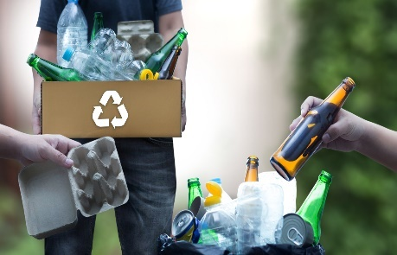 | 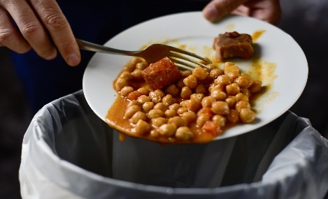
1. ________ organic ___________ | 2. _____________your rubbish | 3. get rid of your ____________
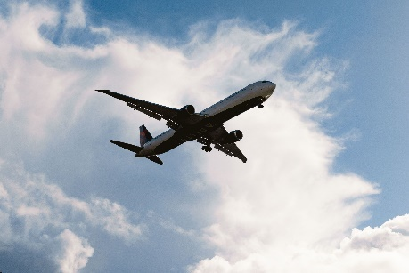 | 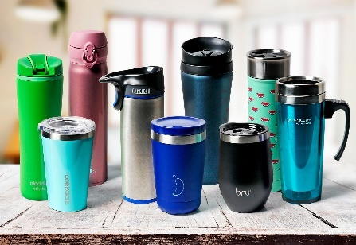 | 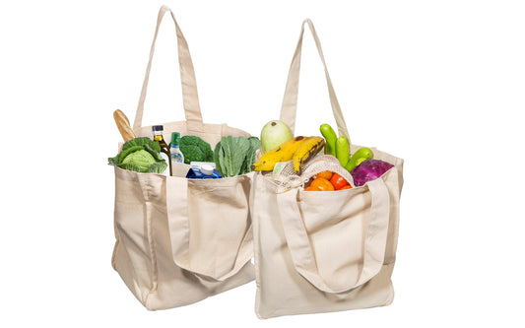
4. take few _____________ every year | 5. drink from _________________ | 6. shop with a _________________
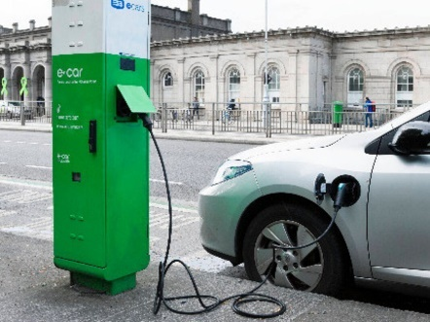 | 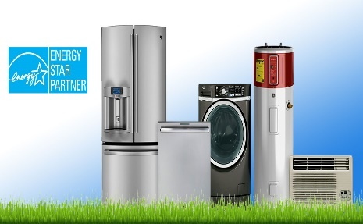 | 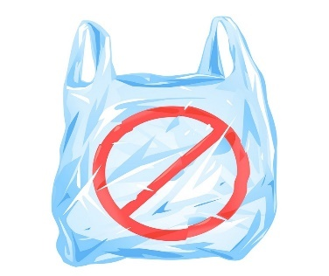
7. drive an _______________ car | 8. use _________________devices | 9. stop using _________________

II. Work in groups. Make a poster about the ways to reduce carbon footprint at school. Then present to the class.

LESSON 3E WRITING

I. Rewrite the sentences using the given words.
1. warming/up/ global/ heating/ planet/is/ the/.
_________________________________________________________________________________________________________
2. ecosystems/ in/ problems/ many/ caused/ the/ rising/ have/.
_________________________________________________________________________________________________________
3. products/ try/ use/ we/ to/ energy-saving/ only/.
_________________________________________________________________________________________________________
4. gases/ we/ use/ cars/ should/ reduce/ to/ greenhouse/.
_________________________________________________________________________________________________________
5. air/ already/ in/ the/ CO2/ we/ should/ plant/ on/ down/ cut/ more/ trees/
_________________________________________________________________________________________________________

II. Correct the mistake in each sentence.
1. They stopped contacting us for 2 weeks ago.
2. Sarah and I haven’t hung out last month.
3. I didn’t call any customers this morning. (It’s still in the morning.)
4. Jackson and Simon didn’t invite us to their parties since our argument.
5. Richard has gone to the zoo every weekend when he was a child.
II. Rewrite the sentences so that it has the same meaning with the provided sentences.
1. That old man has lived here for 10 years.
→ That old man moved___________________________________________________________________________.
2. She hasn’t texted me since the party.
→ She stopped_______________________________________________________________________________________.
(dùng ‘after’)
3. My sister started playing the guitar when she was 15.
→ My sister has______________________________________________________________________________________.
4. They stopped calling each other when she moved to Paris.
→ They haven’t_____________________________________________________________________________________.
5. Brian started doing yoga 6 years ago.
→ Brian has_________________________________________________________________________________________.
6. This is the first time I have seen such a beautiful house.
→ I ___________________________________________________________________________________________________.
7. I haven’t gone to school for 4 months because of covid-19.
→ The last time ______________________________________________________________________________________.
8. I have never visited Halong Bay before.
→ This is ___________________________________________________________________________________________.
9. How long have she lived in New York?
→ When ______________________________________________________________________________________________
10. He hasn’t smoked for 2 years.
→ It is _____________________________________________________________________________________________.

Tài liệu được chia sẻ bởi Website VnTeach.Com
https://www.vnteach.com

