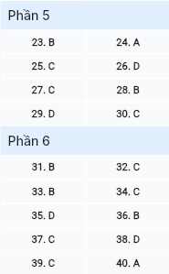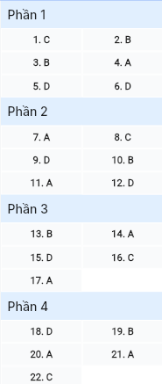**ĐỀ MINH HỌA SỐ 06**  
**KỲ THI TỐT NGHIỆP TRUNG HỌC PHỔ THÔNG NĂM 2025**  
(Đề thi có 08 trang)  
**Môn thi: TIẾNG ANH**  
**Thời gian làm bài: 50 phút, không kể thời gian phát đề**

***Read the following advertisement and mark the letter A, B, C or D on your answer sheet to indicate the option that best fits each of the numbered blanks from 1 to 6.***

🌴 **TROPICAL PARADISE BEACH TOUR – DIVE INTO BLISS** 🌴

Looking for an escape to a paradise of sun and sand? Our beach tour is perfect for those who (1) _______ immense pleasure in soaking up tropical vibes. The pristine shores and vibrant coral reefs (2) _______ visitors the chance to experience nature's wonders firsthand are the highlights of this tropical paradise. You will bask in the warm sun, feel the (3) _______ sea breeze, and leave your worries behind. Don't forget (4) _______ your swimsuit and sunscreen for a full day of fun! Led by friendly locals, our (5) _______ ensures you get the most out of each location, with unique experiences crafted just for you. Book now, and let us welcome you (6) _______ a sunny getaway you'll never forget!

**Question 1 [695302]:** A. make B. get C. take D. keep

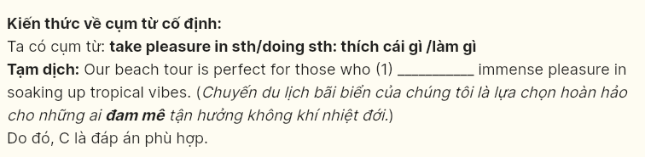

**Question 2 [695303]:** A. which provides B. providing C. provided D. are provided

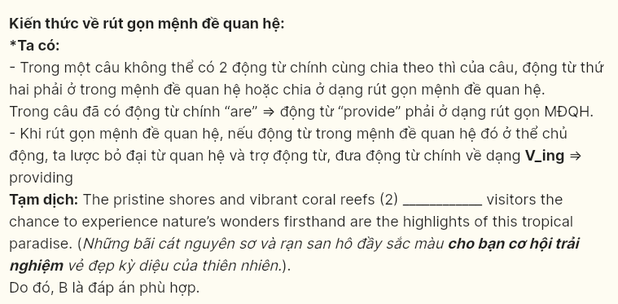

**Question 3 [695304]:** A. peace B. peaceful C. peacefully D. peacefulness

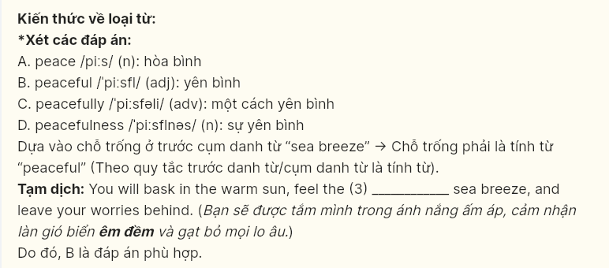

**Question 4 [695305]:** A. to bring B. bringing C. to bringing D. bring

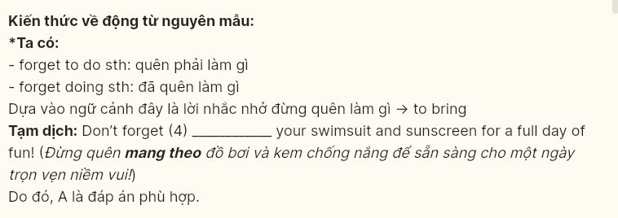

**Question 5 [695306]:** A. adventure island exciting B. island adventure exciting

C. exciting adventure island D. exciting island adventure

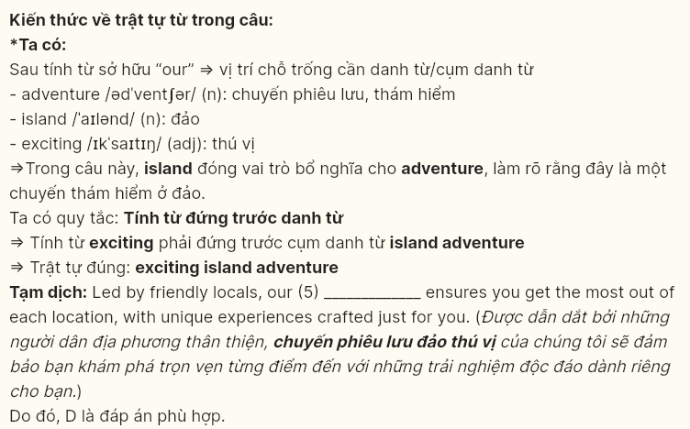

**Question 6 [695307]:** A. for B. in C. on D. to



**Read the following leaflet and mark the letter A, B, C or D on your answer sheet to indicate the option that best fits each of the numbered blanks from 7 to 12.**

💬 **Make a Difference – Volunteer with Us!** 💬  
**Your time and kindness can change lives.**

**Why Volunteer?**  
Volunteering opens doors to new experiences, helping you connect with (7) _______ while making a real impact. You'll meet people from different backgrounds and learn from diverse perspectives. It's a meaningful way to (8) _______ to people who are in need, making a positive difference for yourself and those around you.

**Ways to Contribute**

* **Community Clean-Up 🌳**  
  Be part of our (9) _______ to restore beauty to local parks and streets. Together, we create a cleaner, more welcoming space that everyone can enjoy and feel proud of.
* **Mentorship for Youth 🧑‍🎓**  
  Step into a rewarding role as a mentor, helping students navigate their studies and set meaningful goals. Encourage them to build confidence and grow the skills they need to thrive. Your (10) _______ can be the spark that motivates a young mind to aim higher and achieve more.
* **Elderly Care Visits ❤️**  
  Spend time with seniors in care facilities, sharing stories and listening to theirs. (11) ________ these small acts of companionship, their days become brighter and more joyful. Your presence can (12) _______ their spirits and bring them comfort when they need it most.

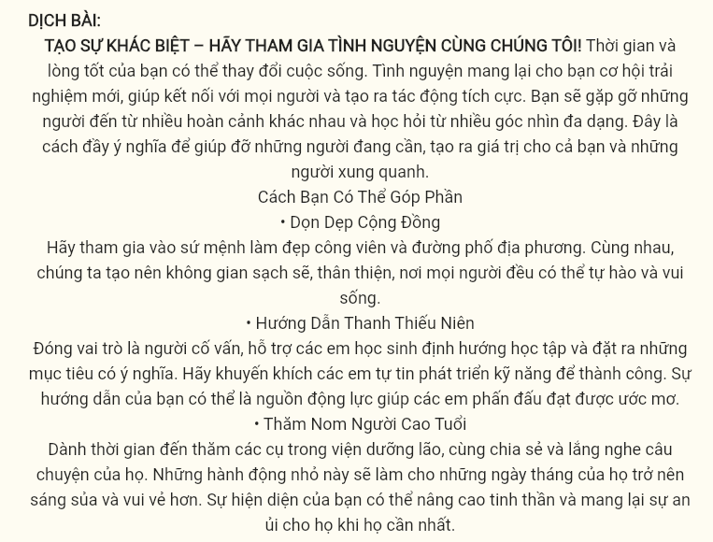

**Question 7 [695308]:** A. others B. another C. other D. the others

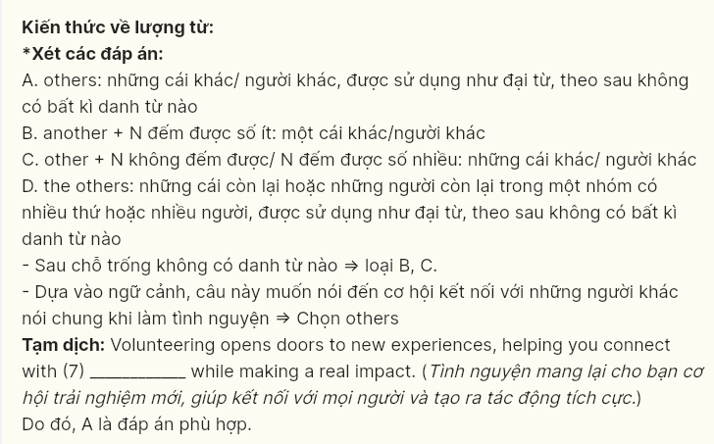

**Question 8 [695309]:** A. turn out B. make out C. reach out D. keep out

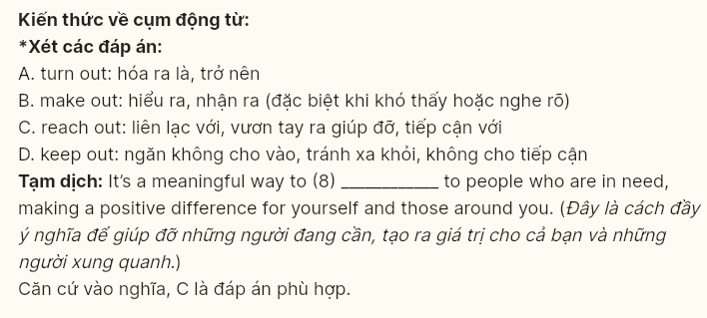

**Question 9 [695310]:** A. reason B. excuse C. purpose D. mission

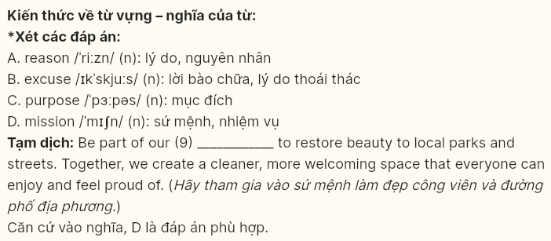

**Question 10 [695311]:** A. permission B. guidance C. application D. dependence

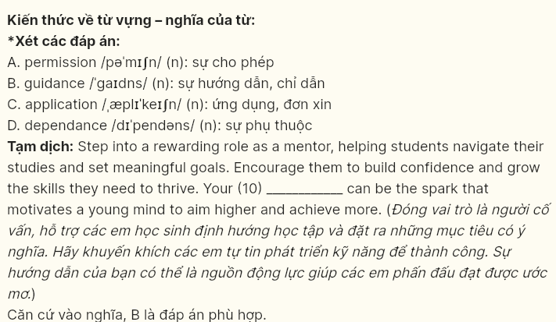

**Question 11 [695312]:** A. owing to B. regardless of C. instead of D. except for

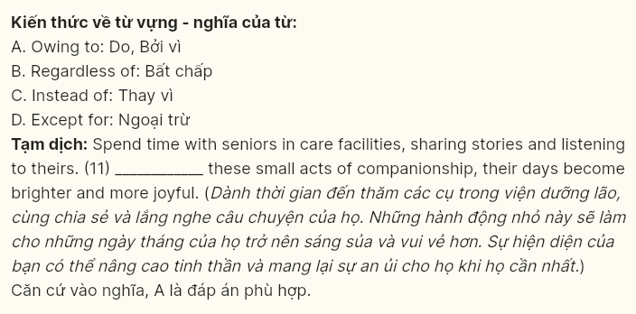

**Question 12 [695313]:** A. regulate B. imitate C. evaluate D. elevate

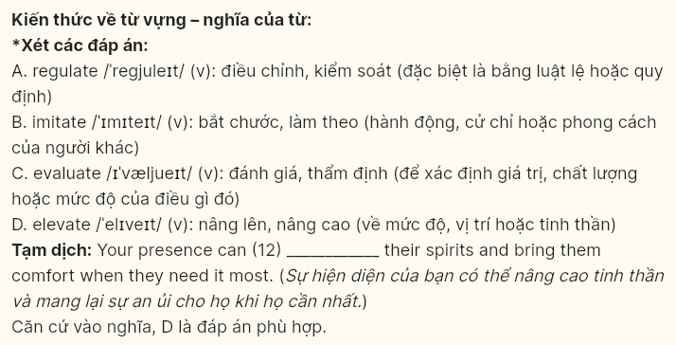

**Mark the letter A, B, C or D on your answer sheet to indicate the best arrangement of utterances or sentences to make a meaningful exchange or text in each of the following questions from 13 to 17.**

**Question 13 [695314]:**

a. Alice: Sure! Just go straight down this road and take a right at the first intersection. It will be on your left.  
b. Bella: Excuse me, can you tell me where the nearest bakery is? I’m really in the mood for some pastries!  
c. Bella: Thank you so much! I really appreciate your help.

A. c-a-b B. b-a-c C. c-b-a D. a-c-b

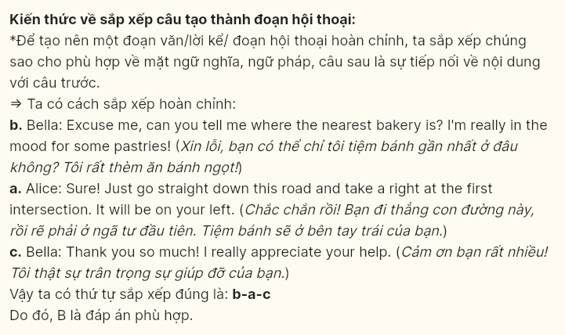  
**Question 14 [695315]:**

a. David: That’s a great idea! We could partner with local businesses for supplies.  
b. Lisa: What if we organized a community clean-up? It could really raise awareness.  
c. Lisa: Hey David, have you noticed the plastic waste in our parks? It’s really concerning!  
d. Lisa: Exactly! And we should promote it on social media to get more people involved.

**A**. c-e-b-a-d B. a-b-d-c-e C. b-a-e-d-c D. c-a-d-b-e

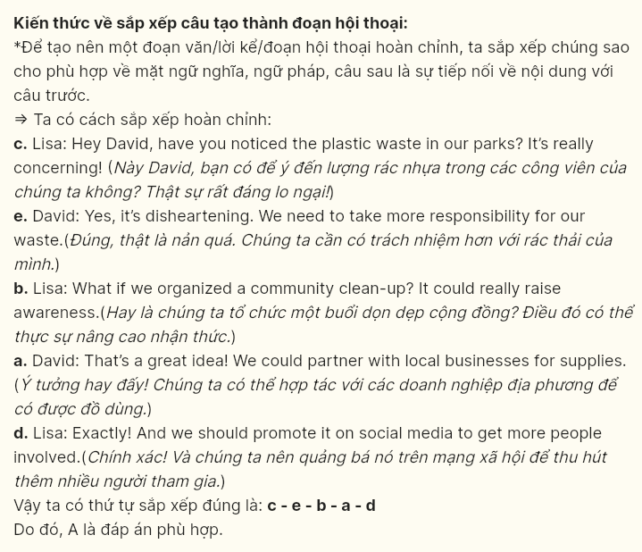

**Question 15 [695316]:**

Dear Emma,  
a. Raising awareness about mental health can help reduce stigma and encourage open conversations among friends and family.  
b. In today’s fast-paced world, mental health often takes a backseat to other pressing issues.  
c. I would love to discuss this further with you; perhaps we can meet up for coffee sometime soon!  
d. I hope this letter finds you well. I wanted to take a moment to share my thoughts on a topic that has been on my mind lately: the importance of mental health awareness.  
e. However, I believe it is crucial for us to prioritize our mental well-being, just as we do with our physical health.

Warm regards,  
Jane

A. e-b-d-a-c B. c-d-b-e-a C. b-a-d-e-c D. d-b-e-a-c

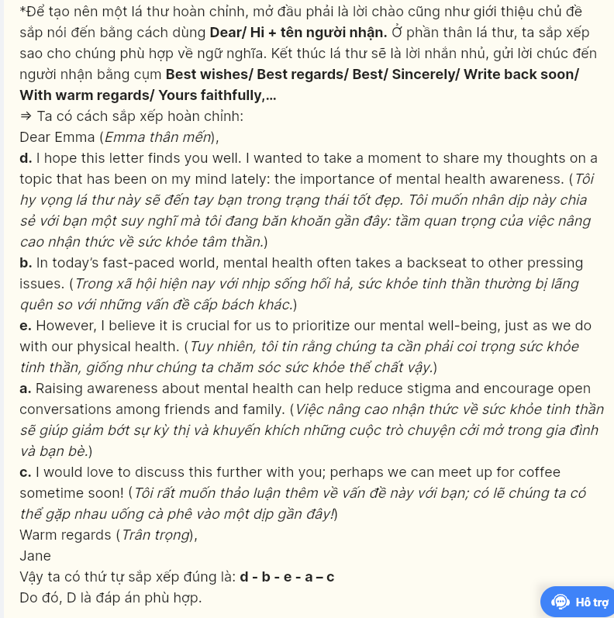  
**Question 16 [695317]:**

a. I’ve seen other neighborhoods thrive with similar projects, fostering both friendships and fresh produce.  
b. Additionally, we can host workshops on gardening techniques and healthy eating.  
c. Overall, I believe this initiative would bring our community closer together while promoting sustainability.  
d. We could gather a group of volunteers to help with the planting and maintenance.  
e. The idea of creating a community garden is exciting and could really enhance our neighborhood.

A. d-a-e-b-c B. b-e-d-a-c C. e-a-d-b-c D. a-e-b-d-c

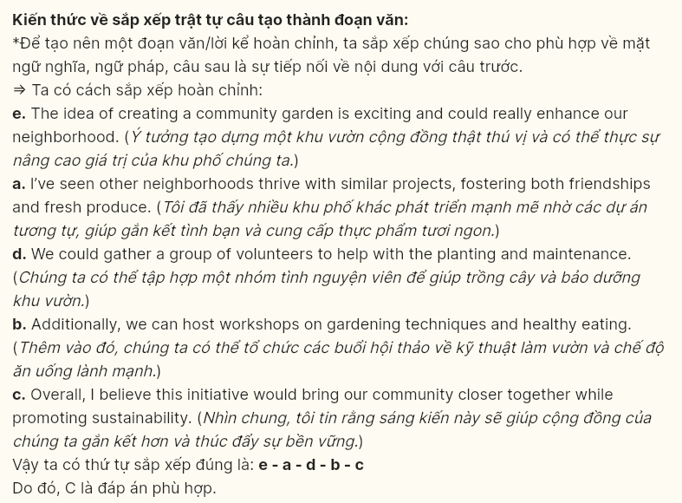  
**Question 17 [695318]:**

a. Besides, the introduction of innovative programs in fields like data science reflects the institution’s response to current job market demands.  
b. However, while these changes are promising, some students feel that more can be done to address the existing challenges.  
c. The university has undergone significant changes in recent years to enhance the student experience.  
d. New facilities have been built, providing modern resources that support learning and collaboration.  
e. These developments have led to an increase in enrollment, attracting a more diverse group of students.

A. c-d-a-e-b B. c-b-e-a-d C. c-a-b-e-d D. c-e-a-d-b

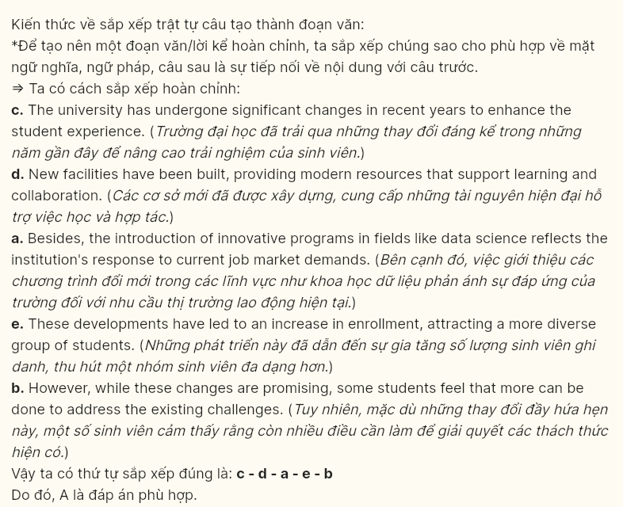  
 **Read the following passage and mark the letter A, B, C or D on your answer sheet to indicate the option that best fits each of the numbered blanks from 18 to 22.**

Nguyen Thi Anh Vien, a celebrated Vietnamese swimmer, (18) _______. Born on November 9, 1996, in Can Tho City, she demonstrated a passion for swimming at an early age, training rigorously to refine her skills. Overcoming numerous challenges such as intense competition and rigorous training schedules, Anh Vien quickly rose to prominence in national swimming events, earning a reputation as one of Vietnam’s top athletes.

Her breakthrough came when she represented Vietnam in international competitions. Anh Vien’s dedication and hard work have earned her multiple medals at major tournaments (19) _______. As a result, she has become a role model for young athletes across the country.

Beyond her athletic career, Anh Vien is passionate about promoting swimming and sports among youth in Vietnam. She actively participates in community outreach programs (20) _______. Through her efforts, she aims to inspire the next generation of swimmers and instill a love for the sport.

Fostering young talent through the establishment of a swimming academy, (21) _______. This initiative reflects her belief that every child should have the opportunity to learn how to swim. By offering quality training and support, she inspires confidence in young swimmers (22) _______.

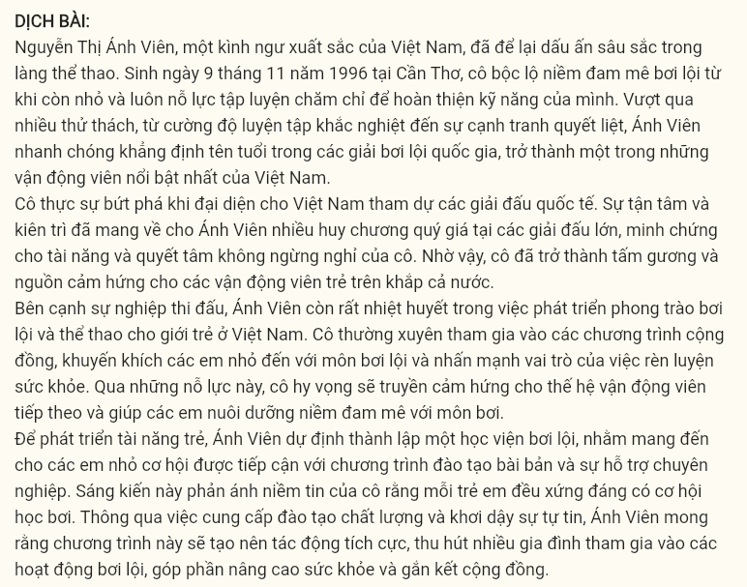

**Question 18 [695319]:**  
A. having made a significant impact in the world of sports  
B. who has made a significant impact in the world of sports  
C. whose significant impact in the world of sports has been made  
D. has made a significant impact in the world of sports

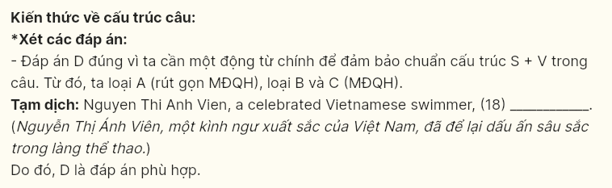

**Question 19 [695320]:**  
A. of which her impressive performances as well as a testament to her determination  
B. which showcase her impressive performances as well as a testament to her determination  
C. showcase her impressive performances and serve as a testament to her determination  
D. succeed in showing her impressive performances and serving as a testament to her determination

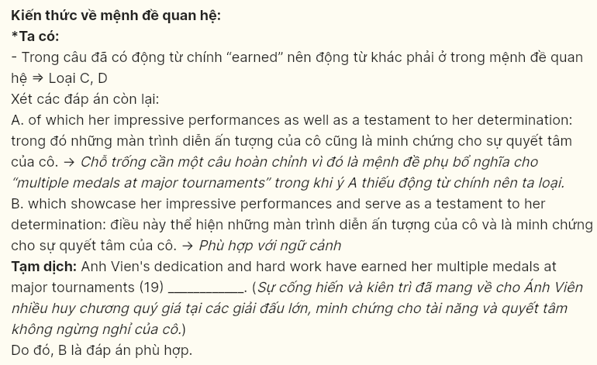

**Question 20 [695321]:**  
A. Anh Vien plans to ensure that more children have access to quality training and support  
B. More and more children have access to quality training and support through Anh Vien’s plans  
C. Access to quality training and support can be provided for more children through Anh Vien’s plans  
D. There are plans to provide access to quality training and support for more children

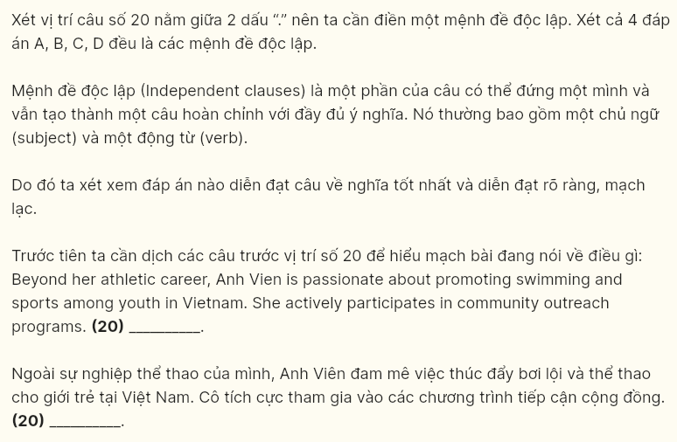

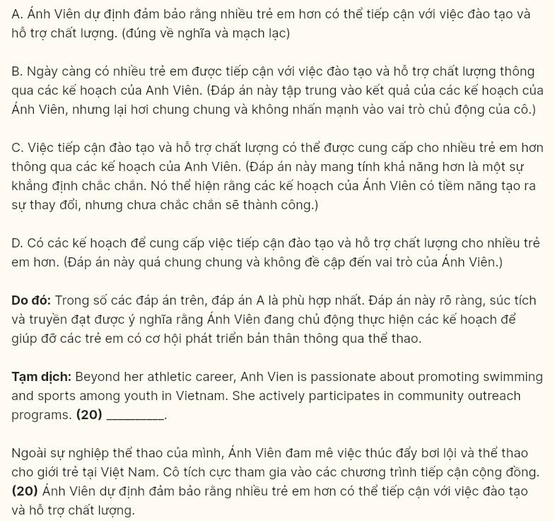

**Question 21 [695322]:**  
A. Anh Vien plans to ensure that more children have access to quality training and support  
B. More and more children have access to quality training and support through Anh Vien’s plans  
C. Access to quality training and support can be provided for more children through Anh Vien’s plans  
D. There are plans to provide access to quality training and support for more children

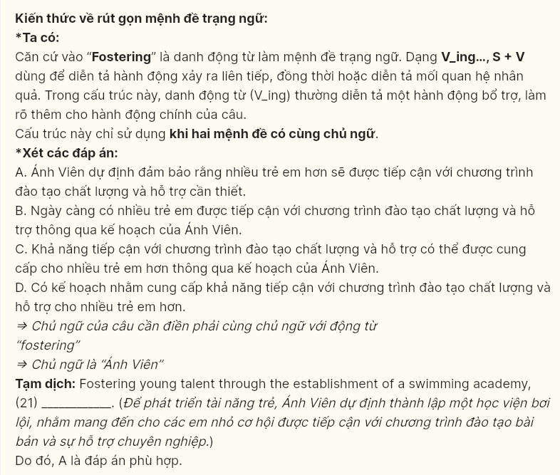

**Question 22 [695323]:**  
A. Without encouraging more families to engage in swimming activities, she expects this program to create a positive impact on the community  
B. More families engage in swimming activities so that she envisions this program creating a positive impact on the community  
C. She envisions this program creating a positive impact on the community, encouraging more families to engage in swimming activities  
D. Imagine creating a positive impact on the community, this program encourages more families to engage in swimming activities

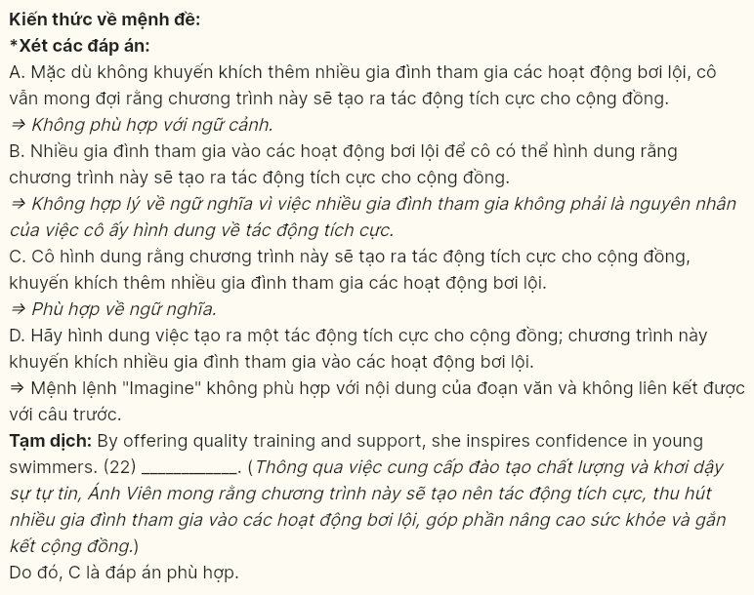

**Read the following passage and mark the letter A, B, C or D on your answer sheet to indicate the best answer to each of the following questions from 23 to 30.**

Conservation of endangered animals is an urgent issue in today’s world. According to the International Union for Conservation of Nature (IUCN), over 28,000 species of animals are currently facing extinction, with approximately 6,500 species listed as critically endangered. This alarming figure highlights the pressing need for conservation efforts worldwide. One **notable** example is the Javan rhinoceros (*Rhinoceros sondaicus*), with an estimated population of only about 80 individuals surviving in the wild, primarily in Ujung Kulon National Park, Indonesia. This species has suffered from habitat loss due to agricultural developments and poaching for **their** horns.

The main causes of the decline in these animal populations include habitat loss, poaching, and climate change. For instance, the white rhinoceros (*Ceratotherium simum*) has nearly gone extinct due to uncontrolled hunting, with only two northern white rhinos remaining, both females, living in a secure reserve in Kenya. **These two rhinos symbolize the drastic consequences of human actions on wildlife and serve as a reminder of the urgent need for protective measures.**

Conservation organizations are working **tirelessly** to reverse this trend. Many breeding and reintroduction programs have been implemented, such as the panda conservation program (*Ailuropoda melanoleuca*) in China, which has successfully increased the wild giant panda population to over 1,800 individuals. Additionally, investments in education and community awareness campaigns are crucial in protecting endangered species and their habitats.

The future of many animal species depends on our actions today. If we promote conservation measures, support protective programs, and implement comprehensive environmental policies, we can ensure that future generations will experience and appreciate the rich biodiversity of our planet. Collective efforts are essential to safeguard these remarkable creatures and secure their ecosystems for further time.

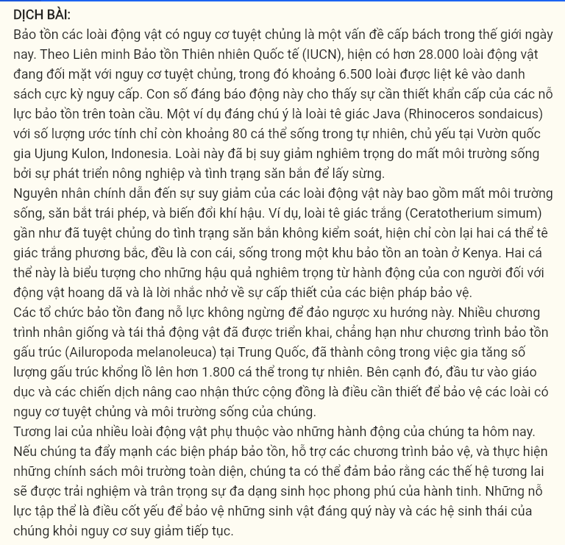

**Question 23 [695324]:** The word **notable** in paragraph 1 is OPPOSITE in meaning to ______.  
A. striking B. minor C. outstanding D. serious

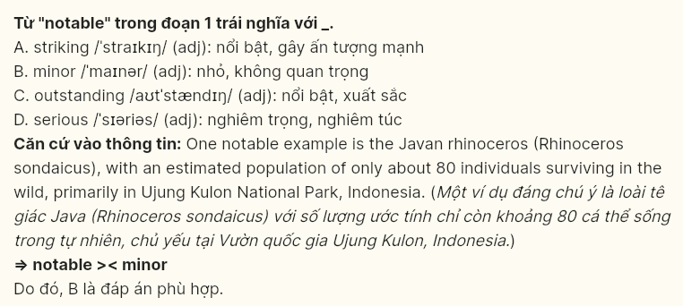

**Question 24 [695325]:** Which of the following is **NOT** mentioned as a cause of the decline in animal populations?  
A. natural predators B. climate change C. habitat loss D. poaching

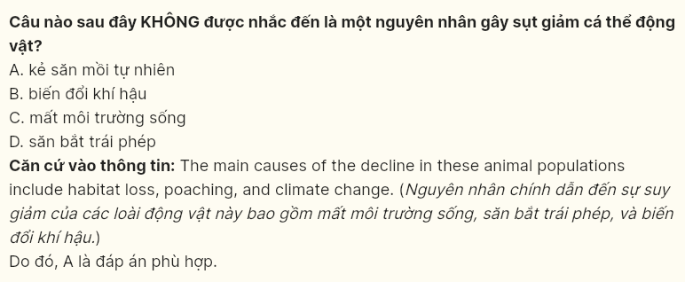

**Question 25 [695326]:** The word **their** in paragraph 1 refers to _______.  
A. endangered animals B. conservation efforts  
C. Javan rhinoceros D. agricultural developments

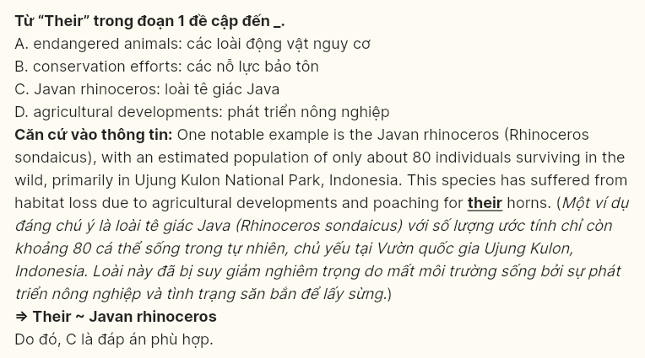

**Question 26 [695327]:** Which of the following best paraphrases the underlined sentence in paragraph 2?  
A. These two rhinos demonstrate the adverse effects of human actions on wildlife and overestimate the pressing need for protective measures.  
B. These two rhinos show the important impact of human actions on wildlife and introduce some possible protective measures.  
C. These two rhinos indicate the serious consequences of human actions on wildlife and emphasize the pressing need for alternative measures.  
D. These two rhinos represent the severe effects of human actions on wildlife and underscore the pressing need for protective measures.

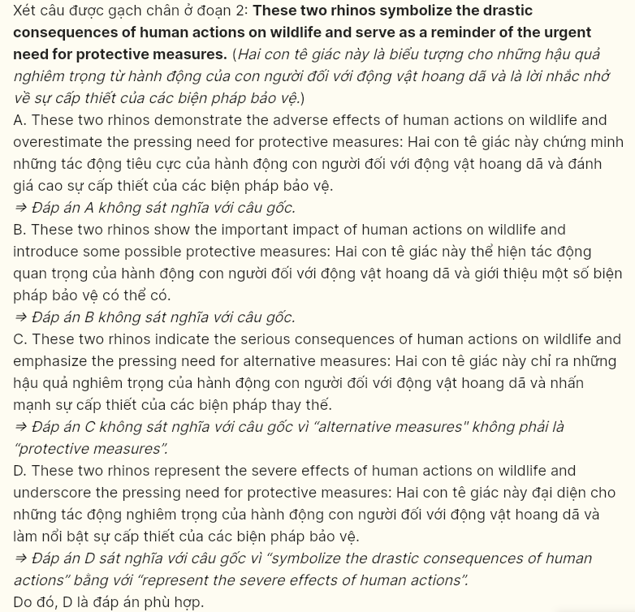

**Question 27 [695328]:** The word **tirelessly** in paragraph 3 could be best replaced by ______.  
A. positively B. dramatically C. continuously D. immediately

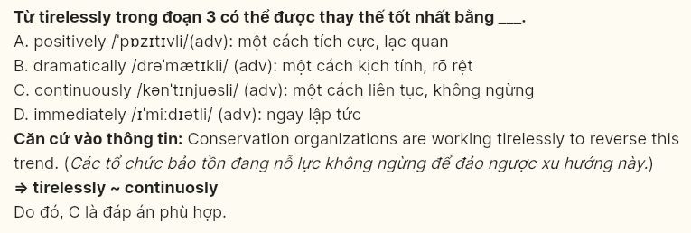

**Question 28 [695329]:** Which of the following is **TRUE** according to the passage?  
A. The Javan rhinoceros has a stable population of over 1,800 individuals.  
B. The panda conservation program has helped increase the giant panda population.  
C. Habitat loss is not a significant threat to endangered species.  
D. Conservation organizations have ceased their efforts to protect wildlife.

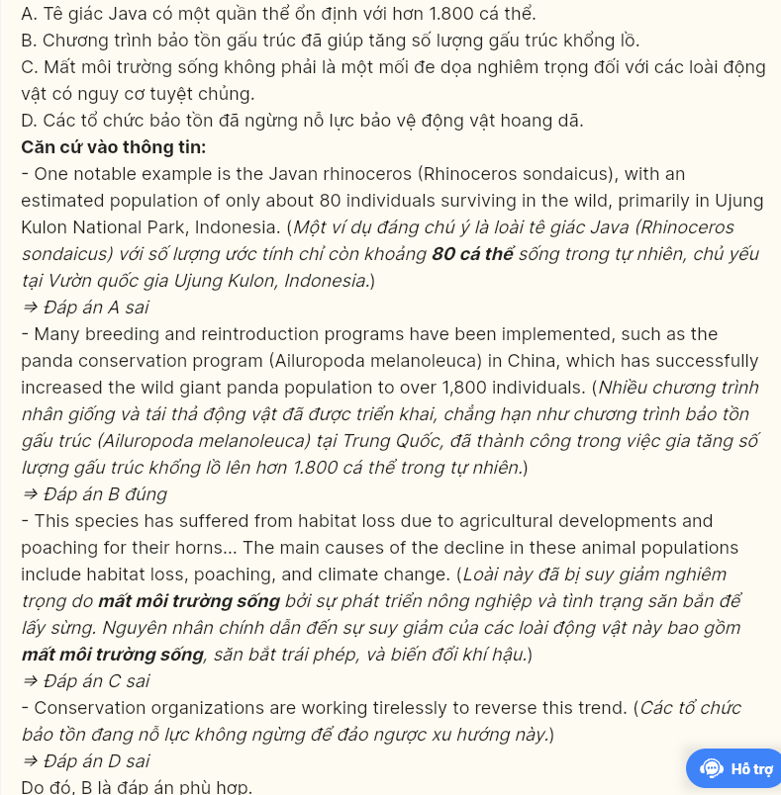

**Question 29 [695330]:** In which paragraph does the writer mention a **conditional relationship**?  
A. Paragraph 1 B. Paragraph 2 C. Paragraph 3 D. Paragraph 4

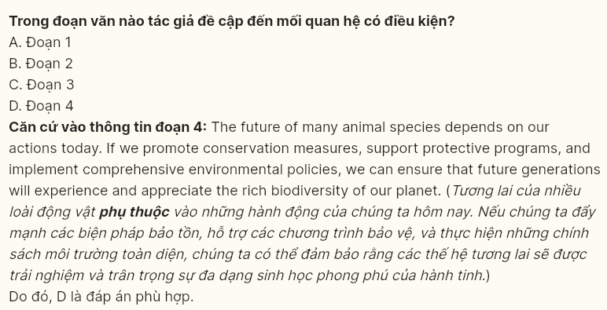

**Question 30 [695331]:** In which paragraph does the writer describe initiatives taken to improve the situation of endangered animal species?  
A. Paragraph 1 B. Paragraph 2 C. Paragraph 3 D. Paragraph 4

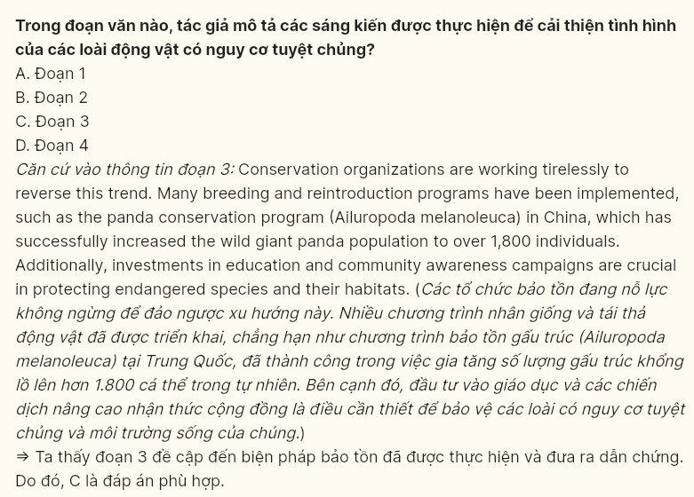

**Read the following passage and mark the letter A, B, C or D on your answer sheet to indicate the best answer to each of the following questions from 31 to 40.**

**[I]** In today’s society, celebrities wield significant influence over young people. **[II]** With the rise of platforms like Instagram, TikTok, and YouTube, celebrities can easily connect with their audience, creating a more personal relationship that often **translates** into admiration and emulation. **[III]** This dynamic can lead to both positive and negative effects on youth, making it a crucial topic of discussion. **[IV]**

On one hand, celebrities can inspire young people to pursue **their** dreams and passions. Many celebrities use their platforms to advocate for important social issues, such as mental health awareness, environmental conservation, and equality. For instance, figures like Selena Gomez and Dwayne “The Rock” Johnson have openly discussed their struggles with mental health, encouraging young people to seek help and destigmatize these conversations. Such visibility can empower youth to take action and make positive changes in their lives and communities.

However, the influence of celebrities is not always beneficial. The unrealistic standards of beauty, success, and lifestyle often promoted by celebrities can lead to feelings of inadequacy among young people. When celebrities flaunt extravagant lifestyles or promote **unattainable** beauty ideals, it can create pressure on youth to conform to these images, potentially leading to issues like low self-esteem and body image disorders. Furthermore, the glamorization of negative behaviors, such as substance abuse or reckless living, can have detrimental effects on impressionable minds.

In conclusion, while celebrities hold the power to inspire and motivate young people, their influence can also lead to negative consequences**. It is essential for youth to develop critical thinking skills and to recognize that celebrity lifestyles are often curated and not representative of reality***.* Encouraging a balanced perspective on celebrity influence can help empower young people to make informed choices and to follow their own paths rather than simply imitating those they admire.

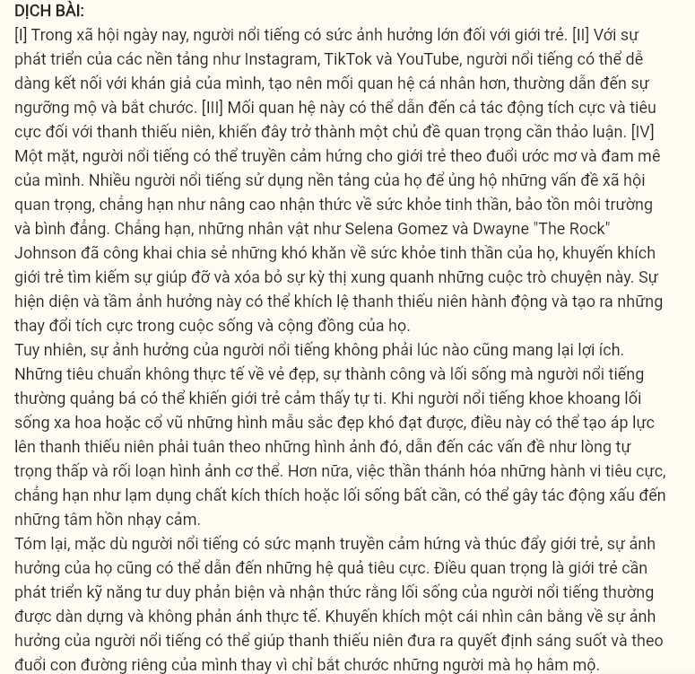

**Question 31 [695332]:** Where in paragraph 1 does the following sentence best fit?  
***“Whether through music, film, sports, or social media, their actions and opinions can shape the thoughts, behaviors, and aspirations of millions.”***  
A. [I] B. [II] C. [III] D. [IV]

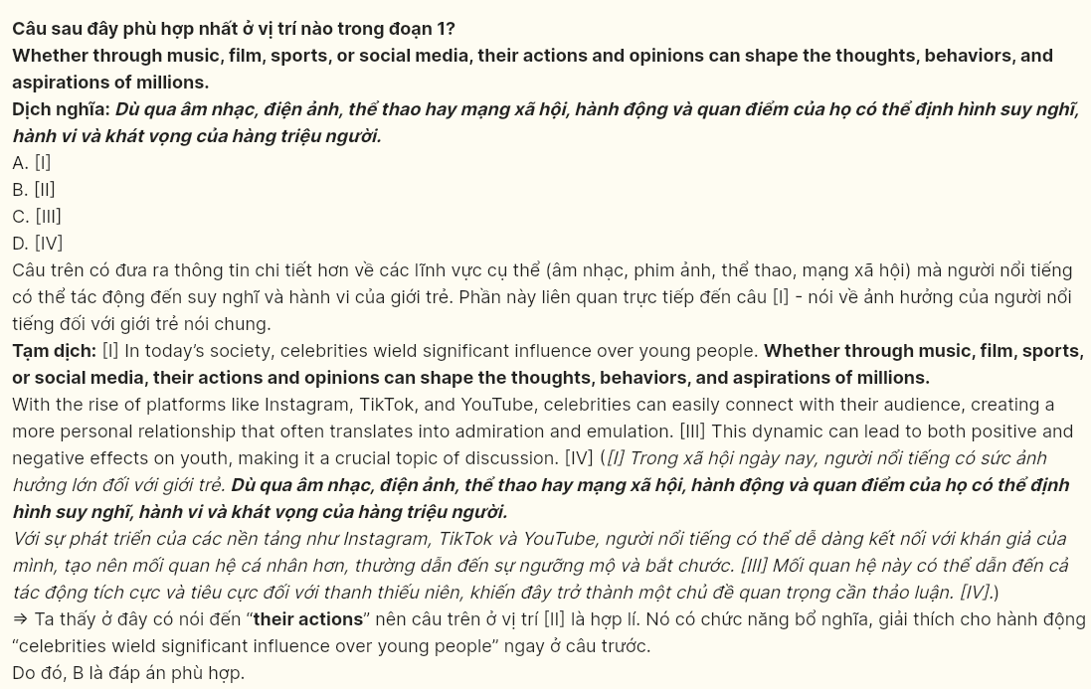

**Question 32 [695333]:** The word ***translates*** in paragraph 1 could be best replaced by ______.  
A. pronounces B. remains C. changes D. transports

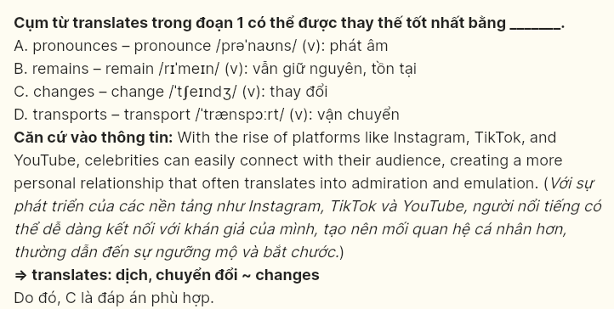

**Question 33 [695334]:** The word ***their*** in paragraph 2 refers to ______.  
A. celebrities B. young people C. dreams D. passions

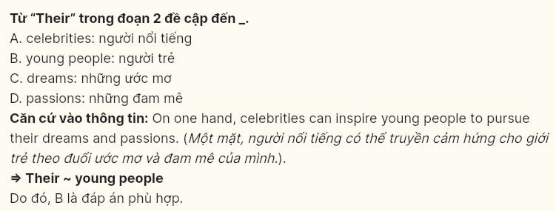

**Question 34 [695335]:** According to paragraph 2, which of the following is **NOT** a reason why celebrities can inspire young people?  
A. advocating for important social issues  
B. discussing their personal struggles  
C. promoting beauty standards  
D. encouraging positive changes in communities

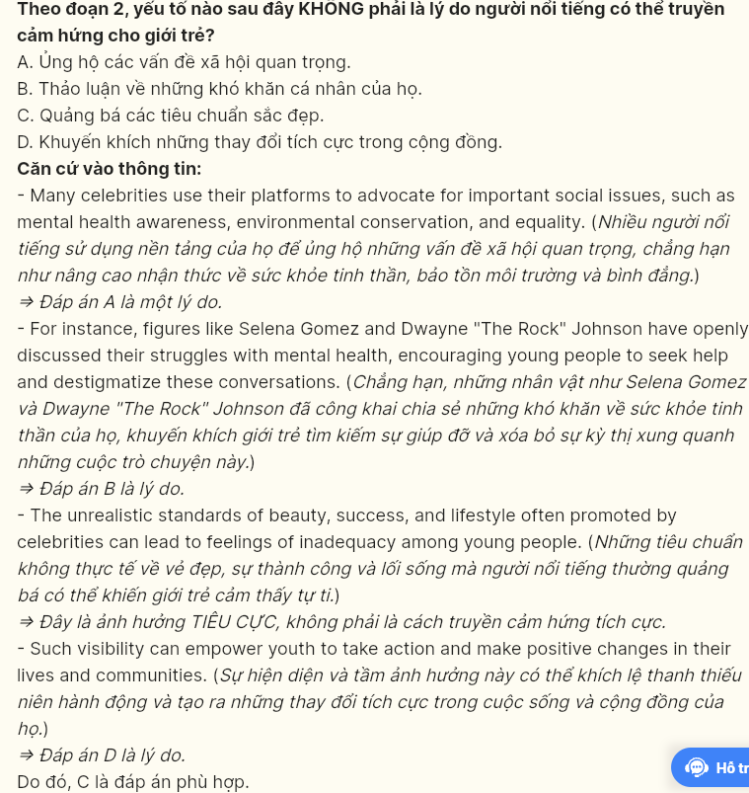

**Question 35 [695336]:** Which of the following best summarizes paragraph 3?  
A. Celebrity influence can lead to feelings of inadequacy among young people due to unrealistic beauty standards they promote.  
B. The extravagant lifestyles flaunted by celebrities create pressure on youth to conform to unattainable ideals.  
C. The glamorization of negative behaviors by celebrities can harm impressionable young minds and it should be addressed.  
D. Celebrity influence can negatively affect young people by promoting unrealistic beauty standards and lifestyles, leading to low self-esteem and the glamorization of harmful behaviors.

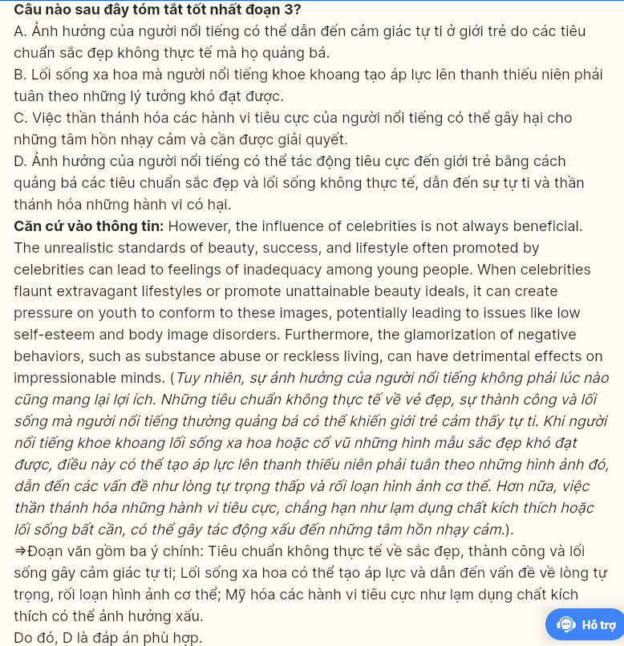

**Question 36 [695337]:** The word **unattainable** in paragraph 3 is OPPOSITE in meaning to ______.  
A. avoidable B. achievable C. impossible D. unrealistic

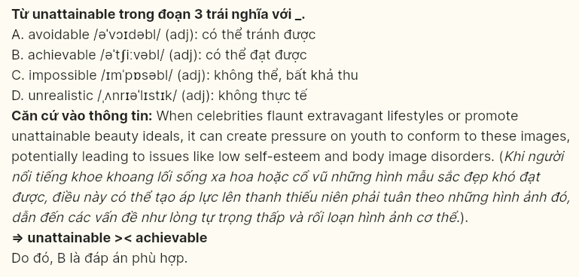

**Question 37 [695338]:** Which of the following is **TRUE** according to the passage?  
A. The influence of celebrities on young people is entirely positive.  
B. Celebrities only promote harmful behaviors and have no positive impact.  
C. The impact of celebrities on youth can be both beneficial and harmful.  
D. All young people blindly follow celebrity lifestyles without question.

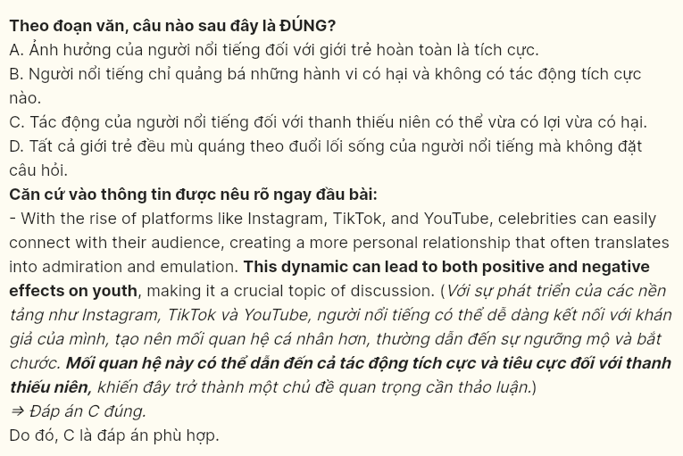

**Question 38 [695339]:** Which of the following best paraphrases the underlined part in paragraph 4?  
A. Young people need to enhance their critical thinking abilities and recognize that celebrity lifestyles are usually fabricated and always depict actual reality.  
B. It is vital for youth to improve their reasoning skills and understand that the lives of celebrities are often underestimated and not a true reflection of everyday life.  
C. Young individuals should focus on building their critical thinking skills and understand that celebrity lifestyles are portrayed in a way that reflects real-life experiences.  
D. It is important for young people to cultivate critical thinking skills and understand that celebrity lifestyles are planned and carefully designed, rather than reflective of actual reality.

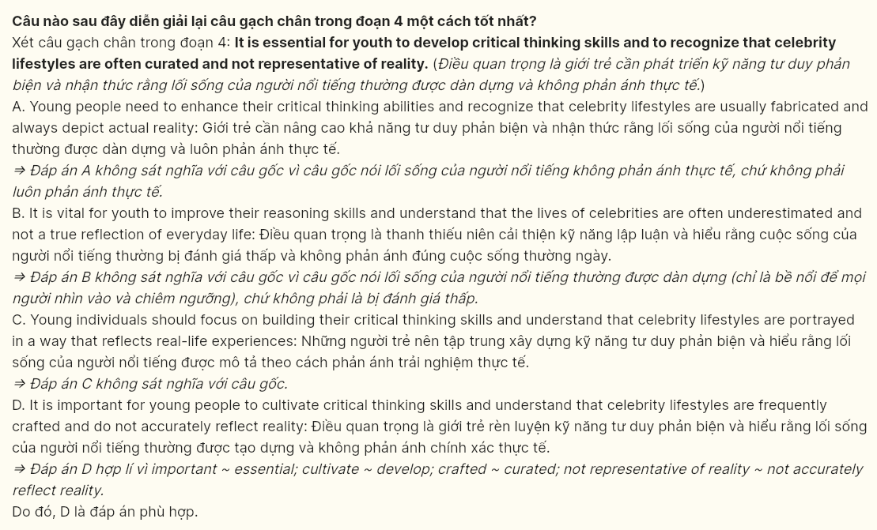

**Question 39 [695340]:** Which of the following can be inferred from the passage?  
A. Celebrities have a responsibility to shape the values and decisions of young people positively.  
B. Young people understand the realities behind celebrity lifestyles but often choose to imitate them.  
C. A balanced view of celebrity influence can enable young people to make reasoned life choices.  
D. Many young people believe that celebrity lifestyles are realistic and attainable for everyone.

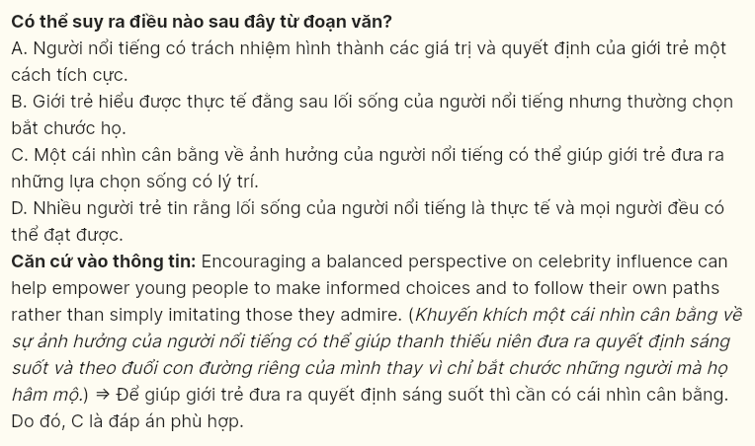

**Question 40 [695341]:** Which of the following best summarises the passage?  
A. Celebrities can inspire young people, but their influence also creates unrealistic expectations, making critical thinking essential for informed choices.  
B. Young people are influenced by social media and often admire celebrities without questioning their lifestyles or values critically.  
C. The influence of celebrities is primarily negative, promoting unattainable beauty standards that lead to low self-esteem among youth.  
D. Many celebrities advocate for important social issues, but their lifestyles can still mislead young people about what is realistic.

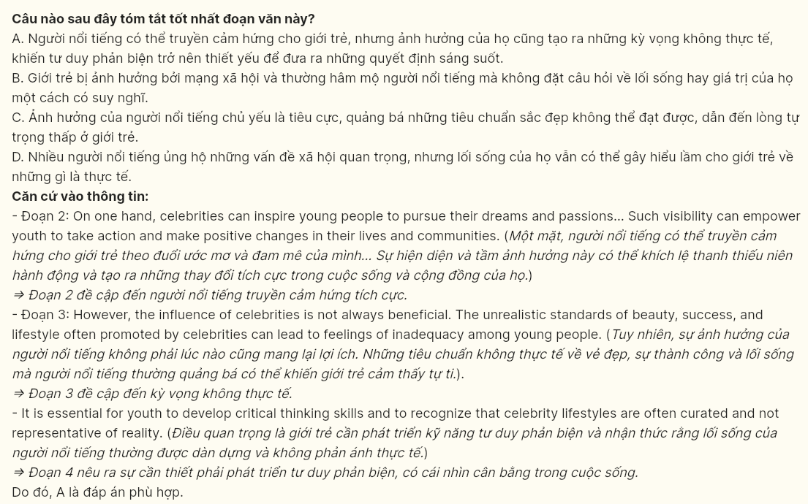

**---- THE END -----**