Date of preparing: ………………………………….
Date of teaching: ………………………………….

Period……
UNIT 2: SCHOOL
Lesson 3 - Part 1 (Page 20) - Vocabulary and Listening

I. OBJECTIVES
By the end of the lesson, Ss will be able to...
1. Knowledge
- know more vocabularies used in book reviews.
- talk about different kinds of books.
- use some useful languages to talk about their favorite book.
2. Ability
- improve the use of English, speaking and listening skills.
3. Quality
- have positive attitude in English language learning so that they actively participate in all classroom activities.
- love their school, love reading books, love English and literature.

II. TEACHING AIDS AND LEARNING MATERIALS
Lesson plan, PPT slides, student’s book, workbook, notebook, personal computer (if any), projector/TV, speakers, DCR &DHA on EDUHOME, handouts…

III. PROCEDURES
A. Warm up: (5’)
a) Objective: to introduce the new lesson and set the scene for Ss to acquire new language; to get students' attention at the beginning of the class by means of enjoyable and short activities as well as to engage them in the steps that followed.
b) Content: Introduction of 3 books: Peter Pan, The Secret of the Old Clock and My Side of the Mountain
c) Product: Ss have general ideas about the books they are going to talk about in the lesson.
d) Competence: Collaboration, critical thinking
e) Organization of the activity:
Teacher’s Activities | Students’ Activities
- Give greetings  - Check attendance  - Option 1:  - Show a trailer of one of the three films: Peter Pan, The Secret of the Old Clock or My Side of the Mountain. These films were made from the famous books with the same name  - Link:  Peter Pan: https://www.youtube.com/watch?v=SyYESEvDNIg  The Secret of the Old Clock: https://www.youtube.com/watch?v=uR57KXwedhg  My Side of the Mountain: https://www.youtube.com/watch?v=I7xFu0xU5Rc  → Lead to the new lesson  - Option 2: Matching  - Show 3 pictures and have Ss match them with the names given  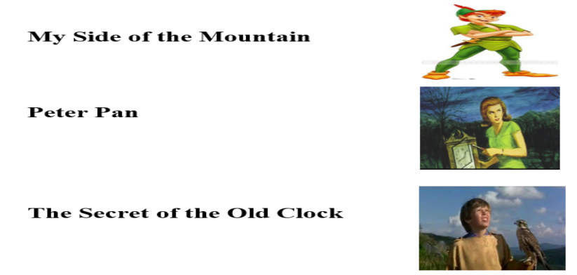  - Call Ss to give answers  - Check Ss’ answers, then introduce the three books: Peter Pan, The Secret of the Old Clock and My Side of the Mountain  - → Lead to the new lesson | - Greet T  - Watch and guess what they are going to study in this lesson  - Look and match  Answer keys  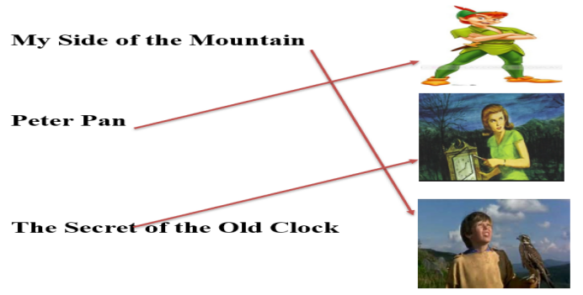  - Give answers  - Listen

B. New lesson (35’)
- Activities 1: Vocabulary (15’)
a) Objective: Ss know more vocabularies used in book reviews and they can use new vocabularies to talk about the story they like to read.
b) Content:
- reading and matching bold words with definition
- talking about the story they like to read
c) Products: Ss know how to pronounce the new words correctly and use them in appropriate situations.
d) Competence: Communication, collaboration, presentation, listening, creativity
e) Organization of the activity:
Teacher’s Activities | Students’ Activities
a. Read the text and match the underlined words with the definition. Listen and repeat  - Option 1:  - Demonstrate the activity, using the example in the book  - Have Ss read the text and match the underlined words with the definitions  - Ask Ss to work in pairs to check their answers with their partners  - Check answers as a whole class  - Explain more about the meaning of the new words if necessary  - Play the audio (CD1 – Track 26) for Ss to listen and repeat  - Call some Ss to read the words / phrases again, correct their pronunciation and stress  - Option 2: (for class with low-level students)  - Demonstrate the activity, using the example in the book  - Have Ss read 5 sentences first, help them with difficult and strange words  - Then have Ss read the text and match the underlined words with the definitions. Guide Ss to find key words to help them find answers quickly and correctly  - Call Ss to give answers, check  - Play the audio (CD1 – Track 26) for Ss to listen and repeat  - Call some Ss to read the words / phrases again, correct their pronunciation and stress  b. Talk to your partner: Which story would you like to read?  - Have Ss work in pairs  - Have Ss share their ideas with the class | - Look and listen  - Read and match  - Work in pairs  - Listen and check  - Listen and repeat  - Read  Answer keys  2. adventure 3. novel  4. author 5. mystery  - Read  - Read and match  - Underline key words  - Give answers  - Listen  - Read  Answer keys  2. adventure (key words: new place, away from New York to live in a mountain)  3. novel (key words: people, events)  4. author (key words: the name: J.M. Barrie)  5. mystery (key words: secret)  - Work in pairs  - Give answers  Expected answers  - Which story would you like to read?  - I’d like to read The Secret of the Old Clock. I like mystery story. / I’d like to read My Side of the Mountain. I like adventure story.
- Activity 2: Listening (10’)
a) Objective: Ss can develop their listening comprehension skills.
b) Content: listening to some students talking about books.
c) Products: Ss can listen main ideas and specific information about books.
d) Competence: Collaboration, communication, listening, analytical and synthesizing skills.
e) Organization of the activity:

Teacher’s Activities | Students’ Activities
a. Listen to some students talking about books. Circle their favorite kind of book  - Have Ss look at the request of the task  - Play audio (CD1 – Track 27)  - Have Ss listen and circle the speaker’s favorite kind of book  - Call Ss to give answers  - Check answers as a whole class  b. Listen and fill in the blanks  - Have Ss read the sentences in the task  - Have guess the possible words to be filled in – paying attention to the part of speech of the words in blanks (noun or adjective)  - Play audio (CD1 – Track 27)  - Have Ss listen and fill in the blanks  - Call Ss to write answers on the board  - Check answers as a whole class | - Read  - Listen and circle  - Give answers  Answer keys  1. mystery  2. adventure  - Read  - Listen and fill in the blanks  - Write answers  Answer keys  1. author  2. interesting  3. exciting  4. author
- Activity 3: Grammar – Useful language (10’)
a) Objective: Ss can use some useful languages in their speaking.
b) Content: Structures to ask and answer about favorite books.
c) Products: Ss produce the new language successfully.
d) Competence: Collaboration, communication, public speaking.
e) Organization of the activity:

Teacher’s Activities | Students’ Activities
Listen then practice  - Option 1:  - Have Ss look at the Useful Language box  - Play audio (CD1 – Track 28)  - Have Ss practice the useful language  - Call Ss to demonstrate the dialogue in front of the class  - Have Ss practice the conversation, using other vocabularies from “New words”, and their own ideas  - Call some pairs to present, give feedback and evaluation  - Option 2: (for class with low-level students)  - Play audio (CD1 – Track 28)  - Have Ss practice the useful language in pairs, then use their own ideas about books to make a conversation  - Give Ss some cues about books for their free practice  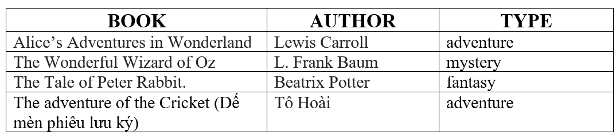  - Call some pairs to present, give feedback and evaluation | - Look  - Practice in pairs  - Act out the dialogue  - Work in pairs  - Listen  - Practice  - Write answers

C. Consolidation (3’)
* Vocabulary about books: novel, adventure, author, mystery, fantasy
* Some useful languages:
What’s your favorite book? – I like …
What kind of book is it? – It’s …
Who’s the author? – It’s by …
Why do you like it? – I think it’s very …
D. Homework (2’)
- Learn by heart the new vocabularies
- Ask and answer about your favorite book.
- Do exercises in Workbook: Lesson 3 - New words – Listening (page 12)
- Prepare: Lesson 3 – Reading, Speaking and Writing (page 21 – SB)

