|  |  |
| --- | --- |
| UBND HUYỆN CẨM GIÀNG  **TRƯỜNG THCS CẨM VŨ** | **ĐỀ KIỂM TRA GIỮA HỌC KỲ I**  **NĂM HỌC 2022 - 2023**  **MÔN: TIẾNG ANH LỚP 6**  **Thời gian làm bài 60 phút**  **Đề gồm có 03 trang** |

**A. LISTENING:**

**I. Listen and choose the correct picture. ( 1.0 pt)**

1. What’s Tom playing?

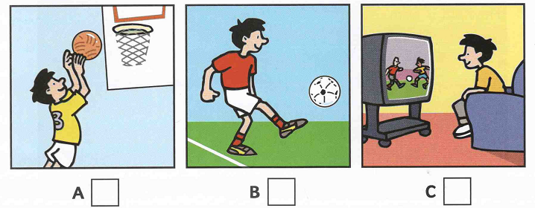

2. What’s Nick doing?

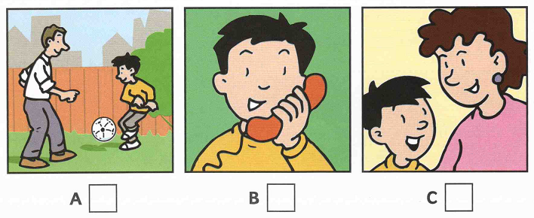

3. What’s Pen doing?

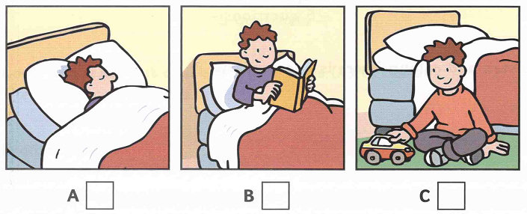

4. What’s Kim doing?

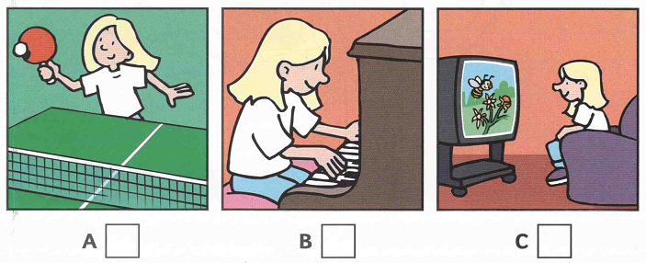

5. What’s Ann painting?

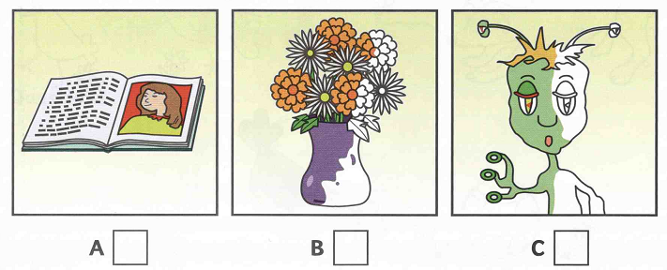

**II. Listen and complete the gaps. ( 1.0pt )**

What’s the boy’s name: ***Nick***

How old is he? ***9***

6. What is the name of Nick’s dog? ………………………………

7. How old is the dog? ………………………………

8. Where is Nick’s flat? In…………………………Street

9. Where is Nick going now? To………………………..Park

10. What number is Nick’s bus? ………………………………

**B. VOCABULARY – GRAMMAR – LANGUAGE FUNCTION**

**I. Choose the best option A, B, C or D to complete the sentences. (3.0pts)**

11. Is the boy strong or weak? - ________ is weak.

A. He B. She C. It D. They

12. ________ color is your shirt?

A. How B. What C. Where D. When

13. What ________ is your bag? - It's green.

A. size B. color C. date D. money

14. Is she old or ________?

A. tall B. weak C. young D. short

15. Is her face round ________ oval?

A. and B. but C. or D. so

16. They ________ badminton every day.

A. do B. have C. play D. study

17. He ________ an intereting book at the moment.

A. read B. is reading C. are reading D. reads

18. Hoa is very ________. She always does her homework.

A. creative B. hard-working C. kind D. helpful

19. There is a washing machine in the ________.

A. bedroom B. attic C. kitchen D. living room

20. I have ________ hair.

A. black long B. black and long C. a long black D. long black

21. We live in a town house, but our grandparents live in a ________house.

A. villa B. big C. city D. country

22. My car is new but ________ is old.

A. her B. hers C. she D. it

23. Nam: "How are you, Ba and Ha?" Ba and Ha: "________ "

A. I'm fine. Thanks. B. We are fine. Thanks.

C. They are fine. Thanks. D. He's fine. Thanks.

24. Phong: "Let’s go to the bookshop." Mi: “________”

A. Good idea B. No, thanks C. Yes, I can D. No, I don't.

25. Nga: "What is your best friend like?" Lan: “________”

A. She’s tall and slim. B. She’s kind and friendly.

C. She likes reading. D. She is a student.

**C. READING:**

**I. Read the passage and choose the best answer A, B, C or D to complete the passage (1.5pts)**

I live in a small house near the sea. There are two bed rooms upstairs _____(26) _____ no bathroom. The bathroom is down stairs between the kitchen and there is a living room where there is a lovely old fire place. There is a garden_____ (27) _____ the house. The garden _____ (28) _____ down to the beach and in spring and summer_____ (29) _____flowers everywhere. I love my house for_____ (30) _____reasons: the garden, the flowers in summer, the fee in winter, but the best thing is the view from my bedroom window.

26. A. and B. but C. so D. or

27. A. in front B. front C. front of D. in front of

28. A. is going B. goes C. going D. go

29. A. these are B. there are C. they are D. those are

30. A. a B. any C. many D. much

**II. Read the passage and choose the best answer A, B, C or D(1.5 pts)**

Hi, my name is Anna. This is the photo of my family. There are six people in my family: my grandmother, my grandfather, my mother, my father, my elder brother and me. These are my grandparents. They are old and retired. They love gardening and doing morning exercise. This is my father. He is forty-one and he is a doctor. He works in a big hospital. This is my mother. She is thirty-eight. She is an Art teacher. She teaches in a secondary school. This is my elder brother. His name is Jack. He is sixteen and he is a high school student. I'm ten and I'm the youngest in my family. Our family lives in a house on Nguyen Hue Street. The house is a little small but it's lovely. There is five rooms: a living room, two bedrooms, a bathroom and a kitchen. However, the thing I love most is that the house also has a big garden and a large pond behind it. These are the places where my family likes to relax or fish on weekends.

***31.How many people are there in Anna's family?***

A. 6 B.7 C. 8 D. 9

***32. How old are Anna's parents?***

A. Her mother is 40 and father is 41. B. Her father is 38 and mother is 41.

C. Her mother is 38 and father is 41. D. Her mother is 41 and father is 41.

***33. Where does Anna's father work?***

A. In a big school B. In a big hospital

C. In a secondary school D. On a big farm.

***34. How many rooms are there in her house?***

A. 5 B.6 C.7 D.8

***35. Is there a garden behind her house?***

A. No, there isn't. B. Yes, it is.

B. Yes, there is. C. Yes, there are.

**D. WRITING**

**I. Rewrite these sentences with the same meaning.(1.0pt)**

36. My school has thirteen classes.

-> There …………………………………………………………….……..

37. Her hair is long and brown.

-> She has………………………………………………………........……..

38. My house is behind the bookshop.

-> The bookshop is ……………………………………………...................

39. There are five rooms in my house.

-> My house………………………………………………..............……….

40. Let’s go swimming this afternoon.

-> How about …………………………………………………………........?

**II. Write a parargraph (40-50 words) about your new school, using these suggested words and phrases. (1.0pt)**

*My school/ Cam Vu Secondary school. It/ Phu Loc.*

*It/ have/ trees/ big yard.*

*There/ 13 classes/ 500 students/ 27 teachers.*

*Students/ study/ hard./ They/ play games/ resess.*

*Thing I like/ the air/ fresh. I/ love/ school.*

**\*\*\*The end\*\*\***