Unit 4-English 7
II. TOPIC SPEAKING.
1
11
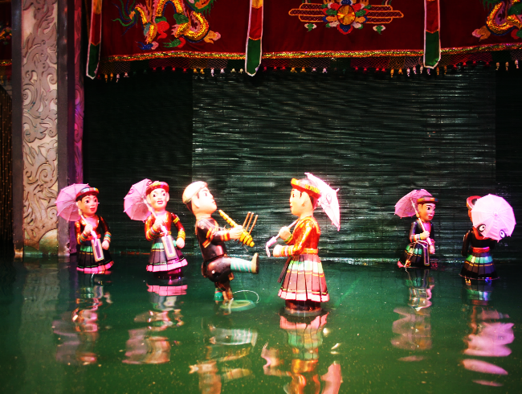 | 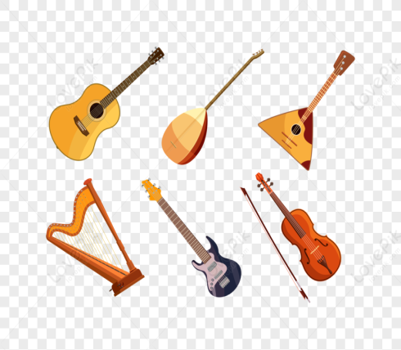  2 |   3 |   4
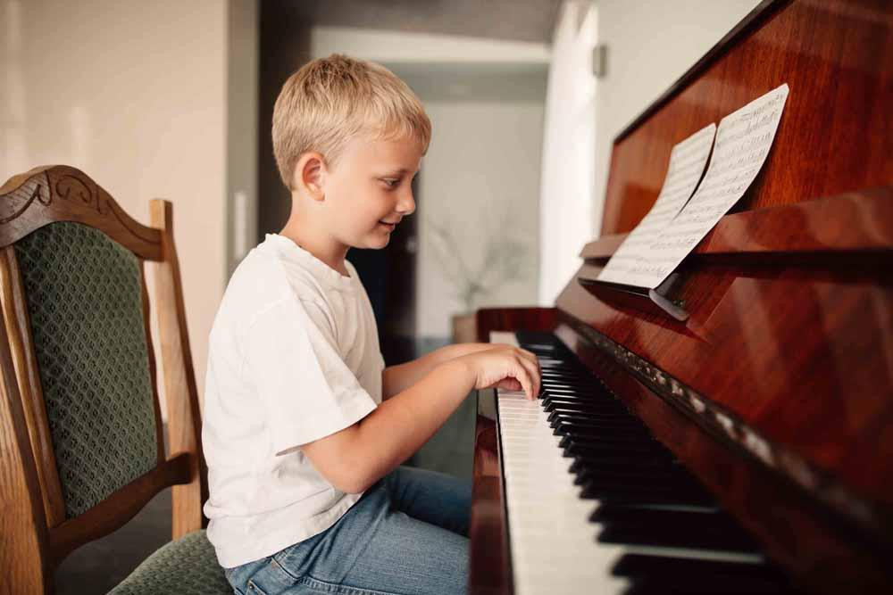    12 | 1. What is this/What are these? (2, 3, 6, 9)  2. What can you see in the picture? (2, 3, 6, 9)  3. Where is he/she? (8)/Where are they? (5)  4. What is she doing? (4, 7, 11, 12)  5. What does she/he prefer doing? (7, 4, 11, 12)  6. It is a traditional Vietnamese art form which artists perform in a pool. (1)  7. This is a person who writes songs. (10) |  | 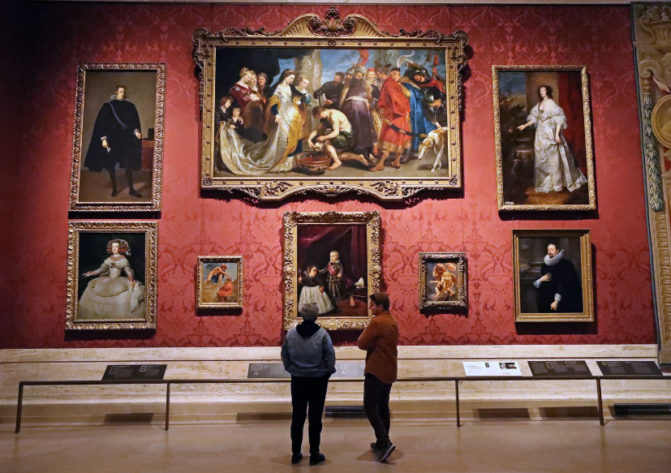  6  5
 |  |  | 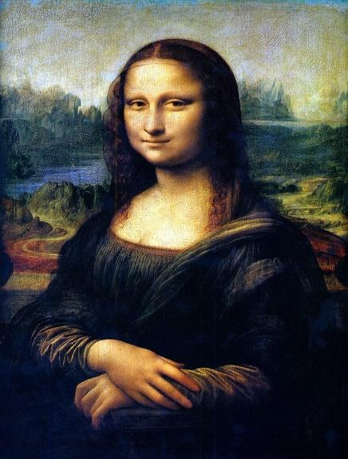
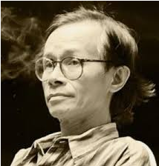  10 | 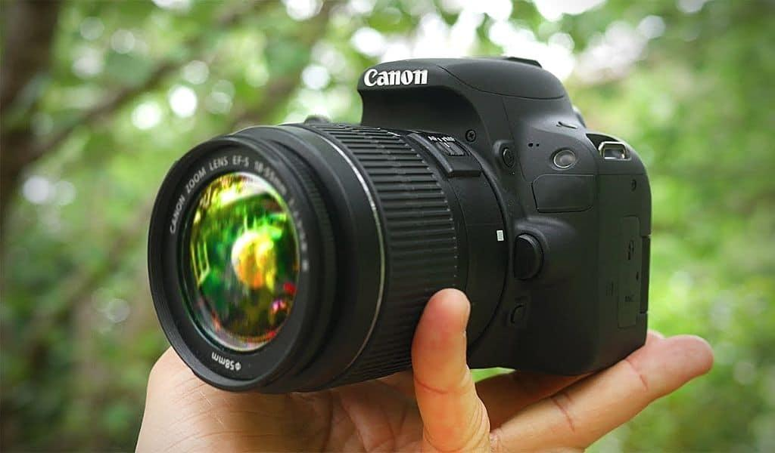  8  9 | 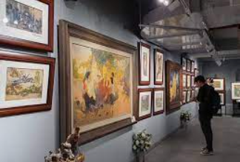 | 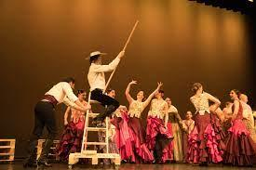  7
KEY:
- water puppetry | 7. perform
- musical instruments | 8. art gallery
- paintbrush | 9. camera
- taking photos | 10. composer
- museum | 11. playing the piano
- portrait | 12. painting
III. Q&A.
1. Can you name some musical instruments?
2. What kind of musical instruments can you play?
3. How often do you go to the concert/ theater/ art gallery/ cinema?
4. Who do you often go to the concert/ theater/ art gallery/ cinema?
5. What kind of music do you prefer?
6. Who is your favourite composer/ singer/ artist?

