Date of preparing: ………………………………….
Date of teaching: ………………………………….

Period …
UNIT 5: AROUND TOWN
Lesson 4 - REVIEW (Page 94)

I. OBJECTIVES
By the end of the lesson, Ss will be able to…
1. Knowledge
- review vocabularies about food around the world
- review language used in clothing stores and restaurants
- review grammar: Countable and uncountable nouns; quantifiers, demonstratives
2. Ability
- improve the listening, reading, speaking and writing skills
3. Quality
- have positive attitude in English language learning so that they actively participate in all classroom activities
- review the old lesson and have good preparation for any assessment

II. TEACHING AIDS AND LEARNING MATERIALS
Lesson plan, PPT slides, student’s book, workbook, notebook, personal computer (if any), projector/TV, speakers, DCR & DHA on Eduhome, handouts…
III. PROCEDURES
A. Warm up: (5’)
a) Objective: Introduce the new lesson and set the scene for Ss to review the language learnt; get students' attention at the beginning of the class by means of enjoyable and short activities as well as to engage them in the steps that follow.
b) Content: Revision of vocabulary and grammar of unit 5
c) Product: Ss are ready for the new lesson
d) Competence: collaboration, communication, critical thinking
e) Organization of the activity:
Teacher’s Activities | Students’ Activities
- Give greetings  - Check attendance  - Option 1: Leave me out  - Give Ss some words with incorrect spelling  - Have Ss leave out 1 redundant letter in each word to make it correct  - Call Ss to give answers and read the correct word  - Check Ss’s answers  Lead to the new lesson.  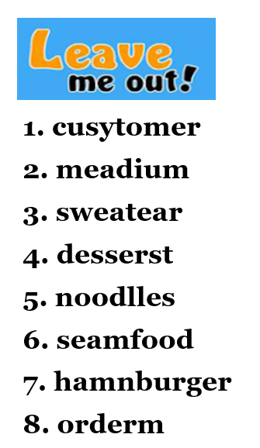  - Option 2: Error Recognition  - Give Ss some sentences which are grammatically incorrect.  - Have Ss choose the underlined word or phrase in each sentence that needs correcting  - Call Ss to give answers and make it correct  - Give feedback  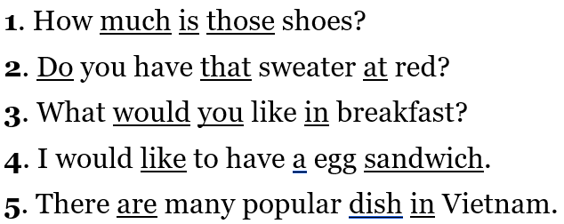  Lead to the new lesson | - Greet T  - Work in groups / pairs  - Give answers  - Check with the teacher  Answer Keys  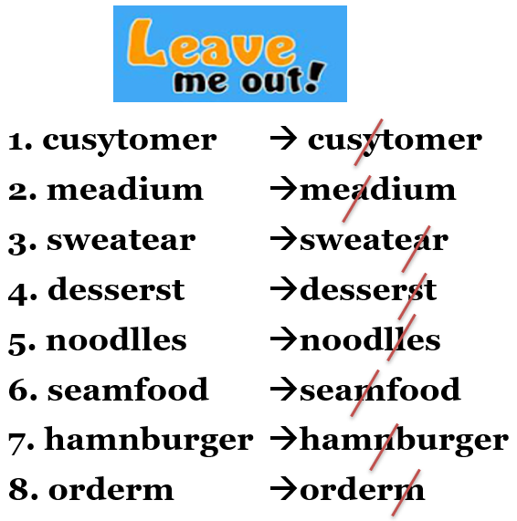  - Look  - Do the task  - Give answers  Answer Keys  1. is are  2. at in  3. in for  4. a an  5. dish dishes

B. New lesson (36’)
- Activities 1: Listening (10’)
a) Objective: Ss improve their listening skill
b) Content:
- Listening and choosing the correct answer
c) Products: Ss listen for details and get familiar with the listening test format.
d) Competence: collaboration, analytical and synthesizing skill.
e) Organization of the activity:
Teacher’s Activities | Students’ Activities
You will hear Matt and Amy talking in a restaurant (twice). For each question, choose the correct answer (A, B or C)  - Have Ss read the task  - Demonstrate the activity by using the example  - Play the audio (CD 2 – Track 67)  - Have Ss check answers with pairs and then give answers  - Check answers as a whole class. | - Read in silence  - Listen and then give answers  - Check and correct mistakes  Answer keys  1. C 2. A 3. C 4. B 5. A
- Activity 2: Reading (9’)
a) Objective: Ss can improve reading skill
b) Content: Reading an email and filling in the blanks
c) Products: Ss read for comprehension and get familiar with the reading test format.
d) Competence: collaboration, communication, analytical and synthesizing skills.
e) Organization of the activity:

Teacher’s Activities | Students’ Activities
Read the email. Write one word for each blank.  - Demonstrate the activity by using the example  - Have Ss read the email and guess answers, then write one word for each blank.  - Call Ss to give answers, explain  - Give feedback | - Observe and listen  - Work in pairs  - Give answers  Answer keys  1. some 2. They 3. where 4. go 5. with
- Activity 3: Vocabulary (7’)
a) Objective: Ss can review vocabulary of unit 5
b) Content: Filling in the blanks with the words from the unit
c) Products: Ss can use these vocabularies actively, correctly in communication.
d) Competence: collaboration, communication, critical thinking
e) Organization of the activity:

Teacher’s Activities | Students’ Activities
Fill in the blanks with the words from the unit.  - Demonstrate the activity using the example  - Have Ss read the sentences and fill in the blanks-beginning with the letter given  - Ask Ss to work in pairs to check each other’s work  - Have Ss give answers, say the Vietnamese meaning again  - Check answers as a whole class | - Look  - Work individually  - Work in pairs  - Give answers  - Listen, correct mistakes  Answer keys  1. extra large  2. changing room  3. Sale assistants  4. tip  5. dessert  6. noodle  7. fry
- Activity 4: Grammar (5’)
a) Objective: Ss can review the use of English: Countable and uncountable nouns; quantifiers, demonstratives
b) Content: filling in the blanks with the words from the box
c) Products: Ss can use the grammar point learnt correctly and actively in communication.
d) Competence: collaboration, communication, analytical and synthesizing skills.
e) Organization of the activity:

Teacher’s Activities | Students’ Activities
Fill in the blanks with the words from the box  - Ask Ss to work individually to fill in the blanks with the words from the box  - Have Ss work in pairs to check each other’s work  - Call Ss to read their answers  - Check answers as a whole class | - Work individually  - Work in pairs  - Give answers  - Listen, correct mistakes  Answer keys  1. an  2. it  3. those  4. some  5. this  6. some  7. them
- Activity 5: Pronunciation (5’)
a) Objective: Ss can review the vowels and stress
b) Content: Circling the word that has the underlined part pronounced differently from the others
c) Products: Ss can pronounce correctly when using these vowels and words in communication.
d) Competence: Collaboration, communication, critical thinking skill.
e) Organization of the activity:
Teacher’s Activities | Students’ Activities
Circle the word that has the underlined part pronounced differently from the others.  - Have Ss distinguish the sound /ӕ/, /eɪ /, /ə/, /ɪ/, /ai/  - Ask Ss to work individually  - Have Ss work in pairs to check each other’s work  - Call Ss to give answers, pronounce the words again  - Give feedback, correct Ss’ pronunciation if necessary  - Have Ss find more words with the sounds / ӕ/, / eɪ/, / ə/, /ɪ/, /ai/  - Give feedback and evaluation  Circle the word that differs from the other three in the position of primary stress in each of the following questions  - Have Ss review ways to put stress on words with 2 and 3 syllables  - Ask Ss to work individually  - Have Ss work in pairs to check each other’s work  - Call Ss to give answers, pronounce the words again  - Give feedback, correct Ss’ pronunciation if necessary  - Give feedback and evaluation | - Listen  - Work individually  - Work in pairs  - Give answers  - Listen, correct mistakes  - Give more examples  Answer keys  1. A 2. B 3. A 4.D  - Listen  - Work individually  - Work in pairs  - Give answers  - Listen, correct mistakes  Answer keys  5. B 6. D

C. Consolidation (2’)
* Grammar of Unit 5: Countable and uncountable nouns; quantifiers, demonstratives
* Vocabulary of Unit 5: Vocabulary about food, ordering in a restaurant, buying clothes in a store

D. Homework (2’)
- Review vocabulary, grammar of unit 5.
- Do exercises in Workbook: Review of Unit 5 (page 68).
- Prepare: Unit 6 – Vocabulary and Listening (page 46 – SB).

