|  |  |
| --- | --- |
| **School: ………………………………………..** | **Date:…………………………………….** |
| **Class: …………………………….....................** | **Period: ………………………….........** |

**UNIT 4: COMMUNITY SERVICES**

**Lesson 3.2 – Speaking and Writing (Page 35)**

**I. OBJECTIVES**

By the end of the lesson, Ss will be able to:

**1.1. Language knowledge and skills**

- know format of writing an email to describe past experiences.

- talk about environmental problems.

- write an email to a friend describing their experience of an environmental clean-up.

**1.2. Competences**

- improve communication, collaboration, writing and critical thinking skills.

**1.3. Attributes**

- be active to take part in social activities.

- help other people.

- raise awareness of protecting the environment.

**II. TEACHING AIDS AND LEARNING MATERIALS**

**1. Teacher’s aids:** Student book and Teacher’s book, class CDs, Digital Book (DCR phần mềm tương tác SB, DHA (từ vựng/ cấu trúc) phần mềm trò chơi tương tác), projector/interactive whiteboard / TV (if any), PowerPoint slides.

**2. Students’ aids:** Student’s book, workbook, notebook.

**III. ASSESSMENT EVIDENCE**

|  |  |  |
| --- | --- | --- |
| **Performance Tasks** | **Performance Products** | **Assessment Tools** |
| - Speaking: Look at the pictures of places in Greenview City. Can you see similar problems near where you live? Where? Why is there so much trash? | **-** Ss’ answers / presentation. | - T’s feedback/Peers’ feedback. |
| **-** Choose a place in Greenview City. Use your own ideas to fill in the tables about a clean-up there. | - Ss’ answers. | - T’s feedback/Peers’ feedback. |
| - Writing: Read about writing emails to describe past experiences. Then, read Jane’s email again and circle the information, answering "what?," "when?," "where?," and "who?". | - Ss’ answers. | - T’s feedback/Peers’ feedback. |
| - Write full sentences using the prompts. Then, number the sentences (1–4) to match them with the order in the skill box. | - Ss’ answers. | - T’s feedback/Peers’ feedback. |
| - Now, write an email to a friend describing your experience of an environmental clean-up. Use the Feedback form to help you. Write 60 to 80 words. | - Ss’ answers. | - T’s observation and feedback. |

**IV. PROCEDURES**

**A. Warm up: (5’)**

**a) Objective:** Introduce the new lesson and set the scene for Ss to acquire new language; get students' attention at the beginning of the class by enjoyable and short activities as well as to engage them in the follow-up steps.

**b) Content:** Jumbled sentences / talking about the environmental problems.

**c) Expected outcomes:** Ss know about the topic that they are going to talk and write about in new the lesson.

**d) Organization of the activity:**

|  |  |
| --- | --- |
| **TEACHER’S ACTIVITIES** | **STUDENTS’ ACTIVITIES** |
| **Option 1: Speaking part a.**  - Use the Speaking part a (page 35) for warm up activity.  - Have Ss look the pictures of places in Greenview City using DCR, discuss and answer the questions:  *1. Can you see similar problems near where you live? 2. Where?*  *3. Why is there so much trash?*  - Have Ss give answers.  - Give feedback and evaluation.  - Lead to the new lesson.   * **Option 2: Jumbled sentences**   - Have Ss close all books.  - Give Ss some sentences relating to cleaning-up the beach. These sentences are not correct in time order.  *1. There were plastic bags and trash everywhere.*  *2. I arrived at the Pebble beach in Somerton on Tuesday morning.*  *3. We worked for eight hours and picked up over 5 tons of trash!*  *4. It was really dirty and the smell was horrible*  - Have Ss rearrange the sentences in time order.  - Call Ss to read answers.  - Give feedback, show correct answers and lead to the new lesson: Writing an email about environmental clean-up. | - Work in pairs: Look and discuss.  - Give answers.  - Listen.  - Close all books.  - Read the sentences and rearrange them in time order.  - Work in pairs.  - Read answers.  - Listen.  **Answer keys**  *2. I arrived at the Pebble beach in Somerton on Tuesday morning.*  *4. It was really dirty and the smell was horrible.*  *1. There were plastic bags and trash everywhere.*  *3. We worked for eight hours and picked up over 5 tons of trash!* |

**B. New lesson (35’)**

* **Activity 1: Pre-Writing (Speaking) (8’)**

**a) Objective:** Ss prepare for what they are going to write about.

**b) Content:**

**-** Speaking: Look at the pictures of places in Greenview City. Can you see similar problems near where you live? Where? Why is there so much trash?

**-** Choose a place in Greenview City. Use your own ideas to fill in the tables about a clean-up there.

**c) Expected outcomes:** Ss have more ideas and language for their writing.

**d) Organization of the activity:**

|  |  |
| --- | --- |
| **TEACHER’S ACTIVITIES** | **STUDENTS’ ACTIVITIES** |
| **Task a. In pairs: Look at the pictures of places in Greenview City. Can you see similar problems near where you live? Where? Why is there so much trash?**  **-** Divide the class into pairs.  - Have students ask and answer using the questions.  - Go round and support Ss if necessary.  - Have some students share their ideas with the class.  - Give feedback and evaluation.  **Task b. Now, choose a place in Greenview City. Use your own ideas to fill in the tables about a clean-up there.**  - Have students choose a place in Greenview City, then use their own ideas to fill in the tables about a clean-up there.  - Go round and give help if necessary.  - Have some pairs read their answers.  - Give feedback and evaluation. | - Work in pairs.  - Present.  - Fill in the tables.  - Present. |

* **Activity 2: While - Writing (22’)**

**a) Objective:** Students can develop their writing skill.

**b) Content:**  - Read about writing emails to describe past experiences. Then, read Jane’s email again and circle the information, answering "what?," "when?," "where?," and "who?".

- Write full sentences using the prompts. Then, number the sentences (1–4) to match them with the order in the skill box.

- Now, write an email to a friend describing your experience of an environmental clean-up. Write 60 to 80 words.

**c) Expected outcomes:** Students can write an email to a friend describing their experience of an environmental clean-up, using right format and rich vocabularies.

**d) Organization of the activity:**

|  |  |
| --- | --- |
| **TEACHER’S ACTIVITIES** | **STUDENTS’ ACTIVITIES** |
| **Task a. Read about writing emails to describe past experiences. Then, read Jane’s email again (page 34) and circle the information, answering "what?," "when?," "where?," and "who?"**  -Briefly explain the Writing skill box using DCR and have some Ss read it aloud.  - Have Ss read Jane’s email again (page 34) and circle the information, answering "what?," "when?," "where?," and "who?  - Have Ss check their answers with a partner.  - Call Ss to give answers.  - Check answer as a whole class using DCR.  **Task b. Write full sentences using the prompts. Then, number the sentences (1–4) to match them with the order in the skill box.**  - Have students read the prompts.  - Have students write full sentences using the prompts.  - Then, have students number the sentences (1–4) to match them with the order in the skill box.  - Have students check their answers with a partner.  - Check answer as a whole class using DCR.  **\*Let’s Write: Now, write an email to a friend describing your experience of an environmental clean-up. Write 60 to 80 words.**  - Draw Ss’ attention to the feedback form using DCR.  - Have Ss use their notes in speaking part and the instruction in the Writing box to write an email to a friend describing their experience of an environmental clean-up.  - Go round, observe and give help if necessary.  - Have some Ss write their email on the board. | - Listen.  -Work in pairs.  - Exchange their answers with a partner.  - Give answers.  **Answer keys**    - Read the prompts and write full sentences.  - Number the sentences (1–4).  - Exchange answers.  - Read answers.  **Answer keys**      - Look and listen.  - Do the writing part.  -Write.  **Suggested writing** |

* **Activity 3: Post - Writing (5’)**

**a) Objective:** Help Ss realize their mistakes in writing and correct them.

**b) Content:**  Correcting Ss’ writings.

**c) Expected outcomes:** Students know whether their writings follow the model and use the correct structures and language, whether their writings are interesting and understandable or not.

**d) Organization of the activity:**

|  |  |
| --- | --- |
| **TEACHER’S ACTIVITIES** | **STUDENTS’ ACTIVITIES** |
| - Give feedback, correct Ss’ mistakes.  - Use the feedback form to give evaluation. Focus on:  + the format, the structures  + the understandability  + the coherence and cohesion  + the spelling | - Look, listen and correct mistakes. |

**C. Consolidation and homework assignments (5’)**

**\* Consolidation:**

**- Writing Skill**:

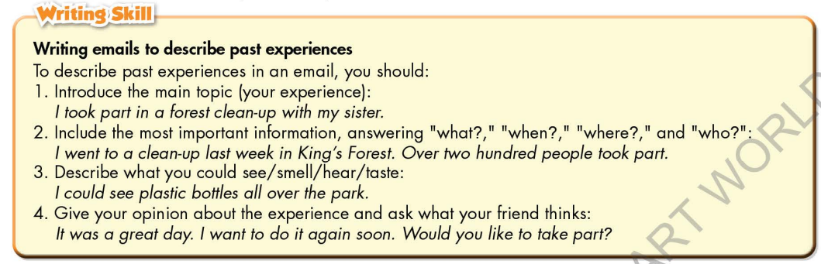

**\* Homework**

- Remember how to write an email to describe past experiences.

- Finish the writing part.

- Do the exercises in WB: Lesson 3 – Writing (page 25).

- Complete the grammar notes in Tiếng Anh 7 i-Learn Smart World Notebook (page 27).

- Play consolation games in Tiếng Anh 7 i-Learn Smart World DHA App on [www.eduhome.com.vn](http://www.eduhome.com.vn)

- Prepare: Unit 4 – Review pages 92, 93.

**D. Reflection**

a. What I liked most about this lesson today:

…………………………………………………………………………………………

1. What I learned from this lesson today:

…………………………………………………………………………………………

c. What I should improve for this lesson next time:

…………………………………………………………………………………………