Period
LESSON PLAN
TIẾNG ANH 10 FRIENDS GLOBAL
TEACHER’S ACTIVITIES | STUDENT’S ACTIVITIES | CONTENTS
PRACTICE. T-Ss/ S-S/ Indiv.  Activity 1(8’): Group work. Read the ‘Learn this!’ box. Match all the past simple forms with rules a- d in the box.  - Have students read the box and match all the past simple verbs in exercise 2.  - Check the answers.  - Provide some popular regular and irregular verbs for students to learn by heart.  Activity 2(5’): Listen and complete the text with the verbs in the bracket.  - Play the audio for the students.  - Show the answers.  Activity 3(7’): Complete the sentences with the adjectives below & the past simple form of the verbs in brackets.  - Have students complete the exercise 5  - Check the answers. | - Read the box and work in group to match.  - Check the answers with the teacher.  - Take note.  - Listen carefully and do the task.  - Check the answer with the teacher.  - Do the task.  - Check the answers with the teacher. | 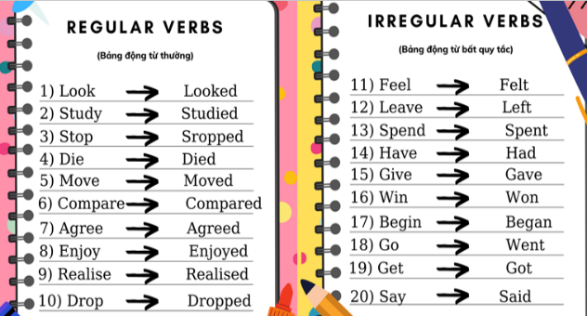  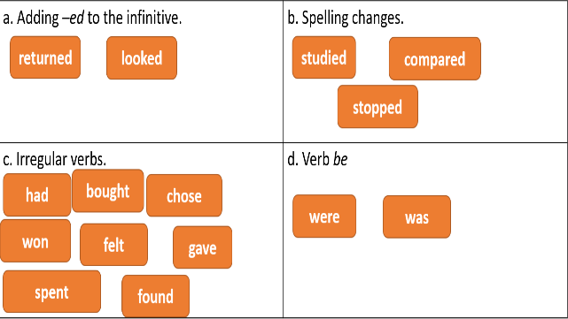  Answer:  1. were 2. won 3. gave 4. spent  5. got 6. was 7. decided 8. had  9. began 10. said  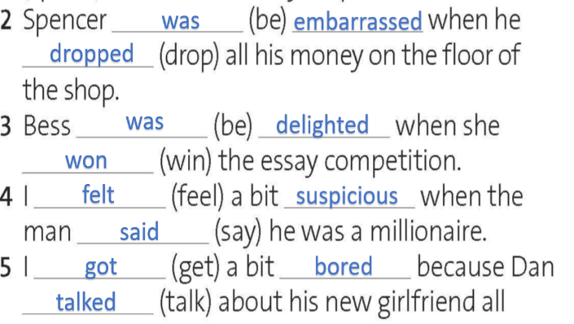  Answer:
UNIT 1: FEELINGS
LESSON 1B: PAST SIMPLE (AFFIRMATIVE)
I. OBJECTIVES:
By the end of the lesson, Ss will be able to:
1. Knowledge:
- Review the simple past tense of some verbs
- Grammar: simple past affirmative
2. Ability:
- main skills: reading and writing skills
- sub skills: listening and speaking skills
- Use the past affirmative properly in exercises as well as everyday conversations.
3. Quality:
- have positive attitude in English language learning so that they can participate enthusiastically in all classroom activities, especially with the topic conducted by the teacher
- know how to use the past tense precisely
II. TEACHER AIDS AND LEARNING MATERIALS:
Lesson plan, PPT slides, student’s book, workbook, notebook, personal computer (if any), projector/TV, speakers, IWB software.
III. PROCEDURES:
A. Warm-up (8’)
a) Objective: Introduce the new lesson and set the scene for Ss to acquire new language; get students' attention at the beginning of the class by means of enjoyable and short activities as well as to engage them in the steps that followed.
b) Content: Ask students two questions in exercise 1 and find verbs which are in simple past tense.
c) Outcomes: Students can gain more confidence and interest in the lesson.
d) Competence: communication, collaboration, critical thinking
e) Organisation of the activity:
TEACHER’S ACTIVITIES | STUDENT’S ACTIVITIES | CONTENTS
WARM-UP. T- Ss/ S – S/ Indiv  THINK  - Ask students 2 questions in exercise 1.  - Correct students’ pronunciation if necessary.  - Ask students to read the text and answer the question.  - Have students underline and count all the past simple verbs form in the text.  - Lead in the topic of the lesson ‘Past Simple’ | - Answer 2 questions, volunteer to share their opinions.  - Read the text on the screen or in the book and answer the question.  - Underline and count.  - Notice what the teacher said. | Questions:  - Is there a lottery in your country?  - Do you think it is a good idea to buy tickets? Why?/ Why not?  Question: ‘Are all lottery winners happy?’  Suggested answer:  People are not always happy when they win the lottery. People can make bad decisions.

B. New lesson (32’)
- Activity 1: Presentation (5’)
a) Objective: Review student simple past tense in affirmative form
b) Content: Students review how to use affirmative form of action verbs and ‘to be’ verbs in past simple tense.
c) Outcomes: Students can apply the useful language in everyday reading and writing.
d) Competence: communication, presentation
e) Organisation of the activity:

TEACHER’S ACTIVITIES | STUDENT’S ACTIVITIES | CONTENTS
PRESENTATION. T-Ss/ S-S/ Individual.  - Review the usage of past simple.  - Show the structure for action verbs and ‘to be’ verbs in affirmative form.  - Have students take note. | - Listen to the teacher and take note.  - Take note. | 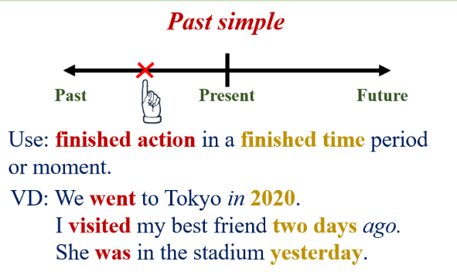  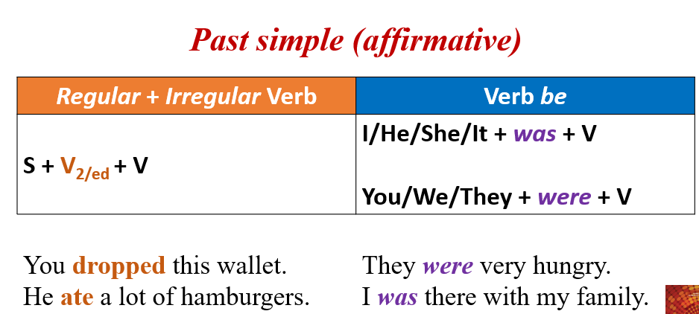
- Activity 2 Practice (20’)
a) Objective: Students know more about past simple tense and some irregular verbs.
b) Content:
Grammar study
Writing
c) Outcomes: Ss how to use irregular and regular verbs in past simple properly.
d) Competence: communication, collaboration, presentation
e) Organisation of the activity:

- Activity 3: Outcomes (7’)
a) Objective: Ss can answer questions to describe feelings in some situations in the past. Communication is also be practiced.
b) Content: ‘Avenger’ Game
c) Outcomes: Ss speak and listen mutually, they can apply the structure of past simple or some adjectives to their conversations.
d) Competence: Collaboration, communication, guessing
e) Organisation of the activity:
TEACHER’S ACTIVITIES | STUDENT’S ACTIVITIES | CONTENTS
PRODUCT. T- Ss/ S-S  Activity 1(7’): ‘Avenger’ Game.  - Divide class into groups, ask students to pick one number from 1 to 10 and make a sentence with each picture.  - Check students’ answer and give bonus. | - Volunteer to play game and make sentences. | 
C. Consolidation (3’)
a) Vocabulary: adjectives to describe feelings
b) Grammar: Past Simple (Affirmative)
D. Homework (2’)
- Learn by heart simple past form of the irregular verbs
- Review simple past affirmative structure
- Do exercise
- Prepare: Unit 1 – C-Listening (page 13 – SB)

