School: ……………………………………….. | Date: ………………………………..
Class: ……………………………..................... | Period: ………………………….........

UNIT 10: ENERGY SOURCES
Lesson 1.2 - Grammar (Page 77)

I. OBJECTIVES
By the end of the lesson, Ss will be able to:
1.1. Language knowledge and skills
- use comparison (more…than… and less…than…) correctly.
- compare the consumption of energy in different places.
1.2. Competences
- improve speaking, listening skills.
- improve the use of English.
1.3. Attributes
- save energy.
- choose suitable and economical types of energy for everyday use.

II. TEACHING AIDS AND LEARNING MATERIALS
1. Teacher’s aids: Student book and Teacher’s book, class CDs, Digital Book (DCR phần mềm tương tác SB, DHA (từ vựng/ cấu trúc) phần mềm trò chơi tương tác), projector/interactive whiteboard / TV (if any), PowerPoint slides, handouts.
2. Students’ aids: Student’s book, workbook, notebook, handouts.

III. ASSESSMENT EVIDENCE
Performance Tasks | Performance Products | Assessment Tools
- Listen and repeat. | - Ss’ performance. | - T’s feedback.
- Study the grammar box. | - Ss’ answers/ presentation. | - T’s feedback.
- Unscramble the sentences. | - Ss’ answers. | - T’s feedback/Peers’ feedback.
- Look at the table and write the sentences. | - Ss’ answers. | - T’s feedback/Peers’ feedback.
- Speak: Compare more information from the table. Use the prompts. | - Ss’ answers/ presentation. | - T’s observation, T’s feedback/Peers’ feedback.

IV. PROCEDURES
A. Warm up: (5’)
a) Objective: Introduce the new lesson and set the scene for Ss to acquire new language; get students' attention at the beginning of the class by enjoyable and short activities as well as to engage them in the steps that followed.
b) Content: Review: types and sources of energy.
c) Expected outcomes: Ss review some types and sources of energy which are very useful for them in the new lesson.
d) Organization of the activity:
TEACHER’S ACTIVITIES | STUDENTS’ ACTIVITIES
- Option 1: Chatting and reviewing types of energy  - Have Ss close books and notebooks.  - Ask Ss some questions:  1. What is renewable energy?  2. What is non - renewable energy?  3. Can you tell some sources of energy that are renewable and non-renewable?  4. What sources of energy do Vietnamese people use most?  - Call Ss to give answers.  - Check Ss’ answers, give feedback.  - Lead to the new lesson.  - Option 2: Pie chart of energy consumption  - Briefly introduce the pie chart.  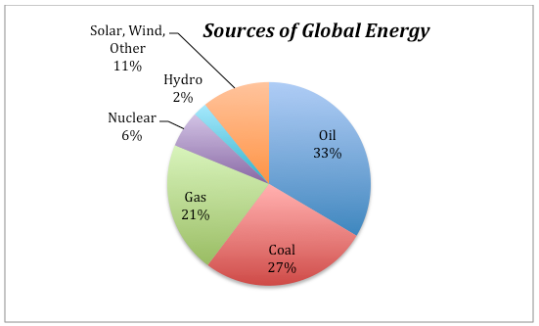  Source: https://www.e-education.psu.edu/earth104/node/1345  - Have Ss look at the pie chart and answer some questions:  1. How many sources of energy are there?  2. Which source of energy do people use most / least?  3. Which is consumed more: fossil fuels (non-renewable energy) or non - fossil fuels (renewable energy)? How many percent?  - Call Ss to give answers.  - Check Ss’ answers, give feedback.  - Lead to the new lesson. | - Close books and notebooks.  - Listen, then answer the questions.  - Listen.  - Listen.  - Look at the pie chart, then answer the questions.  - Give answers.  - Listen and write the new lesson.

B. New lesson (35’)
- Activity 1: Presentation (10’)
a) Objective: Introduce: Comparison (more…than… and less…than…)
b) Content:
- Listen and repeat.
- Introduce the grammar points.
c) Expected outcomes: Ss know the new grammar points: Comparison (more…than… and less…than…) and use them in some exercises that follow.
d) Organization of the activity:
TEACHER’S ACTIVITIES | STUDENTS’ ACTIVITIES
Task a. Listen and repeat.  - Have Ss look at the picture using DCR.  - Play audio (CD2 – Track 26) and have Ss listen and read the speech bubbles.  - Remind Ss ways to read %: percent.  - Play the audio again and have Ss listen and repeat.  Grammar box  - Option 1:  - Have Ss look at the grammar explanation and read: Comparison (more…than… and less…than…)  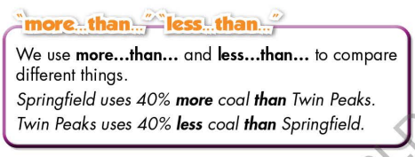  - Have Ss read the examples:  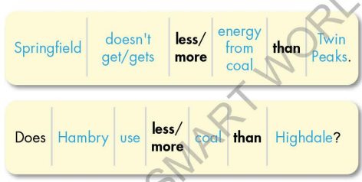  - Explain more about the way to use Comparison (more…than… and less…than…).  - Ask Ss to make more sentences using Comparison (more…than… and less…than…).  - Give feedback and evaluation.  - Option 2:  - Have Ss look at the sentences in the speech bubbles in Task a and read them again.  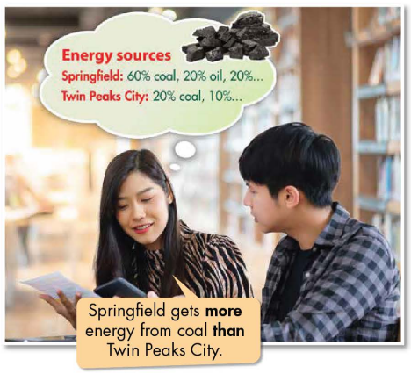  - Have Ss make comments on the words in bold (more … than …).  - Ask Ss some elicit questions:  1. Do they use “more…than…” to make comparison for things with bigger amount or smaller amount?  2. What types of word / phrases that go between “more …” and “than …”?  - Call Ss to give answers.  - Give feedback.  - Then, lead to the grammar box, briefly explain the way to use Comparison (more…than… and less…than…).  - Have Ss read the grammar box and examples.  - Ask Ss to make more sentences using Comparison (more…than… and less…than…).  - Give feedback and evaluation. | - Look.  - Listen, then read.  - Listen and repeat.  - Look and read.  - Read examples of different forms.  - Listen and take notes.  - Give more examples.  - Look and read.  - Comment.  - Listen and take notes.  - Read.  - Give more examples.  - Listen.
- Activity 2: Practice (19’)
a) Objective: Students can use Comparison (more…than… and less…than…) to do the given exercises.
b) Content:
- Unscramble the sentences.
- Look at the table and write the sentences.
c) Expected outcomes: Students can get used to the usage of Comparison (more…than… and less…than…) and use them correctly.
d) Organization of the activity:

TEACHER’S ACTIVITIES | STUDENTS’ ACTIVITIES
Task b. Unscramble the sentences.  - Demonstrate the activity on DCR, using the example.  - Have Ss read the prompts, then unscramble the sentences.  - Have Ss work in pairs to check each other’s work.  - Have some Ss share their answers with the whole class.  - Give feedback, correct Ss’ answers if necessary.  Task c. Look at the table and write the sentences.  - Have Ss look at the information in the table.  - Demonstrate the activity using the example.  - Have students look at the table and write the sentences.  - Have pairs check each other's work.  - Have some students share their answers with the class. | - Look and listen.  - Work individually.  - Work in pairs.  - Write answers on the board.  Answer keys  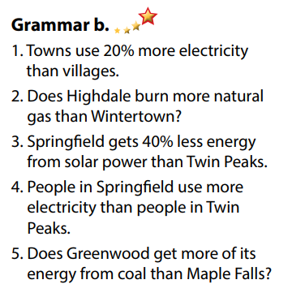  - Look and listen.  - Work individually.  - Work in pairs.  - Read answers, explain.  Answer keys  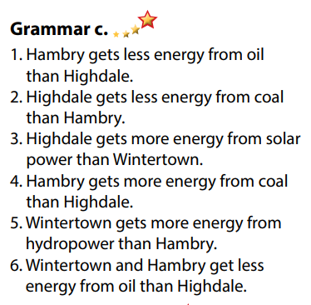

- Activity 3: Production (6’)
a) Objective: Students master the grammar points they study in the lesson.
b) Content: Speaking: Compare more information from the table. Use the prompts.
c) Expected outcomes: Ss produce the new language successfully, and they can use the grammar point in the lesson in everyday speaking and writing.
d) Organization of the activity:
TEACHER’S ACTIVITIES | STUDENTS’ ACTIVITIES
Task d. In pairs: Compare more information from the table. Use the prompts.  - Divide class into pairs.  - Have Ss take turns to compare more information from the table, use the prompts.  - Have some pairs share their answers with the class.  - Give feedback and evaluation. | - Work in pairs.  - Present.  - Listen.

C. Consolidation and homework assignments (5’)
* Consolidation: Comparison (more…than… and less…than…)

* Homework:
- Make 2 sentences using Comparison (more…than… and less…than…)
- Do the exercises in WB: Grammar (page 57).
- Complete the grammar notes in Tiếng Anh 7 i-Learn Smart World Notebook (page 61).
- Play consolation games in Tiếng Anh 7 i-Learn Smart World DHA App on www.eduhome.com.vn
- Prepare: Lesson 1.3 – Pronunciation and Speaking (page 78 – SB).

D. Reflection
a. What I liked most about this lesson today:
…………………………………………………………………………………………
- What I learned from this lesson today:
…………………………………………………………………………………………
c. What I should improve for this lesson next time:
…………………………………………………………………………………………

