
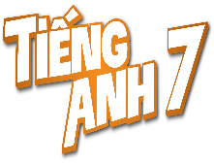
Tiết thứ ....
UNIT 7: TRAFFIC
Lesson 7: Looking back & project

Class | Date of teaching | Attendence
7A | ..../09/2022
7B | ..../09/2022
7C | ..../09/2022
I. OBJECTIVES: By the end of this unit, students will be able to gain the following things:
1. Knowledge:
- Review the vocabulary and grammar of Unit 7
- Apply what they have learnt (vocabulary and grammar) into practice through a project
+ Pronunciation:
+ Vocabulary: Use the words about means of transport.
+ Grammar:
2. Competence:
a) General competencies:
- Students will be able to know more words and phrases about means of transport.
- Develop communication skills and cultural awareness
- Be collaborative and supportive in pair work and teamwork
- Actively join in class activities
b) Specific competencies:
- Group work and independent working, pair work, linguistic competence, cooperative learning and communicative competence.
- Sts can introduce themselves or one another fluently.
3. Qualities: The love of traffic; The awareness about importance of trafffic; Be ready to talk about means of transport; Know some daily activities in the street.
- Develop self-study skills.
II. PREPARATIONS
Teacher: Grade 7 text book, laptop, TV, pictures and realia, Computer connected to the Internet, Sach mem.vn
Students: Text books, pencils, pics, blank papers, realia,….
III. PROCEDURE:
In each activity, each step will be represented as following:
* Task delivering
** Task performance
*** Report and discussion
 Judgement
Activity 1. WARM UP (5’-IW, GW)
* Aim:
To help students revise the vocabulary items they have learnt in the unit.
To enhance students’ skills of cooperating with team mates.
* Content: BRAIN STORMING:
* Product: Having a chance to speak English and focus on the topic of the lesson.
* Implementation: Teacher’s instructions…
Teacher’s & Student’s activities | Content
Quick revision check
* Teacher asks Ss to think of what they have learnt already in Unit 7.
** Ss work in pairs to do the task.
***Teacher calls some students to retell.
 Teacher confirms and leads them to do all the exercises in books.
Activity 2. KNOWLEDGE FORMATION (15'- PW, IW)
* Aim:
To help Ss revise the vocabulary items (verbs) they have learnt in the unit.
* Content: Listening
* Product: Ss learn how to use them.
* Implementation: Teacher’s instructions…
Teacher’s & Student’s activities | Content
Task 1: Label each sign. Work in pairs. What does each sign tell us to do?  * Teacher has Ss work individually.  ** Ss do this activity individually, then compare their answers with their partners.  *** Teacher asks for Ss’ answers.  Teacher confirms the correct ones  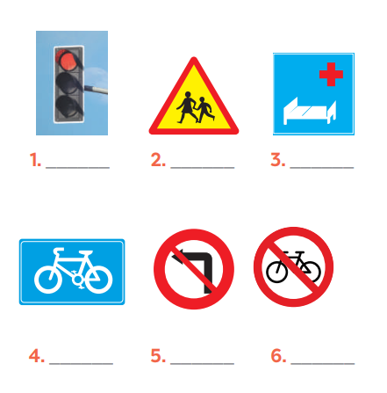 | Task 1: Label each sign. Work in pairs. What does each sign tell us to do?  Answer keys:  1. traffic light  2. school ahead  3. hospital ahead  4. cycle lane  5. No left turn  6. Do not cycle
Activity 3. PRACTICE (15’-IW, PW, GW)
* Aim:
To help Ss revise the vocabulary items (adjectives) they have learnt in the unit
To help Ss revise grammar points.
To help Ss revise the grammar points of the unit
* Product: Students’ answers.
* Implementation:
Teacher’s Student’s activities | Content
Task 2: Fill in each gap with one word to complete the sentences.  * Teacher has Ss work individually.  ** Ss do this activity individually, then compare their answers with their partners.  *** Teacher asks for Ss’ answers.  Teacher confirms the correct ones  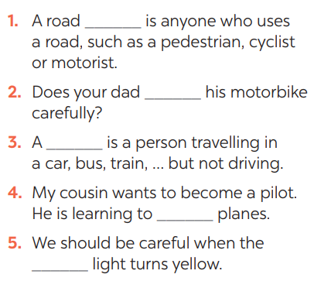  Task 3: Write complete sentences, using these cues.  * Teacher asks Ss to recall the structures of asking and answering about distance, and tell them to do Ex 3 in the book.  ** Ss do the exercise individually and swap with their partners.  *** Teacher calls some Ss to check their answer.   Teacher confirms the correct answer.  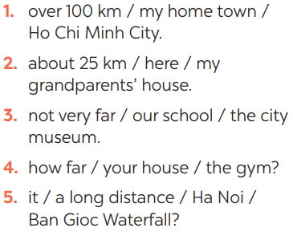  Task 4: Choose A, B, or C to complete the sentences.  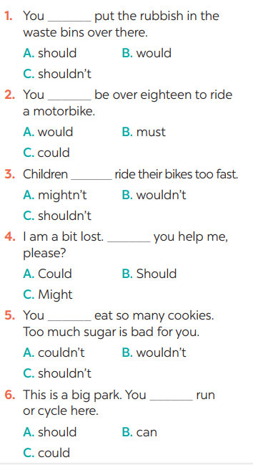  * Teacher asks Ss to do the task.  ** Ss work individually to do the task.  *** Teacher calls Ss to give out their answers.   Teacher checks and confirms their answer. | Task 2: Fill in each gap with one word to complete the sentences.  Answer keys:  1. user  2. ride  3. passenger  4. drive  5. see/notice  Task 3: Write complete sentences, using these cues.  Answer keys:  1- It’s over 100km from my hometown to Ho Chi Minh city.  2- It’s about 25 km from here to my grandparents’ house.  3- It’s not very far from our school to the city museum.  4- How far is it from your house to the gym?  5- Is it a long distance from Ha Noi to Ban Gioc Waterfall?  Task 4: Choose A, B, or C to complete the sentences.  Answer keys:  1. C 2. B 3. C  4. A 5. C 6. B
Activity 4. APPLICATION (7’-IW, PW, GW)
* Aim:
To help Ss identify common traffic signs and make their own road signs.
* Content: Traffic signs
* Product: Students’work.
* Implementation: Teacher’s instructions
Task 5: Show the prepared signs. Make your own sign.    * Teacher asks Ss to show the signs they have prepared and identify the messages in each of the sign.  * Teacher also has Ss spend some time to make their own signs and practise presenting within their groups.  ** Ss discuss with their partners.  *** Some students raise their ideas and explain their answers.   Teacher listens and confirms.  Task 6: Traffic signs exhibition  * Teacher asks Ss to work in groups of 4 – 6 to stick their traffic signs onto the classroom’s wall and present about them.  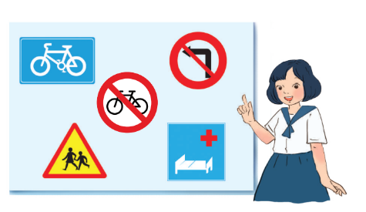  ** Ss work in group to do the task.  *** Teacher calls some groups to present their signs to the class   Teacher confirms and corrects. | Task 5: Show the prepared signs. Make your own sign.  I saw some traffic signs on my way from home to school:  1. Red light  => I see a red light on a traffic light when going through a crossroads. A "red light" sign means you have to stop.  2. School ahead>On my way to school, so I see a “school ahead sign”. A "school ahead" sign means there is a school ahead.  3. Not turn right  =>On the way to school, I see in a traffic light a “not turn right” sign.A "not turn right" sign means we must not turn right here.  5. No cycling  =>A "no cycling" sign means we are not allowed to cycle.  Task 6: Traffic signs exhibition
* Wrap up  - To consolidate what students have learnt in the lesson.  * Homework:  - To prepare for the next lesson:  Unit 8: Getting started. | * Wrap up  - Teacher asks students to talk about what they have learnt in the lesson.  * Homework:  - Exercises in the workbook  - To prepare for the next lesson:  Unit 8: Getting started.
V. FEEDBACK:
With 7A ……………………………………………………………………………..…
With 7B …………………………...……………………………………..……………
With 7C ………………………………………………………………………….……

