**Electronic devices**

**Task 1. Look at the photos and complete the words.**

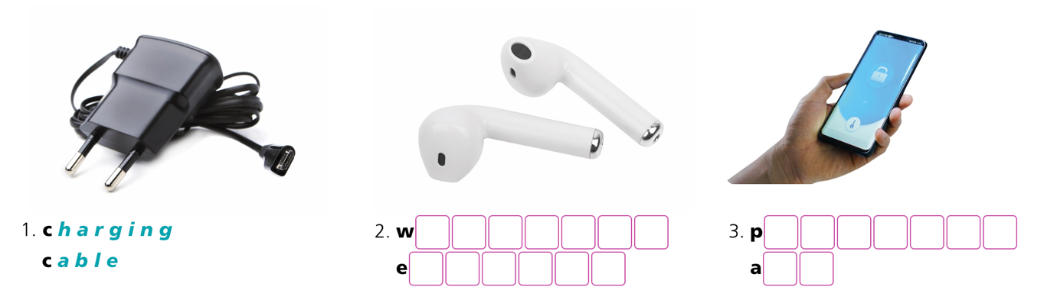

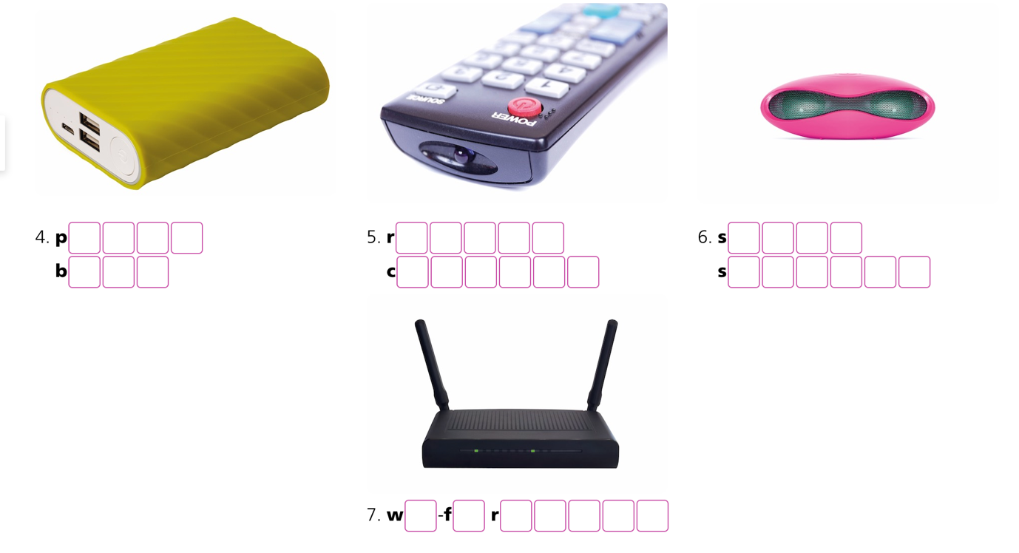

**Task 2: Complete the correct word for each definition. Use words from the previous exercise.**

smart speaker wireless earbuds wi-fi router

charging cable power bank password app

1. You use this to change the channel on TV. _________*remote control*_________
2. You use this to remember your login information.  _______________________
3. You use these to listen to music so that no one else can hear, but you don’t need wires.  ________________
4. You use this to put more power into your phone from a wall socket.  _______________
5. You use this to connect to the internet.  _______________________
6. A device you talk to. It can answer your questions and find information.  ____________
7. A gadget you can take anywhere to charge your phone.  _______________________

**Task 3. Match the sentence halves.**

| 1. I don’t post ____***d_____***  2. She updates ___________  3. Some people delete ___________  4. Let’s take ___________  5. I follow ___________  6. My mum wants to connect ___________  7. I can only chat ___________  8. Please don’t add ___________  9. Who do you message ___________ | a. a selfie so we remember this moment!  b. with friends at the weekend. Not after school.  c. photos of themselves, but I don’t mind.  d. on social media every day.  e. me to any more groups!  f. her story when she does something fun.  g. all my classmates on social media.  h. when you can’t do your homework?  i. with me on social media! |
| --- | --- |

**ANSWER KEY**

**Task 1.**

1. charging cable 2. wireless earbuds 3. password app

4. power bank 5. remote control

6. smart speaker 7. Wi-fi router

**Task 2**

1. remote control 2. password app

3. wireless buds 4. charging cable

5. wi-fi router 6. smart speaker 7. power bank

**Task 3**

*1. d 2. f 3. c 4. a*

*5. g 6. i 7. b 8. e 9. h*

**WORDLIST**

| **Word** | **Pronunciation** | **Meaning** |
| --- | --- | --- |
| charging cable | / ˈtʃɑːdʒɪŋ ˈkeɪbl/ | Dây sạc pin (cho các thiết bị điện tử) |
| remote control | /rɪˌməʊt kənˈtrəʊl/ | Điều khiển từ xa |
| password app | / ˈpɑːswɜːd æp/ | Ứng dụng quản lý mật khẩu |
| power bank | / ˈpaʊə bæŋk/ | Sạc dự phòng (không dây) |
| smart speaker | / ˈsmɑːt spiːkə(r)/ | Loa thông minh |
| wi-fi router | / ˈwaɪ faɪ ˈruːtə(r) / | Thiết bị định tuyến không dây (Bộ phát sóng wifi) |
| wireless buds | / ˈwaɪələs bʌdz/ | Tai nghe không dây |