**ĐỀ MINH HỌA SỐ 04**  
**KỲ THI TỐT NGHIỆP TRUNG HỌC PHỔ THÔNG NĂM 2025**  
(Đề thi có 08 trang)  
**Môn thi: TIẾNG ANH**  
**Thời gian làm bài: 50 phút, không kể thời gian phát đề**

KEY A _ B _ C _D:

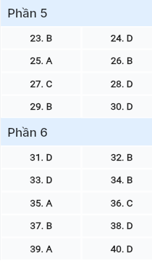`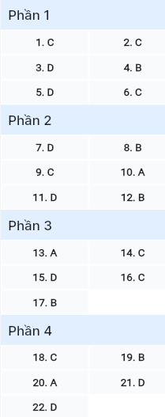

**Read the following advertisement and mark the letter A, B, C, or D on your answer sheet to indicate the option that best fits each of the numbered blanks from 1 to 6.**

**Unleash Your Inner Scientist!**

Are you curious about how things work? Join our (1) ______ which uncovers the mysteries of the universe through hands-on experiences! From experimenting in labs to connecting (2) ______ renowned scientists, we offer a unique journey (3) ______ to spark curiosity and expand your imagination. Whether you’re a beginner or a seasoned enthusiast, you’ll manage (4) ______ beyond what you thought possible, exploring science in ways that ignite a lifelong love for discovery. Don’t let your curiosity go unanswered— (5) ______ today to start delving into fascinating ideas and finding solutions to real-world challenges. Let science (6) ______ a difference in how you see the wonders of the world, waiting just for you!

**Question 1 (696884):** A. program science engaging B. science engaging program  
 C. engaging science program D. program engaging science

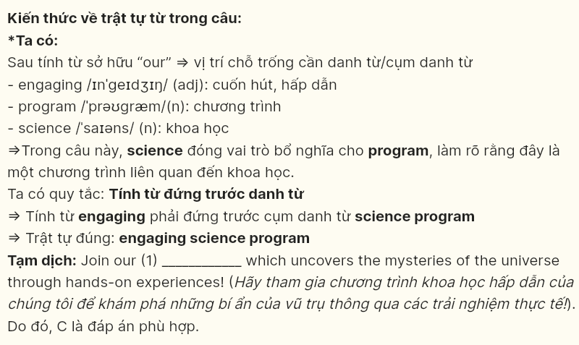

**Question 2 (696885):** A. to B. for C. with D. in

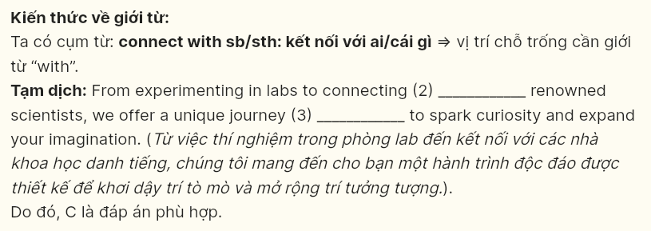

**Question 3 (696886):** A. which designed B. designing C. was designed D. designed

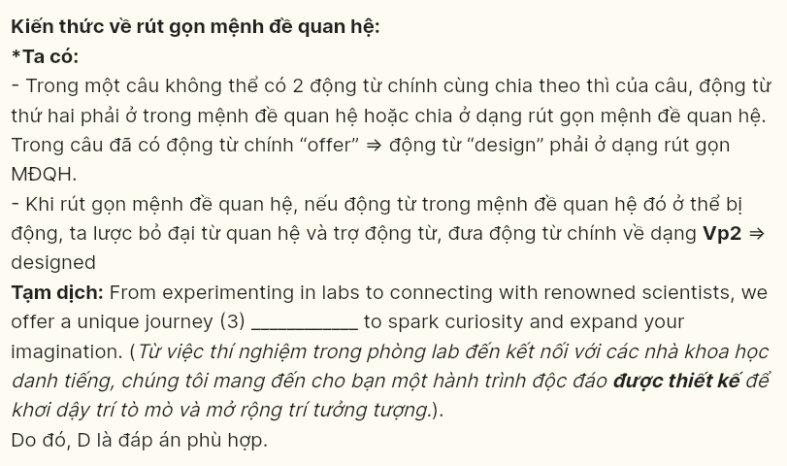

**Question 4 (696887):** A. push B. to push C. to pushing D. pushing

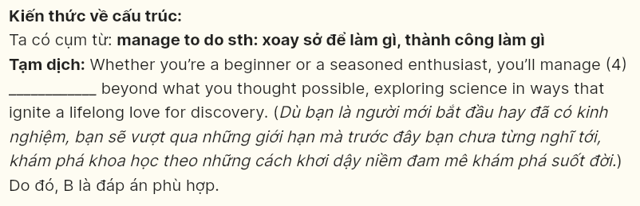

**Question 5 (696888):** A. check in B. look after C. put on D. sign up

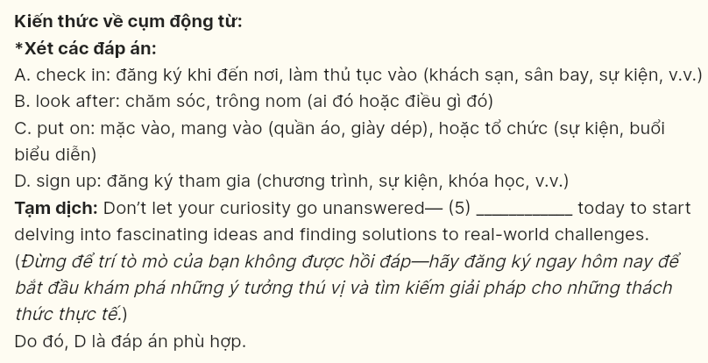

**Question 6 (696889):** A. see B. tell C. make D. take



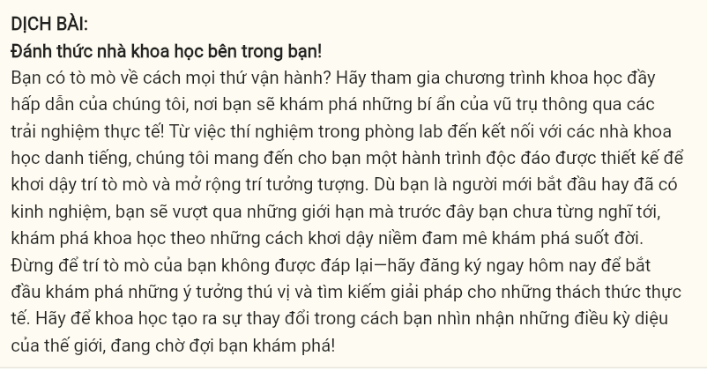

**Read the following leaflet and mark the letter A, B, C, or D on your answer sheet to indicate the option that best fits each of the numbered blanks from 7 to 12.**

**Healthy Eating - Fuel Your Body Right**  
Good nutrition is the foundation of a healthy, active lifestyle.

**Why Healthy Eating Matters**  
Eating a balanced diet supports energy levels, mental clarity, and overall health. Studies show that those who consume at least five servings of fruits and vegetables daily have a 20% lower risk of heart disease. (7) ______ benefits in improved immunity, for example, diets rich in vitamins C and D can reduce the chance of illness by 30%. By choosing nutritious foods, you can (8) ______ on unhealthy fats, sugars, and processed foods, which helps maintain a healthy weight and lowers the risk of chronic diseases.

**Simple Steps to Eat Healthier**

* Start by swapping sugary drinks for water or herbal teas and include a serving of vegetables in every meal. Choose whole grains like brown rice and oats instead of (9) ______ grains.
* Gradually reduce processed foods, focusing on natural (10) ______. Prepare snacks like nuts, yogurt, or fruit in advance to ensure (11) ______ and avoid binge eating.
* Practice mindful eating by focusing on your meal without distractions. It’s a perfect approach (12) ______ its ability to improve digestion and enhance the enjoyment of each bite.

**Question 7 (696890):** A. others B. other C. the others D. another

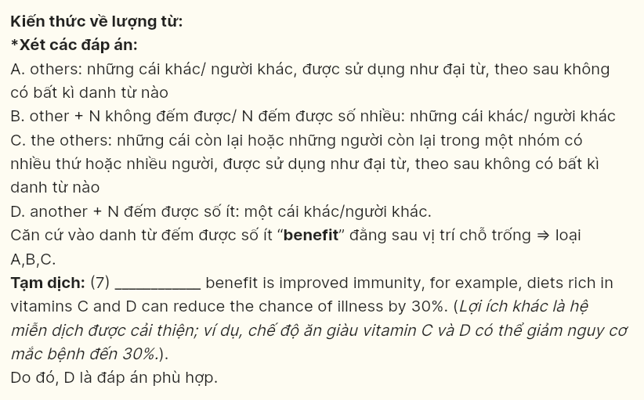

**Question 8 (696891):** A. give up B. cut down C. take out D. turn off

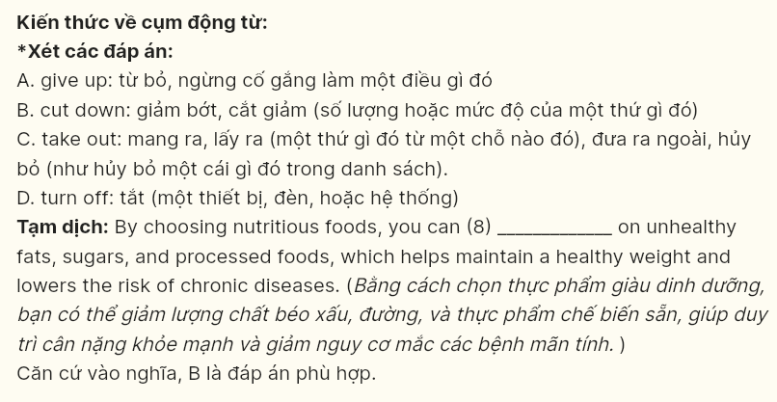

**Question 9 (696892):** A. confined B. defined C. refined D. refilled

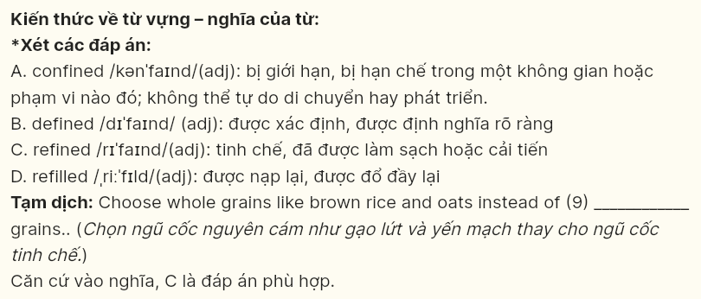

**Question 10 (696893):** A. ingredients B. components C. recipes D. elements

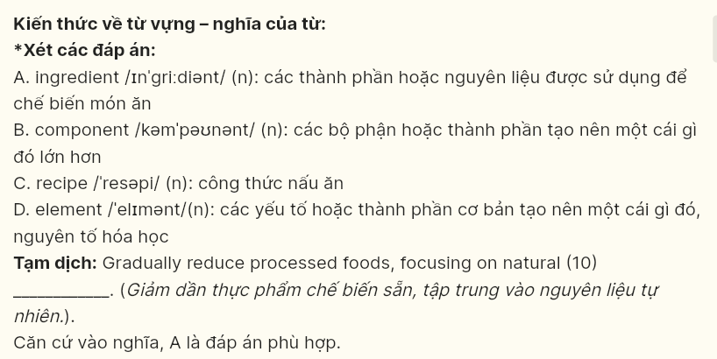

**Question 11 (696894):** A. quantity B. capacity C. intensity D. quality

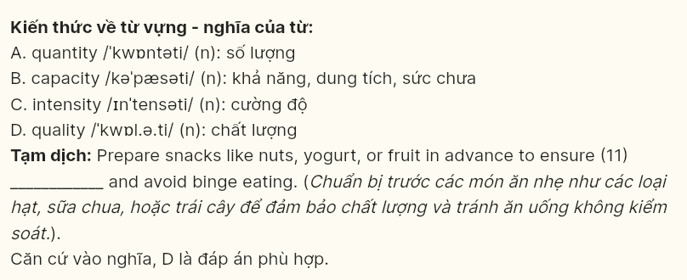

**Question 12 (696895):** A. in addition to B. by virtue of C. irrespective of D. in the face of

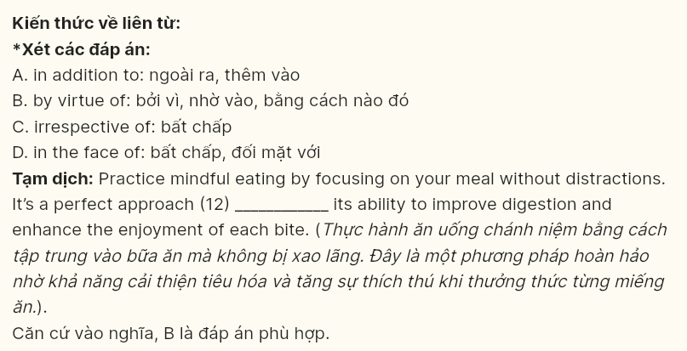

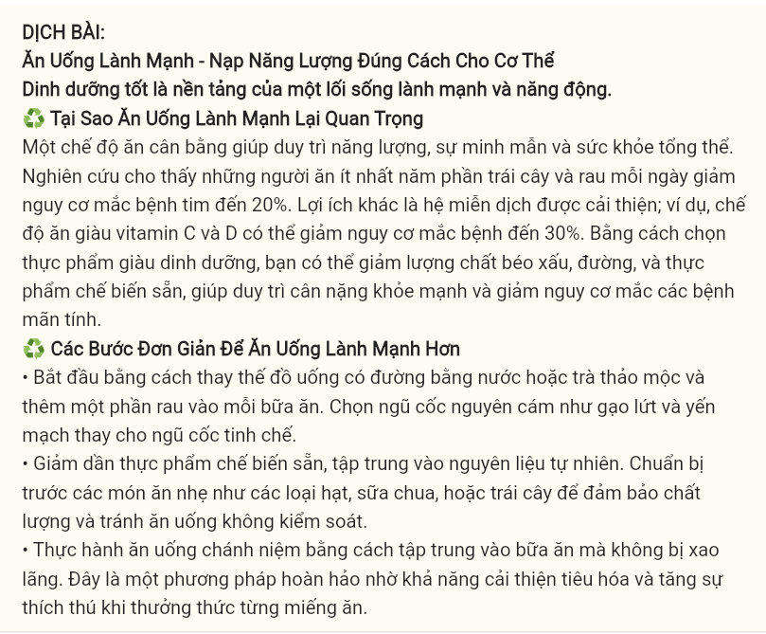

**Mark the letter A, B, C, or D on your answer sheet to indicate the best arrangement of utterances or sentences to make a meaningful exchange in each of the following questions from 13 to 17.**

**Question 13 (696896):**  
a. Tom: Sounds good! I can benefit from a workout. What time are you thinking?  
b. Lily: How about around 5? It won’t be too hot by then.  
c. Lily: I’m planning to go for a run in the park later. Do you want to join me?  
**A. c-a-b** **B. b-c-a** **C. c-b-a** **D. a-c-b**



**Question 14 (696897):**  
a. Ben: That’s great to hear! Do you have any specific theme in mind for your room makeover?  
b. Sam: Thanks! I’ll start by picking out some plants this weekend.  
c. Sam: I’m thinking of adding some greenery and natural lighting to make it feel more relaxing.  
d. Ben: That makes sense! They’ll definitely create a calming atmosphere.  
e. Sam: I want to refresh my room because it feels a bit dull lately.  
**A. c-a-e-d-b** **B. c-d-b-a-e** **C. e-a-c-d-b**  **D. e-d-b-a-c**

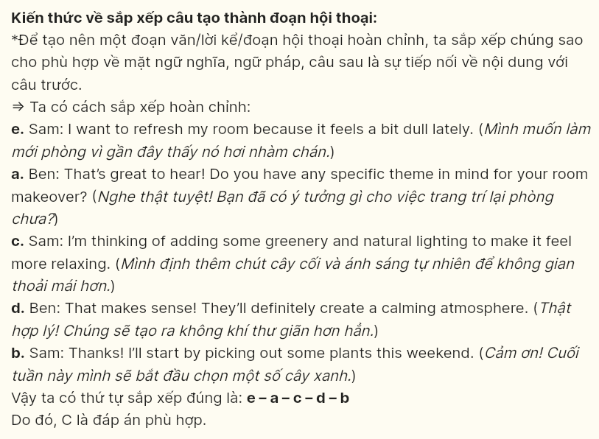

**Question 15 (696898):**  
Hi Tom,  
a. I can’t believe it’s been so long since we last caught up!  
b. Maybe we could plan a hike together soon. It’d be a great way to reconnect.  
c. I remember the last trail we hiked was so beautiful, and I’d love to do something similar.  
d. Let me know if you’re free sometime this month—I’ll make sure to bring snacks!  
e. Hope you’re doing well and enjoying your new job.  
Take care,  
Alex  
**A. b-a-d-e-c** **B. e-b-a-d-c** **C. c-e-a-b-d** **D. a-e-b-c-d**

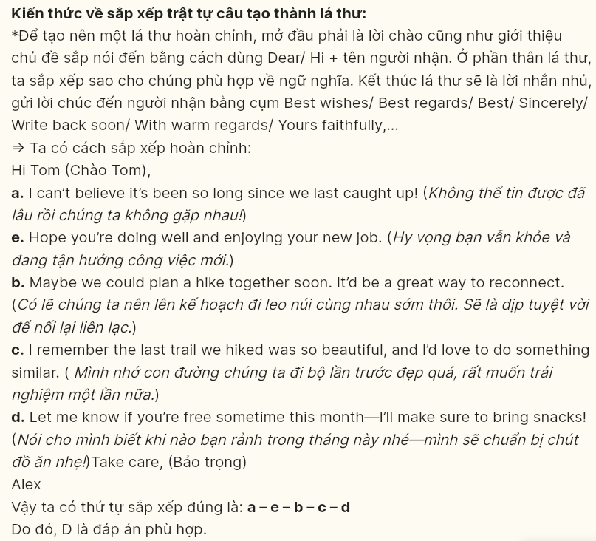

**Question 16 [696989]:**  
At first, I was unsure how to approach teaching the children, but I quickly learned effective techniques.  
A. To sum up, I'm thrilled about the opportunity to help these kids improve their reading skills and proud of the progress they've made.  
B. My fellow volunteers and I work together to create engaging activities that make learning enjoyable for everyone.  
C. I have gained valuable experience in education and mentoring since I began volunteering at the local literacy program.  
D. Currently, we're organizing a reading challenge that requires careful planning and coordination.

**A. c-a-d-e-b B. e-a-c-d-b C. d-a-c-e-b D. a-e-d-c-b**

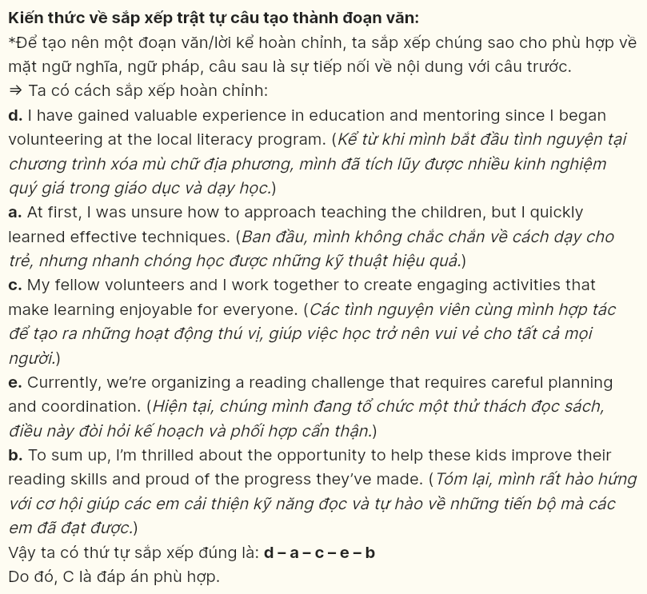

**Question 17 [696990]:**  
A. For instance, traveling becomes more enjoyable and meaningful when you can communicate with locals, making each interaction a chance to learn something new.  
B. Studies show that bilingual individuals often have improved cognitive abilities, which can lead to better problem-solving skills and memory retention.  
C. Being able to speak another language not only opens doors to new cultural experiences but also allows people to connect more deeply with others.  
D. Learning a second language has become a popular goal for people of all ages.

E. Moreover, language skills are highly valued in today’s global job market, where employers seek candidates who can communicate across cultures.

**A. d-e-c-b-a B. d-b-c-a-e C. d-a-c-b-e D. d-c-a-e-b**

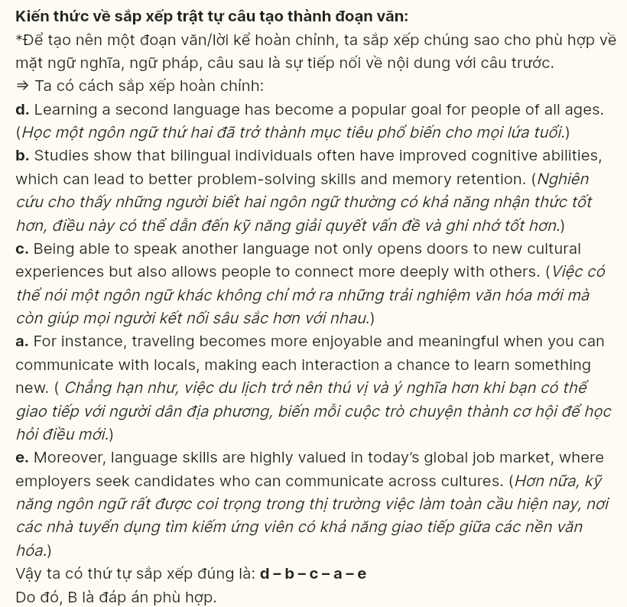

***Read the following passage about Tet and mark the letter A, B, C or D on your answer sheet to indicate the option that best fits each of the numbered blanks from 18 to 22.***

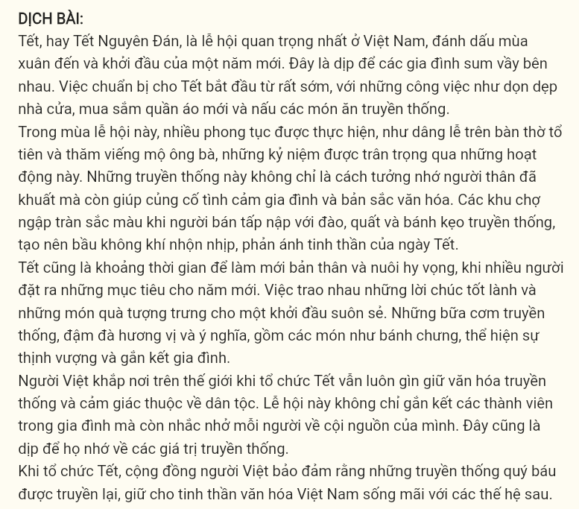

Tet, or the Lunar New Year, (18) ______ marking the arrival of spring and the beginning of a new year. It is a time for families to come together. Preparation for Tet begins well in advance, with families cleaning their homes, buying new clothes, and cooking traditional dishes.

During this festive season, various customs are observed, such as making offerings at family altars and visiting the graves of ancestors (19) ______. These traditions not only pay tribute to loved ones but also strengthen family bonds and cultural identity. Street markets burst with color as vendors sell peach blossoms, kumquat trees, and traditional sweets, creating a vibrant atmosphere that embodies the spirit of Tet.

Tet also serves as a time for renewal and hope, with many people setting intentions for the year ahead. (20) ______ Traditional meals, rich in meaning and flavor, include dishes like banh chung, which represent prosperity and family unity.

As Vietnamese people around the world celebrate Tet, they preserve their cultural heritage and strengthen their sense of belonging. (21) ______. This festive occasion serves as a reminder of their values.

Celebrating Tet, (22) ______, keeping the spirit of Vietnamese culture alive for future generations.

**Question 18 [696901]:**  
A. which is the most important celebration in Vietnam  
B. being the most important celebration in Vietnam  
C. is the most important celebration in Vietnam  
D. whose celebration is the most important part of Vietnam



**Question 19 [696902]:**  
A. from whom memories through these practices  
B. whose memories are honored through these practices  
C. are memorized through these practices  
D. get their memories honored through these practices

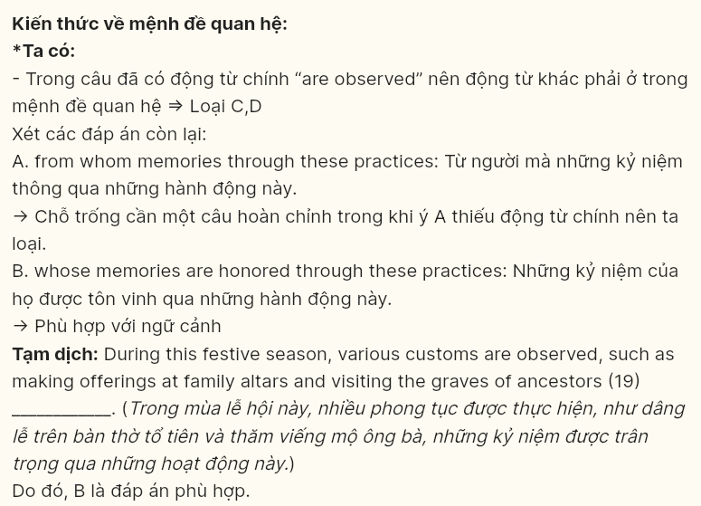

**Question 20 [696903]:**  
A. The exchange of good wishes and gifts represents a fresh start  
B. Wanting to represent a fresh start, the exchange of good wishes and gifts occurs  
C. The presence of a fresh start results in the exchange of good wishes and gifts  
D. People are expecting that the exchange of good wishes and gifts represents a fresh start

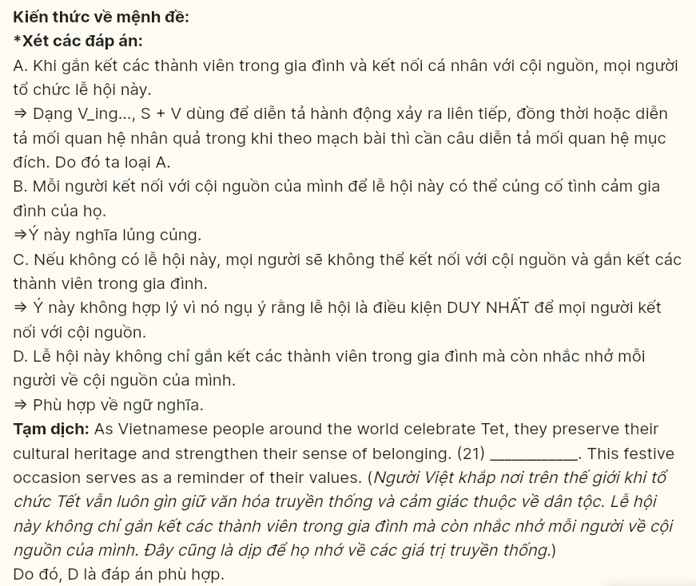

**Question 21 [696904]:**  
A. Reinforcing family ties and connecting individuals to their roots, people celebrate this festival  
B. Individuals connect to their roots so that this festival can reinforce their family ties  
C. But for celebrating this festival, individuals wouldn’t connect to their roots and reinforce their family ties  
D. This festival not only reinforces family ties but also connects individuals to their roots

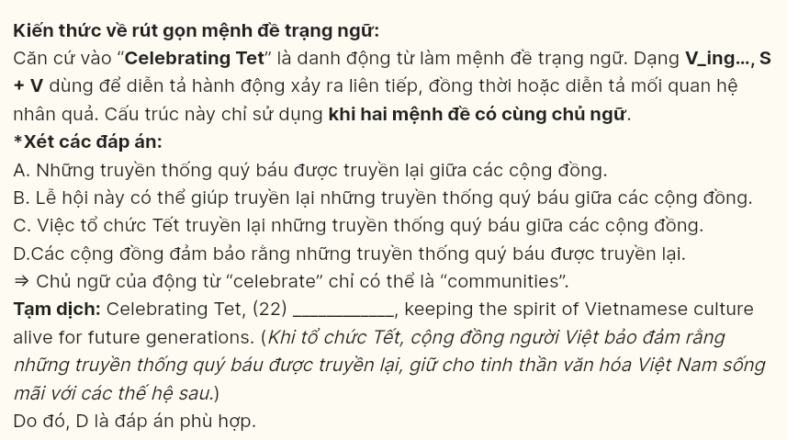

**Question 22 [696905]:**  
A. cherished traditions are passed down among communities  
B. this festival can help pass down cherished traditions among communities  
C. the celebration of Tet passes down cherished traditions among communities  
D. communities ensure that cherished traditions are passed down

***Read the following passage and mark the letter A, B, C or D on your answer sheet to indicate the best answer to each of the following questions from 23 to 30.***

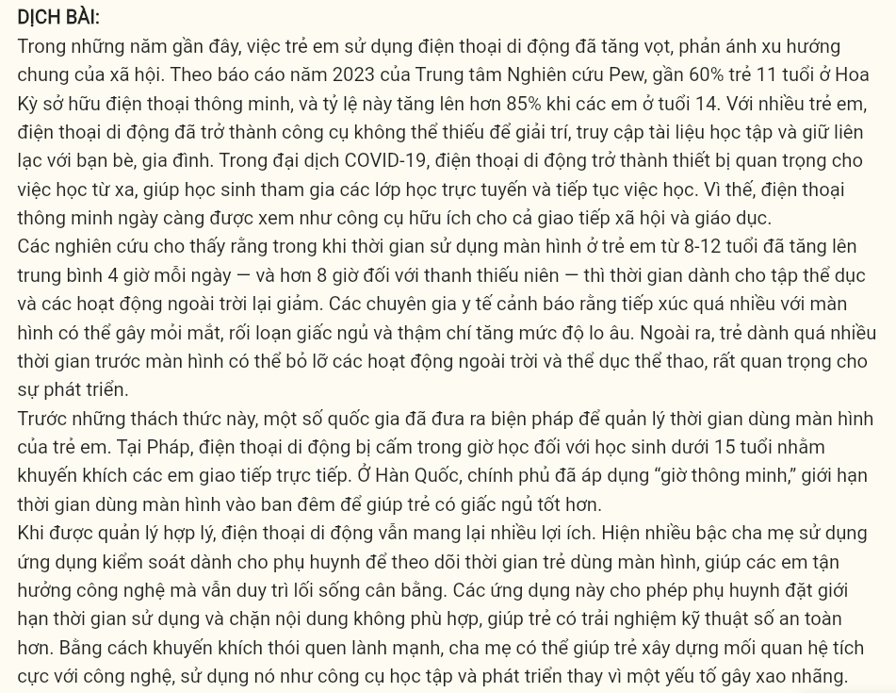

In recent years, the usage of mobile phones among children has surged, reflecting a broader trend in society. According to a 2023 report by the Pew Research Center, nearly 60% of children aged 11 in the United States own a smartphone, and this number rises significantly to over 85% by the age of 14. For many children, mobile phones have become essential tools for entertainment, accessing educational resources, and staying connected with friends and family. During the COVID-19 pandemic, mobile devices became **crucial** for remote learning, allowing students to attend online classes and continue their studies. In this context, smartphones are increasingly seen as valuable for both social interaction and education.

Studies show that while screen time among children aged 8–12 has increased to an average of 4 hours daily—and over 8 hours for teenagers—time spent on physical exercise and outdoor activities has decreased. **Health professionals warn that excessive screen time can lead to problems such as eye strain, disrupted sleep patterns, and even heightened levels of anxiety**. Additionally, children spending too much time on screens may miss out on outdoor activities which are essential for **their** growth.

In response to these challenges, some countries have introduced measures to **regulate** screen time for children. In France, mobile phones are banned during school hours for students under 15, a policy aimed at encouraging face-to-face social interactions. In South Korea, the government has implemented "smart hours," which limit screen time for children at night to support healthier sleep habits.

When managed responsibly, mobile phones offer benefits. Many parents now use parental control apps to monitor screen time, helping children enjoy technology while fostering a balanced lifestyle. These apps allow parents to set limits on usage and restrict access to inappropriate content, ensuring a safer digital experience for children. By encouraging healthy habits, parents can help children develop a positive relationship with technology, using it as a tool for learning and growth rather than a distraction.

**Question 23 [696906]:** Which of the following is **NOT** mentioned as one of the reasons children use mobile phones?  
A. for entertainment purposes  
B. to complete school homework  
C. to stay connected with friends and family  
D. to access educational resources

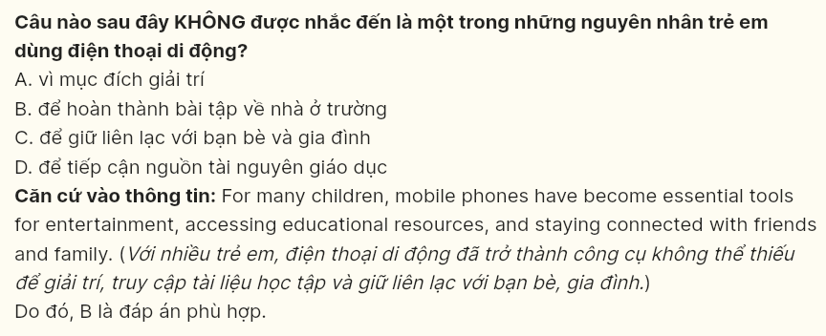

**Question 24 [696907]:** The word ***crucial*** in paragraph 1 is **OPPOSITE** in meaning to ________:  
A. essential B. significant C. important D. minor

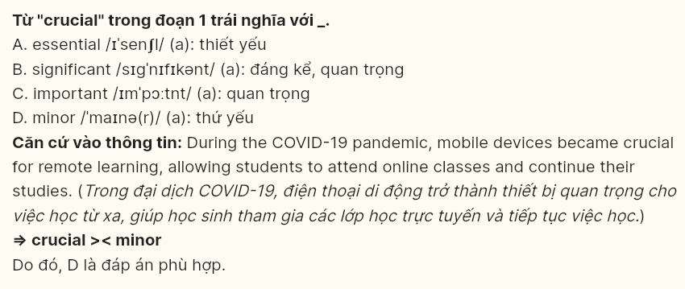

**Question 25 [696908]:** The word ***their*** in paragraph 2 refers to ________:  
A. children B. screens C. outdoor activities D. levels

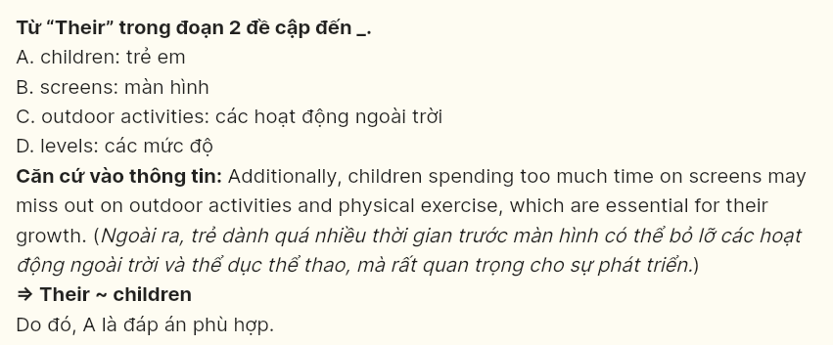

**Question 26 [696909]:** The word ***regulate*** in paragraph 4 could be best replaced by________:  
A. promote B. control C. increase D. encourage

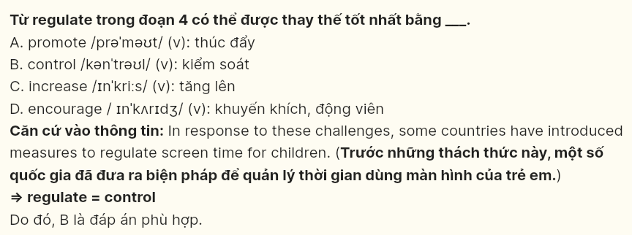

**Question 27 [696910]:** Which of the following best paraphrases the underlined sentence in paragraph 2?  
A. Health professionals state that spending moderate time on screens can still result in issues such as eye strain, disrupted sleep patterns, and even heightened levels of anxiety.  
B. Health professionals predict that spending too much time on screens may result in issues such as eye strain, disrupted sleep patterns, and even heightened levels of anxiety.  
C. Health professionals caution that spending too much time on screens may result in issues such as eye strain, disrupted sleep patterns, and even heightened levels of anxiety.  
D. Health professionals suppose that spending too much time on screens may lead to issues such as eye strain, disrupted sleep patterns, and even heightened levels of anxiety.

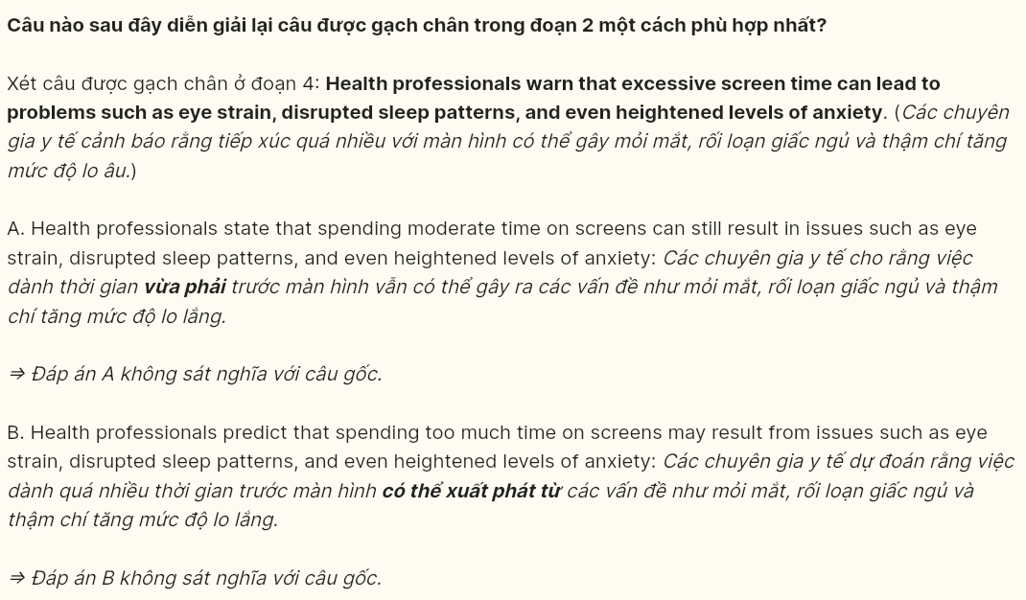

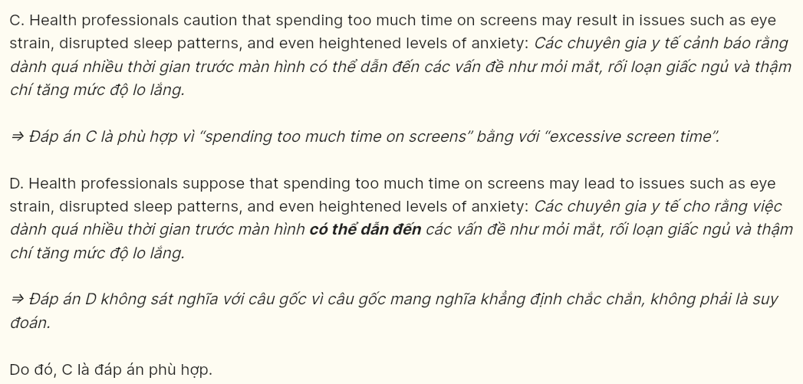

**Question 28 [696911]:** Which of the following is **TRUE** according to the passage?  
A. Over 85% of children aged 11 in the United States have a smartphone.  
B. During the COVID-19 pandemic, mobile devices were rarely used for remote learning.  
C. In France, students under 15 are allowed to use mobile phones freely during school hours.  
D. Teenagers spend more than double the time on screens compared to children aged 8–12.

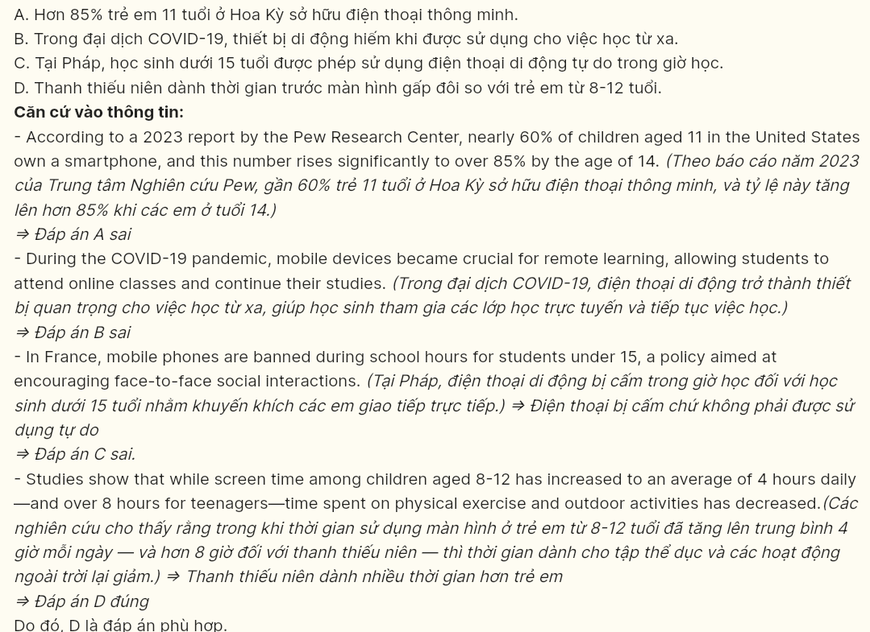

**Question 29 [696912]:** In which paragraph does the writer mention an inverse relationship?  
A. Paragraph 1 B. Paragraph 2 C. Paragraph 3 D. Paragraph 4

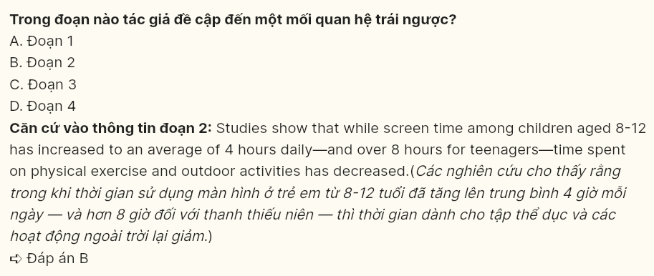

**Question 30 [696913]:** In which paragraph does the writer describe a method for parents to manage children’s screen time?  
A. Paragraph 1 B. Paragraph 2 C. Paragraph 3 D. Paragraph 4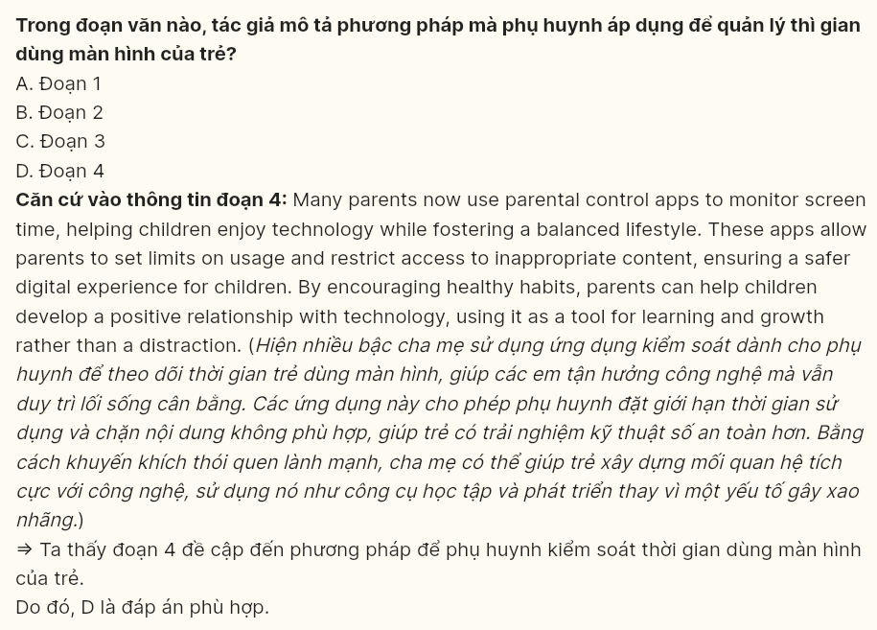

**Read the following passage and mark the letter A, B, C or D on your answer sheet to indicate the best answer to each of the following questions from 31 to 40.**

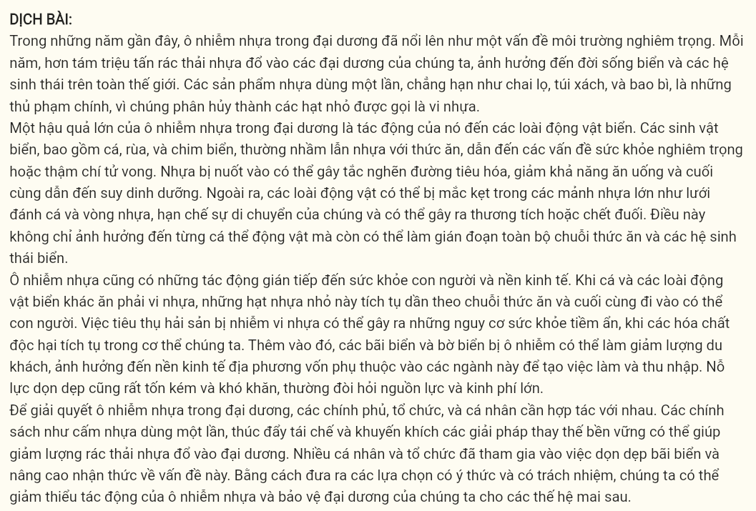

[I] In recent years, plastic pollution in the ocean has emerged as a severe environmental issue. [II] Each year, over eight million tons of plastic waste end up in our oceans, impacting marine life and ecosystems worldwide. [III] Single-use plastics such as bottles, bags, and packaging are among the main culprits, as they break down into tiny particles known as microplastics. [IV]

One major consequence of ocean plastic pollution is its impact on marine animals. Sea creatures, including fish, turtles, and seabirds, often mistake plastic for food, leading to severe health problems or even death. Ingested plastic can block digestive tracts, reduce feeding, and ultimately cause starvation. Additionally, animals may become **entangled** in larger plastic debris like fishing nets and plastic rings, which **restrict** their movement and may lead to injuries or drowning. This not only affects individual animals but can also disrupt entire marine food chains and ecosystems.

Plastic pollution also has indirect effects on human health and economies. As fish and other marine animals ingest microplastics, these tiny particles move up the food chain and eventually reach humans. Consuming seafood contaminated with microplastics poses potential health risks, as harmful chemicals can accumulate in our bodies. Furthermore, polluted beaches and coastlines can deter tourism, impacting local economies that rely on these industries for jobs and income. Cleanup efforts are costly and challenging, often requiring **substantial** resources and funding.

To address ocean plastic pollution, governments, organizations, and individuals must work together. Policies such as banning single-use plastics, promoting recycling, and encouraging sustainable alternatives can help reduce the amount of plastic waste entering the ocean. Many individuals and organizations are already participating in beach cleanups and spreading awareness about the issue. **By making conscious choices and taking responsibility, we can mitigate the impacts of plastic pollution and protect our oceans for future generations.**

**Question 31 [696914]:** Where in paragraph 1 does the following sentence best fit?  
*These microplastics are now found in all ocean depths, from surface waters to the seafloor, posing a serious threat to marine biodiversity.*  
A. [I] B. [II] C. [III] D. [IV]

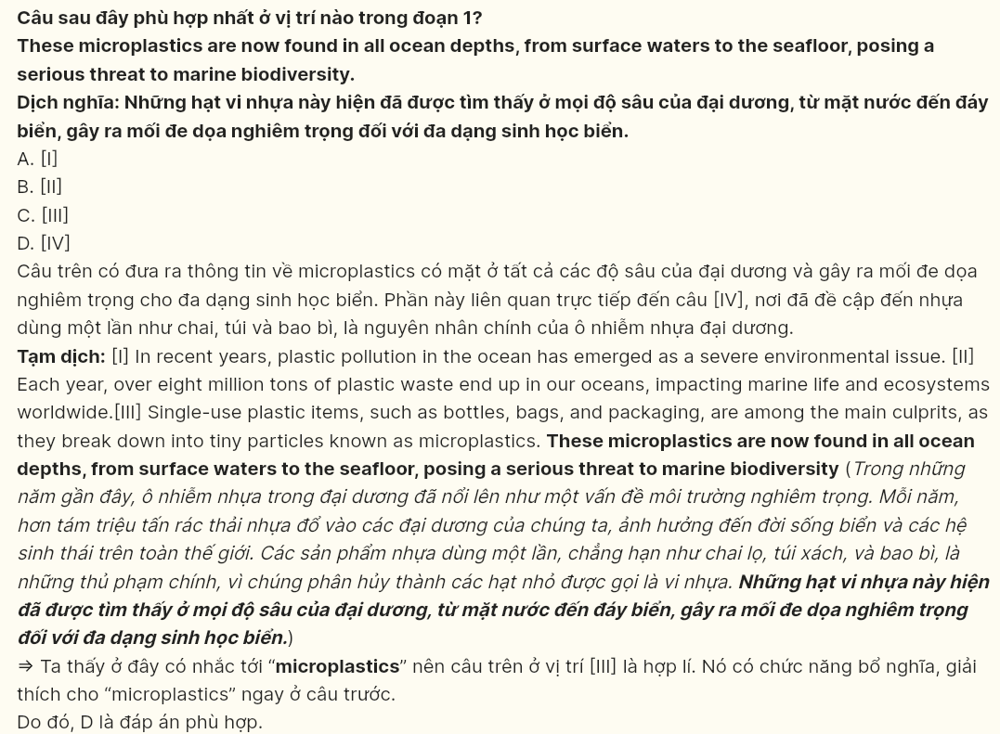

**Question 32 [696915]:** The phrase ***entangled*** in paragraph 2 could be best replaced by ______:  
A. escaped from B. twisted in C. protected from D. engaged in

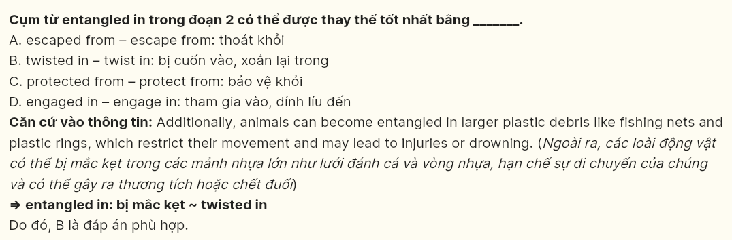

**Question 33 [696916]:** The word *their* in paragraph 2 refers to ______:  
A. plastic debris B. fishing nets C. plastic rings D. animals

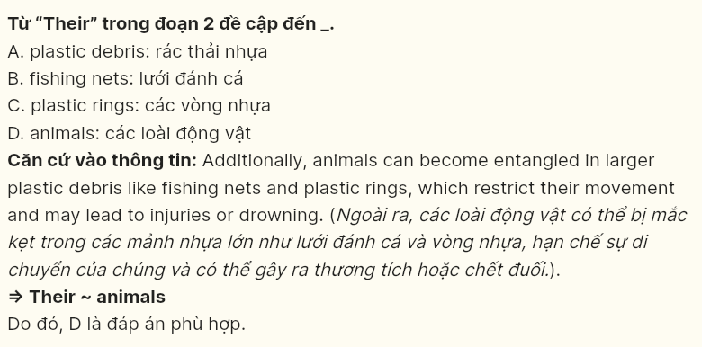

**Question 34 [696917]:** According to paragraph 3, which of the following is **NOT** a consequence of plastic pollution?  
A. Seafood contaminated with microplastics poses health risks to humans.  
B. Plastic pollution results in reduced oxygen levels in the ocean.  
C. Polluted coastlines harm tourism and local economies.  
D. Plastic pollution leads to increased cleanup costs for coastal areas.

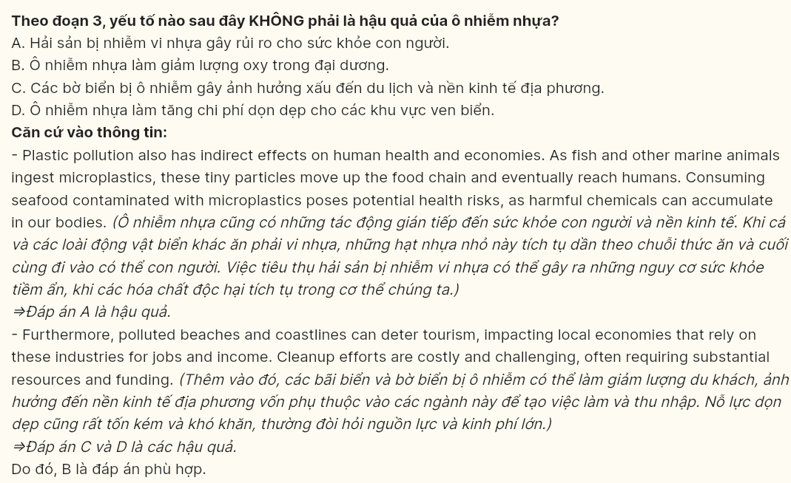

**Question 35 [696918]:** Which of the following best summarises paragraph 3?  
A. Plastic pollution harms human health, affects tourism, and requires costly cleanup efforts.  
B. Microplastics in seafood threaten human health and increase cleanup needs.  
C. Contaminated seafood poses health risks and impacts tourism in coastal regions.  
D. Plastic pollution leads to economic costs and harms human health through seafood.

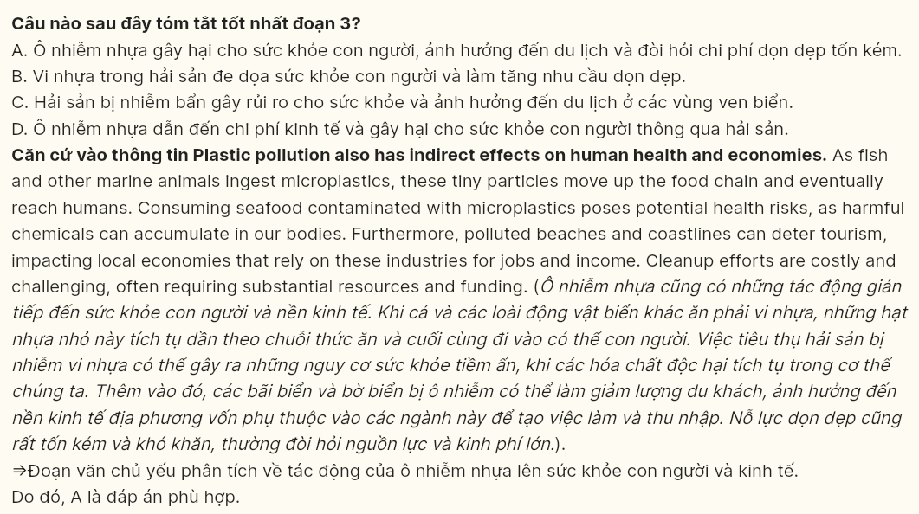

**Question 36 [696919]:** The word ***substantial*** in paragraph 3 is OPPOSITE in meaning to -_____:  
A. considerable B. noticeable C. negligible D. massive

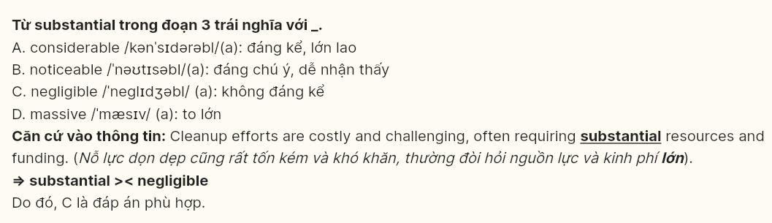

**Question 37 [696920]:** Which of the following is **TRUE** according to the passage?  
A. Most plastic waste in the ocean comes from biodegradable materials.  
B. Plastic pollution directly affects marine animals and has indirect impacts on humans.  
C. Microplastics only accumulate in shallow waters, affecting coastal marine life.  
D. Consuming seafood contaminated with microplastics does not affect human health.

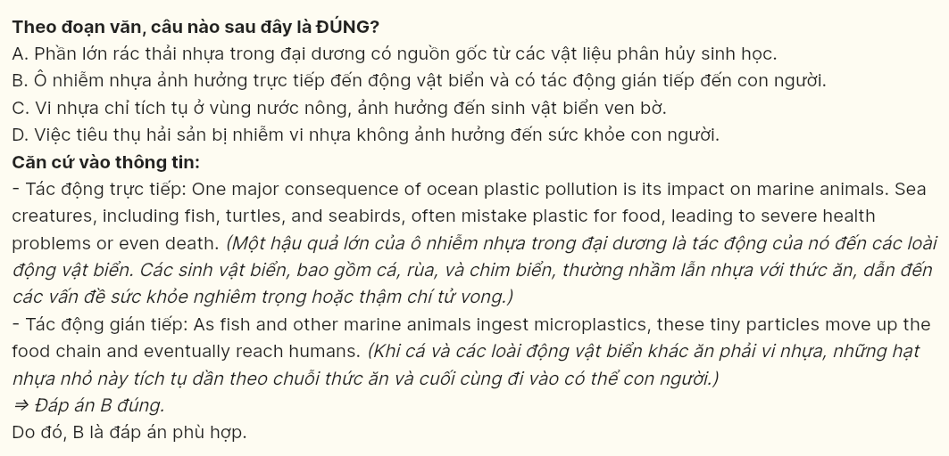

**Question 38 [696921]:** Which of the following best paraphrases the underlined sentence in paragraph 4?  
A. Taking responsibility and reducing waste will allow us to prevent plastic pollution and save our oceans permanently.  
B. We can reduce the causes of plastic pollution and make our oceans safe for future generations by increasing our awareness.  
C. Taking immediate action for the environment will help protect future generations from plastic pollution and keep our oceans clean.  
D. We can lessen the effects of plastic pollution and protect our oceans for future generations by making thoughtful decisions and taking responsibility.

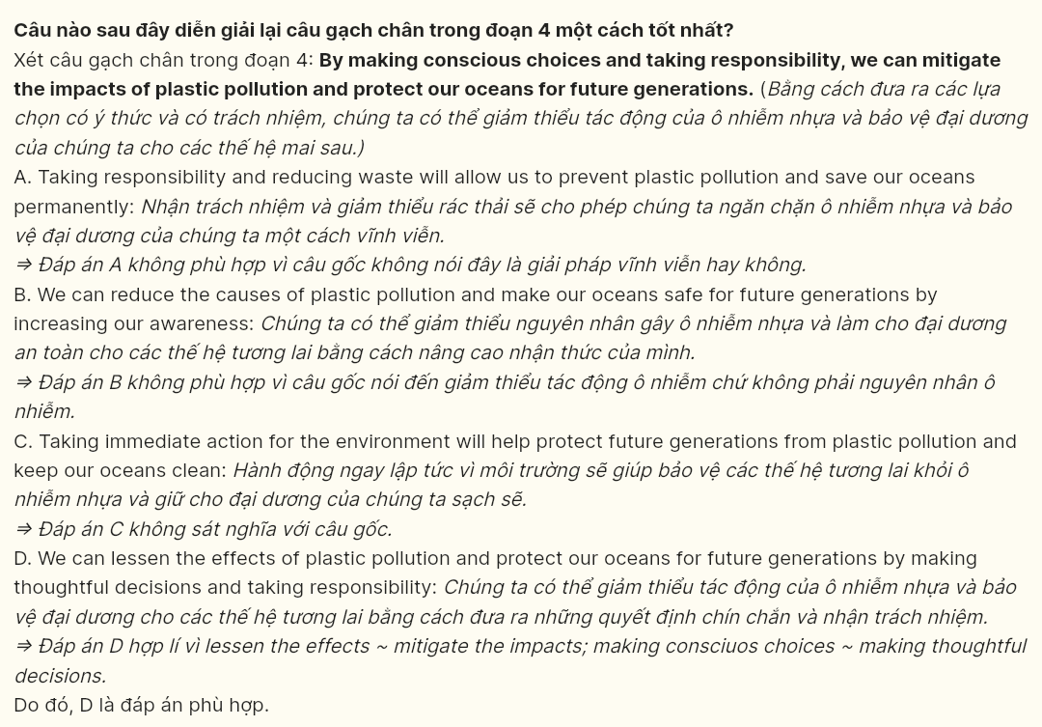

**Question 39 [696922]:** Which of the following can be inferred from the passage?  
A. Collective actions are necessary to effectively reduce ocean plastic pollution.  
B. International cooperation is the most critical factor in resolving plastic pollution.  
C. Reducing plastic waste in oceans depends on limiting individual use of single-use plastics.  
D. Increased awareness alone will lead to a significant decrease in ocean plastic pollution.

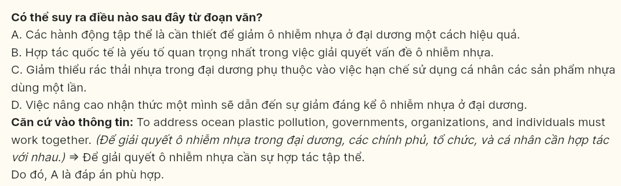

**Question 40 [696923]:** Which of the following best summarises the passage?  
A. Ocean plastic pollution endangers marine species and impacts human health through contaminated seafood, with cleanup efforts essential to managing the effects.  
B. Plastic waste in oceans poses risks to marine animals, damages tourism, and leads to costly cleanup efforts, which can be addressed by increased awareness and individual action.  
C. Ocean plastic pollution affects both marine life and coastal communities; individual actions, like reducing single-use plastics, can help address the problem.  
D. Plastic pollution in oceans harms marine life and has indirect impacts on human health and local economies, requiring joint efforts to reduce single-use plastics and promote sustainable practices.

