Mã đề 9.1.15 | BÀI KIỂM TRA GIỮA KÌ I  MÔN: TIẾNG ANH 9

- LISTENING
- Listen and tick (1ms)
- Where did he go first?
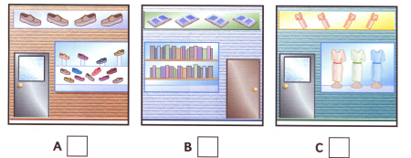
- What was she doing when the fire started?
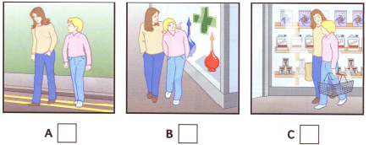
- Where did she have lunch?
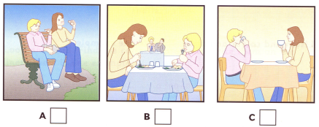
- What has she bought for Katy?
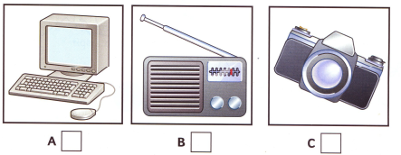
- When is she going to give it to Katy?
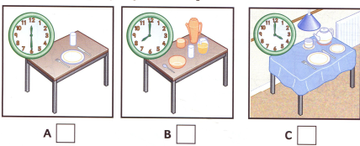

- Listen and complete (1ms)
DANCING CLASSES
- Age: …………………………………………
- Phone number: …………………………………………
- School: …………………………………………
- Days: …………………………………………
5.Time of lesson: …………………………………………
B.LANGUAGE
I. Find the word which has a different sound in the part underlined.(0,4m)
1: A. conduct B. difficult C. stuck D. fun
2: A. feature B. culture C. suggestion D. statue
II. Choose the correct answer to complete these sentences. (2,6 ms)
1. He feels ________ after the exam because he did the test very well.
A. stressful B. delighted C. nervous D. bored
2. ________, I’d buy an English – Vietnamese dictionary.
A. If I have money B. If I had your shoes
C. If I were in your shoes D.If I have your shoes
3. City life not only offers young people with lots of opportunities, but it has lots of ________as well.
A. variety B. advantages C. drawbacks D.benifits
4. What is the point of trying to stay here when you don’t have a job? You have been ______ for two years!
A. uncomfortable B. unemployed C. unhappy D. happy
5. Minh: “I promise I will study harder from now on.” Hoa “ __________ ”
A. I hope so B. Good idea C. No, thanks D. Sorry, I can’t
6. John: “Thank you for your help, Jane.” Jane: “ . ”
A. Don’t say me name B. Forget it C. No problem D. It’s my pleasure
7. Nam: “ How do you usually go to school?” Giang: “______________.”
A. Fifteen minutes B. One kilometer C. Every day D. On foot
8. They have to ________the factory because of the economic problem.
A. close down B. turn down C. pass down D.pass over
9: Most big companies are built and developed in .................... areas.
A. urban B. rural C. mountainous D. remote
10: He wants to buy an .................... car because he doesn’t have much money.
A. expensive B. affordable C. rich D. poor
11: His house is ............... mine.
A. twice as big as B. as twice big asC. as two times big as D. as big as twice
12. If you don’t know the meaning of this word, look for in the dictionary!
A B C D
13: He lost the key, or he couldn’t get into the house.
A B C D
C.READING
I. Choose the word or phrase among A, B, C or D that best fits the blank space in the following passage.(1,5ms)
City planners have claimed trees (1)…… an important role in an urban environment. Children (2)…….. close to nature have better health, while walking in parks helps reduce blood pressure, stress and obesity. The problem is to select the right trees and (3)…… them.
Ha Noi is considered one of the greenest cities in Viet Nam thanks to its beautiful and precious trees. Ancient trees in Ha Noi are frequently (4)……. in poems. Each street can be (5)……… by a tree. To local residents, the hundred-year old trees that line the streets are more than just beautiful, they are part of the city's identity.
1:A. act B. play C. enjoy D. perform
2:A. grow up B. grown up C. growing up D. being grown up
3:A. maintain B. service C. provide D. care
4:A. referred B. indicated C. spoken D. mentioned
5:A. described B. presented C. expressed D. explained

II.. Read the text and choose the correct answer. (1.5ms)
More than 80% of American high school students work at part-time jobs in the evenings, on weekends or in summer. These part-time jobs bring teenagers great advantages.
One of the benefits of the work is the students can learn the skills that will be useful for the rest of their lives. When they work, they have to manage both the job and schoolwork. To be able to do so, they must be very organized and able to keep a sensible schedule. They also learn to cope with the job stress apart from the stress of the schoolwork. Some of the most stressful jobs include teaching, nursing, and police work. These skills help prepare teenagers for their later careers. High school students who work are more likely to succeed as adults than people who enter the job market at a later age with no work experience.
Teenagers want a lot of expensive things: clothes, mp3 players, trips with their friends, etc. Not all parents can afford them. And even if they can, the teens might not really appreciate that money because they did not earn it. When teenagers make money for themselves, they know its true and are less likely to spend it foolishly.
1. Which of the following is a good title for the passage?
A. Why teenagers should work
B. Advantages and disadvantages of part-time jobs
C. Part-time jobs cause stress
D. Disadvantages of part-time jobs.
2. According to the passage, what is NOT an effect of part-time jobs?
A. Teenagers become organized.
B. Teenagers become stressed.
C. Teenagers are more likely to have successful careers.
D. Teenagers want a lot of expensive things
3. The word “cope with” in the passage is closest in meaning to ______.
A. fight against B. deal with C. suffer from D.concern
4. According to the passage, when teenagers have jobs, they are more likely to _______.
A. spend foolishly B. want expensive things C. appreciate money D. spend less
5. According to the passage, which of the following is TRUE?
A. Only some US students do part-time jobs.
B. US students suffer part-time job stress
C. Part-time jobs are somehow good for teenagers
D. The part-time jobs don’t bring teenagers great advantages.
D.WRITING
I. Rewrite the second sentences in other way so that the meanings stay the same as the first. (1.0m)
1. Despite being tired, she stayed up late to finish knitting the scarf for her dad.
→Although
2. “How can I make this kind of cake?” She wondered. (how to…)
→She wondered how
3. My uncle spent his childhood in the countryside. (grew up)
→My uncle
4. You shouldn’t leave the lights on when you leave the classroom. (off)
→You should
5. He has a good relationship with his siblings. (on well)
→He gets
II. Imagine that your pen friend is coming to Viet Nam and will spend a day in your hometown.She/He has asked for your advice on the places of interest they should go to and things they can do there. (1m)
Dear Alex,
1.I /glad/ you / come / Viet Nam next week
………………………………………………………………………..
2. There/ many places of interest /hometown / you / visit/
………………………………………………………………….
3.I/ like /you/ come / Cao temple, Con Son mountain, …..
………………………………………………………………………………………
4. You/ take photos,/climb mountain, /visit many caves.. I/ sure /you/ have/ fun.
……………………………………………………………………………….
5. I/look forward / see you soon.
………………………………………………………………………………
Love
Lan

Question | Answer keys | Marks
A.Listening | Listening I Tổng 1 điểm. Mỗi đáp án đúng 0.2 đ  1. C 2. B 3. A 4. C 5. A | 1 điểm  0.2x5
 | Listening II Tổng 1 điểm. Mỗi câu đúng 0.2 đ  1. 9 2. 849033 3. Forest Hill 4. Friday 5. 5 o’clock | 1 điểm  0.2x5
B.Pronunciation  Grammar and vocabulary | I.Pronunciation Tổng 0,4 điểm. Mỗi câu đúng 0.2 đ  1.B 2.C  II. Grammar and vocabulary  Tổng 1,6 điểm. Mỗi câu đúng 0.2 đ  1. B 2. C 3. C 4. B 5. A  6. D 7. D 8. B 9. A 10. B 11.A 12.D 13.B | 3 điểm  0.2x15
C.Reading | I.Tổng 1.0 điểm. Mỗi câu đúng 0.2 đ  1 – B 2 – A 3 – D 4 – D 5 – C  II.Tổng 1.0 điểm. Mỗi câu đúng 0.2 đ  1. A 2. B 3. B 4. C 5. C | 2 điểm  0.2x10
D.Writing | I.Tổng 1.0 điểm. Mỗi câu đúng 0.2 đ  1. Although she was tired, stayed up late to finish knitting the scarf for her dad.  2. She wondered how to make that kind of cake.  3. My uncle grew up in the countryside.  4. You should turn off the lights when you leave the classroom.  5. He gets on well with his siblings.  II.Tổng 1.0 điểm. Mỗi câu đúng 0.2 đ  1.I am glad that you are going to come to Viet Nam next week  2. There are many places of interest in my hometown for you to visit.  3.I’d like you to come to Cao temple, Con Son mountain, …..  4. You can take photos, climb mountain, visit many caves… I am sure you will have a lot of fun.  5. I am looking forward to seeing you soon. | 2.0 điểm  0.2x10
Nếu thấy học sinh làm theo cách khác mà đúng, vẫn cho điểm tối đa.

