Tiếng Anh 7 – i-LEARN SMART WORLD

FINAL TEST – SEMESTER 1
Note: Each correct answer earns 0.2 points.

I. PRONUNCIATION (0.8 points)
A. Choose the word whose underlined part is pronounced differently.
1. A. hamburger B. tablespoon C. plastic D. sandwich
2. A. raised B. fried C. helped D. cleaned
B. Choose the word that has a different stressed syllable from the rest.
3. A. collect B. teaspoon C. flour D. reggae
4. A. charity B. dangerous C. medicine D. exciting

II. VOCABULARY AND GRAMMAR (2.4 points)
Choose the best option (A, B, C or D) to complete each of the following questions.
5. Do you need the scissors to open the __________ of juice?
A. can B. carton C. bag D. glass
6. Person A: How much pasta would you like?
Person B: ________, please. I’m not very hungry.
A. A lot B. Just a few C. Just a little D. Much
7. Last weekend, we __________ the beach in our area and we collected 1,000 kilograms of trash. Most of them came from the people who visited the beach.
A. organized B. planted C. recycled D. cleaned up
8. __________ we have a car wash? It’s a simple and fun way to raise money.
A. Let’s B. Why don’t C. Why not D. How
9. Student A: Where __________?
Student B: To the sports center. He __________ table tennis with Ryan on Mondays.
A. is James going/ plays B. is James going/ is playing
C. does James go/ plays D. does James go/ is playing
10. This bag of __________ is empty. How can I cook dinner now?
A. milk B. oil C. butter D. rice
11. Last week, I __________ at a soup kitchen. We cooked and delivered free meals to the poor and low-income families across Ho Chi Minh city.
A. donated B. volunteered C. organized D. raised
12. Student A: Let’s have a(n) __________.
Student B: That’s a good idea. We can sell handmade cards and jewelry.
A. art fair B. art exhibition C. fun fair D. craft fair
13. I bought __________ stick of butter this morning. I used half of __________ butter to make cupcakes.
A. a/ some B. the/ the C. a/ the D. a/ -
14. Student A: I really enjoy classical music.
Student B: _________
A. So do I. B. No, I’m not. It’s so boring.
C. No, I won’t. I prefer pop. D. I am, too.

15. Read the poster and choose the correct statement.
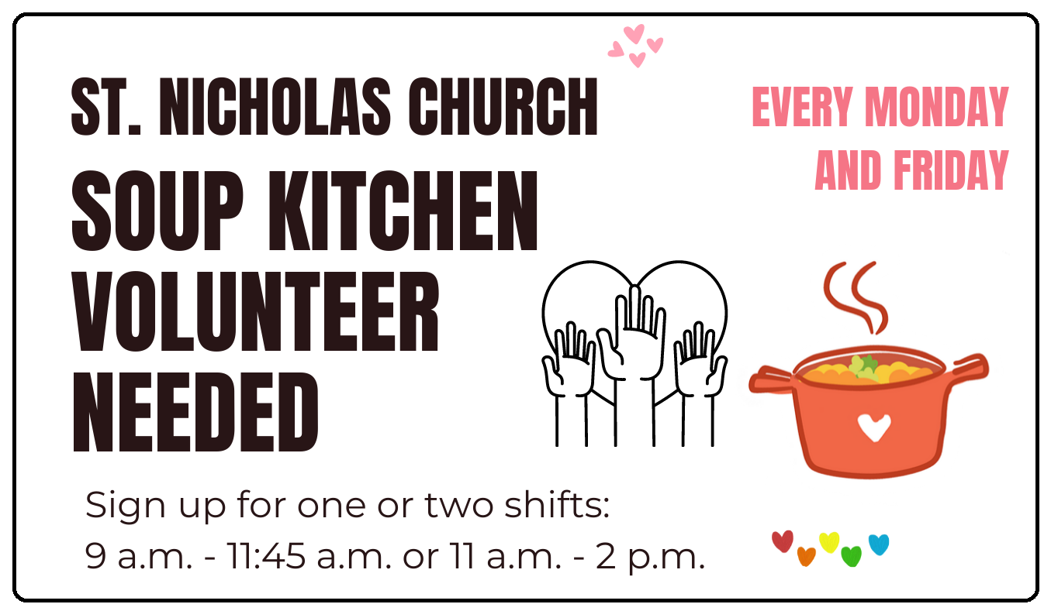 | A. The soup kitchen delivers free meals every day.  B. Volunteers have to work from 9 a.m. to 2 p.m.  C. There are two shifts for volunteers to choose.  D. Volunteers will work on the weekends from 11.45 a.m. to 2 p.m.
16. What does this sign mean?
 | A. There are no flashlights here.  B. You can’t use flashlights here.  C. You can’t bring any cameras to this place.  D. Photographers can’t use flash here.

III. WORD FORMATION (1.2 points)
Write the correct form or compound of the words in brackets.
17. The Saigon Zoo and Botanical Garden in HCM city received many ___________ of meat, fruits and vegetables to help take care of the animals during the COVID-19 outbreak. (DONATE)
18. We left the cinema early because the movie was so ___________. (BORE)
19. My mum is a great cook. She can make __________ dishes, such as Spanish omelet or lemon chicken. (TASTE)
20. We are all __________ about going to the concert. Taylor Swift is performing there. (EXCITE)
21. I took part in a park __________ yesterday. The park looked beautiful after we finished. (CLEAN)
22. John couldn’t sleep last night, so he had a terrible __________ this morning. He had to take medicine. (HEAD)

IV. LISTENING (2 points)
A. You will hear Julia talking to her mum. For questions 23-27, listen and choose the correct option A, B, C or D.
23. What time does Jack finish his study?
A. 3.30 p.m. B. 4 p.m. C. 5.30 p.m. D. 7 p.m.
24. Mum asks Julia to cook _______.
A. the rice B. the chicken C. tuna salad D. cereal
25. Julia needs to buy ________.
A. two bottles of milk B. a box of cereal
C. a carton of eggs D. a bunch of bananas
26. How much yogurt do they need?
A. some B. a bottle C. two cartons D. four pots
27. Where is the bread?
A. in the bottom cupboard B. next to the sink
C. on top of the fridge D. in the top cupboard

B. You will listen to two teenagers talking about their hobbies. For each question from 28 to 32, listen and write short answers.

28. What does Anita use her camera for?
→
29. When does the film club take place?
→
30. Where does Pablo go skateboarding?
→
31. What is Camelia’s hobby?
→
32. How often does Camelia go to the sports center?
→
V. READING (2 points)
A. Read the following passage. For each question from 33 to 37, write T if the statement is TRUE, F if the statement is FALSE and NI if there is NO INFORMATION on it.

Vietnamese Bánh Mì is popular and easy to find everywhere in Vietnam. You can buy it from vendors in the street and it’s really cheap. It’s normally a takeaway and wrapped in recycled paper. The bread is a short baguette which is crunchy outside, soft and airy inside. People fill bánh mì with a variety of ingredients, such as coriander, fish sauce, pickled carrots, cucumber slices, chili peppers, pork, ham, pâté and mayonnaise. It is also possible to buy vegetarian bánh mì. Sometimes, you can eat it with fish, eggs or even ice cream. Vietnamese people enjoy bánh mì at any time of the day.
A Falafel sandwich is one of the best Middle Eastern vegan meals. There are so many wonderful flavors in this sandwich. First, the chef prepares falafel balls. They are made of chickpeas and are deep-fried for a few minutes until they turn golden brown and crispy. Or at home, you can bake them in a hot oven. That way is healthier, but fried balls taste better. Then, the chef stuff falafel balls into a warm pita. He also adds vegetables like cucumber, tomatoes, and onions, and creamy tahini sauce. You can enjoy it as a quick and easy weekday meal or late-night snack.

33. Bánh mì is a typical cheap street food in Vietnam.
34. People can serve bánh mì with different ingredients.
35. Vietnamese people have bánh mì for breakfast only.
36. Baking falafel balls makes them healthier and tastier.
37. It takes only a few minutes to cook pita bread.

B. Read the passage. For questions from 38 to 42, complete each blank with a suitable word in the box. There are TWO extra words that you don’t need.
IN EXPERIENCE LOOK FOR ON
READ HAVE DONATING

Are you looking for a great way to help others, learn new skills, gain (38) __________, and make new friends? Try volunteering! There are many ways you can do to help people in need. First, you can work at a soup kitchen. Soup kitchens always (39) __________ volunteers to help serve food and cook meals. Working at a soup kitchen gives you the opportunity to meet people from different backgrounds. Second, you can spend time visiting the elderly. Old people in nursing homes may not see visitors often enough and would love to have some company. You can (40) __________ books to them, bring them cookies or make birthday cards for them, and so much more. In return, you’ll probably hear some great stories about the good old days. You can also take part (41) __________ clean-ups. By picking up trash and doing some yard work or planting trees, you can make your neighborhood a more pleasant and beautiful place to live. Besides, you should consider (42) __________ unwanted items to charity shops, or giving unused food to a food bank. It’s a great way to help out the community.

VI. WRITING (1.6 points)
A. Rewrite the following sentences without changing their meaning. Use the given word(s) if any.
43. Lucas ate something bad and his stomach hurt.
→ Lucas ate something bad and he .
44. We should have a bake sale to raise money for our football uniforms.
→ How about ?
45. Andy is a good guitar player.
→ Andy is good .
46. When you have a fever, it’s not a good idea to go to school.
→ You .
B. Use the given words or phrases to make complete sentences.
47. What/ kind/ music/ Andrew/ like?
→
48. Let’s/ organize/ fun run/ support/ poor students/ our school.
→
49. I/ have/ sandwich/ bottle/ milk/ breakfast/ this morning.
→
50. We/ need/ two tablespoons/ oil/ 400 g/ flour.
→

***End – Of – Test***

