School: ……………………………………….. | Date: ……………………………..
Class: ……………………………..................... | Period: ………………………......

UNIT 8: FESTIVALS AROUND THE WORLD
Lesson 2.1 – New words and Listening (page 63)

I. OBJECTIVES
By the end of the lesson, Ss will be able to:
1.1. Language knowledge and skills
- know more words relating to festivals. (exchange, tradition, midnight, wish, greeting, celebrate).
- talk about festivals and holidays in their country and traditions to celebrate them.
- listen to and understand a conversation of two friends talking about traditions (general and specific details).
- know how to show interest.
1.2. Competences
- improve communication, collaboration, and critical thinking skills.
1.3. Attributes
- be active to take part in outdoor activities.
- respect cultures and tradition of home-country and other countries in the world.

II. TEACHING AIDS AND LEARNING MATERIALS
1. Teacher’s aids: Student book and Teacher’s book, class CDs, Digital Book (DCR phần mềm tương tác SB, DHA (từ vựng/ cấu trúc) phần mềm trò chơi tương tác), projector/interactive whiteboard / TV (if any), PowerPoint slides.
2. Students’ aids: Student’s book, workbook, notebook.

III. ASSESSMENT EVIDENCE
Performance Tasks | Performance Products | Assessment Tools
- Fill in the blanks. | - Ss’ answers. | - T’s feedback/Peers’ feedback.
- Listen and repeat. | - Ss’ presentation. | - T’s feedback/Peers’ feedback.
- Talk about festivals and holidays in your country and the traditions to celebrate them. | - Ss’ presentation / answers. | - T’s feedback/Peers’ feedback.
- Listen to two friends talking about traditions. What are they celebrating? | - Ss’ answers. | - T’s feedback/Peers’ feedback.
- Listen and fill in the blanks. | - Ss’ answers. | - T’s feedback/Peers’ feedback.
- Speak: Which of these Spanish or Scottish traditions do you think is the most interesting? | - Ss’ answers/ presentation. | - T’s observation and feedback.

IV. PROCEDURES
A. Warm up: (5’)
a) Objective: Introduce the new lesson and set the scene for Ss to acquire new language; get students' attention at the beginning of the class by enjoyable and short activities as well as to engage them in the follow-up steps.
b) Content: Review: Festivals around the world.
c) Expected outcomes: Ss get to know some new words they are going to study in the lesson.
d) Organization of the activity:
TEACHER’S ACTIVITIES | STUDENTS’ ACTIVITIES
- Option 1: Matching: Festivals with countries  - Have Ss match each festival with its right country (in pairs).  - Call Ss to give answers.  - Give feedback and show correct answers.  - Lead to the new lesson.  *Illustration:  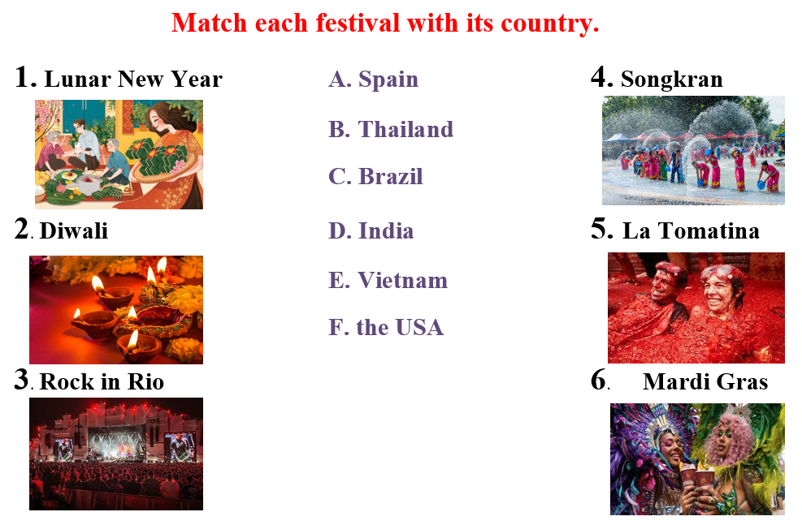  - Option 2: Matching: New Year traditions with countries  - Have Ss match each country with its New Year tradition (in pairs / groups).  - Call Ss to give answers.  - Give feedback and show correct answers.  - Lead to the new lesson.  *Illustration:  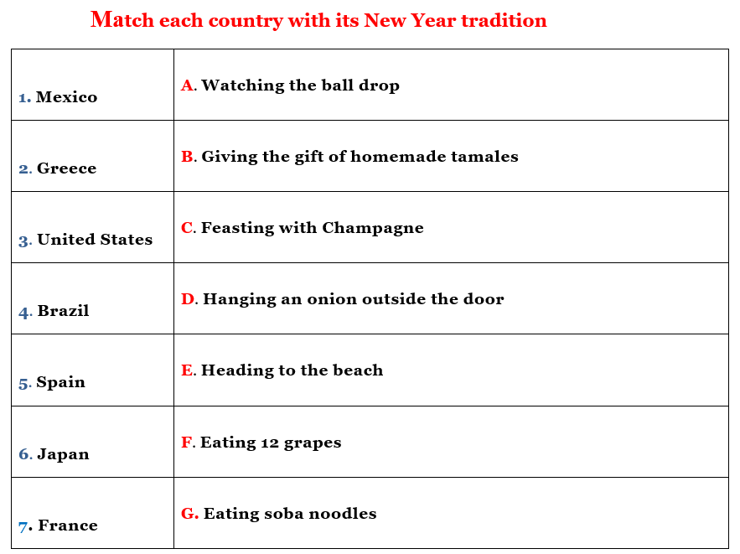 | - Work in pairs to match.  - Give answers.  Answer keys  1E  2D  3C  4B  5A  6F  - Take part in the class’s activity.  - Read answers.  - Listen.  Answer keys  1 B  2 D  3 A  4 E  5F  6 G  7 C

B. New lesson (35’)
- Activity 1: Pre-Listening (Vocabulary) (12’)
a) Objective: Ss get to know words about festivals.
b) Content:
- Vocabulary study (exchange, tradition, midnight, wish, greeting, celebrate, …).
- Speaking: Talk about festivals and holidays in your country and the traditions to celebrate them.
c) Expected outcomes: Ss know how to pronounce the new words correctly and use them when they do some listening tasks.
d) Organization of the activity:
TEACHER’S ACTIVITIES | STUDENTS’ ACTIVITIES
Task a. Fill in the blanks. Listen and repeat.  - Demonstrate the activity on DCR, using the example  - Have Ss fill in the blanks.  - Divide class into pairs and have them check their answers with their partners.  - Call Ss to give answers.  - Check answers as a whole class using DCR.  - Play audio (CD2 – Track 05). Have Ss listen and repeat.  - Correct Ss’ pronunciation.  Task b. In pairs: Talk about festivals and holidays in your country and the traditions to celebrate them.  - Have Ss work in pairs to discuss festivals and holidays in their country and the traditions to celebrate them.  - Go round and give help if necessary.  - Have some pairs demonstrate the activity in front of the class.  - Give feedback and evaluation. | - Look and listen.  - Work individually.  - Work in pairs.  - Give answers.  - Listen and repeat.  Answer keys  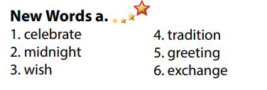  - Work in pairs to discuss.  - Present.  Sample answers  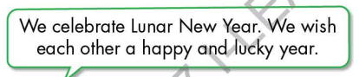
- Activity 2: While - Listening (17’)
a) Objective: Students can develop their listening skill.
b) Content:
- Listen to two friends talking about traditions. What are they celebrating?
- Listen and fill in the blanks.
c) Expected outcomes: Ss can listen to and understand a conversation of two people about traditions (for general and specific details).
d) Organization of the activity:
TEACHER’S ACTIVITIES | STUDENTS’ ACTIVITIES
Task a. Listen to two friends talking about traditions. What are they celebrating?  - Have Ss read the question, guess the answer.  - Play audio (CD2 - Track 06).  - Have Ss listen and circle the correct answer.  - Check answer as a whole class using DCR.  Task b. Now, listen and fill in the blanks.  - Have Ss read the through the content of Task b, underline the key words.  - Play the audio again (CD1 - Track 06).  - Have Ss listen and fill in the blanks.  - Remind Ss to write short answer for each sentence (only 1 word).  - Have Ss check answers with their partners.  - Call Ss to give answers.  - Give feedback and show correct answers using DCR. | -Work individually.  - Listen.  - Circle the correct answers.  Answer keys  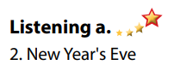  - Read, underline the key words.  - Do the task.  - Exchange answers.  Answer keys  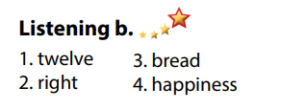

- Activity 3: Post - Listening (6’)
a) Objective: Students can use the vocabulary and the content in listening part to develop their speaking skill.
b) Content: Speaking: Which of these Spanish or Scottish traditions do you think is the most interesting?
c) Expected outcomes: Students can express their idea about the festival they prefer.
d) Organization of the activity:
TEACHER’S ACTIVITIES | STUDENTS’ ACTIVITIES
Conversation skill  - Have Ss look at the Conversation skill box and read (using DCR).  - Play audio (CD 2 - Track 07), have Ss listen and repeat.  - Ask Ss to find more ways to show interest.  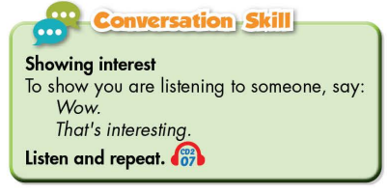  Task c. In pairs: Which of these Spanish or Scottish traditions do you think is the most interesting?  - Have Ss work in pairs to discuss.  - Observe and give help if necessary.  - Call some pairs to share their ideas with the class.  - Give feedback and evaluation. | - Look and read.  - Listen and repeat.  - Give answers.  - Work in pairs.  - Present.

C. Consolidation and homework assignments (5’)
* Consolidation:
- Words relating to festivals (exchange, tradition, midnight, wish, greeting, celebrate, …).
- Language to ask show interest: Wow! / That’s interesting! / That’s amazing! / …

* Homework
- Learn the new words by heart.
- Practice talking about festivals and holidays in your local area.
- Do the exercises in WB: New words and Listening (page 46).
- Do the vocabulary exercise in Tiếng Anh 7 i-Learn Smart World Notebook (page 50).
- Play consolation games in Tiếng Anh 7 i-Learn Smart World DHA App on www.eduhome.com.vn
- Prepare: Lesson 2.2 – Grammar (page 64 – SB).

D. Reflection
a. What I liked most about this lesson today:
…………………………………………………………………………………………
- What I learned from this lesson today:
…………………………………………………………………………………………
c. What I should improve for this lesson next time:
…………………………………………………………………………………………

