School: ……………………………………….. | Date:……………………………………..
Class: ……………………………..................... | Period: 91

UNIT 6: BE GREEN
Grammar 6b (Page 98)

1. Objectives
By the end of this lesson, students will be able to…
1.1. Language knowledge/ skills
- review some tenses: present simple, present continuous, past simple, future simple and be going to.
- practise doing grammar exercises.
- practise making questions and answers based on a text.
1.2. Competences
- improve Ss’ analytical, collaboration and critical thinking skills.
1.3. Attributes
- build their motivation for study.
- develop their patriotism, kindness, honesty.
2. Teaching aids and materials
- Teacher’s aids: Student’s book and Teacher’s book, class CDs, IWB – Phần mềm tương tác trực quan, projector/interactive whiteboard /TV (if any), PowerPoint slides.
- Students’ aids: Student’s book, Workbook, Notebook.
3. Assessment evidence:
Performance Tasks | Performance Products | Assessment Tools
- Fill in the blanks with the verbs in present simple or present continuous.  - Fill in the blanks with the verbs in past simple.  - Make questions and answers based on a text. | - Ss’ answers.  - Ss’ answers.  - Ss’ own sentences. | - Observation.  - Observation.  - Observation.

4. Procedures
A. Warm up: 5 minutes
a. Objectives: to review some tenses.
b. Content: Sentences using the present simple, present continuous, past simple, future simple and be going to.
c. Expected outcomes: Ss can remember the usage of the tenses.
d. Organization

Teacher’s activities | Students’ activities
Complete the sentences with the correct form of the verbs in brackets.  1. He ______ (work) in the office now.  2. I _____(visit) my grandparents last week.  3. I have got a cold. I____(see) a doctor.  4. My brother_____(play) football very well.  5. I think people ____(use) fewer plastic bags in the future.  - Show the sentences and ask Ss to complete them.  - Check Ss’ answers. | - Complete the sentences with the correct form of the verbs in brackets.  Answer Keys  1. is working 2. visited  3. am going to see 4. plays  5. will use  - Listen to the teacher and take notes.
B. Presentation: 10 minutes
a. Objectives: to help Ss review the tenses: using the present simple, present continuous and past simple.
b. Content: Language box.
c. Expected outcomes: Ss can understand the usage of tenses: present simple, present continuous and past simple.
d. Organization
Teacher’s activities | Students’ activities
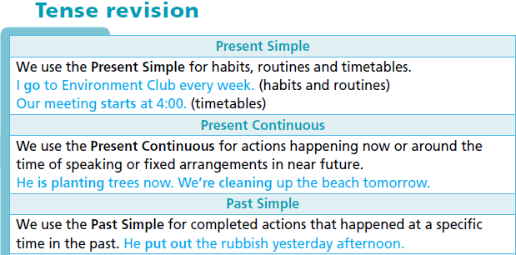  - Read through the theory, using the IWB and elicit further examples from Ss.  - Check Ss’ understanding. | - Read the theory and listen to teacher.  - Take notes.

C. Practice: 15 minutes
a. Objectives: to help Ss practise tenses mentioned earlier.
b. Content: task 1 and task 2.
c. Expected outcomes: Ss can understand how to use the tenses correctly in the context.
d. Organization:

Teacher’s activities | Students’ activities
Task 1: Put the verbs in brackets into the Present Simple or the Present Continuous.  1 I walk (walk) to school every day.  2 ________ (you/go) to the clean-up day tomorrow?  3 Jim ____ (build) a birdhouse now.  4 We ______ (not/have) an English lesson on Wednesdays.  5 They _______ (not/do) any environmental projects at the moment.  - Explain the task (using the IWB) and give Ss time to complete it.  - Check Ss’ answers. | - Listen to teacher’s explanation and read the sentences and do the task.  Answer Keys:  2. Are you going  3. is building  4. don’t have  5. aren’t doing
Task 2: Put the verbs in brackets into the Past Simple.  Dian Fossey (1932 – 1985) 1) _____ (be) from the USA. She first 2) ____ (go) to Africa in 1963, and she 3) ____ (fall) in love with mountain gorillas, an endangered species in Rwanda. She 4) ____ (decide) to save them. Her work 5) _____ (help) many mountain gorillas, but it also 6) _____ (make) some people angry because they 7) _____ (not/want) to save the gorillas. Some of these people 8) _____ (want) to stop Dian, so they 9) _____ (kill) her. Her death 10) ____ (not/stop) her good work – it continues today with the Dian Fossey Gorilla Fund International.  - Explain the task (using the IWB) and give Ss time to complete it.  - Check Ss’ answers. | - Put the verbs in brackets into the Past Simple.  - Do the task individually and then share with their partner.  Suggested Answers  1. was 2.went 3. fell 4.decided 5.helped 6. made 7. didn’t want 8. wanted 9.killed 10. didn’t stop

D. Production: 10 minutes
a. Objectives: to help Ss to use the target language.
b. Content: Task 3.
c. Expected outcomes: Ss can make questions and answer them based on the text, using the past simple.
d. Organization
Teacher’s activities | Students’ activities
Task 3: Ask and answer questions based on the text.  A: Where was Dian Fossey from?  B: She was from the USA. When did she first go to Africa?  - Explain the task (using the IWB) and read out the example.  - Give Ss time to complete the task in pairs.  Monitor the activity around the class. | - Listen to teacher’s explanation and read the example.  - Work with partner to make questions and answers based on the text.  Suggested Answer:  A: Where was Dian Fossey from?  B: She was from the USA. When did she first  go to Africa?  A: She first went to Africa in 1963. What did  she fall in love with?  B: She fell in love with mountain gorillas. etc.
E. Consolidation and homework assignments: 5 minutes
- Grammar point: the tenses.
- Do the exercises in workbook on page 49.
- Complete the grammar note in TA7 Right On! Notebook page 46.
- Prepare the next lesson: Grammar 6b (page 99).
5. Reflection
a. What I liked most about this lesson today:
…………………………………………………………………………………………
b. What I learned from this lesson today:
…………………………………………………………………………………………
c. What I should improve for this lesson next time:
…………………………………………………………………………………………

