SỞ GIÁO DỤC VÀ ĐÀO TẠO  ĐỒNG NAI  ĐỀ CHÍNH THỨC | KỲ THI TUYỂN SINH VÀO LỚP 10 THPT  NĂM HỌC 2023-2024  Môn thi: Tiếng Anh  Ngày thi: 04.06.2023  Thời gian làm bài: 60 phút (Không kể thời gian giao đề)
I. PHONETICS (1.0 point)
Choose the letter (A, B, C or D) to indicate the word whose underlined part differs from the other three in pronunciation in each of the following questions.
1. A. what B. which C. who D. where
2. A. health B. appear C. ready D. heavy
Choose the letter (A, B, C or D) to indicate the word that differs from the other three in the position of primary stress in each of the following questions.
3. summer B. support C. replace D. consist
4. A. designer B. vacation C. important D. national
II. LEXICO-GRAMMAR AND COMMUNICATION (3.25 points)
Choose the letter (A, B, C or D) to indicate the correct answer to each of the following questions.
5. You should spend more time _____________ to English programs on the radio.
A. to listen B. listen C. listening D. listened
6. In order not to waste electricity, please turn _____________ the lights before you leave the room.
A. at B. on C. up D. off
7. You haven’t seen the new Star Wars movie, _____________?
A. do you B. have you C. won’t you D. did you
8. I prefer watching music videos _____________ are on YouTube.
A. which B. whose C. who D. whom
9. The Lunar New Year holiday is the most important _____________ for Vietnamese people.
A. decoration B. interaction C. religion D. celebration
Choose the letter (A, B, C or D) to indicate the word CLOSEST in meaning to the underlined word in the following question.
10. Wearing informal clothes makes me feel comfortable.
A. colorful B. loose C. casual D. striped
Choose the letter (A, B, C or D) to indicate the underlined part that needs correction in each of the following questions.
11. We can save nature resources by using solar energy instead of coal, gas and oil.
A. save B. nature C. using D. of
12. My father still walked to the office although the heavy rain.
A. My B. walked C. although D. heavy

Complete the conversation between two friends. What does Emma say to Jacob? Choose the correct letter (A-F). There is ONE extra letter you do not need to use.
Jacob: Who’s your favourite writer, Emma?
Emma: I think it must be J.K. Rowling.
Jacob: Oh yes. I love all her Harry Potter books.
Emma: (13) ___________________________________________
Jacob: You’ll have to wait for a while, I think.
Emma: (14) ___________________________________________
Jacob: Have you seen the latest Harry Potter film?
Emma: (15) ___________________________________________
Jacob: My brother says it’s even better than the others.
Emma: (16) ___________________________________________
Jacob: That’s a good idea. When are you free?
Emma: (17) ___________________________________________
Jacob: That’s great. See you then.
A. I know. I read somewhere that she hasn’t started writing it yet.
B. What about going to see it together?
C. Me too! I can’t wait to read the next one.
D. It’s a book I’m reading at the moment.
E. Friday is best because I don’t have any homework.
F. Not yet. I’ve been quite busy.
III. READING (3.25 points)
Read the following passage. Choose the letter (A, B, C or D) to indicate the correct word that best fits each of the numbered blanks.
I’ll never forget something that happened to me when I was 16 years old. I thought that it was time to get fit. All my friends were (18) _____________ part in sports or going to gym every day (19) _____________ I thought it was a good idea to do the same. Well, I decided to take up football. I was a fast runner and it was fun hanging out with all the other payers. Anyway, our team trained very hard every day and we (20) _____________ enough games to play in the final! On the day of the big match, we were very nervous. There were hundreds of people in the (21) _____________. With two minutes left, the score was 2-2. The ball came to me and I kicked it as hard (22) _____________ I could. The ball went the wrong way and the spectators went silent. I looked around and saw why – I had scored a goal for the other team!
18. A. bringing B. putting C. taking D. making
19. A. so B. but C. although D. however
20. A. win B. winning C. to win D. won
21. A. market B. stadium C. zoo D. library
22. A. than B. like C. to D. as
Read the following article and choose the letter (A, B, C or D) to indicate the correct answer to each of the following questions.
Identical twins have the same physical appearance. When you look at a photo of identical twins, you might see that they both have the same height, hair and eye color.
When you first see them, identical twins look the same, but there are some differences in their looks. Patrick Flynn, a computer scientist from the University of Notre Dame in the United States, uses computer technology to look closely at identical twins. Computers can recognize people when they cut their hair or grow a beard. So how about twins? Can computers tell the difference? The answer is: Yes! While humans can tell how people feel, computers are good at noticing very small physical differences. Technology can see things like differences in the size of freckles.
So what can humans do to identify identical twins? Their personalities can be different. One twin may be quiet, while the other twin may be talkative. They may also like different things and have different hobbies. Looking alike doesn’t mean acting alike.
23. Identical twins are twins that _____________.
A. look almost the same B. look very different
C. wear the same clothes D. use computer technology
24. In the second paragraph, the word they refers to _____________.
A. computers B. differences C. people D. things
25. Technology can be used to see small differences between identical twins, such as _____________.
A. fashions B. hairstyles C. interests D. freckles
26. In the last paragraph, the words quiet and talkative may describe someone’s _____________.
A. hobbies B. personality
C. physical appearance D. looks
27. What could be the best title for this article?
A. The Same, but Different? B. The Lives of Twins
C. Why Twins Look Alike? D. The Differences in Appearance

Read the following texts and choose the letter (A, B, C or D) to indicate the correct answer to each of the following questions.
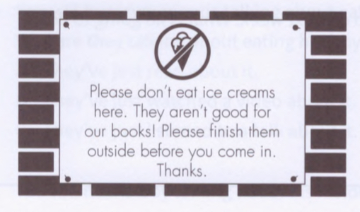 | 28. Where might you see this?  A. in a café  B. in a swimming pool  C. in a library  D. in a picnic area
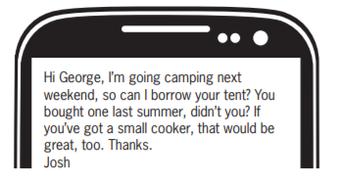 | 29. Why has Josh sent this message?  A. to ask George to go camping with him next weekend  B. to ask if George will lend him some camping equipment  C. to tell George about a new tent he’s going to buy  D. to tell George to buy a tent
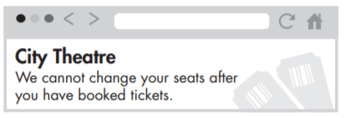 | 30. What can’t theatre customers do?  A. ask for different scats after they’ve paid  B. choose where they sit before they book  C. get their money back on tickets  D. buy tickets at the City Theatre
IV. WRITING (2.5 points)
Rewrite the second sentence so that it has a similar meaning to the original one, beginning with the given words.
31. The children are excited about seeing you again.
The children are looking forward
32. Nobody has answered my questions properly. .
My questions
33. Work hard and you will pass the exam.
If you work
Order the words to make complete sentences.
34. go/you/to/tonight/the/to/Would/party/like/?

35. I / to / go / the / park / with / to / used / my / parents /.

36. passed / My father / learning / was / I / had / the / entrance exam / that / high school / pleased / when/.

Write a paragraph.
37. In about 100 words, write a paragraph about the advantages of using the Internet. Use the cues below or your own idea?
connect with people across distances
get access to information, education, or entertainment
buy and sell things online

HẾT
Thí sinh không được sử dụng tàỉ liệu. Cán bộ coi thi không giải thích gì thêm.
Tài liệu được chia sẻ bởi Website VnTeach.Com
https://www.vnteach.com

