TRƯỜNG THPT CHUYÊN  NGUYỄN CHÍ THANH  TỔ TIẾNG ANH | KỲ THI HỌC SINH GIỎI CÁC TRƯỜNG THPT CHUYÊN  KHU VỰC DUYÊN HẢI VÀ ĐỒNG BẰNG BẮC BỘ  NĂM 2023  MÔN: TIẾNG ANH 11  HƯỚNG DẪN CHẤM  (Hướng dẫn chấm gồm có 13 trang)
_________________________________________
I. LISTENING (50 points)
Part 1: For question 1-5, listen to the talk about how technology helps archaeologists who want to learn more about text written known as Roman tablets. Decide whether the following statements are True (T) or False (F). Write your answers in the corresponding numbered boxes on the answer sheet. (10 points)
1. F | 2. T | 3. T | 4. T | 5. F

Part 2: For questions 6-10, you will hear part of the lecture about tea tree oil. Write NO MORE THAN THREE WORDS taken from the recording. (10 points))
6. oil extraction
7. coughs, colds (or coughs and colds)
8. constant leg pain
9. paper bark tree(s)
10. powerful antiseptic properties

Part 3: For questions 11-15, you will hear part of a discussion between two environmentalists, Ken Forbes and Maggie Dimas, who are talking about cars of the future and cyclists. Choose the answer (A, B, C or D) which fits best according to what you hear and write your answers in the corresponding numbered boxes on the answer sheet. (10 points)
11. C | 12. A | 13. C | 14. A | 15. C

Part 4: For questions 16-25, you will hear a talk about SpaceX planning to launch its biggest rocket ever. Complete the summary with NO MORE THAN FOUR WORDS taken from the recording. Write your answers in the corresponding numbered boxes on the answer sheet. (20 points)
16. explosive
17. prototype
18. rocket-grade krosene
19. bell nozzle
20. humongous nozzles
21. drone ship
22. crew and cargo
23. grabbing arm
24. static fire tests
25. glimpse

II. LEXICO - GRAMMAR (30 points)
Part 1. For questions 26-45, choose the best option A, B, C or D to complete each of the following sentences and write your answers in the corresponding numbered boxes on the answer sheet. (20 points)
- D | - B | - B | - D | - C
- A | - B | - D | - C | - C
- B | - D | - A | - B | - A
- C | - C | - A | - B | - D

Part 2: For questions 46-55, give the correct form of each given word in brackets to complete the following sentences and write your answers in the corresponding numbered boxes on the answer sheet. (10 points)
- ascertain | - deleterious | - impressionable | - malpractices | - unappreciative
- infantile | - unassuming | - lukewarm | - luxuriant | - demystify

III. READING (60 points)
Part 1: For questions 56-65, fill each of the following numbered blanks with ONE suitable word and write your answers in the corresponding numbered boxes on the answer sheet. (15 points)
56. Unlike | 57. by | 58. While/ Although/ Whereas | 59. feeding | 60. never/ seldom/ rarely
61. whose | 62. put | 63. until/ before | 64. least | 65. yet

Part 2: For questions 66-75, read the following passage and choose the best answer A, B, C or D to each question. Write your answers in the corresponding numbered boxers provided on the answer sheet. (10 points)
- A | - C | - A | - A | - C
- D | - D | - D | - D | - C

Part 3: For questions 76-88, read the following passage and do the tasks that follow. (13 points)
- Paragraph A i
- Paragraph B v
- Paragraph C iii
- Paragraph D vii
- Paragraph E vi
- Paragraph F ix

- F | - T | - T | - F | - F | - NG | - T

Part 4. In the passage below, seven paragraphs have been removed. For questions 89-95, read the passage and choose from the paragraphs A-H the one which fits each gap. There is ONE extra paragraph which you do not need to use. Write your answers in the corresponding numbered boxes provided. (7 points)
89. G | 90. F | 91. D | 92. A | 93. H | 94. E | 95. C

Part 5: The passage below consists of five sections marked A-E. For questions 96-105, read the passage and answer the questions by choosing from the sections of the article (A-E). The sections may be chosen more than once. Write your answers (A-E) in the corresponding numbered boxes provided on the answer sheet. (15 points)
- C | - B | - E | - B | - A
- C | - D | - E | - E | - D

IV. WRITING (60 points)
Part 1: Read the following extract and use your own words to summarise it. Your summary should be between 100 and 120 words long. (15 points)
a) Contents (1.0 pt)
- The summary MUST cover the main points.
- The summary MUST NOT contain personal opinions.
- The summary MUST NOT copy exactly the original text.
b) Language use (0.5 pt)
The summary:
- should show attempts to convey the main ideas of the original text by means of paraphrasing (structural and lexical use)
- should demonstrate correct use of grammatical structures, vocabulary, and mechanics (spelling, punctuations, ...)
- should maintain coherence, cohesion, and unity throughout (by means of linkers and transitional devices)

SUGGESTED ANSWER:
Robots have the potential to replace doctors and teachers. British education expert Anthony Seldon predicts that robot will act as teachers in class in the year 2027 by delivering lectures while human teachers will be like their helpers. However, it is unlikely that robots will ever show their sympathy and understanding for others nor the ability to interact or communicate. However, a robot teacher can be superior to a normal teacher in terms of physical and mental endurance. Therefore, the main focus of education should be how robots can assist teachers with non-teaching work, such as marking homework and writing reports.

Part 2: The graph below shows the number of overseas visitors to three different areas in a European country between 1987 and 2007.
Summarise the information by selecting and reporting the main features and make comparisons where relevant. (15 points)
a) Content: (0.6đ)
All the relevant information has been included.
Make general remarks and effective comparisons.
b) Organisation: (0.3đ)
The answer flows well and is clear and easy to read, that is, the description is easily understood and well-organised.
c) Use of language: (0.6đ)
Appropriate linking words and phrases as well as a good level of grammar have been used. Also, the vocabulary is accurately used.

SUGGESTED ANSWER:
The graph illustrates the statistics of international visitors to three different parts of a country during a 20-year period from 1987 to 2007. Overall, the national tourism industry has experienced generally positive changes throughout the years with coastal destinations being the most attractive of all.
From 1987 to 1997, the hospitality business in the European country witnessed dramatic fluctuations. The mountains and the lakes both had some decent growth in the first half of that decade from 20 thousand to 30 thousand and 10 thousand to 20 thousand respectively. However, mountainous areas lost their attractiveness and went back to their initial statistics in 1987, while lacustrine visits continued to increase and doubled in 1997 compared to the first 5 years. The coasts, though losing some of its visitors at first, had a considerable boost in numbers later that decade, ending at around 50 thousand in 1997, gaining 25% more guests.
Between 1997 and 2007, the influx of comers kept on and the final results were broadly positive. Tourists visiting the seaside had the greatest development in this decade with a 50% increase, while highland tourism also had a small rise of 5 thousand to 35 thousand in 2007. Interestingly, in 2002, lakeside destinations witnessed a boom in interest, reaching the peak of 75 thousand visits at its most popular time. Nonetheless, this instant popularity was not sustained and quickly cooled off, with the number of visitors falling to 50 thousands in 2007.

Part 3: Essay writing (30 points)
Write an essay of (at least 350 words) to express your opinion on the following issue.
Some people prefer to provide help and support directly to those in need. Others, however, prefer to give money to charitable organizations launched by celebrities.
Discuss both views and give your own opinion.
Give reasons for your answer and include any relevant examples from your own knowledge or experience.

a) Task achievement: (10 points)
  - ALL requirements of the task are sufficiently addressed.
  - Ideas are adequately supported and elaborated with relevant and reliable explanations, examples, evidence, personal experience, etc.
b) Organization: (10 points)
- Ideas are well organized and presented with coherence, cohesion, and unity.
- The essay is well-structured:
- Introduction is presented with clear thesis statement.
- Body paragraphs are written with unity, coherence, and cohesion. Each body paragraph must have a topic sentence and supporting details and examples when necessary.
- Conclusion summarises the main points and offers personal opinions (prediction, recommendation, consideration,…) on the issue.
c) Language use: (5 points)
  - Demonstration of a variety of topic-related vocabulary
  - Excellent use and control of grammatical structures
d) Punctuation, spelling, and handwriting (5 points)
- Correct punctuation and no spelling mistakes
- Legible handwriting
- THE END -

TAPESCRIPT
Part 1: At the time of the Roman Empire in Europe, around 2,000 years ago, it was common for information to be written, not on paper, but on things called tablets’. These were pieces of wood about the size and thickness of a typical modem envelope.
Hundreds of such tablets have been unearthed from archaeological sites throughout Europe and the Mediterranean world “ nearly 200 were found in one Roman fort alone - and like most of these discoveries, they have been placed In public collections, mainly in museums In northern Europe, to be viewed but not, unfortunately, to be read.
This is because, although In some cases traces of writing can still be seen, most are now Illegible to the naked eye. But that’s all soon to change because archaeologists hope that with the help of new technology, their secrets may soon be revealed. Many of the tablets took the form of legal documents and letters written by Roman soldiers. An example, now at the British Museum, bears the name of the person who wrote it and the name of the person who received it, plus the word ‘transportation’, which you can just make out, but the rest remains a mystery. Now, with the help of computer techniques, experts hope eventually to be able to read the whole letter. Professor Mike Brady, a leading figure In what’s known as 'computer vision’ for many years, admits that this Is the hardest project he’s ever worked on. But the excitement of seeing the latest Ideas In computing applied to such a very ancient problem has the archaeological community buzzing.
So, In simple terms, why has the writing been preserved and how will it be possible to ‘undo’ the ageing process? Well, the tablets were made with thin, hollow panels cut across them. Wax was poured Into these and the text was then written Into this soft surface using an Instrument with a fine metal point. In virtually all cases, the wax has perished and all that can be detected on the surface of the tablet underneath are scratches. These are too faint to be read, because they are distorted.
For some time, scientists have attempted to study them with laser photography, but this has proved fruitless. However, It is now hoped that by enhancing Images of the tablets on computer, their original messages will become legible again. If this Is the case, a whole new source of historical Information will be opened up, and this promises advances and new knowledge for many decades to come. The new technology has already been used on texts In Ink as well, and In the future, It will be applied to damaged surfaces of many kinds.
Part 2:
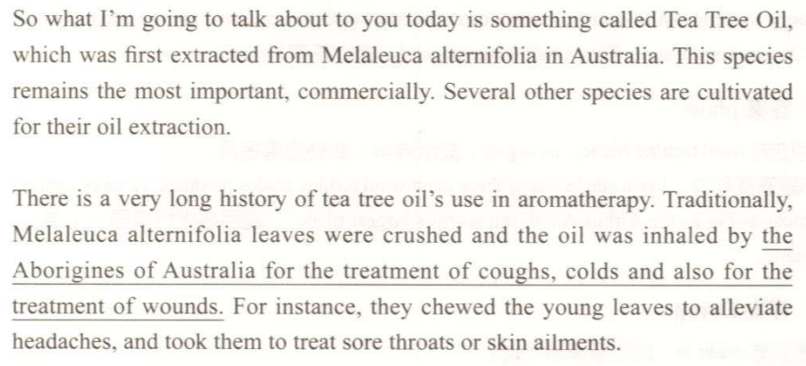
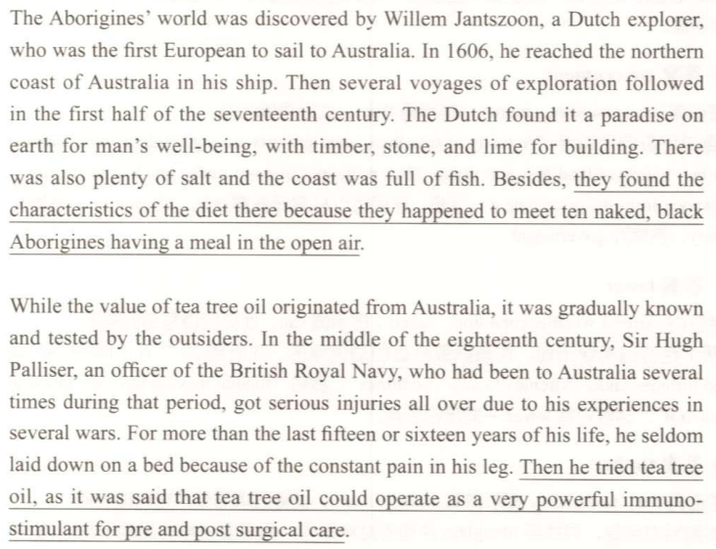
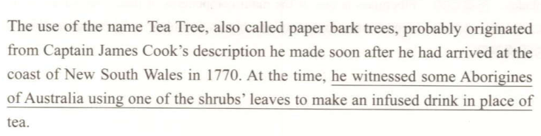
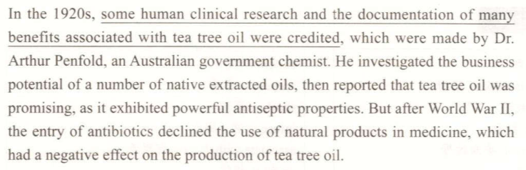
Part 3:
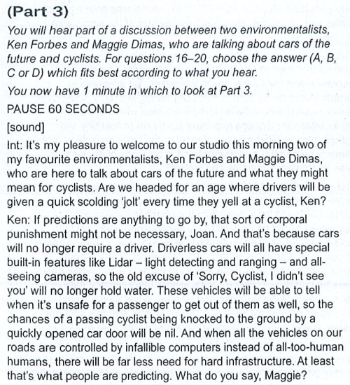
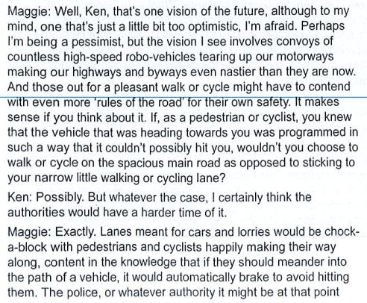
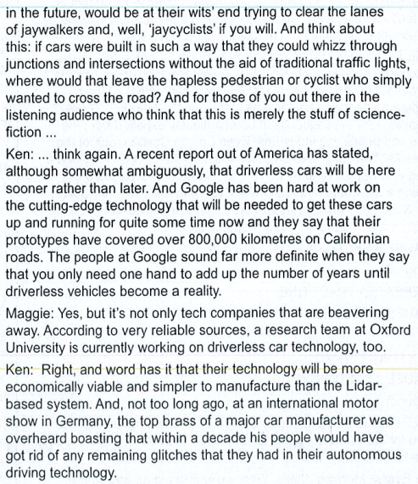
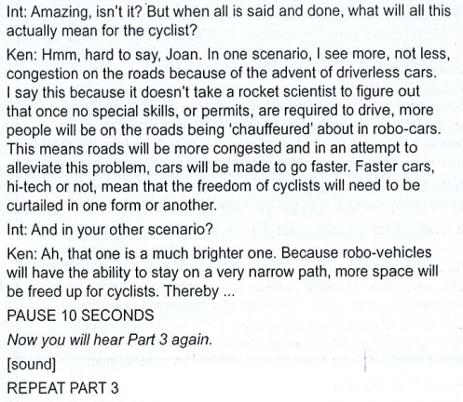
Part 4:
SpaceX’s operation out of Boca Chica, Texas has been hard at work creating a reusable spacecraft capable of taking humans to the moon or even Mars. It started with short hops, then test flights multiple kilometers up with some spectacular landings, both elegant and explosive. Now the company is preparing to make the next giant leap for their space program: they’re going to send their latest prototype into orbit for the first time ever.
Sure, SpaceX has launched stuff into orbit before. Lots of stuff, actually. At this point, Falcon 9 launches and landings seem practically routine. But for a number of reasons, Starship is different, like for example it uses a revolutionary new engine. The Falcon 9 relies on the trusty Merlin engines, but a big part of the Starship development process has been designing and refining an engine the company has dubbed Raptor. The Raptor uses liquid oxygen and methane, a departure from Merlin’s more conventional combination of liquid oxygen and rocket-grade kerosine known as RP-1. The Raptor also uses what’s known as a full-flow staged combustion system which uses every bit of fuel for thrust unlike Merlin’s open-cycle system. These changes are designed to make Starship’s engines more powerful, efficient, and reusable, all desirable traits for engines that could one day ferry people to and from other worlds. To date, Starship prototypes have had at most three raptor engines, but SN 20 will have six. The additional three aren’t for getting the craft into orbit, but don’t you worry we’ll get to that. No, the other three raptors are optimized to work better in the vacuum of space. The most obvious difference between them and the sea-level optimized raptors is the addition of a giant bell nozzle that improves efficiency in space. So then, how is SN20 going to get into orbit if it only has just the three sea level optimized engines plus the added weight of hauling three more engines and their humongous nozzles up there. The solution is to carry Starship up with a booster rocket called the Super Heavy, which will sport 29 raptor engines. This will be the first time ever this massive booster stage has flown. SpaceX briefly stacked one stage on top of the other back in August. It was only to check the fit but at 120 meters tall, it became the tallest rocket ever assembled.
One of the major advances SpaceX made to rocket science is landing the first stage of their rockets safely back on the ground. Falcon 9 boosters gently touching down on drone ships not only look straight out of science fiction, but have allowed the company to reuse their rockets over and over. Their goal is to master the same trick with Starship, and they’ve been fine-tuning just how to
bring it back down gently. If Starship is ever going to land on other planets like Mars, they’ll have to get it down perfectly if they don’t want to flatten the crew or cargo.
Reusability will also drive down the cost of launches, so SpaceX would like to make both stages of the launch capable of soft landing, although the proposed design for the Super Heavy involves a tower with grabbing arms that would literally catch it as it slowly descended toward earth. For SN 20 and its Super Heavy, gentle touchdowns aren’t part of the plan. Its launch is solely focused on getting Starship into orbit, and once it gets there, who cares how it comes
down right now? The Super Heavy is expected to hit the water in the gulf of Mexico, while, fingers crossed, Starship reaches orbit before coming down again near Hawaii. SN20 has had a few static fire tests to make sure both the vacuum and sea level raptors are functioning. If the Super heavy boosts Starship into orbit successfully, then SpaceX’s plans will really start taking shape. They’ll have to perfectly land each stage of the rocket and probably figure out a million other things, but still the outcome of this upcoming starship launch could give us a very clear glimpse of what is to come.

