Week: 15 Date of planning: ......................
Period: 45 Date of teaching:......................
UNIT 6: LIFESTYLES
Lesson 4: Communication
I. OBJECTIVES
By the end of this lesson, Ss will be able to:
1. Knowledge
- Express certainty
2. Competences
- Develop communication skills and creativity
- Be collaborative and supportive in pair work and teamwork
- Actively join in class activities
3. Personal qualities
- Be ready and confident in real life conversations.
II. MATERIALS
- Grade 8 textbook, Unit 6, Communication
- Computer connected to the Internet
- Projector / TV
- hoclieu.vn
III. PROCEDURES
1. WARM-UP (5 mins)
a. Objectives:
- To create an active atmosphere in the class before the lesson;
- To lead into the new lesson.
b. Content:
- Jumbled conversation
c. Expected outcomes:
- Students’ answers
d. Organisation
TEACHER’S AND STUDENTS’ ACTIVITIES | CONTENTS
Broken telephone game:  - T divides the class into 5 groups. Each group stands in one line.  - T shows a word to the last students of all groups. These students must quickly whisper the word to their teammates in order. The first member of each team writes the word on the board. The fastest student writes the correct word earns 1 point for the team.  - T leads to the new lesson | Suggested answers:  Words:  - lifestyle  - communication  - online learning  - technology

2. ACTIVITY 1: PRESENTATION (12mins)
a. Objectives:
- To introduce ways of expressing certainty.
- To help Ss practise expressing certainty.
b. Content:
- Task 1: Listen and read the conversations. Pay attention to the highlighted sentences.
- Task 2: Work in pairs. Make similar conversations to express certainty in the following situations.
c. Expected outcomes:
- Students know how to use the structures to express certainty.
d. Organisation

TEACHER’S AND STUDENTS’ ACTIVITIES | CONTENTS
Task 1: Listen and read the conversations. Pay attention to the highlighted sentences.
(5 mins)

- T plays the recording for Ss to listen and read the two dialogues between Tom and Nam, Alice and Mai at the same time.  - Ask Ss to pay attention to the questions and answers.  - Have Ss practise the dialogues in pairs.  - Call on some pairs to practise the dialogues in front of the class. | 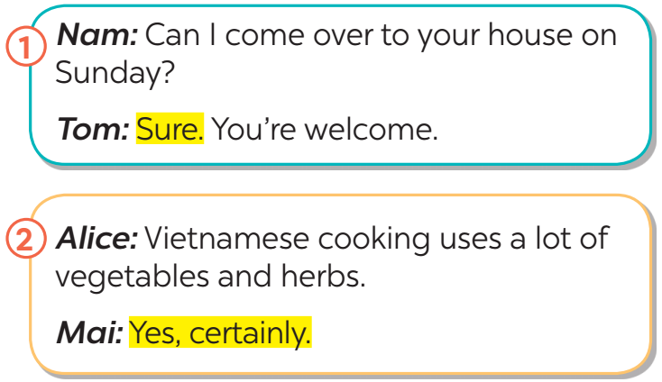
Task 2: Work in pairs. Make similar conversations to express certainty in the following situations. (7 mins)

- T asks Ss to work in pairs to make similar dialogues with the given cues (one asks questions and the other answers).  - Teacher checks students’ understanding by asking some checking-questions.  - Move around to observe and provide help.  - Call on some pairs to practise in front of the class.  - Comment on their performance. | Suggested answers:  - You ask your friend to help you with your maths homework.  ﻿A: Can you help me with my maths homework?  B: Yes, certainly. / Yes, sure.  - You say that Vietnamese love seafood.  A: Vietnamese love seafood.  B: Yes, certainly. / Yes, sure.
3. ACTIVITY 2: PRACTICE (15 mins)
a. Objectives:
- To help Ss ﻿learn about the cuisine of different countries around the world.
- To help Ss develop their reading skill for specific information (scanning).
- To provide Ss with practice in ﻿talking about their opinions and giving reasons.
b. Content:
- Task 3: How much do you know about the cuisines of different countries? Do the quiz to find out.
- Task 4: Work in groups. Read the two passages and discuss the questions below.
c. Expected outcomes:
- Students know about the cuisine of different countries around the world.
- Students can talk about their opinion and give reasons; ask and answer questions about food.
d. Organisation
TEACHER’S AND STUDENTS’ ACTIVITIES | CONTENTS
Task 3: How much do you know about the cuisines of different countries? Do the quiz to find out.(8mins)
﻿- T has Ss work in pairs and do the quiz.  - Give explanations if necessary.  - Check their answers as a class.  - Ss listen to the teacher and work in pairs.  - SS give their answers and self-correct. | Answer key:  ﻿1. B  2. A  3. C  4. A  5. B
Task 4: Work in groups. Read the two passages and discuss the questions below. (7mins)
- ﻿T has Ss read the passages for a few minutes. Make sure they understand the main ideas, and explain if needed.  - Tell Ss work in groups. Each group gives their preference (Italian or Indian food), and gives reasons.  - T goes round the class to monitor.  - T corrects Ss’ mistakes only when it is really necessary.  - T calls on some Ss to perform the task in front of the class.  - T and other Ss listen and make comments. |  | Do you prefer Italian or Indian food?  Why/Why not?
4. ACTIVITY 3: PRODUCTION (10 mins)
a. Objectives:
- To provide Ss with practice in asking and answering about typical food in their area.
b. Content:
- Task 5: Work in groups. Talk about the typical food in your area. Discuss.
c. Expected outcomes:
- Students can talk about their opinion and give reasons; ask and answer questions about food.
d. Organisation
TEACHER’S AND STUDENTS’ ACTIVITIES | CONTENTS
Task 5: ﻿Work in groups. Talk about the typical food in your area.
- Have Ss work in groups, taking turns to ask and answer.  - Let Ss think and give the answers.  - Encourage them to say what they know and what they think. Their opinions may differ.  -T calls on some pairs to perform the task in front of the class.  - T and other Ss listen and make comments. | Suggested outcome:  ﻿- staple food: rice, corn, bread, ...  - favourite food: pork, chicken, beef, fish, seafood, ...  - foods eaten on special occasions: banh chung, moon cakes, sticky rice, ...  Example:  A: What is the staple food in your area?  B: It's rice.  C: Yes. We have rice with most of our meals.
5. CONSOLIDATION (3 mins)
a. Wrap-up
- Have Ss say what they have learnt in the lesson.
- Retell the contents of the lesson
b. Homework
- Read the conversations again
- Do more exercises in workbook.
- Make a list of 10 popular street foods in Asia.
- Prepare next lesson: Skills 1.

