

**PART 2: VOCABULARY**

|  |  |  |  |
| --- | --- | --- | --- |
| **ENGLISH** | **TYPE** | **PRONUNCIATION** | **VIETNAMESE** |
| **campsite** | (n) | /ˈkæmpsaɪt/ | Khu cắm trại |
| **canyon** | (n) | /ˈkænjən/ | Hẻm núi |
| **cave** | (n) | /keɪv/ | Hang động |
| **hiking** | (n) | /ˈhaɪkɪŋ/ | Chuyến đi bộ đường dài |
| **kayaking** | (n) | /ˈkaɪækɪŋ/ | Trò chèo thuyền kayak |
| **rafting** | (n) | /ˈræftɪŋ/ | Việc đi bè |
| **battery** | (n) | /ˈbætəri/ | Pin |
| **bottled water** | (n) | /ˈbɑːtld ˈwɔːtər | Nước đóng chai |
| **flashlight** | (n) | /ˈflæʃlaɪt/ | Đèn pin |
| **pillow** | (n) | /ˈpɪləʊ/ | Gối |
| **sleeping bag** | (n) | /ˈsliːpɪŋ bæɡ/ | Túi ngủ |
| **tent** | (n) | /tent/ | Lều |
| **towel** | (n) | /ˈtaʊəl/ | Khăn |
| **bay** | (n) | /beɪ/ | Vịnh |
| **beach** | (n) | /biːtʃ/ | Bãi biển |
| **forest** | (n) | /ˈfɔːrɪst/ | Khu rừng |
| **highland** | (n) | /ˈhaɪlənd/ | Cao nguyên |
| **island** | (n) | /ˈaɪlənd/ | Hòn đảo |
| **mountain** | (n) | /ˈmaʊntn/ | Núi |
| **waterfall** | (n) | /ˈwɔːtərfɔːl/ | Thác nước |
| **sneakers** | (n) | /ˈsniːkərz/ | Giày chơi quần vợt |
| **sunglasses** | (n) | /ˈsʌnɡlæsɪz/ | Kính râm |
| **confirm** | (v) | /kənˈfɜːrm/ | Xác nhận |
| **decide** | (v) | /dɪˈsaɪd/ | Quyết định |
| **heritage** | (n) | /ˈherɪtɪdʒ/ | Di sản |
| **information** | (n) | /ˌɪnfərˈmeɪʃn/ | Thông tin |
| **snorkeling** | (n) | /ˈsnɔːrklɪŋ/ | Lặn có ống thở |
| **sandcastle** | (n) | /ˈsændkæsl/ | Lâu đài cát |
| **international** | (adj) | /ˌɪntərˈnæʃnəl/ | Thuộc về quốc tế |
| **dangerous** | (adj) | /ˈdeɪndʒərəs/ | Nguy hiểm |
| **description** | (n) | /dɪˈskrɪpʃn/ | Sự miêu tả |

**Task 1. Look at the pictures and write the letter in the box.**

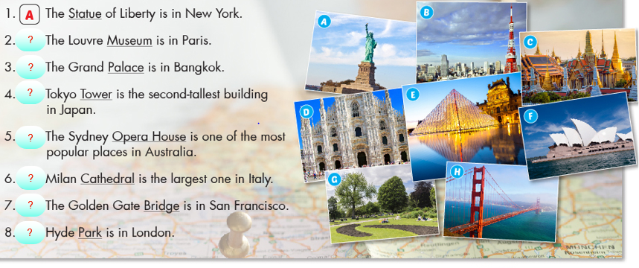

**Task 2. Match the words with the descriptions .**

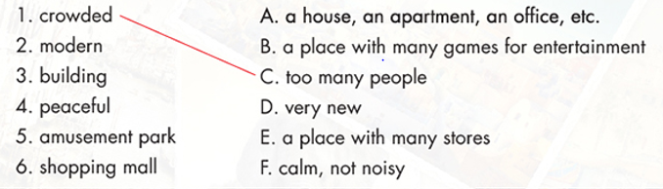

**Task 3.Write the suitable word for each picture.**

|  |  |  |
| --- | --- | --- |
| **images (3)** | **tải xuống (4)** | **images (1)** |
| **1.** _______________ | **2.** _______________ | **3.** _______________ |
| **tải xuống** | **images** | **tải xuống (1)** |
| **4.** _______________ | **5.** _______________ | **6.** _______________ |
| **tải xuống (2)** | **images (2)** | **tải xuống (3)** |
| **7.** _______________ | **8.** _______________ | **9.** _______________ |
| **tải xuống (7)** | **tải xuống (6)** | **images (7)** |
| **10. _______________** | **11. _______________** | **12. _______________** |
| **tải xuống (5)** | **images (5)** | **images (4)** |
| **13. _______________** | **14. _______________** | **15. _______________** |
| **tải xuống (8)** | **images (6)** | **images (9)** |
| **16. _______________** | **17. _______________** | **18. _______________** |



**PART 3: GRAMMAR**

**I. Prepositions of time: On, at , in**

|  |  |  |
| --- | --- | --- |
| **Giới từ** | **Thời gian** | **Ví dụ** |
| **On** (vào) | Các ngày trong tuần, ngày tháng, ngày tháng năm và các ngày cụ thể, cụm từ cố định. | - on Monday: Vào ngày thứ 2 - on 10 March: vào ngày 10 tháng 3 - on 10 March 2019: vào ngày 10 tháng 3 năm 2019 - on Christmas Day: vào ngày lễ giáng sinh. - on time: đúng giờ, chính xác. |
| **At** (vào lúc) | Thời gian trong ngày, các dịp lễ, cụm từ cố định. | - at 10 o’clock: lúc 10 giờ đúng - at midnight: vào giữa đêm - at Christmas: vào dịp giáng sinh - at the same time: cùng lúc - at the end of this year: cuối năm nay - at the beginning of this year: đầu năm nay - at the moment = at the present: ngày bây giờ |
| **In** (trong, vào) | Tháng, năm, mùa, thập niên, thập kỉ, các buổi trong ngày (trừ **at night**), cụm từ cố định. | - in January: vào tháng 1 - in 2010: vào năm 2010 - in summer: vào mùa hè - in the 1960s: vòa những năm 1960. - in the morning: vào buổi sáng. - in time: đúng lúc, kịp lúc - in the end: cuối cùng |
| **Before**  (trước khi) | Các cụm từ chỉ thời gian | - before 10am: trước 10 giờ sáng - before 2015: trước năm 2015 - before Christmas: trước giáng sinh. |
| **After** (sau khi) | Các cụm từ chỉ thời gian. | - After breakfast: sau bữa điểm tâm - After school: sau giờ học. |
| **During**  (trong suốt) | Khoảng thời gian. | - During my holiday: suốt kỳ nghỉ - During September: suốt tháng 9. |
| **By** (trước) | Thời điểm | - By 9 o’clock: trước 9 giờ - By Monday: trước thứ 2. |
| **For** (trong khoảng thời gian) | Khoảng thời gian. | - For 3 years: trong 3 năm - For a long time = for ages: trong một thời gian dài. |
| **Since** (từ khi) | Mốc thời gian | - since 2008: từ năm 2008 - since yesterday: từ ngày hôm qua. |
| **Till/ until** (cho đến khi) | Mốc thời gian | - till/ until 2 o’clock: cho đến 2 giờ - until tomorrow: cho đến ngày mai. |
| **Between** (giữa) | Giữa hai khoảng thời gian | - between 2pm and 5 pm: từ 2 giờ đến 5 giờ - between September to October: từ tháng 9 đến tháng 10. |
| **Up to/ to** (cho đến) | Mốc/ khoảng thời gian | - up to now: cho đến bây giờ - up to 3 hours per day: cho đến 3 giờ một ngày. |
| **From …. To/ till/ until…** (từ… đến...) | Mốc thời gian | - form Monday to Sunday: từ thứ 2 đến chủ nhật - from 8am to 11am: từ 8 giờ sáng đến 11 giờ. |
| **Within** (trong vòng) | Khoảng thời gian | - within 2 minutes: trong vòng 2 phút - within 2 months: trong vòng 2 tháng. |
| **Ago** (cách đây) | Khoảng thời gian | - 5 years ago: cách đây 5 năm. |

**Lưu ý:** Một số từ sau đây không đi kèm với giới từ: **tomorrow, yesterday, today, now, right now, every, last, next, this, that**.

**II. Past Simple with “to be”**

|  |  |  |
| --- | --- | --- |
| **Thể khẳng định** | | |
| **I/ He/ She/ It/**  Danh từ số ít | **was** | + danh từ/ tính từ |
| **You/ We/ They/**  Danh từ số nhiều | **were** |
| **Ví dụ:**  - He was tired. (Anh ấy đã rất mệt.)  - They were in the room.  (Họ đã ở trong phòng.) | | |

|  |  |  |
| --- | --- | --- |
| **Thể phủ định** | | |
| **I/ He/ She/ It/**  Danh từ số ít | **was not/ wasn’t** | + danh từ/ tính từ |
| **You/ We/ They/**  Danh từ số nhiều | **were not/ weren’t** |
| **Ví dụ:**  - He wasn’t at school yesterday.  (Hôm qua anh ấy đã không ở trường.)  - They weren’t in the park.  (Họ đã không ở trong công viên.) | | |

|  |  |  |  |  |  |
| --- | --- | --- | --- | --- | --- |
| **Thể nghi vấn** | | | **Câu trả lời ngắn** | | |
| **Was** | **I/ He/ She/ It/**  Danh từ số ít | + danh từ/ tính từ | **Yes,** | **I/ He/ She/ It/**  Danh từ số ít | **was** |
| **No,** | **wasn’t** |
| **Were** | **You/We/ They/**  Danh từ số nhiều | **Yes,** | **You/We/ They/**  Danh từ số nhiều | **were** |
| **No,** | **weren’t** |
| **Ví dụ:**  • Were they tired yesterday? (Hôm qua họ đã mệt phải không?)  ⇨ Yes, they were./ No, they weren’t.  • Was he at home? (Anh ấy đã ở nhà phải không?)  ⇨ Yes, he was./ No, he wasn’t. | | | | | |

**Lưu ý:** Khi chủ ngữ trong câu hỏi là “**you**” (bạn) thì câu trả Iời phải dùng “**I**” (tôi) để đáp lại.

**Task 1. Use “should/shouldn’t” to fill in the blanks to complete the sentences.**

1. Tom _______________ eat so many lollipops. It’s bad for his teeth.

2. He’s fifteen. He _______________ drive a car.

3. Pregnant women _______________ smoke as it can damage the baby.

4. We _______________ go somewhere exciting for our holiday.

5. People _______________ drive fast in the town centre.

6. You _______________ ask the teacher for help you if you don’t understand the lesson.

7. _______________ I buy the dress or the skirt?

8. She _______________ tell lies.

9. That’s a fantastic book. You _______________ read it.

10. The doctor said: “You _______________ eat healthy food. You _______________ eat fast food. You _______________ watch so much TV. You _______________ walk 1 hour a day. You _______________ drink fruit juice and water. You _______________ drink wine or beer.

11. You _______________ be so selfish.

12. I don’t think you _______________smoke so much.

13. You _______________ exercise more.

14. I think you _______________ try to speak to her.

15. You are overweight. You _______________ go on a diet.

16. Where _______________ we park our car?

17. You _______________ never speak to your mother like this.

18. The kids _______________ spend so much time in front of the TV.

19. _______________ I tell her the truth or should I say nothing?

20. I think we _______________ reserve our holiday in advance.

**Task 2. Use “can/can’t” to fill in the blanks to complete the sentences.**

**1.** I (**can/ can’t**) speak French. I picked it up while I was in France.

**2.** I (**can/ can’t**) come to the party. I am really busy.

**3.** We (**can/ can’t**) hear you. The music is so loud.

**4.** Where are my keys? I (**can/ can’t**) find them.

**5.** I (**can/ can’t**) believe it. We won two million dollars.

**6.** We (**can/ can’t**) meet tomorrow if you want.

**7.** (**Can/ Can’t**) you make me a cup of tea, please?

**8.** He (**can/ can’t**) jump. His leg hurts so much.

**9.** Illiterate people (**can/ can’t**) read and write.

**10.** Fish (**can/ can’t**) swim.

**11.** (**Can/can’t**) you swim? - Yes, I (**can/can’t**)

**12.** I’m sorry I (**can/can’t**) help you today, I’m really busy.

**13.** Please (**can/can’t**) you buy some milk on your way home? - I (**can/can’t**) leave the house because I’m looking after the baby.

**14.** I (**can/can’t**) ride a bike but I (**can/can’t**) drive a car.

**15.** I just (**can/can’t**) manage to wake up on time, I’m always late.

**16.** Hello, (**can/can’t**) I help you? - Actually, no you (**can/can’t**). This restaurant is awful and we’ve been waiting here for half an hour. We’re leaving.

**17.** I have a special talent, I (**can/can’t**) touch my nose with my tongue (**can/can’t**) you?

**18.** (**Can/Can’t**) I go to the bathroom please?- Yes, of course you (**can/can’t**).

**19.** Look! It’s right there! (**Can/Can’t**) you see it? It’s so obvious!

**20.** I’ve never been able to eat breakfast in the mornings. I (**can/can’t**) talk to anyone either!

**Task 3. Choose A, B, C or D to complete the sentences.**

**1.** I like English _______________ I like French very much.

**A.** and **B.** but **C.** or **D.** so

**2.** My brother likes Maths _______________ he doesn’t like history.

**A.** and **B.** but **C.** or **D.** so

**3.** The children forgot their homework,_______________ the teacher was angry with them.

**A.** and **B.** but **C.** or **D.** so

**4.** Can you read _______________ write English words?

**A.** and **B.** but **C.** or **D.** so

**5.** Are the questions right _______________ wrong?

**A.** and **B.** but **C.** or **D.** so

**6.** It’s great _______________ it’s fun.

**A.** and **B.** but **C.** or **D.** so

**7.** Would you like tea _______________ hot chocolate for your breakfast?

**A.** and **B.** but **C.** or **D.** so

**8.** Our car is old, _______________ it drives beautifully.

**A.** and **B.** but **C.** or **D.** so

**9.** It was very warm, _______________ we all went swimming.

**A.** and **B.** but **C.** or **D.** so

**10.** Do we have French _______________ Music after the break?

**A.** and **B.** but **C.** or **D.** so

**11.** I like sugar in my tea, _______________ I don’t like milk in it.

**A.** and **B.** but **C.** or **D.** so

**12.** We were very tired _______________ happy after our flight to Sydney.

**A.** and **B.** but **C.** or **D.** so

**13.** Jane was cold, _______________ he put on a coat.

**A.** and **B.** but **C.** or **D.** so

**14.** Julie has a guitar, _______________ she plays it really well.

**A.** and **B.** but **C.** or **D.** so

**15.** Maria tried to read a novel in French, _______________it was too difficult.

**A.** and **B.** but **C.** or **D.** so

**16.** He lives in London, _______________ he studies at a college.

**A.** and **B.** but **C.** or **D.** so

**17.** You can go to the tourist office _______________ ask them for any information you need.

**A.** and **B.** but **C.** or **D.** so

**18.** Does Miss Smith like the red boots _______________ the black and white sandals?

**A.** and **B.** but **C.** or **D.** so

**19.** Lynda likes Tom _______________ he is in love with Annette.

**A.** and **B.** but **C.** or **D.** so

**20.** Geraldine Chaplin is a great actress ________ she is less well-known than her father Charlie Chaplin.

**A.** and **B.** but **C.** or **D.** so



**LISTENING**

**Task 1: Listen and fill in the blanks.**

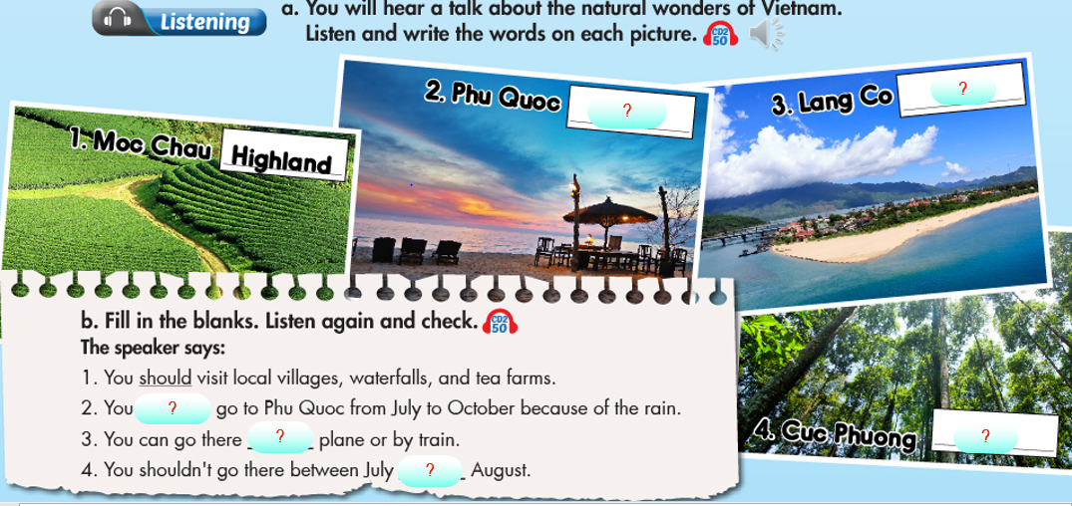

**Task 2: Listen to the passage and decided if the statements are true (T) or False ( F)**

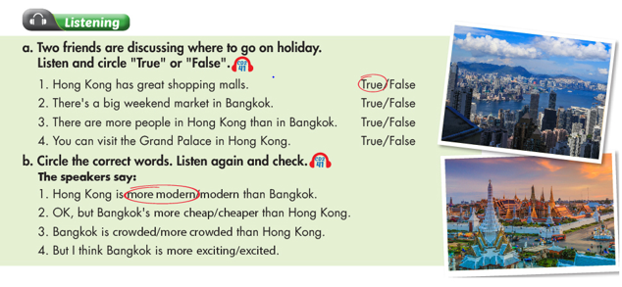



**SPEAKING**

**Task 1. Match the questions and answers. Then practice.**

|  |  |  |
| --- | --- | --- |
| 1. Where is Ha Long Bay? |  | 1. They can see thousand of birds , forest anmals and fish . |
| 1. How can visitors go to Ha Long bay? |  | 1. No, it isn’t. It’s in the South. |
| 1. What can tourists do there? |  | 1. They can visit the small islands and explore amzing cave there. |
| 1. Is Tra Su forest in the north of Viet Nam? |  | D. In Quang Ninh Province |
| 1. What’s the best time to travel through Tra Su forest? |  | E. from September to November. |
| 1. What can visitors do in Tra Su forest? |  | F. By plane and the take a bus to Ha Long Bay. |

**Task 2.**

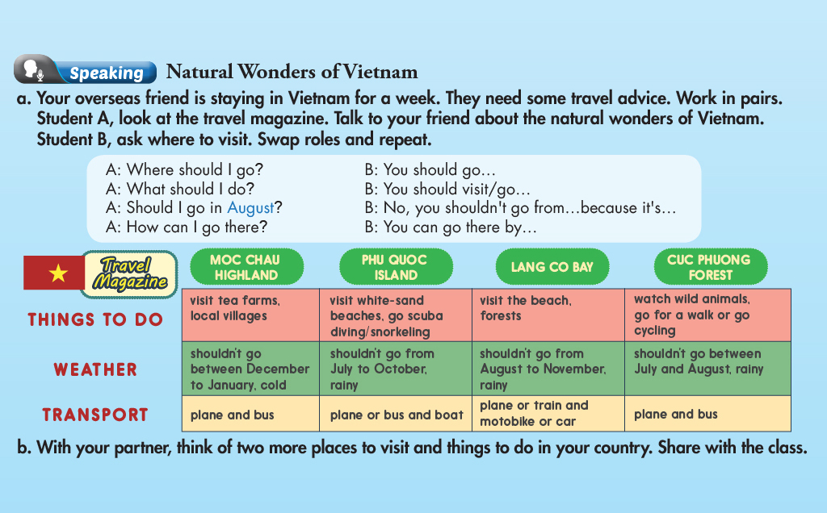



**READING**

**Task 1.**

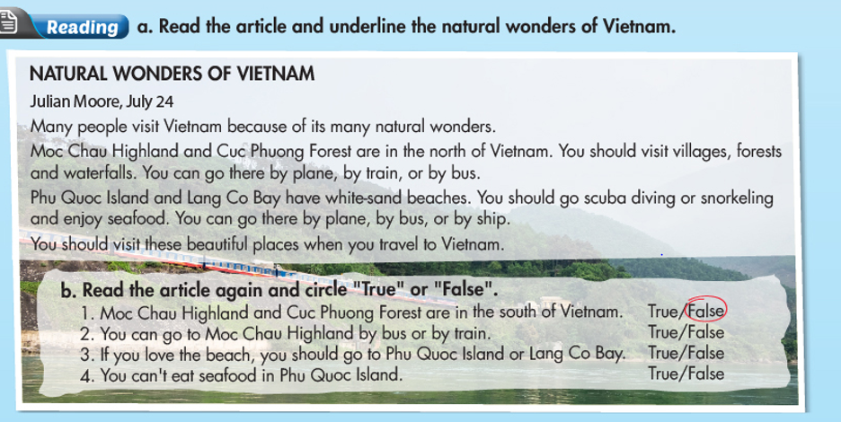

**Task 2. *Read and choose the correct answer (A, B, C or D)***

*Christine Robinson, August 12*

Bali is a wonderful place for o vocation.

A lot of visitors go to Bali for their vacations every year. You can enjoy the white sand beaches, take photos, and moot friendly local people. You can also go on cycling tours, scuba diving, and even snorkeling. Bali is one of the most beautiful islands in Indonesia. You can go there by boat or plane. You should not go there between October and March because it is very rainy. Between April and October are the best times to visit Bali, during the dry season. You can also go to the International Film Festival in Bali every September. If you get the chance, you should spend your vacation in this beautiful place.

**1.** People can enjoy beautiful beaches with _______________.

**A**. golden sand **B.** white sand **C.** rain **D.** forest

**2.** People can enjoy cycling and _______________.

**A.** rock climbing **B.** kayaking **C.** scuba diving **D.** snorkeling

**3.** People can take a _______________ to Bali.

**A.** bus **B.** train **C.** boat **D.** plane

**4.** People shouldn’t go there between _______________ and _______________ because of the rain.

**А**. November - December **B.** October - December

**C.** October – March **D.** September – December

**5.** The Indonesian International Film Festival happens every _______________ in Bali.

**A.** three years **B.** year **C.** two years **D.** four years



**WRITING**

**Task 1. *Look at the travel brochures and choose a place you'd like to go with your friends on vacation. Write a paragraph about your choice using the given information.***

***Write 50 to 60 words.***

|  |  |
| --- | --- |
| THE RED CANYON  Beautiful place What to do: go rock climbing, go rafting How to get there: 3 hours by car Where to stay: a hotel by the canyon Note: swimming: too dangerous! | THE GREEN CAVE  Interesting place What to do: go hiking, go kayaking inside the caves How to get there: 5 hours by bus Where to stay: a campsite near the cave Note: rock climbing: too dangerous! |

***_____________________________________________________________________________________________________________***

***_____________________________________________________________________________________________________________***

***_____________________________________________________________________________________________________________***

***_____________________________________________________________________________________________________________***

***_____________________________________________________________________________________________________________***

**Task 2. *Read the information below and write a postcard telling your friend about Boy of Islands.  
Write 50 to 60 words.***

|  |
| --- |
| **NEW ZEALAND**  **BAY OF ISLANDS**  **- Amazing beaches**  **- go fishing**  **- go surfing**  **- nice, sunny weather**  **- delicious seafood** |

**Hello Liam,**

***_____________________________________________________________________________________________________________***

***_____________________________________________________________________________________________________________***

***_____________________________________________________________________________________________________________***

**Can't wait to see you.**

**Paul**



